Adapting Trust Strategies: A Dyadic Perspective on the Development and Maintenance of Trusting Manager-Employee Relationships

By

Sian Kelly M.Sc., B.Sc.

Research Supervisors:
Prof. Yseult Freeney & Prof. Lisa van der Werff

A Thesis Submitted to Dublin City University Business School in Partial Fulfilment of the Requirements for the Degree of Doctor of Philosophy
November 2024

DECLARATION

I hereby certify that this material, which I now submit for assessment on the programme of study leading to the award of Doctor of Philosophy is entirely my own work, and that I have exercised reasonable care to ensure that the work is original, and does not to the best of my knowledge breach any law of copyright, and has not been taken from the work of others save and to the extent that such work has been cited and acknowledged within the text of my work.

Signed: Sian Kelly
ID No.: 17210205
Date: 18/11/24

Acknowledgments

First and foremost, I would like to thank my supervisors Professor Yseult Freeney and Professor Lisa van der Werff for your invaluable guidance throughout my PhD. I have learned so much from you both throughout my PhD, not just relating to my research but also about teaching, publishing, and the world of academia more broadly. Yseult, the support you have shown me since we first met has been unwavering. From our initial chat about my interest in organizational psychology before I applied for the MWOP, to your encouragement and support to pursue this PhD - quite literally, I wouldn’t be here without you! I feel very fortunate to have such a wonderful mentor in my corner. You always have an interesting take on things and have encouraged my thinking so much throughout the PhD. Lisa, when people share the well-versed notion that you will be more of an expert than your supervisor on your topic by the end of the PhD, I silently think I’m not so sure! Your knowledge of the trust literature never ceases to amaze me. But also, your willingness to share your knowledge and to be totally open-minded and excited about others' perspectives is so encouraging. Beyond supporting the progression of my work, you have both been so kind and supportive along the way and for that, I am equally grateful. Working with supervisors who genuinely care and want the best for me both professionally and personally has been a very lovely experience. I have never felt like I was alone on this journey and that has been hugely comforting and motivating. I could not have asked for a better team and have felt the entire way through this journey that I won the supervisory lottery! Thank you for everything.
To all the staff at DCU who have also helped and supported me during my PhD. Whether it be more formally via teaching, providing feedback, or just chatting and asking how everything is going. It might seem small, but it means a lot. A special thank you to Pamela, my independent panel member, for all your encouragement about my research and progression throughout the PhD. Thank you to Edel for all your support to the PhD community as the Head of Doctoral Studies, especially when we couldn’t be on campus, the zoom meetups and chats helped us to stay connected. And to Lisa for supporting the community to continue to grow and connect over the last two years. And of course, to Ruth, for somehow knowing the answer to every question, and for all your help and kindness generally. We would be lost without you!
To my DCU colleagues and friends, I am so lucky to have completed my PhD alongside such smart, kind, and supportive individuals. Thanks for all the chats and interest in how things were going, it was always a nice reminder to chat and know we were all on the same journey. I am especially thankful for the TrustLAB group - it is such a lovely, supportive group of individuals and I have loved being a part of it. Lisa, thank you for creating such a safe and supportive space for us to share our research and more importantly to get to know each other. Thanks to Sean for all your peer feedback and all the nice chats and lunches. You have such a good attitude and your logical way of thinking about things has helped me lots! A special thanks to Niamh, I’m sorry you got stuck in Ireland during Covid-19 but it was a massive win for all of us at DCU. I’m so grateful to have met you and for all our chats, lunches, coffees, and walks. Having a friend to share the journey with made it so much more fun, not to mention all the valuable and thought-provoking chats about our research!
Thank you to all my participants who gave up their time to take part in this research. I’m so grateful for your support and willingness to be open and vulnerable during interviews. I loved the experience and learned so much through our conversations. Thank you also to DCU Business School and to the Irish Research Council who supported my PhD research.
Outside of DCU, I have an amazing support network in my family and friends. Mum and Dad, you have always made me feel like I could do anything but at the same time that you wouldn’t care what I did and that you would be proud regardless. You are the best and I’m so lucky to have you. To my lovely siblings, thanks for all the love, support, laughs, and chats during the PhD and always. As a family, we have so much fun together, and I always leave time with you all feeling so happy and recharged. Thanks to my amazing friends. From always checking in and asking how it is going, to slagging me for how long a PhD takes but in doing so, providing lots of laughs! A special thanks to Cara, completing our PhDs at the same time has been the most beautiful coincidence that I am unbelievably grateful for. Thank you for always asking and being genuinely so curious about my research. Being able to understand and relate to what was going on for each other at every step of the way has been such a lovely experience. We now have one more big milestone to celebrate together!
Lastly, but by no means least, to my partner Kill. Your belief in me is incredibly encouraging and I am so lucky to have you. Your willingness to talk about trust research is so appreciated and honestly quite impressive! You have such an interesting way of thinking about things, and I love talking to you about everything. You have helped me so much throughout the PhD, especially during the busy times. You made the journey easier but also way more fun. You celebrated all the wins along the way which means the world to me. I’m very grateful for all your support. I can’t wait for our next chapter together!
Table of Contents
Declaration i
Acknowledgements ii
List of Tables viii
List of Figures ix
Abstract x
Introduction and Overview 2
1.1 Chapter Outline 2
1.2 Introduction 2
1.3 Research Aims and Objective 6
1.4 Research Questions 6
1.5 Research Approach 7
1.6 Research Contributions 8
1.7 Thesis Structure 11
Literature Review Chapter 14
2.1 Chapter Outline 14
2.2. Interpersonal Trust 14
2.2.1 Antecedents of Trust 16
2.2.2 The Value of Trust 18
2.2.3 Manager-Employee Trusting Relationships 19
2.3 Trust Development 20
2.3.1 Unidimensional Models of Trust Development 21
2.3.2 Stage Models of Trust Development 23
2.4 Dyadic Trust 25
2.5 Active Trust 29
2.6 Active Trust Development 32
2.6.1 Trustee Intentional Actions 33
2.6.2 Trustor Intentional Actions 35
2.6.3 Bi-Directional Intentional Actions 36
2.7 Active Trust Maintenance 38
2.7.1 Organizational Trust Maintenance 39
2.7.2 Interpersonal Trust Maintenance 41
Research Methodology & Methods 44
3.1 Chapter Outline 44
3.2 Research Aims and Objectives 44
3.3 Research Design 44
3.3.1 Research Philosophy 45
3.3.2 Research Approach 47
3.3.3 Methodology 48
3.4 Participants 49
3.4.1 Unit of Analysis 53
3.4.2 Sampling Approach 54
3.6 Ethical Considerations 55
3.6.1 Voluntary Participation 56
3.6.2 Right to Withdraw 57
3.6.3 Informed Consent 57
3.6.4 Data Protection and Participant Confidentiality 58
3.7 Qualitative Data Collection 59
3.7.1 Developing Instruments for Data Collection 60
3.7.2. Conducting Qualitative Interviews 62
3.8 Qualitative Data Analysis 63
3.8.1 Familiarization 65
3.8.2 Coding 65
3.8.3 Within and Cross-Case Analysis 67
3.8.4 Finalization 68
What Do You Need From Me? Exploring Interpersonal Trust Development in Manager-Employee Dyads Through the Lens of Trust Need Satisfaction 70
4.1 Introduction 70
4.2 Theoretical Background 74
4.2.2 Active Trust Development 76
4.2.3 Trust Needs 77
4.3 Methodology 79
4.3.1 Design 79
4.3.2 Sample 80
4.3.3 Data collection 81
4.3.4 Data analysis: 82
4.5 Findings 85
4.5.1 Trust Needs 86
4.5.2 (Mis)aligned Trust Needs 89
4.5.3 Trust Development Actions 90
4.5.4 Trust Need Satisfaction 96
5.4.5 Categories of Dyads and Relates Trust Outcomes 98
Plain sailing or choppy waters? Maintaining interpersonal trusting relationships in times of uncertainty 104
5.1 Introduction 104
5.2 Theoretical Background 108
5.2.1 Interpersonal trusting relationships 108
5.2.2 Relational threats 109
5.2.3 Active trust maintenance 111
5.3 Methodology 113
5.3.1 Design and data collection 113
5.3.2 Data analysis 115
5.4 Findings 118
5.4.1 Assessment of relational threat 119
5.4.2 Emotionally triggered responses 121
5.4.3 Trust Maintenance Strategies 122
5.4.4 Trust Outcomes 132
Discussion and Conclusions 136
6.1 Chapter Outline 136
6.2 Discussion of Research Questions 136
6.3 Research Contributions 147
6.3.1 Contributions to Theory 158
6.3.2 Practical Contributions 164
6.4 Limitations and Future Research 169
6.5 Conclusion 175
References 177
Appendix A - Recruitment Post 208
Appendix B - Ethical Approval 209
Appendix C - Participant Information Sheet 210
Appendix D - Online Consent Form 212
Appendix E - Online Survey (Demographics) 214
Appendix F - Interview Schedule 219

List of Tables
Table 2.1 Summary of Active Trust Development Strategies………………………………...32
Table 2.2 Summary of Active Trust Maintenance Strategies………………………………...39
Table 3.1 Breakdown of Dyad Demographics………………………………………………. 51
Table 4.1 Supporting Evidence for Trust Needs Categorization……………………………...85
Table 4.2 Mapping of Trust Development Actions to Trust Needs…………………………...93
Table 4.3 Individuals and Dyads with Trust Needs Satisfied or Unsatisfied………………….96
Table 5.1 Conceptual Differences Between Relational Threats and Trust Violations…...…116
Table 5.2 Examples of Relational Threats with Illustrative Quotes………………………….123
Table 5.3 Supporting Evidence for Trust Maintenance Strategies………………………….134
Table 6.1 Overview of Theoretical Contributions…………………………………………...162

List of Figures
Figure 1.1 Overarching Objective and Questions Guiding PhD Research Project……………7
Figure 2.1 Mapping of Trustee Intention Actions to Trustworthiness Dimensions or Other….34
Figure 4.1 Data Structure……………………………………………………………………..83
Figure 4.2 Supporting Evidence for Manager and Employee Trust Development Actions….90
Figure 4.3 Matrix showing Alignment of Trust Needs and Trust Development Actions…….95
Figure 5.1 Data Structure………………………………………………………………....…122
Figure 5.2 Model of Interpersonal Trust Maintenance……………………………………...123
Figure 6.1 Mapping of Key Findings and Research Contributions to Research Questions…..151

Adapting Trust Strategies: A Dyadic Perspective on the Development and Maintenance of Trusting Manager-Employee Relationships (Sian Kelly)

Abstract
Objective: Existing research explains how trusting manager-employee relationships can be developed or maintained; however, several assumptions have impacted its effectiveness. Namely, trust is a passive, unidirectional process that plays out uniformly across all relationships and contexts. I argue that trust is an active process that requires both parties to adapt their efforts to develop and maintain a trusting relationship. Yet, trust scholarship cannot account for this. Therefore, the overarching objective of this research is to explore how both parties, individually and relationally, support the development and maintenance of a trusting manager-employee relationship.
Method: The study employs an exploratory design, gathering interview data from 26 manager-employee dyads. Thematic analysis and multiple case study analysis were carried out to identify generalized patterns across the sample and uncover latent meaning.
Findings: Findings show that both parties effortfully support the development and maintenance of trust. To be effective in forming trust, each party's trust-building efforts must satisfy their counterpart’s trust needs. Further, maintenance efforts become more salient when dyads experience a threat to established trust - this triggers an active maintenance process that can result in trust being maintained or strengthened.
Contributions: This research contributes to theory in three important ways. First, building on literature that reframes trust as an active process, I offer empirical insights into the efforts of each party, as well as their mutual agency, to develop and maintain their trusting relationships. Second, by adopting a relational lens to unpack these core trust processes, I develop new theory outlining how dyads’ ongoing efforts should be adapted to align with the relational stage and context. Third, I illustrate that for some established trusting relationships, depending on each party's active response, the experience of a relational threat can strengthen trust. Practically, this contributes tangible strategies for organizations to develop and maintain trusting manager-employee relationship

Chapter One
Introduction and Overview

Introduction and Overview

1.1 Chapter Outline
Interpersonal trust is a construct of central importance to organizations and will be the focus of the research set out in this thesis. This introduction chapter sets the scene for the overall thesis by providing a brief research topic overview. The main aims and objectives of the thesis, and the corresponding research questions that guide the research are outlined. The theoretical and practical contributions of the research are also presented. Finally, this chapter concludes with an overview of the structure of the overall thesis.

1.2 Introduction
“Trust is one of the most fundamental things. I think it's hugely important to any relationship you have with people inside and outside of work…trust is basically the foundation of all relationships and that's what brings you any success and all happiness and fulfillment in my opinion”. (Eva, Research Participant 3E)

As evidenced by the above quote, the salience of trust in interpersonal working relationships is recognized by participants, as well as being supported by the existing literature. Indeed, interpersonal trust engenders cooperative, prosocial, and helping behaviors that facilitate healthy interactions and collaboration (Ferris et al., 2009; Fulmer & Gelfand, 2012; Korsgaard et al., 2015). This is particularly relevant in the context of the rapid change and uncertainty in which modern organizations are operating (Dirks & de Jong, 2022). For example, advances in technology and increased virtual working presents challenges for developing and maintaining trust (Gilson et al., 2015). At the same time, the nature of workplaces and work relationships have also shifted. Namely, as organizational structures have become flatter and work has evolved from task-based to knowledge-based, workers are required to engage in more knowledge-sharing and collaborative work efforts (Parker et al., 2017). Taken together, these changes to organizations’ internal and external environments have important implications for interpersonal trust. In particular, they portray a working world wherein; despite potentially navigating more technological and physical barriers, workers are more interdependent and vulnerable to one another's actions. This frames interpersonal trust, and its ability to facilitate cooperation (Ferris et al., 2009), as a construct of central importance to modern organizations.

The definition of interpersonal trust accepted in this research was proposed by Rousseau and colleagues (1998) as “a psychological state comprising the intention to accept vulnerability based upon positive expectations of the intentions or behavior of another” (p. 395). This widely accepted definition combines two of the key components believed to form the basis of trust: a positive expectation of another and a willingness to be vulnerable, under conditions of interdependence and risk (Lewicki & Brinsfield, 2012; Mayer et al., 1995). While relevant to all organizational relationships, managers, and employees are particularly interdependent and therefore vulnerable to one another's actions. At the same time, trust allows managers and employees to cooperate freely and affords many desirable behavioral and attitudinal outcomes (Colquitt et al., 2007; Dirks & Ferrin, 2002; Legood et al., 2021). For these reasons, managers and employees will be the focal relationship of the research set out in this thesis.

Given the centrality of trust to effective working relationships, it is vital that trust scholarship can articulate precisely how interpersonal trusting relationships can be formed, and thereafter safeguarded. Although great advances have been made in this regard, our ability to do so has been constrained in (at least) three ways. First, the active nature of trusting has mostly been overlooked (aside from reactive efforts to repair trust post-violation). Existing research has portrayed trust to develop based on the relatively passive evaluation of another's trustworthiness over time (e.g., Mayer et al., 1995) and assumed that established trust is maintained in the absence of a violation (Williams & Belkin, 2016). While a promising stream of literature reframes trust as an active process (e.g., McEvily et al., 2017; Möllering, 2006, 2013; Williams, 2007), the dominant view of trust as more passive has limited our understanding of, and ability to provide guidance regarding, parties’ proactive efforts to build and maintain trusting relationships.

Second, research tends to treat interpersonal trust as unidirectional and focuses too narrowly on one party’s trust in the other (Fulmer & Gelfand, 2012). This assumes that a one-sided judgment can represent trust at the dyadic level, despite evidence that counterparts' trust for one another does not always exist at the same level (Korsgaard et al., 2015). In reality, to understand trust, it is necessary to take a more relational approach that considers each party’s influence and efforts, as well as how these come together relationally (Klein & Kozlowski, 2000). Third, trust is largely portrayed to play out uniformly across relationships and contexts (Baer & Colquitt, 2018; Moore et al., 2023). This assumption has meant that, aside from a general propensity to trust others, individual and relational differences (e.g., needs, expectations) have mostly been overlooked by trust scholars (for an exception see Baer et al., 2021). Similarly, the need to adapt efforts depending on the relational stage has received little attention. That said, existing studies provide some evidence for the indirect effects of relational tenure on trust antecedents and outcomes. For example, trust was found to have a stronger association with demographic similarity in newer relationships and shared perspective in longer relationships (Levine et al., 2006). Further, professional trust was found to be more important for knowledge sharing in shorter relational tenures compared with personal trust in longer relationships (Alexopoulos & Buckley, 2013). Therefore, existing research offers support for relational tenure influencing trusting relationships, however, it does not account for how individuals can adapt their efforts to align with these differences in what is more or less important at different points of a relationship.

These constraints imply an inadequacy of the trust literature to fully account for interpersonal trust as an active and relational construct that is influenced by individual, relational, and contextual factors. This is problematic, not only because it represents important theoretical gaps, but also because it has practical implications. Theoretically, this implies that we do not have a holistic understanding of interpersonal trust that accounts for the intricacies involved in forming or maintaining trusting relationships. For example, trust development research offers valuable insights into how managers can actively support the formation of trusting relationships with employees (e.g., Hughes & Saunders, 2021; Whitener et al., 1998), but employees' intentional efforts to build trust are not reported. Without accounting for the mutual agency between dyadic counterparts, the relational core of trust cannot be truly accessed. Further, given the focus on trust-building strategies for managers more broadly, individual-level, and relational differences are mostly unaccounted for - reinforcing the assumption that trust processes play out uniformly across trusting relationships and limiting theorizing on the need to adapt efforts. This also has implications for our theoretical understanding of trust maintenance as assuming ongoing trust does not require individuals to adapt their efforts to align with the relational stage has meant that the process of interpersonal trust maintenance has received little attention (for an exception see Williams & Belkin, 2016). Taken together, such gaps in our theoretical understanding of core trust processes prevent trust scholars from offering practical, tangible guidance that is targeted to the needs of organizations and their employees (Dirks & de Jong, 2022).

1.3 Research Aims and Objective
The present research aims to explore the active nature of interpersonal trust. In doing so, it challenges the notion of trust as a relatively passive process and considers how trusting relationships are formed and subsequently maintained via the intentional efforts of each party. It also aims to understand how individual efforts interact to influence trust development and maintenance at a relational level. Therefore, the overarching objective of this research is to explore the active and relational nature of interpersonal trust in manager-employee dyads across trust development and trust maintenance processes.

1.4 Research Questions
Guided by the research aims and the objective, this thesis will address four key research questions. This research adopts an abductive research approach meaning the researcher’s existing knowledge on the topic is acknowledged and, to some extent, guides the development of early research questions (Saunders et al., 2019). Entering the field with a clear focus and research questions in mind is in line with best practice (Mintzberg, 1979), however, such early questions should be considered malleable, such that they may shift as the research progresses (Eisenhardt, 1989).

As noted, the objective of this research was to explore the active and relational nature of interpersonal trust in manager-employee dyads across trust development and trust maintenance processes. This objective was translated into an overarching research question “how do managers and employees, individually and relationally, support the development and maintenance of trusting manager-employee relationships?” To avoid the risk of losing any richness in the data by focusing too broadly, this overarching research question was split into two research questions central to advancing our understanding of the trust development and maintenance processes. Early analysis and identification of interesting empirical puzzles (Grodal et al., 2021) prompted the inclusion of two further questions that the research would also address (see Section 3.8 of Chapter Three). Therefore, across two empirical papers, the thesis will address four research questions (see Figure 1.1).

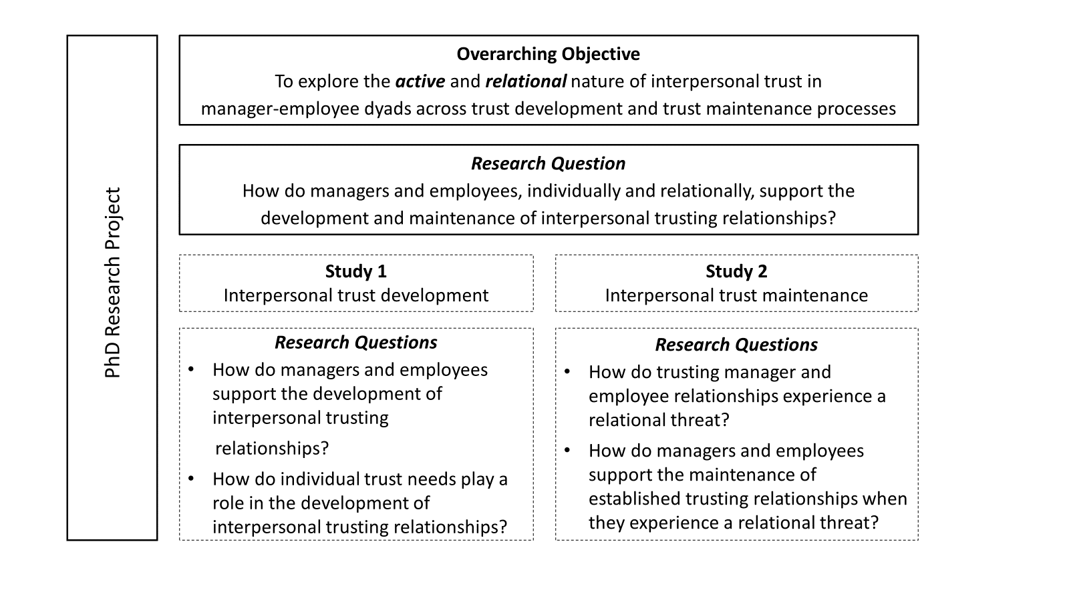
Figure 1.1. Overarching Objective and Questions Guiding PhD Research Project

1.5 Research Approach

To address these research questions, this research adopts a qualitative, exploratory approach that elicits interview data from both parties in 26 manager-employee dyads. Such an approach allows each party to be considered as a trustee and a trustor simultaneously and offers unique insight into trust as a bi-directional, relational construct. In doing so, this addresses a common criticism of trust research for assuming that one party’s trust can be taken to represent dyadic trust (Korsgaard et al., 2015). Further, the dyadic lens provides insight into how dyadic counterparts' efforts can interact with or influence one another, meaning the relational core of trust can be accessed (Krasikova & LeBreton, 2012). Therefore, this research will highlight the efforts of each party, as well as their mutual agency, to develop and maintain trusting relationships. As such, it will contribute to a more complete theoretical understanding of interpersonal trust that accounts for its active and relational nature and develop and extend theory regarding meaningful individual and relational differences in trust processes.

1.6 Research Contributions
By empirically addressing these research questions, the research set out in this thesis makes three valuable contributions to theory, as well as offering important implications for practice. First, building on literature that reframes trust as an active process (e.g., Möllering, 2006; Whitener et al., 1998), this research lends empirical insights into the efforts of each party to develop and maintain trusting relationships. This adds to a promising stream of literature that challenges the notion of trust as passive by illustrating the dynamic role individuals play in trust development (e.g., Child & Möllering, 2003; Hughes & Saunders, 2021; Six et al., 2010; Williams, 2007) and trust maintenance (Gustafsson et al., 2021; Weibel et al., 2023; Williams & Belkin, 2016). While this research lends valuable insight into how individuals can actively support the formation and maintenance of trusting relationships, it primarily focuses on one party and overlooks the other party's contribution to trust, as well as any shared efforts that can be attributed to the dyad. Therefore, the present research extends the existing literature by illustrating the intentional efforts of each party, as well as their mutual agency, to develop and maintain trusting relationships and, in doing so, contributes a new relational perspective to the active trust literature.

Second, this research contributes new theory outlining how dyads’ ongoing efforts should be adapted to align with the relationship stage and the relational context. Specifically, the findings illustrate that dyadic counterparts’ efforts that support the development of trusting relationships are different from those enacted to maintain their established trusting relationships when they experience a relational threat. Despite the need to adapt efforts in ongoing trusting relationships being present in early theorizing (e.g., Luhmann, 1979), this has not been explored empirically by existing trust research. Instead, research has mostly focused on the development of trusting relationships (for review see Lewicki et al., 2006) or the repair of trust in the case of violation (for review see Sharma et al., 2023), and, in doing so, has implicitly assumed that trust is maintained in the absence of violation (Williams & Belkin, 2016). By eliciting insights from dyads about their experiences of forming trusting relationships and maintaining established trusting relationships, this research lends novel insights into individuals' adaptive efforts across different stages of their relationships.

The findings also suggest that individual efforts should also be adapted in line with the relational context. In particular, trust development efforts should be adapted to meet the needs of one's counterpart. This builds on and extends research by Baer and colleagues (2021) that shows how much trust received should be adapted to meet counterparts' needs by also showing that efforts should be adapted to satisfy differences in what individuals need from their counterparts. Further, by asking participants specifically about a time their trusting relationship experienced a challenge, this research lends insight into how operating in a destabilized relational context influences individuals' efforts. This builds on existing research that examines contextual influences on trust antecedents (Colquitt et al., 2011; Sheppard et al., 1998) by exploring how individuals' efforts shift when relationships move from a less to a more uncertain context.

Third, the research illustrates that, for some established trusting relationships, the experience of a relational threat can strengthen trust. The dominant focus in the existing trust literature has been on how negative relational experiences undermine trust and how this can be restored (for review see Sharma et al. 2023) or, more recently, on how trust can be maintained (Gustafsson et al., 2021; Weibel et al. 2023; Williams & Belkin, 2016). The findings of the current research suggest that if dyads proactively respond to a negative relational experience with mutual agency, this can have a strengthening effect on dyadic trust. Two theoretical explanations are offered for this unexpected finding. First, building on theorizing by Ballinger and Rockmann (2010) on anchoring events, the experience of a relational threat offers counterparts new, potentially positive, information and insight into how such negative relational experiences are handled, which replaces their previously held trust belief and supports the dyad to reach a higher level of trusting. Second, building on theorizing by Nienaber and colleagues (2015) on active vulnerability, counterparts disclosing to one another about how the experience of a relational threat made them feel created a sense of shared vulnerability that served to strengthen their trusting relationship. Taken together, these explanations extend trust theory by explaining how dyads' proactive responses to negative relational experiences can strengthen trusting relationships.

Practically, this research offers empirically derived insights to individuals and organizations alike, outlining how interpersonal trusting relationships can be developed and thereafter safeguarded. Specifically, this research provides a detailed account of the strategies that managers and employees can use to develop and maintain trusting relationships, as well as behavioral-level examples of how these can be enacted. This focus on behavioral-level examples extends the work of Williams (2007) who offers specific threat-reducing behavioral examples of how interpersonal emotion management strategies can be enacted to support trust development. Building on the aforementioned theoretical contributions, the practical guidance is also tailored to reflect the strategies that are most fitting to build trust with certain counterparts, depending on their individual-level trust needs, as well as the strategies that are aligned with dealing with specific relational threats. All of this is of significant value to organizations given the centrality of trust to interpersonal work relationships and takes a step towards addressing the need for trust scholars to provide tangible insights to organizations (Dirks & de Jong, 2022).

1.7 Thesis Structure

This thesis is organized into six chapters. This introduction chapter (Chapter 1) has provided an overview of the aims and objectives of this research project, as well as the contributions the research makes. Chapter 2 will provide a review of the existing trust literature that is most relevant to this thesis. This will start by reviewing trust more broadly and then turn its focus to the process of trust development. Despite a plethora of research over the past decades focusing on trust development, several important theoretical areas require further attention. These are brought to light by critically examining the literature and building a case for how these will be addressed in the first empirical paper embedded in this thesis (Chapter 4). Following this, the trust maintenance literature will be reviewed. Again, existing theoretical limitations within this stream of literature will be highlighted and it will be outlined how these will be addressed by the second empirical paper embedded in this thesis (Chapter 5).

Chapter 3 will outline the methodology underlying the research, including the research philosophy and research design. Within this, data collection methods, participant characteristics, and the ethical principles guiding the research will also be covered. Next, Chapter 4 presents a qualitative exploration of the development of trusting manager-employee relationships. Specifically, interview data elicited from both parties in the manager-employee dyad is used to present a relational perspective of how trust at this conceptual level is formed. Chapter 5 follows with a qualitative exploration of how a threat to established manager-employee trusting relationships is experienced and how trusting relationships can be maintained in such instances. Finally, Chapter 6 provides a discussion of the empirical findings outlined in Chapters 4 and 5, positioning these findings in the context of existing literature. The overall contributions of the research, including practical implications, are set out. To conclude, the limitations of the research are acknowledged and recommendations for future research are provided.

Chapter Two
Literature Review

Literature Review Chapter

2.1 Chapter Outline

This chapter begins with a review of interpersonal trust, attending to how trust is defined and conceptualized. The value of trust is outlined, with particular attention paid to trust in manager-employee relationships. Seminal trust development models are then reviewed and critiqued. Next, research that examines trust at the dyadic level is considered. Finally, the literature on active trust, active trust development, and active trust maintenance is reviewed.

2.2. Interpersonal Trust
Trust is considered a construct of central importance across various disciplines, including psychology, sociology, economics, and political science dating back to the 1960s (Lewicki & Bunker, 1996; Möllering et al., 2004). As a result of each discipline approaching trust with its own distinct lens, competing definitions and conceptualizations of trust have emerged (see Dietz & Den Hartog, 2006). Recognizing the need for integration, seminal trust scholars tried to bridge the gap between different disciplinary perspectives (Lewicki & Bunker, 1996; Rousseau et al., 1998). In their multidisciplinary review of trust, Rousseau and colleagues (1998) define interpersonal trust as “a psychological state comprising the intention to accept vulnerability based upon positive expectations of the intentions or behavior of another” (p. 395). Although there is still no universally accepted definition of trust by all disciplines, this is among the most widely accepted definitions and the one this research will adopt. This definition offers promising convergence of the two key components believed to form the basis of trust: a positive expectation of another and a willingness to be vulnerable, under conditions of interdependence and risk (Lewicki & Brinsfield, 2012; Mayer et al., 1995).

After defining trust, research shifted its focus to delineating its theoretical bases. In this regard, scholars have argued that trust should be considered as three intertwined components: as a belief, as a decision, and as an action (Dietz & Den Hartog, 2006; McEvily et al., 2003). A trust belief is based on the likely consequences of another's actions (determined by an assessment of their trustworthiness), while the decision to trust is the willingness to accept vulnerability to these actions (Mayer et al., 1995; Rousseau et al., 1998). Trust as an action, requires one to go beyond the decision to trust and take a leap of faith, i.e., a trustor taking a risk or chance beyond rational calculation, by engaging in risk-taking behaviors (Giddens, 1994; Lewis & Weigert, 1985; Mayer et al., 1995; Möllering, 2001, 2006). It is this sense of being vulnerable and risk-taking that distinguishes the behavioral intentions to trust (operationalized by Gillespie (2003) as reliance and disclosure) and actual trusting behaviors. Despite being recognized as a central element of trust, vulnerability has not historically taken center stage in trust scholarship. While trust scholars are becoming increasingly aware of the need to further understand vulnerability (see Schafheitle et al., 2023), its relationship with trust is not fully realized (Misztal, 2012; Nienaber et al., 2015).

Adding to its complexity, trust is often conceptualized as a multidimensional construct. Early research depicted trust as a cognitive assessment of another's trustworthiness, characterized as ability, benevolence, and integrity (Mayer et al., 1995), and mostly overlooked the affective nature of trust. Building on research that focused on non-work relationships (e.g., Lewis & Weigert, 1985), McAllister (1995) provided empirical evidence for the presence of a more affective form of trust, as well as cognition-based trust, in working relationships. This trust, based on interpersonal emotional bonds between co-workers, was conceptualized as affect-based trust. Although McAllister's (1995) model is still considered to have significantly contributed to the field, trust scholars have since disputed the conceptualization of affect-based trust. Specifically, it is argued that both dimensions of trust are based on cognition, such that cognitive-based trust is a cognitive assessment of one's counterpart and affective-based trust is a cognitive assessment of the relationship between parties (Legood et al., 2022; Van Knippenberg, 2018). While more effort is required to fully understand the affective nature of trust, there is consensus among researchers that trust has both cognitive and affective bases (Legood et al., 2022; Lewicki & Bunker, 1996; McAllister, 1995; Rousseau et al., 1998; van Knippenberg, 2018; Williams, 2001).

2.2.1 Antecedents of Trust
Antecedents of trust explain why individuals trust one another, which, according to Baer and Colquitt (2018), is “because people have trusting dispositions and because others are trustworthy” (p. 163). Specifically, trustors have a certain propensity to trust, and a trustee’s characteristics can be evaluated to determine their trustworthiness (as perceived by the trustor). Mayer and colleagues (1995) argued that these factors should be considered antecedents of trust instead of being incorporated into conceptualizations of trust (e.g., Rotter, 1967; Sitkin & Roth, 1993), and notably separated these antecedents from (the intention to) trust in their seminal model. Building on Rotter's (1971) early theorizing of trust propensity as a stable within-person factor that influences their generalized expectation about the reliability of others, Mayer and colleagues (1995) defined trust propensity as a “general willingness to trust others” (p. 715). While this depicts trust propensity as a stable individual trait, existing research has demonstrated that its influence can vary. For example, trust propensity is a stronger predictor of trust in new relationships when less information about the trustee is available (Grant & Sumanth, 2009; van der Werff & Buckley, 2017).

Perceived trustworthiness is also a widely accepted antecedent to trust. One of the most influential conceptualizations of trustworthiness is that of Mayer and colleagues (1995) as a trustor's perception of three independent but interrelated characteristics of the trustee: ability, benevolence, and integrity. Ability is the perception that a trustee has skills and competencies in the domain of interest, benevolence is the trustor's perception that the trustee cares about the trustor, and integrity is the perception that the trustee adheres to a set of principles that the trustor finds acceptable (Mayer et al., 1995). It is important to note that more recent scholarship lends support for integrity having different components, extending its conceptualization as value congruence to also include word-action alignment, i.e., behavioral integrity (Tomlinson et al., 2014). While considerable research focused on identifying the characteristics that inform one's perception of another's trustworthiness (e.g., Mishra, 1996; Sitkin & Roth, 1993), most of these can be incorporated within the “ABI” model put forward by Mayer and colleagues (1995). Since the inception of the influential ABI model meta-analyses have validated these trustworthiness characteristics as antecedents of trust (e.g., Colquitt et al., 2007; Dirks & Ferrin, 2002; Legood et al., 2021).

Although high trust presumes a high level of all three characteristics, Mayer and colleagues (1995) encourage trustworthiness (as an aggregate and individual characteristic) to be thought of as a continuum, noting that trust can develop with more or less of any of the three. Empirical work has since validated this, finding that the influence of one or another characteristic on trust can be larger in magnitude (Colquitt et al., 2007; van der Werff & Buckley, 2017) and that certain trustee attributes can have an interacting influence on trust development (Cheng et al., 2023). That said, studies regarding which characteristics are more or less fitting in different situations remain uncommon (Baer & Colquitt, 2018). Therefore, while Mayer and colleague’s model made great advances by parsimoniously bringing together the trustworthiness characteristics previously proposed, there is a growing consensus that scholars have been overly reliant on these characteristics and overlooked other antecedents to trust, as well as individual and situational differences (Baer et al., 2018; Möllering, 2020).

2.2.2 The Value of Trust
Efforts to define and conceptualize trust provided an important base for researchers to study the value of trust within organizations. Since then, several reviews of the trust literature have provided support for interpersonal trust as an antecedent of an array of behavioral and attitudinal outcomes that can add value at the individual and relational levels, as well as for overall organizational effectiveness (Dirks & de Jong, 2022; Fulmer & Gelfand, 2012). For example, existing research lends support for trust as a predictor of knowledge exchange, collaboration, creativity, task performance, job satisfaction, engagement, and citizenship behaviors (Alexopoulos & Buckley, 2013; Colquitt et al., 2007; De Cremer & Tyler, 2007; Dirks & Ferrin, 2002; Lee et al., 2018). The importance of trust for effective working relationships has also increasingly been recognized (Ferris et al., 2009; Fulmer & Gelfand, 2012). Trust is fundamental to cooperative, social-exchange relationships (Blau, 1964; Dirks & Ferrin, 2001). Specifically, trust engenders prosocial and helping behaviors that facilitate healthy interactions and collaboration (Korsgaard et al., 2015). In the presence of trust, individuals can cooperate freely and effectively, whereas, in its absence, individuals are less willing to be vulnerable and let their guard down, meaning their cognitive resources can become preoccupied with non-productive behaviors (Mayer & Gavin, 2005). To this end, trust has established itself as a construct of central importance to organizations and management scholars, specifically within organizational behavior and psychology (Dirks & DeJong, 2022).

It is important to acknowledge that trust is not always inherently good. As outlined, to trust is to take a risk and make oneself vulnerable to another's actions. While this can engender trust and its associated desirable outcomes, it also exposes one to the potential of being manipulated or exploited (Mayer et al., 1995; Skinner et al., 2014). Indeed, existing research shows that feeling trusted heightens employees' perceptions of their workload and concerns about their reputation (Baer et al., 2015). However, these undesirable by-products were coupled with positive outcomes such as employees’ feelings of pride - reinforcing Skinner and colleagues’ (2014) analogy of trust as a double-edged sword. More recently, Baer and colleagues (2021), examined this from a congruence lens and provided empirical validation for trust having negative consequences for employee performance when they were receiving more trust from their supervisors than they wanted. These findings align with the idea of optimal trust, which is conceptualized as a point that moves along the continuum, depending on the individual and the context (Wicks et al., 1999). Therefore, despite being associated with many desirable outcomes, trust can also have a downside, particularly if individual and relational differences are overlooked.

2.2.3 Manager-Employee Trusting Relationships
While trust can add significant value to all organizational relationships, the manager-employee relationship is positioned as a particularly critical intra-organizational relationship (Ferris et al., 2009; Jawahar et al., 2019). This emphasis seems fitting given the high levels of vulnerability and interdependence between these groups (Li, 2012). In particular, employees are highly vulnerable to the influence managers have over their daily work lives and decisions made regarding their careers, while managers depend on employees' individual and collaborative work efforts (Dirks, 2006). When trust is present between managers and employees, they are less likely to engage in self-protective behaviors and are more willing to be vulnerable and cooperate freely (Mayer & Gavin, 2005). For example, managers are more likely to delegate important tasks and employees are more willing to seek help or offer their opinions. Therefore, the presence of trust supports managers and employees to make coordinated efforts to achieve shared goals.

A further rationale for the salience of the manager-employee relationship is the array of valuable outcomes associated with vertical trust. For example, meta-analyses link trust in one's manager to increased performance, organizational citizenship behaviors, and reduced counterproductive behavior, including intentions to quit (Colquitt et al., 2007; Dirks & Ferrin, 2002; Legood et al., 2021). Further, research suggests the positive association between trust and role-related performance is greater in magnitude for trust in a leader versus trust in a peer (Schaubroeck et al., 2013). From the other perspective, managers' trust in the employee is positively related to performance and organizational citizenship (Brower et al., 2009). However, while trust in the manager-employee relationships has been the recipient of considerable attention, the majority of this research has treated trust as unidirectional (see Brower et al., 2009 for an exception) and focused too narrowly on the benefits of employees’ trust in their managers (e.g., Colquitt et al., 2007; Dirks & Ferrin, 2002; Legood et al., 2021).

2.3 Trust Development
Recognizing its value, researchers were motivated to understand how trust is established within interpersonal relationships. Early theorizing often relied on social exchange theory (Blau, 1964) to explain the process of trust development. Building on the norm of reciprocity (Gouldner, 1960), the social exchange perspective asserts that trust is formed via repeated voluntary exchanges between parties that serve to demonstrate trust and engender reciprocal trust (Brower et al., 2000). Since then, subsequent models of interpersonal trust development have extended our knowledge, identifying antecedents to trust and the psychological processes that underlie it.

As this stream of literature grew, two approaches that each held their own perspective regarding trust formation evolved: the behavioral approach and the psychological approach (for a review see Lewicki et al., 2006). The behavioral approach views trust as a rational choice, whereas the psychological approach incorporates both cognitive and affective processes (Kramer, 1999). While it is important to make this distinction, the seminal models of trust development applied in the organizational behavior and psychology field originate from the psychological tradition of trust (e.g., Lewicki & Bunker, 1996; Mayer et al., 1995; Rousseau et al., 1998). Within the psychological perspective, Lewicki et al. (2006) further classified trust development into unidimensional, two-dimensional, or transformational approaches. As noted, some ongoing debate ensues about how trust is conceptualized, with the more recent theorizing depicting trust as a unidimensional construct with cognitive and affective bases (for a review see Legood et al., 2022). That said, while the early approaches differ in their conceptualizations of trust and how it changes over time, there is consensus in viewing trust development as an ongoing dynamic process that plays out over time (Korsgaard et al., 2018; Lewicki & Bunker, 1996; Mayer et al., 1995; McAllister, 1995; Rousseau et al., 1998; van der Werff & Buckley, 2017).

2.3.1 Unidimensional Models of Trust Development
Unidimensional models suggest that trust can be viewed as a single construct, despite having multiple components (e.g., cognitions, affect, behavioral intentions) (Lewicki et al., 2006). The most prominent unidimensional model of trust development is Mayer and colleague's (1995) integrative ABI model. A major contribution of the model was setting clear theoretical boundaries between key constructs and bringing these together in a parsimonious model of trust. Specifically, their model separated trust from its antecedents, portraying a trustor’s propensity to trust, and a cognitive assessment of a trustee’s trustworthiness to lead to trust. Like earlier theorists (e.g., Lewis & Weigert, 1985; Luhmann, 1979), Mayer and colleagues (1995) recognized the salience of risk in the conceptualization of trust and separated trust (as an intention) in their model from risk-taking behavior. This distinction acknowledges that the level of trust can grow over time, based on a series of interactions, as they incorporate a feedback loop from the outcome of the risk-taking behavior back to the antecedents of trust. This feature also supports the belief that the trustor is continuously reassessing the trustee's trustworthiness and using this new information to update their trust belief (Williams, 2001).

Despite its widely accepted contribution to trust research, Mayer and colleague's (1995) model is not without its critiques. Namely, the model has been criticized for its portrayal of trust development as a relatively inactive process wherein the trustor passively observes characteristics of the trustee - who is also modeled as passive rather than trying to actively influence how trustworthy they are perceived to be (Kramer & Lewicki, 2010; Möllering, 2006; William, 2007). As noted, the feedback loop incorporated into the model recognizes that trust is dynamic and the level of trust can change over time, however, this is said to occur via repeated interactions between counterparts rather than being influenced by either party’s active efforts. A further criticism of Mayer and colleague's (1995) model is that trust is conceptualized as unidirectional. Despite being designed to examine trust as a dyadic process, each party is portrayed as a trustor or trustee, and the interactive and reciprocal role of the two parties in the trust development process is not accounted for (Schoorman et al., 2007).

2.3.2 Stage Models of Trust Development
Another core idea from the psychological approach to trust development is that there are different types of trust and the nature of trust changes over time (Lewicki et al., 2006). This idea is represented in transformational models, wherein early-stage trust is presented as a cognitive rational choice and trust forming later is relational (e.g., Lewicki & Bunker, 1996; Rousseau et al., 1998; Shapiro et al., 1992). Lewicki and Bunker’s (1996) model is recognized as the most comprehensive model of this kind, depicting trust to evolve through three stages based on calculation, knowledge, and identification respectively. They theorize that as the relationship develops over time, trust moves beyond a calculated choice based on potential outcomes of the relationship and the parties' continued interactions lend a generalized expectancy as to whether the trustee will act trustworthily (Lindskold, 1978). In some cases, trust evolves beyond knowledge-based trust to identification-based trust, meaning the parties effectively understand and identify with one another's needs and internalize some of these as their own (Lewicki & Bunker, 1996; Shapiro et al., 1992). Other models portray trust to evolve through two stages, e.g., cognitive-based trust and affective-based trust (McAllister, 1995) or calculus-based trust and relational trust (Rousseau et al., 1998). However, they follow the same premise that initial trust is based on a rational cognitive process and, through repeated interactions between trustor and trustee, a deeper attachment can develop.

Although these stage models are more dynamic and extend our knowledge regarding the changing nature of trust over time, they have also been the subject of criticism. For example, critiques have been made that trustors are modeled as passive, and relationships are depicted as evolving through predetermined stages of trust. Instead, scholars argue that trust should be portrayed to move to the next stage “if and when the basis for this happens to develop” (Child & Möllering, 2003, p.71). Further, although this evolution from trust as a cognition to a more affective-based trust is portrayed as the natural trajectory of trust development within these transformational models, it is important to note that this is not always the case. Some trust relationships appear to bypass the calculus stage and hold positive expectations of their counterpart from the start of their relationship (van der Werff & Buckley, 2017), while others may not progress past this calculative stage. Of those that do, only a small subset of relationships transition to the identification stage (Lewicki & Bunker, 1996). Therefore, while stage models have taught us that the nature of trust shifts over time, they do not fully explain under what circumstances this does (or does not) happen, i.e., they do not account for how individual, relational, or contextual differences impact the trust development process.

Taken together, seminal research represents great advances in our understanding of how trust develops interpersonally. While it is not in the scope of this research to review all existing literature on trust development, it is important to highlight the key insights from this body of research that influence the present research. In particular, understanding the antecedents to forming trusting relationships, and how the level and nature of trust can evolve (Lewicki & Bunker, 1996; Mayer et al., 1995). As important (if not more) is identifying the common limitations within the seminal trust development models that have impacted our ability to fully comprehend the process of interpersonal trust development. While these models have received much criticism over the past two decades, two of the same critiques that both approaches have been subject to are particularly salient and relevant to this research. First, trust is modeled as a passive process that involves one party evaluating the trustworthiness of another (passive) party over time, and the intentional efforts exerted by each party to build trust are not accounted for (Kramer & Lewicki, 2010; Williams, 2007). Second, while these models acknowledge that trust is a dyadic process that involves two parties, each party is positioned as a trustee or a trustor, and the more likely reality within workplace relationships that each party is simultaneously trusting and being trusted is not addressed (e.g., Mayer et al., 1995; Lewicki & Bunker, 1996; McAllister, 1995).

Importantly, subsequent research has made attempts to address these limitations. In particular, the number of studies examining trust at the dyadic level is increasing (Korsgaard et al., 2015). At the same time, a growing body of research considering the active nature of trust is emerging (e.g., Child & Möllering, 2003). However, these concepts have not been a central focus of trust scholarship, and passive, unidirectional theories of trust development remain dominant, implying that the active and dyadic nature of trust warrants further research. The next sections will review the existing literature on dyadic trust and active trust.

2.4 Dyadic Trust

Trust exists at multiple conceptual levels, i.e., individual, dyadic, group, and organizational, and in relation to multiple referents (e.g., employees, co-workers, managers, organizations) (Fulmer & Gelfand, 2012). As outlined in previous definitions, interpersonal trust is a psychological state within an individual directed towards a specific trust referent (Rousseau et al., 1998). As a psychological state, trust starts within the individual (Korsgaard et al., 2015), however, trust cannot exist in isolation from another party (Dirks & Ferrin, 2002). For example, within a trust dyad, a trustor is making a trust-related judgment about another party i.e., the trustee (Dietz & Den Hartog, 2006). However, this conceptualization of trust is unidirectional, implying that trust only goes from trustor to trustee i.e., is one-sided. Yet in a working context, interpersonal trust occurs within a relationship where each party has to both trust and be trusted to engage in mutually beneficial exchanges (Korsgaard et al., 2015). Hence, individual-level interpersonal trust considered in isolation cannot explain trust between dyadic counterparts. In their critical review emphasizing the lack of dyadic research, Korsgaard and colleagues (2015) define dyadic trust as “an emergent property of the dyad representing the pattern of trust between two parties'' (p. 49). Importantly, this definition does not replace the accepted definition of trust as a psychological state that originates within the individual (Rousseau et al., 1998), instead it recognizes the relational, bi-directional nature of trust and considers individual-level trust as a building block for dyadic-level trust.

As noted, the seminal models of trust development acknowledge the dyadic nature of trust but do not accurately portray trust development as a bi-directional, relational process that involves dyadic counterparts simultaneously acting as a trustee and a trustor. Consequently, most trust research has been one-sided (Fulmer & Gelfand, 2012), assuming one party's trust can be taken to represent the trusting relationship (Dirks & de Jong, 2022). This is problematic for two reasons. First, it overlooks the relational core of trusting (Krasikova & LeBreton, 2012). Second, trust between dyadic counterparts is not always mutual and can also be characterized by asymmetry (Korsgaard et al., 2015). This challenges assumptions about dyadic trust mostly drawn from unidirectional assessments and builds a strong case for adopting a dyadic lens to study trust. Since Korsgaard and colleagues’ (2015) critical review, research examining trust from a dyadic perspective is increasing, however, relative to the vast amount of research on trust, remains low.

Research that considers dyadic trust has mostly focused on patterns of reciprocal influence between dyadic counterparts or the degree of convergence or divergence in the level of trust between dyadic counterparts, categorized as reciprocal trust, mutual trust, or asymmetric trust (Korsgaard et al., 2015; Tomlison et al., 2009). Following the trend highlighted by Korsgaard and colleagues' (2015) review, dyadic trust research predominantly focuses on the reciprocal pattern of trust formation between counterparts (e.g., McEvily, 2017; Wilson & Cunliffe, 2022; Yao et al., 2021). Reciprocal trust has its foundations in social exchange theory (Blau, 1964) and suggests that the individual-level trust of each party in a dyad will have an iterative influence on the other’s trust - thereby treating each party as a trustee and a trustor. For example, empirical research shows that one party’s trusting behavior can serve as a signal of their trustworthiness and lead to their counterpart reciprocating with trusting behavior (Serva et al., 2005; Wilson & Cunliffe, 2022). While these insights help us to understand how each party’s trust may influence the other’s trust, the individual-level focus means that reciprocal research cannot fully account for the emergence of dyadic trust (Korsgaard et al., 2015).

Compared to reciprocal trust research that focuses on the iterative influence of counterpart trust, research on mutual and asymmetric trust concerns the level of trust between dyadic counterparts (Korsgaard et al., 2015). Specifically, mutual trust exists when both parties in a dyad have complementary levels of trust for one another and each party is aware of the level of trust the other has for them (Deutsch, 1958). Earlier research mostly focused on the antecedents or the outcomes of mutual trust, e.g., helping behavior and shared understanding (e.g., Brower et al., 2009; Stoel & Muhanna, 2012), and paid less attention to the process of emergence of mutual trust (Korsgaard et al., 2015). More recently, empirical research offers insights into how (low levels of) mutual trust are associated with joint gains (Yao et al., 2021) and shows how fairness asymmetry inhibits negotiating organizations from reaching a level of mutual trust (Wang et al., 2022). While this research advances our understanding of what factors support dyads to reach a mutual level of trust, and the associated outcomes, these studies deal with trust between interacting organizations. Indeed, mutual trust research has tended to focus on inter-organizational trust (Korsgaard et al., 2015), with significantly less attention paid to interpersonal trust.

In contrast to a mutual level of trust, asymmetric trust acknowledges that dyadic counterparts may have different levels of trust for one another, ranging from high to low levels of convergence (Tomlinson et al., 2009). Interestingly, trust symmetry at low levels of trust is preferable to asymmetrical trust at higher levels of trust (Tomlinson et al., 2009) because when one party trusts the other more the outcome for the more trusting party and the joint outcomes for the dyad are less favorable (Korsgaard et al., 2015). Despite receiving considerably less attention than reciprocal or mutual trust, research offers some insights into the impacts of trust asymmetry (e.g., Brattström et al., 2019; de Jong & Dirks, 2012; Methot & Cole, 2021). For example, empirical research shows that asymmetrical trust has negative implications for performance, and trust convergence at the team level strengthens the relationship between trust and team performance (Dirks & de Jong, 2012). Further, research shows that trust asymmetry can interfere with the development of supportive peer relationships (Methot & Cole, 2021). That said, existing research also suggests that trust asymmetry can have some positive effects, such that divergence in trust levels can contribute to a relational context wherein inter-organizational relationships can deal with conflict (Brattström et al., 2019). This challenges the notion that trust asymmetry has only negative implications for relationships, however, this research is limited, and asymmetrical trust warrants further exploration (Graebner et al., 2020).

Overall, Korsgaard and colleagues' (2015) review of dyadic trust literature and subsequent research has greatly advanced our understanding of dyadic trust. In particular, by unpacking the iterative influence of one party’s trust on their counterparts and illustrating that counterparts' levels of trust are not always mutual and can also be asymmetric (Wang et al., 2022; Wilson & Cunliffe, 2022). However, as this research tends to rely on individual-level measures to assess the relationship between counterparts’ trust (reciprocal) or the convergence between counterparts’ level of trust for one another (mutual or asymmetric) it is criticized for not fully accounting for the emergence of dyadic trust (Korsgaard et al., 2015). Indeed, to fully capture a construct dyadically, Kozlowski and Klein (2000) advocate for researchers to consider each party at an individual level, interactions between parties, and other relational factors. In response to this, the present research will treat trust as a bi-directional phenomenon where each party is simultaneously a trustee and a trustor. Such an approach will assess each party's trust effort, how these are perceived by their dyadic partner, as well as other relational features that influence trust in their relationship. The next section will review the concept of active trust and the existing literature that reflects the active nature of trust in trust development and maintenance processes.

2.5 Active Trust

A growing body of literature criticizes the passive portrayal of trust and the actors involved, arguing instead that trusting is an active, co-created process (Kramer & Lewicki, 2010; McEvily et al., 2017; Möllering, 2006, 2013; Williams, 2007). This argument hinges on the concept of active trust, grounded in the work of sociologists such as Simmel (1950, 1990), Luhmann (2017), and Giddens (1994) (for a review of the links between these theorists see Möllering, 2001), which views trusting as an ongoing accomplishment that requires continuous work by actors, even once established (Möllering, 2006, 2013). Giddens (1994) coined the term active trust to highlight the need for individuals to actively cultivate and sustain trusting relationships in response to the increasingly complex and less certain nature of modern society. That said, the substantial agency exercised by actors in trusting relationships is also a central tenet to both Simmel and Luhmann’s theorizing on trust. In particular, the agency of the trustor in suspending uncertainty and vulnerability beyond good reason, i.e., taking a leap of faith (Giddens, 1994). However, trusting as a co-created process also recognizes the agency required by the trustee to show their trustworthiness and “build the expectations of others” (Luhmann, 1979, p.62). Overall, such a conceptualization suggests that trust is built through a more active process of interpersonal engagement than the dominant narrative suggests. Further, it emphasizes the need to safeguard existing trusting relationships, which until recently had been mostly overlooked by trust scholars who have mostly focused on how trusting relationships can be developed and repaired in the case of violation.

As our understanding of trust active trust moves forward, several important areas require attention. The idea of a leap of faith, or suspension as per Möllering (2001), recognizes the substantial agency on the part of the trustors who cannot be forced to take the initial leap of faith (Simmel, 1950). Scholars introduced this notion of taking a leap of faith or suspension into the trust literature to elaborate on the explanation of trust development put forward in the rational choice models (e.g., Möllering, 2001, 2006; Zaheer et al., 1998). For example, Möllering (2001) argues that suspension is the link to explain the process of moving from interpretation to expectation. That is, for a relationship to reach a point of positive expectations (i.e., trust), there is a need for a trustor to suspend uncertainty and vulnerability to take a chance beyond rational calculation (i.e., their interpretation of the trustee). However, although the concept of a leap of faith is often referred to in the trust literature, Möllering (2006) cautions that it is not clearly conceptualized and what it actually looks like in reality is uncertain.

Similarly, the role of a trustee in creating the impression of trustworthiness was outlined but not clarified in early theorizing on active trust (e.g., Luhmann, 1979). While seminal trust models offer insights into the facets of trustworthiness attended to by trustors (Mayer et al., 1995), the input on the part of the trustee is not accounted for. The resulting narrative has been that of a passive trustee who does not exert effort to build or maintain trust or try to influence trustors' evaluation of their trustworthiness (William, 2007). Luhmann's (1979) theorizing also signals the importance of adapting efforts to the relationship stage - pointing out that once trust is established it would be “tactless” for one to continue to use “the cautious strategies which were sensible at that early juncture” (p. 44) - however, this lacks specificity in terms of what maintenance efforts should look like. Therefore, while the idea of parties' intentional efforts to build and maintain trust was present in early theorizing, they were not fully unpacked and did not remain a core feature as the trust literature evolved.

Despite the focus of the wider literature on trust as a passive process, a promising stream of research that reframes trusting as an active process is emerging. Indeed, existing research illustrates trustor intentional efforts to develop trust (Child & Möllering, 2003; Hughes & Saunders, 2021) and maintain their counterpart's trust (van der Werff et al., 2019). As well as providing evidence for the dynamic role the trustee plays across the development process (Hughes & Saunders, 2021; Long, 2018; Six et al., 2010; Williams, 2007) and maintenance process (Gustafsson et al., 2021; Weibel et al., 2023; Williams & Belkin, 2016). However, at present, there is a lack of continuity within this stream of literature as a consequence of varied foci in terms of trust referents, conceptual levels, and trust processes. Therefore, despite receiving theoretical and empirical attention, current theory does not offer a clear conceptualization of the intentional role individuals can play in supporting interpersonal trust development and maintenance.

2.6 Active Trust Development
In line with previous research, active trust development relates to the intentional actions of individuals through which trust can be constructed (Child & Möllering, 2003). While this concept was explored by early trust theorists (e.g., Whitener et al., 1998), it did not become a feature of mainstream trust scholarship. Instead, researchers tended to rely on earlier models that portrayed trustee and trustor roles in trust development as mostly passive. That said, over the past two decades, researchers have continued to point to the intentional ways individuals can contribute to trust formation (Child & Möllering, 2003; Six et al., 2010; Williams, 2007) (see Table 2.1). At present, the literature is somewhat fragmented as, comparable to the wider trust literature, active trust development has mostly been studied unidirectionally, focusing on trustee or trustor intention actions (for an exception, see Hughes & Saunders, 2021). Research that considers each party's efforts will be reviewed in the next sections, followed by research that adopts a bi-directional approach to explore active trust development.

Table 2.1 Summary of Active Trust Development Strategies
Authors | Active Trust Strategies | Trust Process | Trusting Relationship | Active Agent | Level of Analysis
Whitener et al. (1998)  (T)*  Child & Möllering (2003) | Behavioral consistency  Reliability, integrity, sharing  and delegation of control, communication, and demonstration of concern  Developing personal rapport, recruiting local staff, transferring business practices | Trust Development  Trust Development | Manager-employee  Manager-  employee | Trustee  Trustor | Individual  Individual
Williams (2007)  (T) | Threat regulation strategies: perspective-taking, threat-reducing behavior, reflection | Trust Development | Boundary spanner & counterpart (no hierarchical difference) | Trustee | Individual
Six et al.  (2010) | Positive relational signals: actions that demonstrate trustee solidarity frame: (enacting the solidarity frame, accepting influence and preventing misattribution of a self-interest frame) & actions that stimulate trustor solidarity frame (prevention of disappointments and bolstering self-confidence) | Trust Development | Managers and their work unit (defined as those with whom managers have most contact) | Trustee | Individual
Long (2018) | Demonstrations of  Trustworthiness (ability, benevolence and integrity) | Trust Development | Manager-  employee | Trustee | Individual
Hughes & Saunders (2021) | Behaviors demonstrating trustworthiness: supporting, protecting and adding value; career development & coaching; communicating beyond the agenda; ensuring availability and perceived proximity; being open; Behaviors demonstrating trust: being open, granting autonomy, and demonstrating value and respect. | Trust Development | Leader-  member | Trustee & Trustor (leader in both roles) | Dyadic
*Note (T) represents theory papers

2.6.1 Trustee Intentional Actions
Within the trust literature, trustworthiness has mostly been considered in the context of a trustor's perception of trustee attributes, however, a small body of literature has drawn attention to how a trustee could signal their trustworthiness as a trust-building mechanism. An early example of this is Whitener and colleagues' (1998) theoretical framework outlining behaviors that trustees could use to influence how trustworthy others perceive them. These were categorized as behavioral consistency, behavioral integrity, sharing and delegation of control, communication, and demonstration of concern. Some of these intentional behaviors align with the facets of trustworthiness included in Mayer and colleagues’ (1995) integrative model of trust, where others do not (see Figure 2.1). More recently, Williams's (2007) threat regulation model positions cognitive appraisal-related perspective-taking, threat-reducing behavior (e.g., altering the situation), and reflection as effective strategies to regulate a trustor's anticipation of harm and facilitate trust development. Such theorizing challenges the passive portrayal of trust development as gathering data about others’ trustworthiness, and points to the agentic role trustees can play in interpersonal trust development. However, empirical investigation is needed to validate this idea.

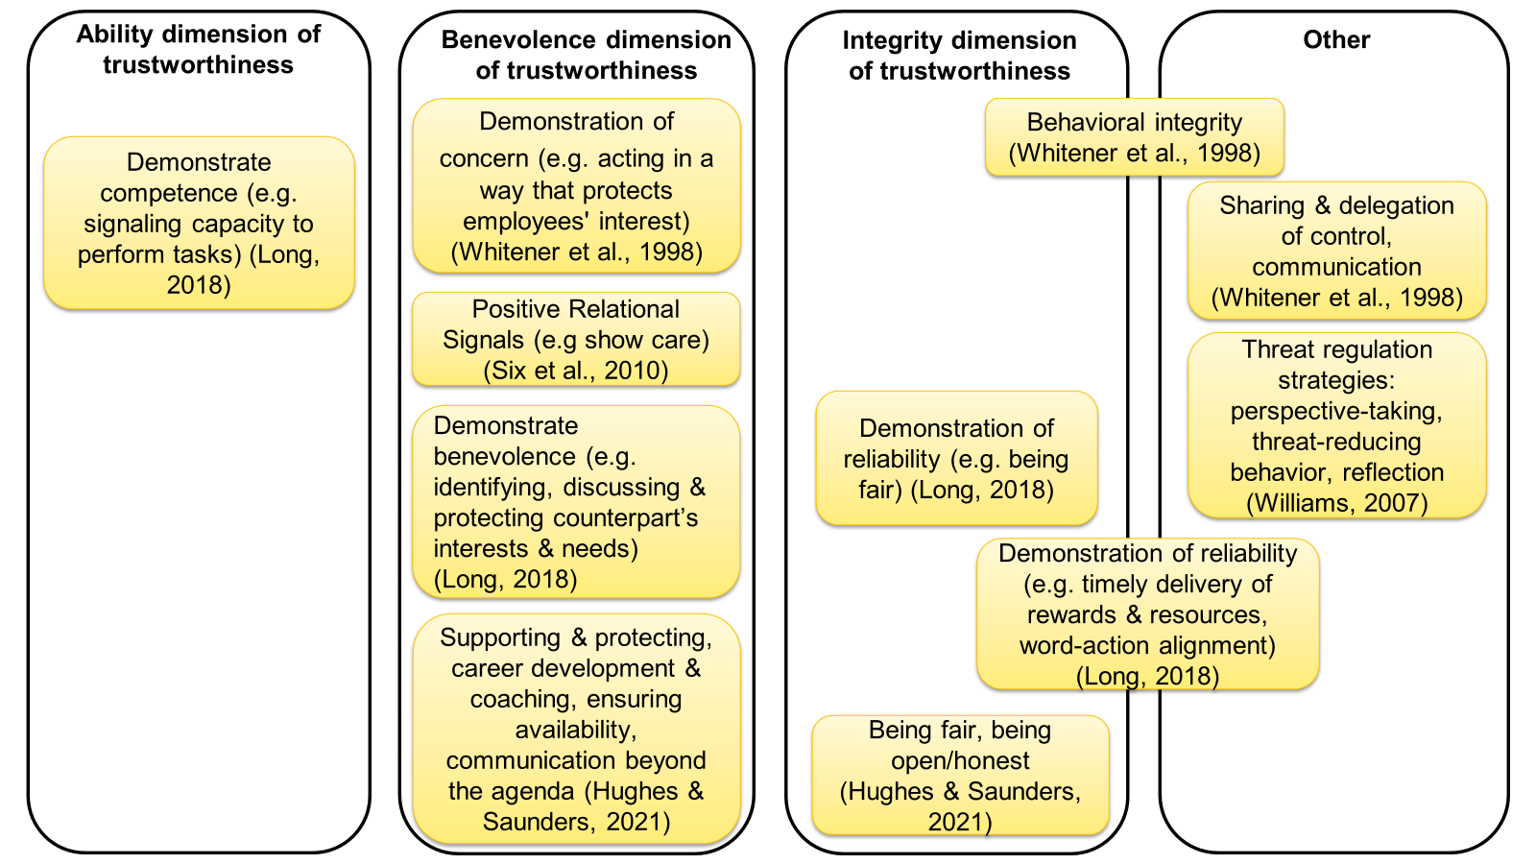
Figure 2.1 Mapping of Trustee Intentional Actions to Trustworthiness Dimensions or Other

A small (but growing) stream of empirical studies provide backing for trustees' engaging in proactive efforts to support trust development. For example, Six and colleagues (2010) demonstrated that trustees consciously send relational signals, i.e., behavioral clues that a trustee will attend to the needs of the trustor and refrain from acting opportunistically, that show trustors they are operating from a solidarity frame. More recently, Long (2018) offers additional insight into the behaviors that managers adopt to actively gain the trust of their subordinates, classified as demonstrations of ability, benevolence, and reliability. While this empirical validation adds value, the study was designed such that managers appraised their own behavior, and vital insights regarding how trustworthy employees perceived this behavior were not captured. Relatedly, Six and colleagues (2010) elicited insights from the trustor perspective about the trust-building actions they perceived trustees enacting, but did verify these with accounts from their counterparts. This is a common limitation of this research thread that focuses solely on trustees’ intentional actions to support trust development, without considering the trustor or the relational nature of trust. This implies that trust is not empirically examined as a dyadic construct, such that each party's contribution to trust and relational factors are considered (Korsgaard et al., 2015).

2.6.2 Trustor Intentional Actions
A smaller stream of research draws attention to the proactive role a trustor can employ in the trust development process. Child and Möllering (2003) empirically illustrate trustor purposive actions, operationalized as developing personal rapport and transferring business practices, to support the formation of trusting relationships between foreign investment firm managers and local staff in Chinese institutions. In such a context where institution-based trust is low, trust is perceived to carry higher risk and, therefore, requires the trustor to make themselves more vulnerable, for example, managers sharing valuable business-related information with local staff (Child & Möllering, 2003). Such strategies represent examples of a trustor making a leap of faith (Giddens, 1994; Möllering, 2001, 2006). In doing so, the trustor exercises agency by consciously accepting vulnerability and suspending uncertainty (Möllering, 2006). Such insights offer us the desired level of detail regarding what trustors can specifically do to actively support trust development. However, this research can be subjected to the same criticism as other empirical research (e.g., Long, 2018; Six et al., 2010), in that the authors do not elicit insights from both parties in the trust dyad and, therefore, corresponding (or shared) efforts to build trust are missing (Child & Möllering, 2003).

2.6.3 Bi-Directional Intentional Actions
It is important to note that the bi-directional trust-building efforts of both parties are acknowledged by some scholars. For example, both parties are said to engage in threat regulation (Williams, 2007) and signal their solidarity frame to their counterpart (Six et al., 2010). That said, this work recognizes that both parties are involved in forming trusting relationships and each individual simultaneously acts as a trustee and trustor but does not offer specific insights into individuals’ active efforts in each role. Building on this, Hughes and Saunders (2021) empirically examined leader-employee trust in a virtual context and put forward a framework that positions employees' trust to develop as an outcome of leaders' behaviors that signal trustworthiness and demonstrate trust in the member. In this sense, the leader is considered in both the trustee and trustor role. As a trustee, a leader's behavior determines how trustworthy they are perceived to be, while in a trustor role, a leader's engagement in trusting behaviors can influence members' felt trustworthiness (Lester & Brower, 2003). From the trustor perspective, managers demonstrated their trust in their counterparts by being open, granting autonomy, and demonstrating value and respect (Hughes & Saunders, 2021). Here, leaders' openness and granting of autonomy build on Child and Möllering's (2003) framing of trustors’ intentional trust building as a sense of active vulnerability and offer further tangible examples of a leap of faith.

From the trustee perspective, leaders’ deliberate efforts to demonstrate their benevolence and integrity engendered employee trust (Hughes & Saunders, 2021). While leaders reported behaviors that represent all three trustworthiness characteristics (i.e., ability, benevolence, and integrity), in line with earlier research (e.g., Knoll & Gill, 2011; Colquitt et al., 2007), benevolence and integrity were found to be the dominant influences on judgments of leaders' trustworthiness. Therefore, despite leaders’ efforts to signal their ability, employees rarely mentioned this characteristic as a rationale for perceiving leaders as trustworthy - authors speculated this might be due to assumptions of leader ability based on their level of seniority (Hughes & Saunders, 2021). Whatever the reason, these findings strongly reinforce the value of a truly dyadic approach to understanding active trust development. By treating each party simultaneously as a trustee and trustor, one's intentional efforts to build trust can be verified by their dyadic counterparts as to what supported them to trust (or not). While Hughes and Saunders’ (2021) framework greatly advances our understanding of how leaders actively contribute to the trust development process (as both trustee and trustor), the insights elicited from employees were used to verify leader behaviors, and no insights to how employees actively support trust development are included in their framework.

Taken together, the insights elicited from this stream of literature dispute the idea of trust development as a passive process and build a case for the intentional use of strategies by the trustee (Hughes & Saunders, 2021; Six et al., 2010; Williams, 2007), and the trustor (Child & Möllering, 2003; Hughes & Saunders, 2021; Möllering, 2001, 2006). This is in line with theorizing by Luhmann (1979, 1988) that frames trust as truly relational, unfolding from the coordinated selection of actions by both parties. That said, despite the valuable insights gained from research to date, our understanding of both parties’ intentional efforts, as well as any relational factors, that contribute to active trust development is incomplete. Accordingly, an empirical study exploring how managers and employees (individually and relationally) support the development of a trusting relationship forms part of this thesis and will be presented in Chapter 4.

2.7 Active Trust Maintenance
Active trust maintenance relates to the practices used to protect established trust, triggered by a jolt that heightens uncertainty and vulnerability in the relationship (Gustafsson et al., 2021). In comparison to the theoretical and empirical attention that trust development has received, research on trust maintenance is in its nascent stage. That said, a promising stream of literature that focuses on trust maintenance and how individuals actively contribute to this core trust process is starting to emerge (see Table 2.2). For example, Williams and Belkin (2016) dispute the notion that trust is maintained simply by the absence of violations and highlight the substantial agency and intentionality that trust maintenance requires. In line with trust as an ongoing accomplishment that requires continuous work by actors (Möllering, 2006, 2013), Williams and Belkin (2016) acknowledge that trust maintenance can be routine at times but also point to the frequent need for individuals to actively engage in trust maintenance strategies in response to complex social situations and external uncertainty. Building on this, research has tended to contextualize the maintenance process in times of heightened uncertainty and disruptions to established trusting relationships (e.g., Gustafsson et al., 2021; van der Werff et al., 2019; Weibel et al., 2023). To date, research focused explicitly on interpersonal trust maintenance is limited and, therefore, a parallel stream of research that explores how trust in the organization can be maintained will also be reviewed.

Table 2.2 Summary of Active Trust Maintenance Strategies
Authors | Active Trust Strategies | Trust Process | Trusting Relationship | Active Agent | Level of Analysis
Williams & Belkin (2016)  (T) | Interpersonal sensemaking, perspective taking, interpersonal sensegiving | Trust Maintenance | Not specified (person-  person) | Trustee | Individual
van der Werff et al. (2019) (T) | Discrepancy reduction strategies that regulate trust cognitions, emotions,  and behavior to bring one in line with a trust goal | Trust Maintenance | Not specified (person-  person) | Trustor | Individual
Gustafsson et al. (2021) | Cognitive bridging, emotional embodying, and inclusive enacting | Trust Preservation | Employee-  organization | Trustee | Dyadic
Weibel et al. (2023)  (T) | Symbolic Strategies: comprehensive communication regarding the new situation, signaling employer goodwill to employees, signaling that  ‘we are all in the same boat’) & substantive strategies: investments to build predictability in the workplace environment, committing to and institutionalizing employee-friendly outcomes, institutionalizing interdependence between employees and the employer | Trust Maintenance | Employee-  organization | Trustee | Individual
*Note (T) represents theoretical papers

2.7.1 Organizational Trust Maintenance
At an organizational level, recent theory agrees that disruptions to established trusting relationships can interfere with ongoing trust processes and trigger active trust maintenance (Gustafsson et al., 2021; Weibel et al., 2023). Specifically, Gustafsson and colleagues (2021) identified cognitive bridging, emotional embodying, and inclusive enacting, as the practices that trustees (i.e., the organization represented by its leaders) can use to maintain their trusting relationships in disruptive times. Collectively, these practices reduce vulnerability and uncertainty, facilitating employees to cope emotionally with the ambiguity triggered by the jolt. Simultaneously, the practices portray a unity between the employees and organizational leaders by framing the disruption as something externally attributable that both parties are experiencing - comparable to sensegiving as per Williams and Belkin (2016).

Building on this, Weibel and colleagues (2023) contend that disruption to established trusting relationships (triggered by technological advancement in their theorizing) may impact different forms of employee vulnerability i.e., discontinuity vulnerability or socio-emotional vulnerability (see Misztal, 2012). Depending on the type of vulnerability triggered by the disruption, they position either symbolic maintenance strategies, e.g., signaling employer goodwill to employees, or more substantive (action-oriented) strategies, e.g., institutionalizing employee-friendly outcomes, to be more or less fitting (Weibel et al., 2023). This extends previous research that does not outline when (and why) specific strategies are optimal (e.g., Gustafsson et al., 2021). Differences aside, a common theme visible in this literature is that maintenance strategies prioritizing and involving employees during times of disruption can effectively maintain their trust in their organization (Gustafsson et al., 2021; Weibel et al., 2023). While this research helps us to understand trust maintenance in the broader organizational context, it focused exclusively on the trustee's active maintenance efforts. While the trustor is portrayed as being involved in the maintenance process, they are mostly depicted as a passive recipient of trustee efforts, and their agency in investing in trust or the mutual agency of counterparts is not considered.

2.7.2 Interpersonal Trust Maintenance
At an interpersonal level, trust maintenance efforts have been depicted as trustee attempts to shift attribution away from her/himself, via the use of meaning-making processes, when they behave in a way that could be perceived as harmful (Williams & Belkin, 2016). Specifically, interpersonal sensemaking, perspective-taking, and interpersonal sensegiving allow one to make sense of their counterparts' feelings, thoughts, and behaviors and influence the level of responsibility attributed to them for trust events via explanations that lead to either internal attributions (positive events) or external attributions (negative events) (Williams & Belkin, 2016). Therefore, a trustee can use these strategies to buffer the effects of behaviors at risk of being labeled untrustworthy and protect the trusting relationship. From the other perspective, van der Werff and colleagues' (2019) trust motivation model offers valuable insight into a trustor's active response to maintain trust when they experience a disturbance to their trusting relationship. Specifically, the model depicts a disturbance that moves a trustor away from their trust goal, e.g., maintaining their trusting relationship, which will trigger them to engage in discrepancy-reducing strategies (e.g., regulating trust cognitions, emotions, and behavior) to realign with this. For example, a trustor's perception of unfavorable trust cues attributed to the trustee that results in negative emotion may require a strategy such as emotional suppression to move beyond the discrepancy and sustain their trusting relationship (van der Werff et al., 2019).

Overall, while this promising stream of literature extends our understanding of trust maintenance, we must be mindful of certain constraints. In particular, our knowledge of how trust can be maintained is largely theoretical. Empirical research by Gustafsson and colleagues (2021) represents one exception to this and lends valuable empirical insights to person-organization trust maintenance. That said, considering challenges in applying insights drawn from one conceptual level of trust to another (Fulmer & Gelfand, 2012), findings regarding organizational trust maintenance should not be treated as interchangeable with interpersonal trust. Further, while theoretical insights drawn from the interpersonal level advance our understanding in terms of the substantial agency that trustees (Williams & Belkin, 2016) and trustors (van der Werff et al., 2019) can exert to maintain trust, these perspectives are considered in isolation of one another. This implies that the mutual agency of dyadic counterparts in the maintenance process has mostly been overlooked. Finally, scholars recognize that established trusting relationships are vulnerable to disruptions that can be attributed to the actions of internal parties or external factors (Williams & Belkin, 2016), however, only maintenance efforts in the context of external disruption have received empirical attention (Gustafsson et al., 2021). While van der Werff and colleagues’ (2019) theorizing helps us to understand how the source of disruption might influence a trustor's efforts to maintain trust, this has not been empirically explored. Overall, these constraints highlight important theoretical and empirical gaps in our knowledge that need to be addressed. Accordingly, an empirical study exploring how manager-employee dyads maintain their established trusting relationships when they experience disruptions attributed to internal or external sources forms part of this thesis and will be presented in Chapter 5.

Chapter Three
Methodology

Research Methodology & Methods

3.1 Chapter Outline
This chapter discusses the research methodology guiding this thesis. It begins with a reminder of the research aims and objectives before focusing on the overall methodological approach. Next, information about the research participants and the sampling approach is set out. The ethical principles that guide the research are then outlined. Finally, the processes of data collection and data analysis are described in detail.

3.2 Research Aims and Objectives

The present research aims to qualitatively explore the active and relational nature of trust. In doing so, it challenges the notion of trust as a passive, unidirectional process and considers how trusting relationships between managers and employees are formed and subsequently maintained. More specifically, it explores each party's intentional efforts to develop and maintain trusting relationships and how their efforts interact to influence trust development and/or maintenance at the relational level. Therefore, the overarching objective of this research is to explore how both parties, individually and relationally, support the development and maintenance of a trusting manager-employee relationship.

3.3 Research Design
The effective design of a study requires careful matching of methodology to the research question(s) that the study will aim to address (Edmondson & McManus, 2007). In designing a research project, Saunders and colleagues (2012) set out six key considerations: philosophy, approach, methodological choice, strategies, time horizon, and data collection and data analysis techniques. These considerations were reflected on when designing the present study and will be touched on in the following sections. It is important to note that it is not my view that any one research design is better than another, instead the research was designed in a way that was best suited to answer the research questions guiding the project. Specifically, as the objective of this research was to understand how dyadic counterparts support the development and maintenance of a trusting manager-employee relationship, an exploratory approach was taken in the study (Edmondson & McManus, 2007).

3.3.1 Research Philosophy
Research philosophy is defined as one's basic belief system, which determines one’s way of examining social phenomena and influences the understandings attributed to these phenomena (Guba & Lincoln, 1994). While research philosophy is often framed as a choice between qualitative and quantitative methods, which are aligned with interpretivism and positivism respectively, the reality and choices that face researchers are more complex. Research can be underpinned by a pragmatist, positivist, realist, or interpretivist research philosophy, and a researcher’s choice of philosophy is influenced by their view of the nature of reality or being (i.e., their ontological assumption) and what they regard as acceptable knowledge (i.e., their epistemology assumption) (Saunders et al., 2019).

This research is underpinned by an interpretivist philosophy. Interpretivist research is concerned with understanding human behavior and involves making sense of the interpretations that participants ascribe to phenomena within their social world to explain their behavior (Johnson et al., 2006). From an ontological position, interpretivism asserts that phenomena are the outcome of social actors’ subjective perspectives and subsequent actions and interactions with others - implying that they are socially constructed, and different outcomes or realities are possible (Saunders et al., 2019). It is also emphasized that phenomena are not constant but rather being revised based on the ongoing interactions between social actors (Saunders et al., 2019). Taken together, this builds a strong case for the suitability of an interpretivist philosophy to guide research that sets out to explore trust as a dynamic process co-created by dyadic counterparts’ intentional efforts.

From an epistemological point of view, interpretivism is concerned with the subjective meanings that motivate actions and social phenomena (Saunders et al., 2019), as well as the role the researcher plays in the creation of knowledge (Crotty, 1998). Interpretivist research embraces the complexity of the social world and acknowledges that researchers must enter the realities of their participants to understand their interpretation of it (Shaw, 1999). In this sense, the researcher and research participants are assumed to be “interactively linked” such that the findings are reconstructions of previously held individual constructions (Guba & Lincoln, 1994, p. 111). This active engagement of the researcher is a defining feature of interpretive research and reinforces the belief that multiple realities exist and that our understanding can be enhanced via the reconstruction of multiple subjective perspectives (Guba & Lincoln, 1994). Therefore, concerning the present research, trust – and how it is socially constructed by parties' individual and shared efforts – will be explored and understood by the researcher's reconstruction of each dyadic counterpart's subjective perception of their trusting relationship. This is achieved via eliciting information from each member of the dyad and using the researcher's interpretations of these individual-level insights to build a picture of trust at the relational level.

3.3.2 Research Approach
A researcher can approach their research deductively, inductively, or abductively. Deduction involves moving from theory to data, developing specific hypotheses based on what is known from existing theory, whereas induction involves moving from the data to theory, attending closely to the data, and not being influenced by existing knowledge (Suddaby, 2006). Abduction represents a more recent approach to research that can be thought of as a combination of the two, wherein a researcher has some existing knowledge of the topic and uses this to guide them to move back and forth between data and theory to make sense of what is observed in the data (Suddaby, 2006). Therefore, in line with my existing knowledge of the trust literature, an abductive approach was adopted for the present research.

Sætre and Van de Ven (2021) compare abductive reasoning to sensemaking, as per Weick (1995), and set out a four-step abduction process that enables researchers to make sense of complex phenomena (observe anomaly, confirm anomaly, develop hunches, and evaluate hunches). This aligns with an earlier depiction that abduction begins with the observation of something surprising and then turns to existing theory for possible explanations for how this could occur (Van Maanen et al., 2007). In this sense, an abductive approach allows a researcher to be reflexive, being guided by research questions but also being open to empirical puzzles (Alvesson & Sköldberg, 2017; Grodal et al., 2021). For example, in the present research, one area of interest was how trusting relationships can be maintained when they experience a threat, and I was surprised to find several relationships were strengthened by this experience. This presented an empirical puzzle and signaled the need to unpack this experience by further interrogating the data and consulting with existing literature. In doing so, I noticed that the dyads who talked about threats to their relationship as a shared experience were more likely to report strengthening their relationships and, through consulting the existing vulnerability literature (e.g., Nienaber et al., 2015), I was able to theorize regarding the central role that shared vulnerability played in strengthening dyads’ trust.

3.3.3 Methodology
Research methodology can be described as a plan of action that guides a researcher's methodological choices and use of particular methods (Crotty, 1998). The words methodology and methods are often used interchangeably, however, the methodology is intended to be all-encompassing of a researcher's methodological choices (e.g., strategy of inquiry, time horizon, etc.), whereas methods refer to the chosen method(s) of data collection (e.g., interview, survey, etc.) (Saunders et al., 2019). This section deals with the broader research methodology, while the specific method of data collection will be discussed in Section 3.7.

The first methodological choice a researcher makes is between qualitative, quantitative, or mixed method research, and subsequently, whether this will take the form of mono or multiple methods (Saunders et al., 2019). This research takes the form of a mono-method qualitative study, meaning that it adopts one method of data collection (Van Maanen, 1998). A qualitative approach allows researchers to access the latent meaning of experiences as opposed to testing predetermined hypotheses as in qualitative research (Riege, 2003) and is particularly suited to yield new insights into less understood social phenomena (Eisenhardt & Graebner, 2007). As noted, research that reframes trust as a more active process is growing but is still considered in its nascent stage. Therefore, in line with the research objective to understand how dyadic counterparts intentionally support the development and maintenance of trusting relationships, i.e., a relatively unknown phenomenon, an exploratory qualitative study was deemed as the most appropriate in terms of fit (Edmondson & McManus, 2007).

The next choice pertains to the strategy of inquiry. Research has been grouped into five main qualitative inquiry approaches: narrative research, phenomenology, grounded theory, ethnography, and case study. However, not all research follows a specific strategy of inquiry (Creswell & Poth, 2016). While not explicitly designed as a case study, as this research evolved, it was useful to treat each dyad as a “case” to identify within and cross-case patterns that were relevant to the emergent theory (see Section 3.8).

Finally, regarding time horizon, research can either be cross-sectional or longitudinal. Cross-sectional research involves data that is collected at one point in time, as opposed to longitudinal data collected over three or more points in time (Saunders et al., 2019; Singer & Willett, 2003). The present research collected cross-sectional data from participants during a one-off interview. While longitudinal data offers unique insights into how phenomena play out over time, i.e., a process approach, a variance approach to qualitative research that relies on cross-sectional data is appropriate for showing how (and why) a phenomenon occurs (Corley & Gioia, 2011). This is relevant for the present study, which aims to address how both parties, individually and relationally, support the development and maintenance of a trusting manager-employee relationship.

3.4 Participants
The research participants consisted of 52 individuals who formed 26 manager-employee dyads. This implies that the unit of analysis is at the dyadic level (see Section 3.4.1). While there is no clear guidance on the number of dyads needed for qualitative research, given the goal of theoretical saturation (Eisenhardt, 1989), the number of dyads is in line with the number observed in relational research recently published in a top-tier journal (e.g., Freeney et al., 2022). Further, the sample size is in line with recommendations for interview data from Saunders and Townsend (2016), who estimated that around 50 participants are sufficient for research that recruited participants from multiple organizations, as is the case in the present study. Dyads were labeled from 1-26, with all managers labeled as M, e.g., M1, and all employees labeled E, e.g., E1.

Participants resided in various locations, including England, Ghana, India, and North America, but predominantly in Ireland (see Table 3.1 for demographic breakdown). Most dyads were co-located, with only one manager and employee living in different countries at the time of the interviews (Dyad 8). The relational tenure of dyads ranged from two months to five years, with approximately 40% of participants working together for less than one year and most dyads (50%) in the “1–3-year” bracket. Concerning gender, there was a representation of mixed-gender dyads, as well as all-female and all-male dyads. Both female and male participants were also represented at the manager level.

Participants worked in a broad range of industries, including insurance, banking, consulting, and media, with the largest proportion in the technology industry. Trust scholars recognize the influence the organizational context, in which a relationship is embedded, has on trust (e.g., Li, 2012; Sheppard & Sherman, 1998; Zucker, 1986) and the trusting behavior of its members (Luhmann, 2017). In particular, organizational norms, policies, and practices can influence trust. Given that the sample in this research study was recruited from a range of different industries, it is important to consider how this variation may have shaped the findings of this thesis. Above all else, industry differences were interpreted to influence what individuals needed from their counterparts to trust them (i.e., their trust needs). For example, a manager in a dyad recruited from the investment banking industry described over-working, i.e., “working late hours” and “pulling late hours to turn out material”, as the norm and “how you build trust in our [their] industry” (M3). Another manager referenced the influence of the “deeply engineering, male culture” in their organization and reflected on how this shaped what she and her female counterpart needed from one another to navigate working in a male-dominated industry: “when you can see things together and chat about them afterward and laugh, shed the odd tear occasionally even” (M7). Taken together, this suggests that, for some dyads, the industries they worked in, and the norms and cultures embedded within them, influenced the development of their trusting relationship. Concerning trust maintenance, and dyads’ experiences of and response to relational threats, I did not interpret industry differences across the sample to influence how the maintenance process unfolded.

While the variation in industry shaped the findings to some extent, the relational context was interpreted as playing a more influential role across both trust processes. For example, several dyads worked in the consulting industry, which could be considered a more challenging organizational context to develop trusting relationships as the client-facing nature of the work means counterparts spend less direct time working with one another. However, some dyads who worked in this industry navigated these challenges and formed trusting relationships (e.g., Dyad 23), while others did not (e.g., Dyad 18). Therefore, the different outcomes were attributed to differences at the relational level, i.e., whether counterparts proactively tried to identify and satisfy one another's trust needs, as opposed to the challenges associated with the industry or the nature of work attached to it. Further, managers and employees from the technology industry – the most represented industry in the sample (6 Dyads in total) – were interpreted to have both achievement-based and connection-based trust needs and were found to enact strategies from all three types of trust development strategies uncovered in the analysis. This suggests that the industry did not have a major influence on what individuals needed from one another or how they actively sought to develop trust. Moreover, dyads recruited from the technology industry reflected on a broad range of relational threats and the process they followed to overcome these aligned with the other participants in the sample. Overall, such commonalities uncovered across the different industries, coupled with the differences in dyads' experiences recruited from the same industry, led me to conclude that the industry that dyads worked in was important to consider, however, it did not shape the results of the present research as much as dyads’ relational contexts.

Table 3.1 Breakdown of Dyad Demographics

Dyad Gender (M:E) Tenure Location Industry

1 Male:Male 6 months-1 year Ireland Technology
2 Male:Female 1 - 3 years Ireland Insurance
3 Female:Female 1 - 3 years England Banking
4 Male:Female 3 - 5 years Barbados Recruitment
5 Female:Male 1 - 3 years Ireland Technology
6 Female:Male 6 months-1 year Ireland Charity
7 Female:Female 1 - 3 years Ireland Energy
8 Male:Female 1 - 3 years Ireland: Education
England
9 Male:Female 1 - 3 years Ireland Technology
10 Male:Male 1 - 3 years Ghana Production
11 Male:Female 1 - 3 years Ireland Humanitarian
12 Male:Female 5 - 10 years Ireland Insurance
13 Male:Male 1 - 3 years Ireland Insurance
14 Female:Female 0 - 6 months Ireland Technology
15 Male:Female 0 - 6 months Ireland Media
16 Male:Male 1 - 3 years Ireland Banking
17 Female:Female 1 - 3 years Ireland Construction
18 Female:Female 0 - 6 months Ireland Consulting
19 Female:Male 6 months -1 year Ireland Technology
20 Female:Female 6 months -1 year India Education
21 Female:Female 1 - 3 years England Fashion
22 Male:Male 1 - 3 years Ireland Technology
23 Male:Male 3 - 5 years Ireland Consulting
24 Male:Male 6 months -1 year Ireland Media
25 Female:Female 6 months -1 year Ireland Technology
26 Female:Male 0 - 6 months Ireland Media

3.4.1 Unit of Analysis
The unit of analysis is the entity or object about which assertions or generalizations are being made (Saunders et al., 2019). As the aim of this research was to explore interpersonal trust development and maintenance within manager-employee relationships, the unit of analysis for this research was at the dyadic level. That said, to protect participant confidentiality and encourage openness, interviews were conducted on an individual basis, meaning that the unit of observation was at the individual level. As noted, dyads were labeled with a number, meaning that data could be easily identified, and dyadic counterparts could be matched together following the individual interviews.

Adopting a dyadic unit of analysis for this research was particularly important for three reasons. Firstly, to understand the relational nature of trust and how shared efforts contribute to trust development and maintenance processes, it was essential to elicit insights from both parties in trusting relationships. Although trust is recognized as a relational process that plays out between two parties, research has tended to rely on insights elicited from one party (Fulmer & Gelfand, 2012) - an approach that has been criticized for overlooking the relational core of trust (Krasikova & LeBreton, 2012). Secondly, employing a dyadic approach allowed each participant to be considered as both a trustee and a trustor simultaneously. This meant each party within the trusting relationship had the opportunity to share insights regarding their efforts to build and maintain trust, as well as their perception of their counterpart’s efforts. Therefore, such an approach enabled the account shared by each participant to be verified by their dyadic counterpart. Finally, this dyadic lens gave insight into each party’s trust in the other party and avoided the common pitfall of using one party’s trust as a representation of dyadic trust (Korsgaard et al., 2015).

3.4.2 Sampling Approach
The sampling strategy for this research incorporated three types of sampling. First, I used convenience sampling to recruit participants from my professional network (Coyne, 1997). This involved a recruitment post on the business and employment-focused social media platform LinkedIn that outlined the nature of the study and asked anyone interested in either obtaining more information or volunteering to take part in the study to contact me (see Appendix A). Before starting data collection, I also shared the details about the study with participants in Dublin City University's executive education programs who could subsequently volunteer to participate. Second, a snowball sampling approach was used such that participants were asked to share information about the research project with anyone who may be interested in volunteering to take part (Coyne, 1997).

Following the initial six months of participant recruitment and data collection, it became apparent that the sample had a disproportionate number of dyads who had been working together for longer periods (e.g., 1-3 years, 3-5 years), and there was a need to recruit dyads that had been working together for a shorter period. Therefore, the final sampling approach was purposeful sampling (Patton, 1990), which targeted participants who had been in working relationships for less than one year. The rationale for purposefully recruiting dyads of various tenures was to explore any potential impact that relational tenure had on the trust processes under investigation. Specifically, this allowed me to isolate and compare efforts exerted to develop versus maintain trusting relationships. A further reason for targeting dyads with a shorter tenure was to overcome any potential recall bias that was anticipated to be an issue if the majority of dyads were reflecting on past experiences of trust development (Small & Cook, 2023). Recruiting dyads of shorter tenures meant that these participants were sharing insights about more recent experiences of trust development than more tenured dyads, as well as reflecting on their maintenance efforts. Again, this was achieved by reaching out to my professional network via a LinkedIn post that specified the desire for dyads in more recently formed working relationships to volunteer to take part (see Appendix A).

The inclusion criteria specified that participants needed to be in employment and eighteen years or older. As the unit of analysis is at the dyadic level, having a counterpart willing to participate in the study was also part of the research inclusion criteria. Unfortunately, several individuals expressed their interest in taking part in the research, but they did not have a willing counterpart, which meant that their offer to participate had to be declined. One dyad dropped out of the research post-recruitment as the employee left the organization and the manager did not have another employee reporting to him at the time, meaning he no longer met the criteria to take part in the research. Aside from these, there were no other inclusion criteria for participating in the research.

3.6 Ethical Considerations
This research adhered to practices associated with ethical research and was carried out in a way that ensured there was no harm caused to participants (Frauenberger et al., 2017). Before collecting any data from participants, ethical approval was obtained from the Dublin City University Research Ethics Committee (See Appendix B). This process involved submitting a detailed form outlining how the overall research project adhered to ethical principles, as well as information regarding how participant data would be handled in line with European General Data Protection Regulations. The main ethical principles that needed to be considered were voluntary participation, right to withdraw, informed consent, and ensuring participant confidentiality and data protection.

3.6.1 Voluntary Participation
As previously noted, participants were recruited via convenience and purposeful sampling from my professional network, as well as snowball sampling which targeted connections of the participant's network. Specifically, the details of the study were shared on a recruitment post on LinkedIn or verbally at the end of a guest lecture. In either case, the research was briefly outlined, including its dyadic nature, and anyone interested in either learning more about the research or volunteering to take part was asked to make contact with me via email. Regarding the snowball sampling, I asked my professional network to share the details of the research with others in their network, which led to several people sharing the original recruitment post on their own LinkedIn profile.

Once interested parties made contact, they were sent an email that shared more detailed information about the research project, including the participant information sheet (see Appendix C). At this point, it was confirmed that potential participants had a counterpart who was willing to participate in the study, and they were requested to share their contact information once permission to do so was obtained. Potential participants were reminded that participation was voluntary and that the details of the research should be presented to their counterparts in such a way that they could decline to take part. Once the counterparts voluntarily agreed to take part in the research and their contact details were shared with me, they were also sent an email that shared more detailed information about the research project, including the participant information sheet. While some participants introduced me to their counterparts on a shared email thread, all future correspondence with each participant was on an individual basis, directly between myself and the participant.

3.6.2 Right to Withdraw
Participants had the right to withdraw from the research during the two months post-interview (i.e., the cooling-off period). This was outlined to the participants in the participant information sheet, along with their right to decline to answer any questions during the interview or stop the interview at any point. While I wanted to operate in line with best-practice recommendations to commence data analysis as soon as possible (Saunders et al., 2012), it was ensured that data was only incorporated into the analysis when the cooling-off period had passed. After this point, participants' interview data was combined and grouped to identify codes and themes - a process of analysis that made it difficult to detangle one participant’s data from another. As noted, this information was shared with participants in the participant information sheet and was reinforced in the online consent form (see Appendix D). No participants withdrew their data at any point during the completion of this research project.

3.6.3 Informed Consent
Participants were fully informed about the research project and about how their data would be used by the researchers. Each participant was sent a link to a Qualtrics survey, which included a consent form. Participants were asked to read and digitally sign the consent form and completion was confirmed with participants before starting the interview. By signing the consent form, participants acknowledged that they had read and understood the information provided in the participant information sheet, including their right to withdraw, and consented to their interview being recorded for transcription purposes. If participants did not provide consent or opted not to agree to the terms, they were not able to move on to the next part of the research.

3.6.4 Data Protection and Participant Confidentiality
Interviews were recorded with the permission of the participant using a digital voice recorder. Immediately after the interview, the audio files were transferred from the digital recorder to my secure DCU Google Drive and deleted from the digital recorder. The transcription program Otter.ai was used to support the transcription of the interviews. This involved uploading the audio files to a password protected Otter.ai account, which then produced a written transcript of the interview. I then listened back to the audio recordings and made any necessary edits within the program. The completed transcription was transferred from the Otter.ai program to my drive and deleted from Otter.ai. At this point, the audio recordings of the interview were deleted from my drive and Otter.ai account. An external transcription service was also used to transcribe ten of the interviews. Audio recordings were shared with the transcriber via a link to a shared folder on my secure DCU Google Drive. Once the transcription was completed, they were uploaded to the same drive, and the audio recording was deleted.

Several steps were taken to protect the confidentiality of participants. As noted, dyads were numbered from 1-26, and managers and employees were labeled M or E, respectively. Organizations were labeled with the same number as their dyad number, e.g., Organization 1, to protect the organization's confidentiality. Participants were also assigned pseudonyms once their interview was transcribed and uploaded to my secure DCU Google Drive. The pseudonyms were used when writing up the empirical findings to help bring the story to life for the reader. Participants' labels and pseudonyms were all tracked in a Google Sheet which was stored on my Google Drive. These steps to protect participants’ data and confidentiality were outlined in the participant information sheet and reinforced for participants at the start of their interview. Given the dyadic nature of the current study, it was also emphasized to participants that nothing they shared in their interviews would be referenced or asked about in their counterpart’s interviews. Reinforcing participants’ confidentiality is an important ethical consideration and is also framed as a useful way to encourage participants’ openness during interviews (McDonald & Eisenhardt, 2020).

3.7 Qualitative Data Collection
Data collection took place between October 2021 and September 2022. Data were collected via semi-structured, open-ended interviews with 52 research participants (forming 26 manager-employee dyads). As noted, within interpretive research, part of the researcher's role is to extract meaning via the reconstruction of multiple subjective perspectives (Guba & Lincoln, 1994). Therefore, as interviews offer insights into people's subjective experiences (Lamont & Swidler, 2014), they were deemed the most fitting data collection method for the present study. The semi-structured nature of interviews meant that I identified the central topics that needed to be addressed and developed an interview schedule that was used as a guide, however, the exact formulation and order of the questions were varied (Saunders et al., 2019). This approach was useful as the structured element covering the central topics allowed comparison across dyads, while the unstructured elements encouraged open-ended reflection and elicited the rich description needed to explain social phenomena (Gephart, 2004).

3.7.1 Developing Instruments for Data Collection
Before their interview, along with the digital consent form, each participant was sent a short online survey to complete (see Appendix E). This survey was created using Qualtrics experience management software and shared with participants via a link embedded in an email. The survey included demographic questions (e.g., gender, tenure of relationship, industry) and a scale to gauge participant’s trust propensity (Frazier et al., 2013). The demographic information collected provided important contextual information to make sense of the findings. For example, when analyzing the trust development data, it became clear that, for some dyads, the industry they worked in had some influence over what they attended to when determining whether to trust their counterpart or not

The trust propensity scale included four questions, for example, “I usually trust people until they give me a reason not to trust them” and was answered on a 5-point Likert scale ranging from strongly disagree (1) to strongly agree (5). The inclusion of the trust propensity scale was precautionary so that the data could be later analyzed, if necessary. However, no data gathered from this scale were analyzed or included in the findings of this thesis. The reason is that the analytic process (see section 3.8) supported me in answering the core research questions that the thesis set out to address. While other individual differences were interpreted as explanations for patterns of similarity or difference observed in the data, this was not the case for individual-level differences in trust propensity. For example, relating to the trust development process, individual differences in what counterparts needed from one another were interpreted to be a core part of the explanation regarding whether dyads developed trusting relationships or not. Concerning the trust maintenance process, the analysis uncovered individual differences relating to the attribution of relational threats, however, these were related to individuals’ cognitive and affective sensemaking of the threat, as opposed to differences in their generalized tendency to trust. Therefore, individual differences were considered during the analysis of data, however, I did not interpret that trust propensity was needed as an explanation for the research questions or any inconsistencies or puzzles that I observed in the data.

The interview protocol was designed to unpack trust development and maintenance within manager and employee dyads (unit of analysis) by generating detailed accounts of these core trust processes from each party (see Appendix F). To encourage participants’ openness and candor, several factors were considered when the interview was designed. First, the schedule was short and relied on probes to extend participant responses (Saunders et al., 2019), which allowed me to remain present during the interview. Second, the opening question in the interview schedule was intentionally broad and asked participants to reflect on their working relationship more generally (i.e., “Can you please tell me about your working relationship with your manager/employee?”). This allowed interviewees to relax and settle into the interview and enabled me to build rapport with participants in the early stages of the interview (Conger, 1998). Finally, the semi-structured nature of interviews meant that the schedule was viewed as a guide as opposed to concrete questions and could be modified to allow the researcher to be guided by participants (Pratt et al., 2020). This flexibility was important as it meant I could probe participants further on topics they were comfortable reflecting on and avoid questions that might cause discomfort.

Following the opening broad question, the remaining questions included in the interview schedule focused on trust, specifically how trust was developed and maintained. The questions were designed and asked so that participants reflected on these experiences from both a trustee and trustor perspective. For example, information was elicited from each participant regarding their efforts to build trust, as well as their perceptions of their counterpart’s efforts. This was important as it enabled me to access the desired dyadic lens and to use each counterpart's accounts to build a picture of relational trust (Korsgaard et al., 2015). To access insights regarding the maintenance process, some broad questions about the ongoing relationships and a question that asked participants to reflect on a challenge or disruption their trusting relationships had overcome were also included in the schedule. This critical incident method has been previously adopted to study trust (Breuer et al., 2020; Korsgaard et al., 2002). Such an approach is valuable as it requires participants to situate their responses around a specific time or event and helps participants more readily recall specific behavioral details (Munscher & Kuhlmann, 2012). Further, as participants provided more concrete insights when contextualizing their responses, this better positioned the research to contribute practical implications for organizations, e.g., tangible trust maintenance strategies (Gremler, 2004).

3.7.2. Conducting Qualitative Interviews
In line with the research questions guiding this research and recent methodological recommendations (Hughes & Saunders, 2021; Korsgaard et al., 2015), the research employed a dyadic approach that elicited data from both parties in the trust relationship. As noted, interviews were conducted on an individual basis (unit of observation) and counterpart data was matched post-individual interviews. Where possible, I attempted to schedule dyadic counterpart interviews without much of a time lag between one another, however, this was dependent on the participants' availability. Interviews lasted approximately one hour; some were slightly shorter, lasting 40-45 minutes, and others up to 90 minutes, and took place either in person at the participant's place of work or online via Zoom, depending on their location and their preference. In the early stages of data collection, I monitored the quality of interviews across both mediums to ensure that data elicited from online interviews offered sufficient depth and richness. After conducting several interviews in person and online, I was satisfied with the quality of the data from online interviews. This is consistent with research that has highlighted the advantages and disadvantages of both approaches but has argued that online interviews can offer the same quality as in-person options (Thuberg & Arnell, 2022).

Field notes were also made during the interview process. For example, I took short notes by hand during interviews, however, I was conscious of being present and engaged during interviews. This was achieved with verbal acknowledgments and probes and non-verbal cues, e.g., eye contact, nodding, etc. I also made a short audio recording on the Otter.ai application after each interview highlighting some of the salient themes or ideas that stood out from the interview. This approach of creating field notes while data is being collected is useful because the researcher becomes familiar with the data, creating an overlap between data collection and data analysis (Eisenhardt, 1989). Both the audio recordings and handwritten field notes were later incorporated into research memos which were used during the analysis process. For example, field notes taken while interviewing Dyad 3 highlighted that both parties talked a lot about performance and being able to rely on the other to deliver in the context of trust, and how this was particularly important in the banking industry. These notes helped make sense of the individual differences and external factors that shaped trust needs during the analysis.

3.8 Qualitative Data Analysis
In line with methodological guidance, the analysis overlapped with data collection (Glaser & Strauss, 2017; Saunders et al., 2012). Initially, I waited for the cooling-off period post-interview (two months) to pass for the first three dyads and then analyzed these data. This allowed me to ensure that the data being elicited were appropriate to answer the research question, as well as to identify any empirical puzzles that should be probed with future participants (Grodal et al., 2021). Importantly, this flexibility is “not a license to be unsystematic” but rather allows researchers the opportunity “to take advantage of the emergence of themes to improve resultant theory” (Eisenhardt, 1989, p. 539). Where possible, ongoing analysis was carried out as soon as the cooling-off period had lapsed.

During the initial analysis, two interesting empirical puzzles were noticed in the data. Specifically, the same trust development efforts successfully supported trust to develop in some dyads but not in others, and dyads reported having different outcomes when they experienced a threat to their existing trusting relationship. During ongoing analysis, both empirical puzzles were closely attended to, and I recognized that they were important to the emergent theory. Therefore, in line with previous practice (e.g., Follmer et al., 2018), two further research questions were incorporated to address these empirical puzzles. Along with the initial research questions, these questions were carefully considered during data collection and analysis as I consulted with the existing literature to try to make sense of the findings in line with an abductive approach (Sætre & Van de Ven, 2021; Suddaby, 2006).

The analysis approach was interpretive, meaning the data was scanned for underlying meanings, puzzles, and potential different interpretations (Alvesson & Sköldberg, 2017). To achieve this, techniques from two qualitative data analysis frameworks were combined. Specifically, data were analyzed in line with the six phases of thematic analysis (Braun & Clarke, 2006). While this offered a systematic and rigorous approach to the analytical process (Braun et al., 2022), it is important to note that this was not a linear process, and there were many iterations between phases, as well as between the data and existing theory. Further, by treating each dyad as a separate case, multiple case study analyses were also incorporated into the analytical process to search for cross-case patterns in the sample (Eisenhardt, 1989). The final analysis process involved four steps: familiarization, coding, within and cross-case analysis, and finalization.

3.8.1 Familiarization
The first step of the analysis involves researchers immersing themselves in the data to ensure in-depth familiarity (Braun & Clarke, 2006). For the present research, this involved transcription of recorded interviews - which in itself is considered by some as a key phase of qualitative data analysis (Bird, 2005) - and quality control of transcribed interviews. As noted, the transcription of interviews was supported by Otter.ai software or, in some cases, transcribed by a professional transcription service. In both cases, I read the transcriptions and made any necessary edits. Once the necessary quality was achieved for all transcripts, they were imported into NVivo Qualitative Data Analysis Software (CAQDAS). I then re-read each transcript and created a memo for each participant in NVivo. Earlier field notes, taken during and after interviews, were incorporated into memos and any handwritten notes were destroyed. Once this process was completed for both parties in a dyad, I combined the individual memos to create a memo about the dyad. Each memo had four sections: demographics, trust development, trust maintenance, and puzzles. Once this phase - “the bedrock for the rest of the analysis” - was completed, I moved on to the next step (Braun & Clarke, 2006, p. 87).

3.8.2 Coding
The coding process involved abstracting from the raw data to meaningful groups and themes within the data (Miles & Huberman, 1994). Initially, in line with thematic analysis, this involved generating initial codes (Braun & Clarke, 2006). A code is “a word or short phrase that symbolically assigns a summative, salient, essence-capturing, and/or evocative attribute for a portion of language-based or visual data” (Saldaña, 2016, p. 4). In line with this definition, this phase involved reading through each transcript in NVivo, identifying any portions of the data that were relevant to the research questions and creating a code with a representative label. Data were coded with a combination of descriptive codes, i.e., using a word or short phrase representing its meaning as a label, and in vivo codes, i.e., using participants' own language as a code (Saldaña, 2016). In the earlier stages of analysis, I coded more broadly, generating a higher number of initial codes per transcript, whereas, as the analysis progressed and I became more familiar with the data, coding was narrower. For example, early coding included all data that seemed relevant to trust development, whereas later coding attended to the concepts of trust needs and trust needs satisfaction.

The next three phases of thematic analysis were focused on abstraction from initial codes to themes, i.e., constructing themes, reviewing potential themes, and defining and naming themes (Braun & Clarke, 2006). Initially, this involved reviewing first-order codes, removing and/or combining duplicates, and then grouping first-order codes based on similarities to second-order codes. Once this was completed, second-order codes were then reviewed and grouped in the same way as themes. To give an example of this process from the data set, an initial code of “open dialogue” evolved into a second-order code of “creating a shared mental model”, which ultimately ended up in the overarching theme named “trust maintenance strategies”. Second-order codes and themes were constructed in NVivo by dragging and grouping related codes under hierarchical codes. Once the potential themes had been created, they were reviewed in line with Patton’s (1990) criteria for judging categories, i.e., internal homogeneity within themes and external heterogeneity between themes. This involved ensuring that there was meaningful cohesion between themes, but they were distinguishable from each other. There were several iterations between these phases, which at times involved going back to phase two to regroup some of the initial codes in a way that more accurately fit their meaning. Once I was satisfied with the themes, their names were reviewed and finalized.

3.8.3 Within and Cross-Case Analysis
At this point, I was confident that the themes broadly represented the samples' efforts to build and maintain trust and, therefore, addressed the initial questions that guided the research. However, these did not address the additional research questions incorporated into the research. To address these research questions multiple case study analysis was employed. Following Eisenhardt’s (1989) framework, the first step of this analysis was analyzing within-case data. As a memo had already been created for each participant and, subsequently, each dyad, a lot of the groundwork for this step was completed. I re-read each memo to get familiar with each dyad (or “case”) as a standalone entity. This familiarity allowed the unique patterns within each dyad to be identified and, importantly, paved the way for cross-case comparison (Eisenhardt, 1998). Cross-case comparison involves looking for patterns of similarity or differences across dyads. This was achieved by identifying a particular category and further interrogating any differences or similarities across cases (Eisenhardt, 1989). For example, the coding process uncovered overarching trust maintenance strategies, however, the within-case analysis found that dyads used different combinations of these strategies and reported different trust outcomes. Therefore, the cross-case analysis allowed me to draw comparisons between dyads’ approaches to maintaining trust and the resulting level of trust to understand these differences more fully.

3.8.4 Finalization
Once the research team were satisfied that the analysis process addressed the research questions, I moved on to the last step of finalization. This involved choosing vivid extracts from the data that demonstrated key themes or arguments that the research was making and embedding these into an analytic narrative that accurately told the story of the data (Braun & Clarke, 2006). While I made attempts to model the findings during the overall analysis process, the final steps of refining the models and visual representations of the findings were also completed during this phase. The findings from this process of qualitative data analysis, outlined in this chapter, are presented in the next two chapters in the format of empirical papers. Each chapter has a particular focus: the first focuses on the process of interpersonal trust development, and the second on the process of interpersonal trust maintenance.

Chapter Four
Trust Development

This chapter is based on Kelly, S., van der Werff, L., & Freeney, Y. What do you need from me? Exploring interpersonal trust development in manager-employee dyads through the lens of trust need satisfaction, paper presented at the 5th Human Resources International Conference (HR Division Academy of Management), 10-12th January, 2024, University of Otago, Dunedin, New Zealand.
A version of this paper won Best Student Paper and Best Conference Paper

What Do You Need From Me? Exploring Interpersonal Trust Development in Manager-Employee Dyads Through the Lens of Trust Need Satisfaction

4.1 Introduction
The role of interpersonal trust in facilitating effective working relationships is well-established in the existing literature (Ferris et al., 2009; Fulmer & Gelfand, 2012). While interpersonal trust is valuable to all organizational relationships, forming trusting manager-employee relationships is particularly salient given the high levels of interdependence and vulnerability between these groups (Dirks, 2006; Li, 2012). Vertical trust between managers and employees is also associated with desirable attitudinal and behavioral outcomes including performance, citizenship behaviors, and reduced counterproductive behavior (Colquitt et al., 2007; Dirks & Ferrin, 2002; Legood et al., 2022). The profound influence of interpersonal trust has inspired a wealth of research on how trusting relationships can be formed (for a review see Lewicki et al., 2006). It is generally accepted that trust has cognitive, affective and intentional components, and each plays an important role in developing such relationships (Mayer et al., 1995; McAllister, 1995; van der Werff et al., 2019; Williams, 2001).

While great advances have been made in developing theory on interpersonal trust development, several issues have stalled our understanding. First, research on trust development has mostly hinged on seminal models (e.g., Mayer et al., 1995; McAllister, 1995) that depicts trust to develop based on a cognitive evaluation of another’s trustworthiness, most commonly characterized as ability, benevolence, and integrity (Mayer et al., 1995). While I do not dispute the salience of these characteristics, I note that early theory recognized the potential for trustworthiness cues to vary in importance across relationships and contexts (e.g., Mayer et al., 1995; Schoorman et al., 2007). Yet studies elaborating on this theory have mostly overlooked this idea (Baer & Colquitt, 2018) and assumed individuals uniformly attend to the same characteristics when forming trusting relationships. More conceivable is that individuals have different needs in terms of what they look for from their counterparts depending on relational and contextual features (Baer et al., 2021; Colquitt et al., 2011; Moore et al., 2023). A second complicating issue is that research has mostly relied on a unidirectional view of trust, i.e., a trustor’s evaluation of a trustee’s trustworthiness, and wrongfully assumed one party's trust can be taken to represent trust at the dyadic level (Korsgaard et al., 2015). Taken together, these assumptions portray trust to develop based on one party's uniform evaluation of another’s trustworthiness and does not account for the agency of either party. Hence, this view of trust overlooks the active and relational nature of trusting and, what I argue to be, the more likely reality that each party proactively supports the formation of trust in such a way that considers their counterpart and the relationship in question.

I argue that these issues have resulted in a state of incompleteness, such that current trust development theory cannot adequately account for differences in what individuals need from their counterparts to trust them - which I conceptualize as individual trust needs - or how their counterparts can satisfy these needs. This is of particular concern, not only because it represents an important theoretical gap, but also because it has practical implications. Recent scholarship illustrates that differences exist in how much trust individuals want from counterparts (Baer et al., 2021), however, trust scholarship does not fully account for differences in what individuals need from their counterparts and how this impacts the development of trusting relationships. Adding to the inadequacy of the current theory, despite valuable insights into active trust development (Child & Möllering, 2003; Hughes & Saunders, 2021; Whitener et al., 1998), we still lack a clear picture of how both managers and employees contribute to the formation of trusting relationships. I argue that considering idiosyncratic trust needs and what actions counterparts can take to satisfy these is essential to gain a more complete theoretical understanding of interpersonal trust development. Beyond theory, these issues have also inhibited the ability of scholars to offer tangible guidance to organizations and their employees to build trusting relationships (Dirks & De Jong, 2022).

In response to this, the present research adopts an exploratory approach to understand how each party in a trust dyad proactively supports the formation of a trusting relationship. I challenge the notion that the same efforts to build trust will be effective for all dyads and explore the idea set out in early theorizing that the salience of certain antecedents to trust may vary across relationships (Mayer et al., 1995; Schoorman et al., 2007). To achieve this, I first address how managers and employees support the development of interpersonal trusting relationships. Building on this, to unpack individuals' trust needs and try to grasp how they influence the development of trust, I also address how individual trust needs play a role in the development of trusting relationships. The dyadic lens offers a unique vantage point to see how these insights fit together and illustrates that each party's trust needs must be satisfied by their dyadic counterpart’s trust development actions. I conceptualize this as trust need satisfaction and argue this is necessary for dyads to develop trusting relationships effectively. By identifying how each party contributes to the development of trusting relationships, and how these efforts may be more or less fitting depending on counterparts' idiosyncratic trust needs, this research offers a more complete understanding of the intricacies involved in the formation of trusting interpersonal relationships.

This paper contributes to theory in three important ways, as well as having valuable practical implications. First, I challenge the general consensus - which I believe can be attributed to the sustained regard for Mayer and colleagues' (1995) influential model in trust scholarship - that we uniformly trust others based on the same characteristics. I introduce trust needs as a new construct and contend that idiosyncrasies exist in what individuals need from others (to trust them) and these are centered on achievement or connection. This elaborates on the nascent stream of empirical research that suggests relational (Moore et al., 2023) and contextual features (Colquitt et al., 2011) influence preferences in what one looks for to trust their counterpart. Specifically, it includes individual-level differences in what individuals need from their counterparts to trust them. Second, I illustrate that, for dyads to effectively form trusting relationships, both parties’ trust needs must be satisfied by their dyadic counterparts' trust development efforts, i.e., trust need satisfaction must occur. This builds on research by Baer and colleagues (2021) that shows the need for alignment between how much trust an individual wants and how much they receive from their counterparts by also demonstrating the need for individuals to align their efforts to build trust with their counterpart’s trust needs.

The third and final theoretical contribution to the trust literature is demonstrating that managers and employees rely on the same overarching trust development strategies to gain their counterparts' trust but enact these using different trust development actions. This contributes to a stream of literature that advocates for individuals exerting intentional efforts to support trust development (Child & Möllering, 2003; Whitener et al., 1998; Williams 2007) and elaborates on active trust theory by offering a more relational perspective that accounts for both party’s proactive efforts. By highlighting variations in how managers and employees enact trust development strategies at the behavioral level, I offer a further extension to the active trust literature which has mostly depicted individuals to proactively support trust development in the same way (Hughes & Saunders, 2021; Long, 2018; Six et al., 2010). Building on this, I contribute practical insights for both manager and employee populations that can be harnessed to develop trusting relationships (Dirks & de Jong 2022). I achieve this by highlighting specific trust development actions that managers and employees can use to satisfy their counterparts’ achievement-based or connection-based trust needs. Implementing these insights will enable organizations to support the development of manager-employee trusting relationships and avail of the associated outcomes, including performance and citizenship behaviors (Brower et al., 2009).

4.2 Theoretical Background
4.2.1 Interpersonal Trust and Trust Development
Drawing on previous definitions of interpersonal trust, trust is defined as the willingness of a party to be vulnerable to the actions of another party based on positive expectations of their intentions or behavior (Mayer et al., 1995; Rousseau et al., 1998). Trust is an antecedent to desirable individual and organizational level outcomes (for review, see Dirks & de Jong, 2022), as well as a key component of functioning, healthy working relationships (Ferris et al., 2009). Consequently, research has studied trust in relation to multiple referents (e.g., co-workers, managers, organizations) and across different levels of analysis (i.e., individual, dyadic, team) (Fulmer & Gelfand, 2012). This research focuses on interpersonal trust in manager-employee dyads. A trust dyad is comprised of a trustor, i.e., the individual making trust-related judgments, and a trustee, i.e., the individual who is being trusted by the trustor (Jones & Shah, 2016). Within a dynamic trusting relationship, each party simultaneously acts as both a trustor and trustee. In this sense, each party is forming a trust-related judgment about their counterpart, and these act as the building blocks for dyadic trust, i.e., the pattern of trust between two parties (Korsgaard et al., 2015). Beyond these individual-level judgments from each party, interactions between parties and other relational factors should be considered to gain a full picture of trust at this conceptual level (Jones & Shah, 2016; Klein & Kozlowski, 2000).

Extant research depicts trust as developing over time as counterparts build up a history of interactions with one another and form trust-related judgments (Dietz & Den Hartog, 2006; Lewicki & Bunker, 1996). In their seminal model, Mayer and colleagues (1995) notably separated (intention to) trust from its antecedents, theorizing trust to be shaped by a trustor's propensity to trust and their cognitive evaluation of the trustees' characteristics comprising trustworthiness, i.e., their ability, benevolence, and integrity. Since then, trust researchers have made great strides in accounting for the affective and motivational components that also influence trust development (Legood et al., 2023; McAllister, 1995; van der Werff et al., 2019; Williams, 2001). That said, theory and empirical research on trust development have primarily focused on cognition, specifically assessments of another's trustworthiness, as an antecedent to trust. This is problematic because it has allowed some of the criticisms of early trust scholarship to remain unresolved and limits the attention received by other antecedents, such as individual differences and situational context (Baer & Colquitt, 2018).

As our understanding of trust development moves forward, there are several important areas that require attention. First, the vast majority of the literature has treated interpersonal trust as unidirectional (Fulmer & Gelfand, 2012), despite its very nature being a relational construct (Ferris et al., 2009; Krasikova & LeBreton, 2012). While evaluations of another's trustworthiness should undoubtedly be a key consideration, these should be elicited from both parties and considered in conjunction with other relational features, rather than assuming one party’s trust can be taken to represent relational trust (Korsgaard et al., 2015). Second, traditional models have been criticized for portraying trust development as an overly passive process (Kramer & Lewicki, 2010; Möllering, 2006; Williams, 2007). That is, for modeling trustors as passive observers (Kramer & Lewicki, 2010) and trustees as agents who do not intentionally try to influence trust development (William, 2007). While a growing stream of literature provides backing for trust development as an active process (e.g., Child & Möllering, 2003; Hughes & Saunder, 2021; Six et al., 2010), this has not been the dominant narrative in trust scholarship. Finally, a less common criticism but highly relevant to the present research, is that trust scholarship has tended to stay close to the conceptualization of trustworthiness as an aggregate evaluation of ability, benevolence, and integrity (Mayer et al., 1995) and has seldom considered that trust may develop differently across relationships and contexts (Baer & Colquitt, 2018; Dietz & Den Hartog, 2006). Although some research points to specific antecedents being particularly salient under certain conditions, e.g., in new relationships (van der Werff & Buckley, 2017), the idea that individual differences may place more emphasis on what is important has not been explored.

4.2.2 Active Trust Development
A growing stream of research challenges the more traditional framing of trust as a (unidirectional) passive process (McEvily et al., 2017; William, 2007). In this regard, trusting is portrayed as an ongoing accomplishment that requires continuous work by actors (Möllering, 2006, 2013) - acknowledging the dynamic nature of trust and the intentional efforts of both parties in its co-creation. A promising body of work, building on this conceptualization of trusting, supports the idea of trustees acting with intentionality to gain the trust of their counterparts (Hughes & Saunders, 2021; Long, 2018; Six et al., 2010; Whitener et al., 1998; Williams, 2007), as well as providing evidence for the trustor’s active role in trust development (Child & Möllering, 2003; Hughes & Saunders, 2021) (see Table 2.1 for a summary of existing research).

Although this represents great advances in our awareness of how each party can proactively support trust development, the aforementioned criticism regarding a lack of dyadic research also pertains to this stream of literature (Korsgaard et al., 2015). Indeed, research that accounts for both parties' intentional efforts to build a trusting relationship remains sparse. Hughes and Saunders’ (2021) work makes progress towards addressing this critique as they elicited insights from both parties in the trust dyad. However, they focus explicitly on leader behaviors that support trust development - both from the perspective of the trustee and trustor - and verify these using the insights elicited from employees, as opposed to offering insight into employees’ proactive efforts to build trust. By taking such an approach, or a unidirectional approach considering either the trustee or trustor (e.g., Child & Möllering, 2003; Long, 2018; Six et al., 2010), the efforts of managers and employees and how they interact to support trust formation remains unexplored (Klein & Kozlowski, 2000). Therefore, the present research aims to address the following research questions: How do managers and employees support the development of interpersonal trusting relationships?

4.2.3 Trust Needs
Only recently has the idea that individuals have different needs in terms of what they look for from their counterparts started to garner support in the trust literature (Baer et al., 2021). Existing research has tended to focus on the need for dyadic counterparts to trust one another to the same extent and highlight the implications of (in)congruence in their level of trust (Brower et al., 2009; Korsgaard et al., 2015; Tomlinson et al., 2009). Building on this, Baer and colleagues (2021) demonstrated that there is also a need for alignment between how much trust a party wants and what they receive from their counterpart (as opposed to mutual trust between parties) and that the level of trust individuals want varies. This lends empirical support for individuals having different needs relating to trust, however, their focus is on differences in how much trust individuals want as opposed to qualitative differences in what individuals need from their counterparts.

Existing research has garnered some support that specific antecedents to trust play a more salient role in certain circumstances. For example, contextual features have been found to influence which trustworthiness characteristics act as stronger cues for trust in coworkers, with evidence that integrity is most important in high-reliability contexts (Colquitt et al., 2011). Similarly, depending on who is being trusted, different trustworthiness characteristics can act as more or less important trust cues. Specifically, competence and benevolence appear to be stronger cues for trust decisions in new co-workers (van der Werff & Buckley, 2017), while benevolence (Knoll & Gill, 2011) and integrity (Colquitt et al., 2007), or a combination of the two (Hughes & Saunders, 2021), may be the dominant influences on judgments of leaders' trustworthiness. Most recently, Moore and colleagues (2023) demonstrated that such individual preferences for benevolence or integrity across workplace relationships can be accounted for by key relationship features, i.e., group size, emotional closeness, and hierarchy. Specifically, by manipulating these different relational features, they found that when forming relationships, there is a preference for high-integrity leaders and benevolent friends (Moore et al., 2013). Despite moving towards more generalized preferences rather than individual-level differences, these findings further challenge the assumption that trusting parties uniformly attend to the same characteristics in their counterparts when forming relationships.

While existing research highlights variations in how much trust individuals want from their counterparts, as well as group-level differences in preferences for certain trustworthiness cues depending on the specific relationship and context, it does not fully account for differences at the individual-level. I contend that these individual-level differences exist in the form of trust needs and argue that these represent what individuals need from their counterparts to trust them. Although I agree with research in the wider psychology field that there is an innate universal need for relatedness to be satisfied (Ryan & Deci, 2000), I argue that individuals also have their own set of idiosyncratic needs that are more explicitly linked with trust. To understand this novel concept more fully and how it impacts the formation of trusting relationships, the following research question is addressed: How do individual trust needs play a role in the development of trusting relationships?

4.3 Methodology

4.3.1 Design
I designed a qualitative study to elaborate on existing theory (Fisher & Aguinis, 2017) and offer a complete theoretical explanation of how manager-employee dyads form trusting relationships. This represents a good fit with the research aim and questions as qualitative research is appropriate for addressing “how” questions (Pratt, 2009), as well as integrating new concepts or constructs into existing theory (Edmonson & McManus, 2007). Building on this, I adopted an abductive research approach, meaning that I approached the research with some existing knowledge of the literature and iterated back and forth between the data and theory to make sense of the research findings (Suddaby, 2006). This approach of combining existing knowledge with new empirical insights aligned with our goal of theory elaboration (Fisher & Aguinis, 2017). Specifically, I set out to extend existing knowledge of how each party in a trust dyad contributes to the formation of a trusting relationship, as well as how individual differences influence this process. In line with this aim and methodological recommendations (Hughes & Saunders, 2021; Korsgaard et al., 2015), I employed a dyadic approach, eliciting data from both parties in each dyad. This positioned me to obtain rich accounts of dyads’ holistic view of trust development within their socially constructed world (Lee, 1999).

4.3.2 Sample
The sample consisted of 52 individuals, who made up 26 manager-employee dyads (unit of analysis). This is in line with the sample size recommendations of approximately 50 participants when recruitment is from multiple organizations (Saunders & Townsend, 2016). While there is no clear guidance on the appropriate number of dyads needed for qualitative research given the goal of saturation (Eisenhardt, 1989), the research sample represents a similar number of dyads to that in recently published relational research in a top-tier journal (e.g., Freeney et al., 2022). Dyads were labeled from 1-26 (see Table 3.1 for a demographic breakdown of each dyad).

The sampling strategy incorporated three types of sampling. First, I sampled conveniently from my professional network by sharing a LinkedIn post that requested dyads to volunteer to take part in the study (Coyne, 1997). Second, I used a snowball sampling technique such that participants were asked to share information about the research project with anyone who may be interested in volunteering to take part (Coyne, 1997). Finally, I sampled purposefully (Patton, 1990) to achieve a more even distribution of shorter and longer relational tenures in our sample. Specifically, a disproportionate number of dyads with longer relational tenures initially volunteered so I purposefully targeted dyads in more recently formed working relationships. In combination with achieving a more balanced sample, this approach also reduced potential recall bias as those with shorter relational tenures reflected on more recent experiences (Small & Cook, 2023).

4.3.3 Data collection
Data were collected via semi-structured, conversational interviews from October 2021 to September 2022. Each party from a manager-employee dyad was interviewed on an individual basis (unit of observation) to protect their confidentiality and to encourage openness, and dyadic data was matched following individual interviews. In line with the research questions, this method of data collection was deemed the most appropriate as it allowed participants to reflect openly on their subjective lived experience of trust development (Lamont & Swidler, 2014; Pugh, 2013). The semi-structured nature of the schedule meant that interviews included both open-ended reflections guided by the interviewee and some structured elements (Gephart, 2004). For example, all participants were initially asked a general question about the relationship (i.e., can you please tell me about your working relationship with your manager/employee?) before the focus of the questions narrowed to trust. The questions included in the schedule were deliberately broad to avoid leading participants and to allow unexpected findings and empirical puzzles to emerge (Grodal et al., 2021). For example, during the early phase of data collection, I noticed that the same trust development efforts successfully supported trust to develop in some dyads but not in others and noted this as a puzzle. The interview schedule was revised to probe this with future participants and with the subsequent evolution of the research questions (Grodal et al., 2021; Locke, 2001). For example, participants were asked about how they conceptualized trust and the basis of their trust for their counterparts to capture the idea of trust needs.

Interviews lasted approximately one hour; some were slightly shorter, lasting 40-45 minutes, and others up to 90 minutes. Interviews took place in person at the interviewee's place of work, or online via Zoom. In line with best practice, I took field notes during and after the interviews to capture rich descriptions of the interviewees and their context (Phillippi & Lauderdale, 2017). All interviews were recorded with the permission of the interviewee and transcribed post-interview. Data were anonymized and participants were assured of the confidentiality and anonymity of any quotes used. As noted, dyads were labeled from 1-26, with all managers labeled “M” and all employees labeled as “E”, e.g., M1, E1. The participants were also given pseudonyms to help readers connect with the story.

4.3.4 Data analysis:
In line with methodological guidance, data analysis overlapped with data collection (Glaser & Strauss, 2017; Saunders et al., 2012). This allowed me to check that the data being elicited were appropriate to answer the research question, as well as to identify or probe any empirical puzzles (Grodal et al., 2021). As noted, I noticed during initial interviews that the same trust development efforts reported by participants were effective in some dyads but not others. This puzzle was closely attended to during early data analysis. It became clear that it was important to emergent theory and, in line with previous practice (e.g., Follmer et al., 2018), a further research question that addressed this empirical puzzle was introduced.

To analyze the data, I followed a four-step process that integrated techniques from thematic analysis (Braun & Clarke, 2006) and multiple case study analysis (Eisnehardt, 1898). This approach was valuable as it offered a systematic and rigorous strategy, while also allowing mee to remain flexible and open-minded to different interpretations and discoveries within the data (Braun et al., 2022). Throughout this process, the research team met regularly to discuss emergent theory (Corley & Gioia, 2011).

Familiarization. The first step involved gaining an intimate understanding of the intricacies of each trusting relationship (Braun & Clarke, 2006). Once transcribed, each interview transcript was read in-depth and a detailed memo for each dyad was created based on early observations of the data. Field notes taken during data collection were also incorporated into memos. By treating each dyad as its own “case”, this process of familiarization allowed the unique patterns within cases to be identified (Eisenhardt, 1998). For example, it was noticed that within some dyads, each individual conceptualized trust differently. Such observations were noted in the dyad’s memo and considered in the ongoing analysis.

Coding. The coding process involved abstracting from the raw data to meaningful groups and themes within the data (Miles & Huberman, 1994). Initially, this involved reading through each transcript and creating first-order codes from the raw data that seemed particularly interesting or salient to address the research questions (Braun & Clarke, 2006). These codes were then grouped based on similarity into second-order codes. These second-order codes were then meaningfully linked to create themes. Once identified, themes were reviewed and named in line with the phases of thematic analysis (Braun & Clarke, 2006). This step was not a linear process and involved iterating between phases and contemplating the findings in the context of existing trust development research in line with an abductive approach (Saunders et al., 2012). To give an example of how the themes emerged from the data set, an initial code of “checking in on counterpart” evolved into a second-order code of “demonstrating care towards counterpart'', which ultimately ended up in the overarching theme named “trust development strategies” (see Figure 4.1).

Cross-Case Analysis. This step involved looking for patterns of similarity or differences across dyads (Eisenhardt, 1989). While the coding process helped to identify the salient themes across the data set, it did not interrogate any differences across cases. For example, I uncovered the overarching trust development strategies that were most commonly used but could not explain why certain strategies were more or less effective for dyads to develop trusting relationships. Drawing comparisons across cases allowed me to further interrogate any differences between dyads and unpack how individual and relational differences also impacted trust development (Eisenhardt, 1989). This involved iterations between this step and the previous step (Braun & Clarke, 2006), where the identification of interesting patterns led to further coding to understand what they looked like in the wider data set.

Finalization. Once the research team was satisfied that the analysis process addressed the research questions, I moved on to the last step of finalization. This involved creating tables and visual representations of the findings. This required further iterations between the existing theory and the empirical data, as well as discussion between the researchers to ensure that the findings were presented in a way that most accurately represented the experiences shared by participants. Once confident that this had been achieved, the final report was produced (Braun & Clarke, 2006).

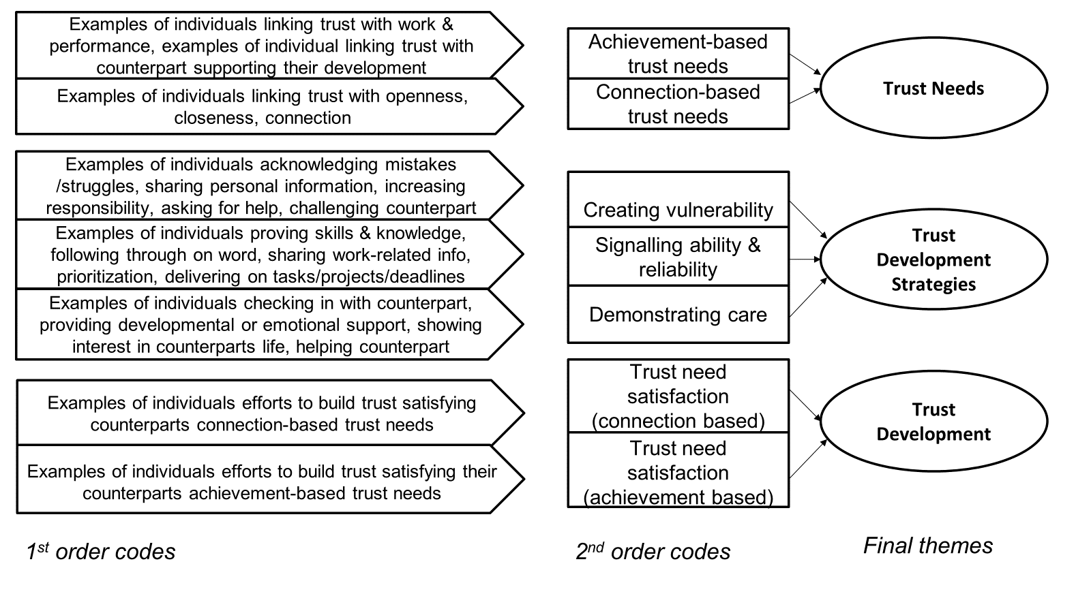
Figure 4.1 Data Structure

4.5 Findings
In this section, I outline how managers and employees in the sample supported the development of trusting relationships and how trust needs played a role in this process. To do so, I first show that dyadic counterparts each had their own trust needs that were based on achievement and connection. Next, I illustrate how managers and employees supported the development of trust via trust development strategies. I highlight that both groups relied on the same overarching strategies, but they enacted them using different trust development actions. Finally, I unpack why some dyads in the sample were effective in forming trusting relationships while others were not. Specifically, I illustrate that the satisfaction of both parties’ trust needs supported dyads to form trusting relationships effectively, regardless of whether the dyadic counterpart’s trust needs were aligned or misaligned.

4.5.1 Trust Needs
What became evident during the analysis process was that there was no one-size-fits-all approach for dyads to develop trusting relationships. The reason was that individuals highlighted differences in how they conceptualized trust and what they needed from their counterparts to trust them - i.e., their trust needs. Participants themselves acknowledged that such individual differences are important to consider when developing a trusting relationship, as reflected by Mia:
I think it's like understanding what someone is about or what they care about, and who they are...having to understand somebody and then build trust with them. I think you do need that element of knowing who the person is. And what they care about, what they're about. (E25)

By drawing comparisons across the sample, I identified that individuals' trust needs could be grouped into achievement-based trust needs and connection-based trust needs (see Table 4.1). For those with achievement-based needs, their needs were more work-centric and centered on their counterpart’s ability to support their success. Whereas, for others, establishing a more meaningful connection with their counterpart was most important to them, and their trust needs centered on their counterpart’s behavior that supported them to feel connected. Often, individuals recognized the value of both achievement and connection but framed one as more important to them. For example, Donal acknowledged the value of connection in a trusting relationship, but placed more value on other factors associated with achievement:
Yeah, I think it's a credibility thing isn't it? Over time consistently performing to a certain level… so I think that's a big part of it, you know, also developing a personal relationship I think that helps. But I think core to it is really building up credibility in performing (E16).

For others, their distinction of having either achievement-based or connection-based trust needs was more clear-cut. For example, Lauren's connection-based needs were evidenced by her noting “I think open communication and support is all part of being able to trust” (E12), while Cecil's achievement-based needs were reflected by his opinion that “it goes back to output, quite simply. That’s where a lot of trust is either built or lost” (M8).

Table 4.1 Supporting Evidence for Trust Needs Categorization
Trust Need | Example Quote
Achievement-  based trust needs | I would want to trust somebody based on how the outputs or the results and the product turns out (Mikey, M10)  And just sort of the output of his work is good. And the numbers and a lot of our work is numbers right and getting the financial analysis done correctly. And he's really strong in that and then you see him in meetings and I could see him interact with clients and get on with clients and you know, they liked him. So that sort of gives you the confidence that you know builds that trust. (Dara, M23)
Connection-  based trust needs | “It's kind of just the openness. I think he's very open in our conversations, you know, maybe that we're not even talking about work… I think it's kind of like what builds and fosters trust like openness, the kind of the personal chats.” (Ivan, M24)  “Trust is for me, it's about honesty and transparency… I definitely do think that there's also the personal element in that you do definitely need to share a level of personal information to build the whole picture of trust” (Mia, E25)

Through the analysis, I learned that individual trust needs could be either driven by internal or external factors. For example, Eoin explained that his own trust needs are centered around another individual “being a genuine person, you know, are you a good person and that's it…” (M12), implying that his needs are shaped by his internal values and moral compass. In comparison, trust needs in some cases were shaped by external factors. For example, achievement-based needs were more common for managers and connection-based needs were more prominent for employees, implying that the roles played by individuals likely influenced their needs to some extent. That said, neither achievement-based nor connection-based needs were exclusive to either group and some managers and employees also placed more emphasis on connection and achievement respectively, suggesting other influences were also at play. Some individuals talked about their needs being shaped by the nature of the work and their seniority in the organization as opposed to their counterpart's role. This is evidenced by Sophia, who pointed out that what she needs from Jess is different from what she would need to trust another employee because her role is a leadership role about people and change, meaning her needs go beyond output:
I'm managing leaders. I'm not managing people doing tasks. And if I were operating at a different level and say, I don't know people were developing software applications - there's a fellow sitting out there, developing software applications, cutting code. Do I really care that much about his integrity?... [Jess’ role] is not just as simple as that, no it's not about tasks. (M6)

The industry individuals worked in, and the norms embedded within it were other external factors referenced to shape individuals' trust needs. For example, Tina described her achievement-based trust needs as being the norm in the banking industry, where trust is gained by working overtime and being responsive. Referring to her counterpart, Eva, she noted:
She will work very late hours, like part of how you build trust in our industry is like your responses over emails. You're quick off the mark when I ask you to do something. Unfortunately, you end up having to pull late hours to turn out materials and turn decks but, through all of that, you build that trust. (M3)

4.5.2 (Mis)aligned Trust Needs
Within some dyads, counterparts’ trust needs were aligned, while other dyadic counterparts reported having misaligned needs. For those dyads whose trust needs were aligned, this meant they were on the same page in terms of what they needed from one another to build trust. For instance, counterparts Sam and Ruth both talked about their connection-based trust needs centering on the ability to be open and vulnerable with one another. This is evidenced by Sam noting “the trust together is, I suppose, a bond, it's an openness, it's a vulnerability.” (M9) and backed up by Ruth's reflection on trust as “I think it's the ability to be vulnerable...” (E9). In this dyad's case, they were aware of their aligned trust needs, with Ruth noting that she thinks “the same things are important to both of us” (E9). Sam acknowledged that this enabled them to “sync up pretty well” (M9). This implies that aligned trust needs can be beneficial for trusting dyads, however, the data made apparent that dyads with misaligned trust needs could also develop trusting relationships.

For example, Brian and Charlotte talked about needing different things from one another, yet they both reported trusting one another. Specifically, Brian's achievement-based needs meant he placed more emphasis on Charlotte's work and productivity: “It’s the day-to-day you need to build that trust, you know? With your responsibilities being done, with your productivity, with your different things you show” (M11). On the other hand, Charlotte's connection-based needs meant that developing a relationship beyond just work with Brian, that involved being open with and looking out for one another, was more important to her:
There is that level of transparency with both our lives as well, when it comes to work, so it’s like I might be having a tough week, “I’m going to take it easy”, he’s like “okay, you take it easy, I’ll hold the slack”. Or you know, if his kids are sick, then I’ll take his slack… So, there’s the working relationship that also, I think, the friendship that’s been formed, really helps with the trust aspect. Rather than it just being the manager employee relationship and that’s it. (E11)

Crucially, this misalignment in Brian and Charlotte's trust needs did not inhibit the formation of a strong trusting relationship, with Charlotte noting that she believes “we fully 100% trust each other” (E11). Therefore, the data made it clear that whether dyads had (mis)aligned trust needs or not, they could still effectively develop trusting relationships. This implies that although trust need alignment was beneficial to dyads, it did not determine whether dyads developed trusting relationships and other factors, such as their efforts to build trust, also needed to be considered.

4.5.3 Trust Development Actions
The data pointed to three overarching strategies that individuals harnessed to support trust development: creating vulnerability, signaling ability and reliability, and demonstrating care towards counterpart. Within the sample, managers and employees relied on these same strategies to build trust, however, the two groups described enacting the strategies differently (see Figure 4.2). For example, participants from both manager and employee populations shared examples of how the active creation of vulnerability supported the development of their trusting relationships but they described using different (trust development) actions to achieve this. For example, Gerri talked about being open with Ted about not knowing how to address certain work-related issues despite being his manager. Ted acknowledged this vulnerability and reflected that feeling like Gerri was letting him in had supported him to trust her:
I think just being completely honest about stuff that I am not knowing or I'm figuring out, I think he saw okay, well, if Gerri doesn't know, who should do X, Y, and Z or doesn't know how things work, then I should be comfortable enough to say neither do I. So I think being honest about that kind of put him more at ease too. (Gerri; M19)
I kind of feel like when she's opening up a bit like that, yeah, I'm like, okay I trust her a bit more as well because she is showing a side that maybe I'm not necessarily meant to see but I'm kind of being let in a little bit so that certainly builds trust (Ted; E19)

From the other perspective, Bob talked about his willingness to be open with his manager, Ivan, and not feeling the need to hold anything back from him. Ivan acknowledged Bob’s openness and its role in building their trusting relationship:
I feel like there's no sort of barriers in the conversation with Ivan, in terms of like, it's not an issue to bring up anything (Bob; E24)
He's very open in our conversations, you know, that we're not even talking about work..I think it's kind of like what builds and fosters trust like openness, the kind of the personal chats (Ivan; M24)

In both scenarios, Gerri and Bob acted in a way that created a sense of vulnerability and supported them in gaining their counterparts' trust, despite differences in their specific actions - Gerri acknowledged not knowing certain work-related information, while Bob spoke openly with Ivan. Differences aside, both parties’ actions supported the development of trust as validated by their counterparts, providing evidence that the two populations enacted the overarching strategies using different trust development actions. In some cases, there was some crossover in trust development actions used by managers and employees, for example, both populations shared examples of checking in with each other to demonstrate their care. Therefore, concerning the first research question of how each party in a manager-employee dyad supports the development of trusting relationships, the findings show that both groups used the same overarching trust development strategies but (mostly) enacted these differently. However, the findings also made abundantly clear that these strategies could not be used uniformly across all relationships to form trusting relationships effectively, and there was a need for dyadic counterparts to consider one another's trust needs.

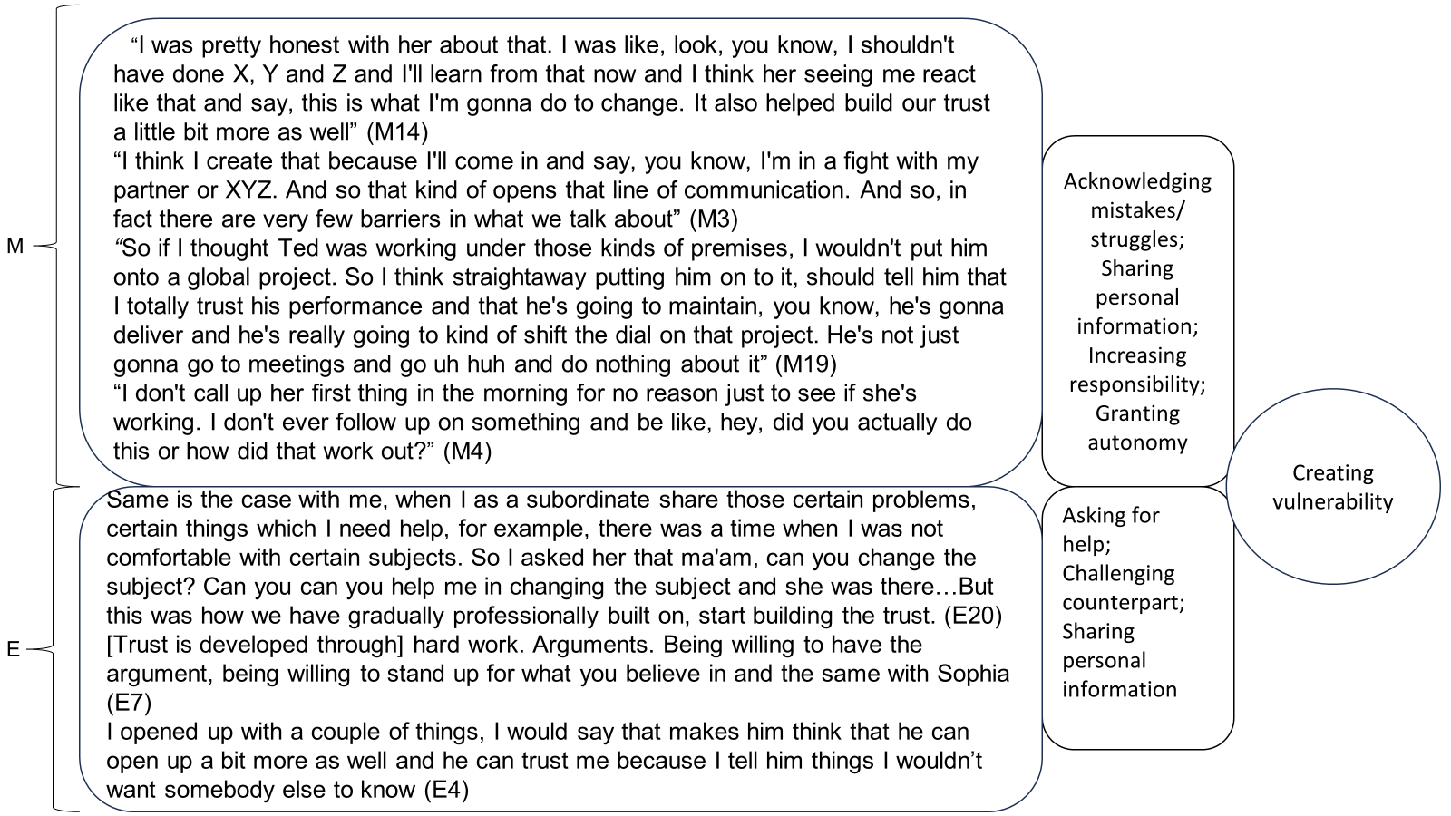
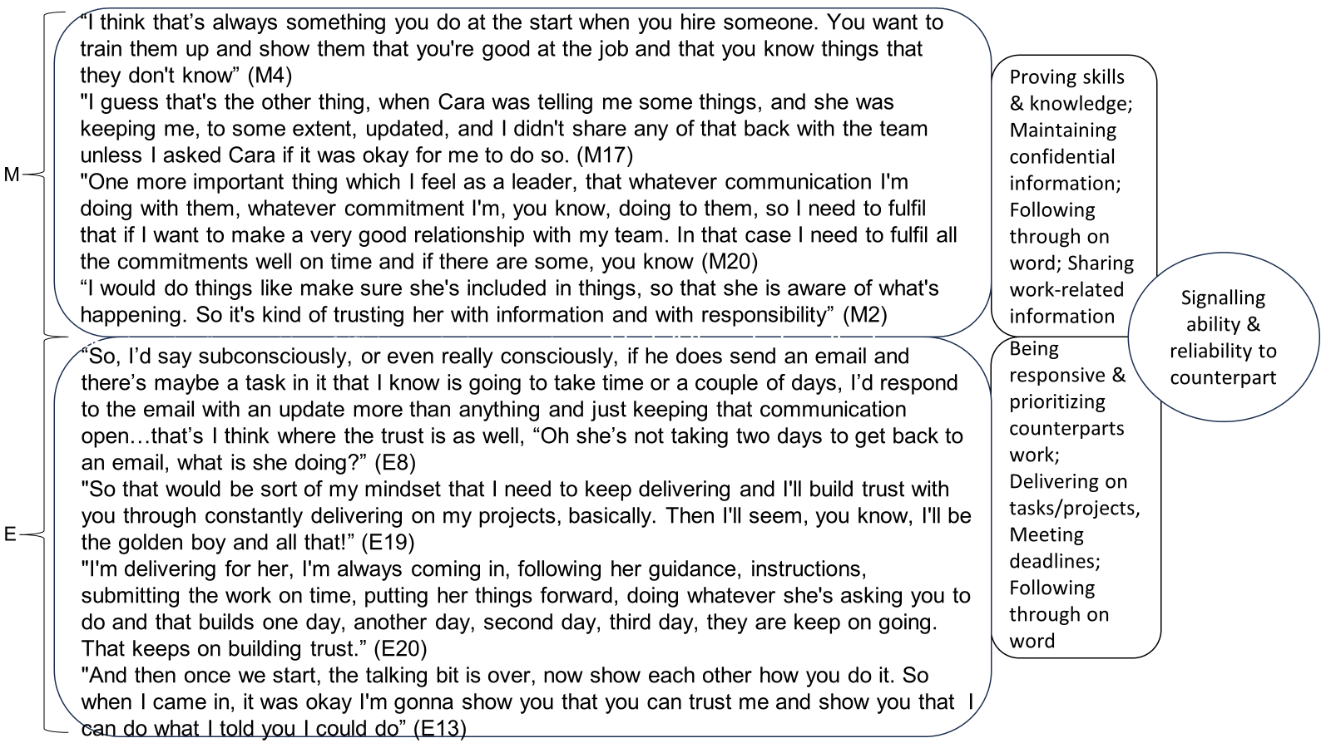

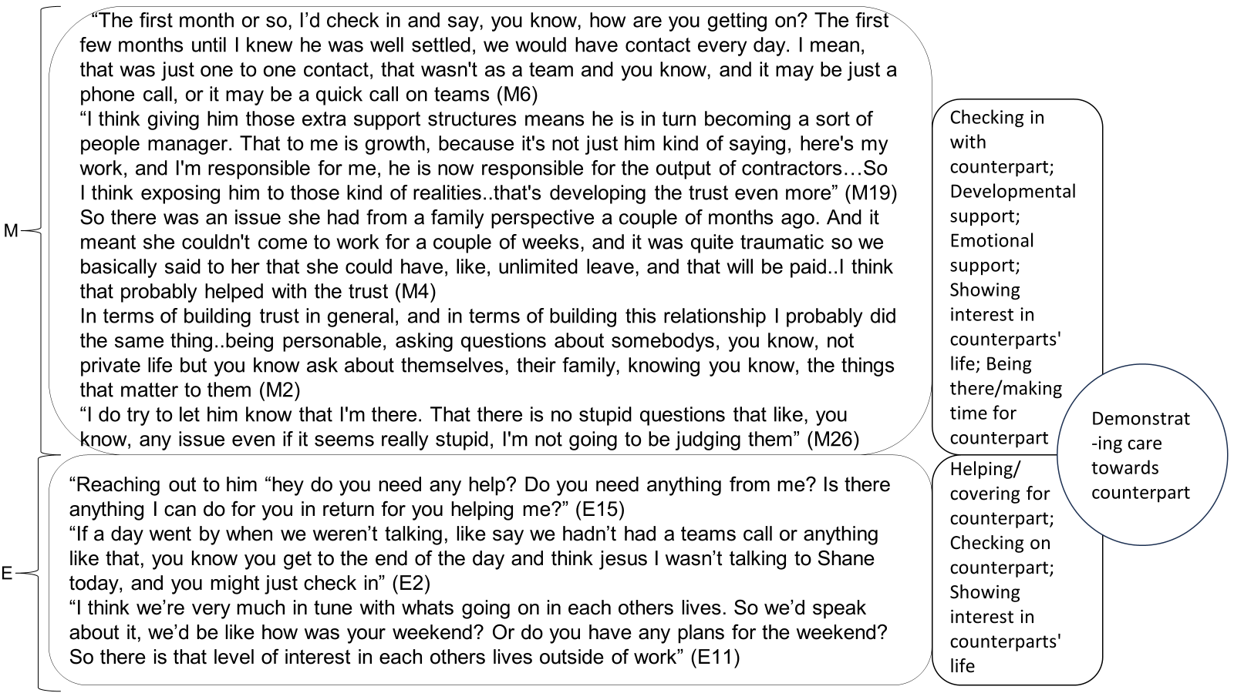

Figure 4.2 Supporting Evidence for Manager and Employee Trust Development Actions

In line with the different trust needs identified in the sample, I grouped the trust development actions uncovered into those that satisfy achievement-based needs and those that satisfy connection-based needs (see Table 4.2). In some cases, this was fairly intuitive, for instance, actions associated with the overarching strategy of signaling ability and reliability were mostly grouped with achievement-based needs, and actions associated with the overarching strategy of demonstrating care to counterparts were mostly grouped with connection-based needs. For example, it can be assumed that Ted’s trust development actions of delivering on tasks and projects - “I'm always like, okay, I need to prove myself in my job, but also doing that I get to build trust with her and show her constantly that I'm consistent and over delivering” (E19) - would satisfy achievement-based needs. Similarly, Eoin’s trust development actions of being there and making time for his counterpart - “it's being there, it's kind of being there for her on a personal level, being there as a friend” (M12) - would satisfy connection-based needs.

Trust development actions associated with creating vulnerability were slightly more nuanced, with some aligned to achievement-based needs and others to connection-based needs. For a small subset of these actions, they were mapped to satisfy both achievement and connection-based needs. For example, considering asking for help or helping a counterpart, if the help was work-related these actions could satisfy achievement-based needs, whereas, if the nature of the help was more personal or put one party in a more vulnerable position, they could also satisfy connection-based needs.

Table 4.2 Mapping of Trust Development Actions to Trust Needs
Trust Development Actions | Trust Needs
Proving knowledge (*M)  Sharing work-related information (M)  Increasing responsibility (M)  Granting autonomy (M)  Acknowledging mistakes (M)  Developmental support (M)  Following through on word (M; E*)  Being responsive & prioritizing counterpart (E)  Delivering on tasks/projects (E)  Meeting deadlines (E)  Asking for help (E)  Challenging counterpart (work related) (E)  Helping/covering for counterpart (E)  Emotional support (M)  Being there/making time for counterpart (M)  Developmental support (M)  Maintaining confidential information (M)  Acknowledging mistakes/struggles (M)  Sharing personal information (M; E)  Checking in with counterpart (M; E)  Showing interest in counterparts life (M; E)  Helping/covering for counterpart (E)  Asking for help (E) | Achievement-  based trust needs  Connection- based trust needs
*Note M represents managers' trust development actions, E represents employees

4.5.4 Trust Need Satisfaction
Through the analytical process, I discovered that trust need satisfaction, i.e., both parties having their trust needs satisfied by one another, was integral for dyads to develop trusting relationships effectively. To achieve this, each party’s efforts to build trust needed to satisfy their dyadic counterpart’s trust needs (see Figure 4.3). For example, if one party had achievement-based trust needs and their counterpart engaged in trust development actions that supported their achievement, via delivering for them or supporting their development, their needs were satisfied. Similarly, if one party had connection-based trust needs and their counterpart engaged in trust development actions that resulted in them feeling closer or more connected, their needs were met. Both party’s trust needs being satisfied, regardless of whether they had the same needs as one another, supported dyads to effectively form trusting relationships. Alternatively, if trust needs were not satisfied, dyads' trust development was inhibited. Participants themselves recognized the value of satisfying their counterpart’s needs, with Al reflecting: “If you know what they value… you can show her that or show them that and it just makes it easier to establish that relationship” (E6).

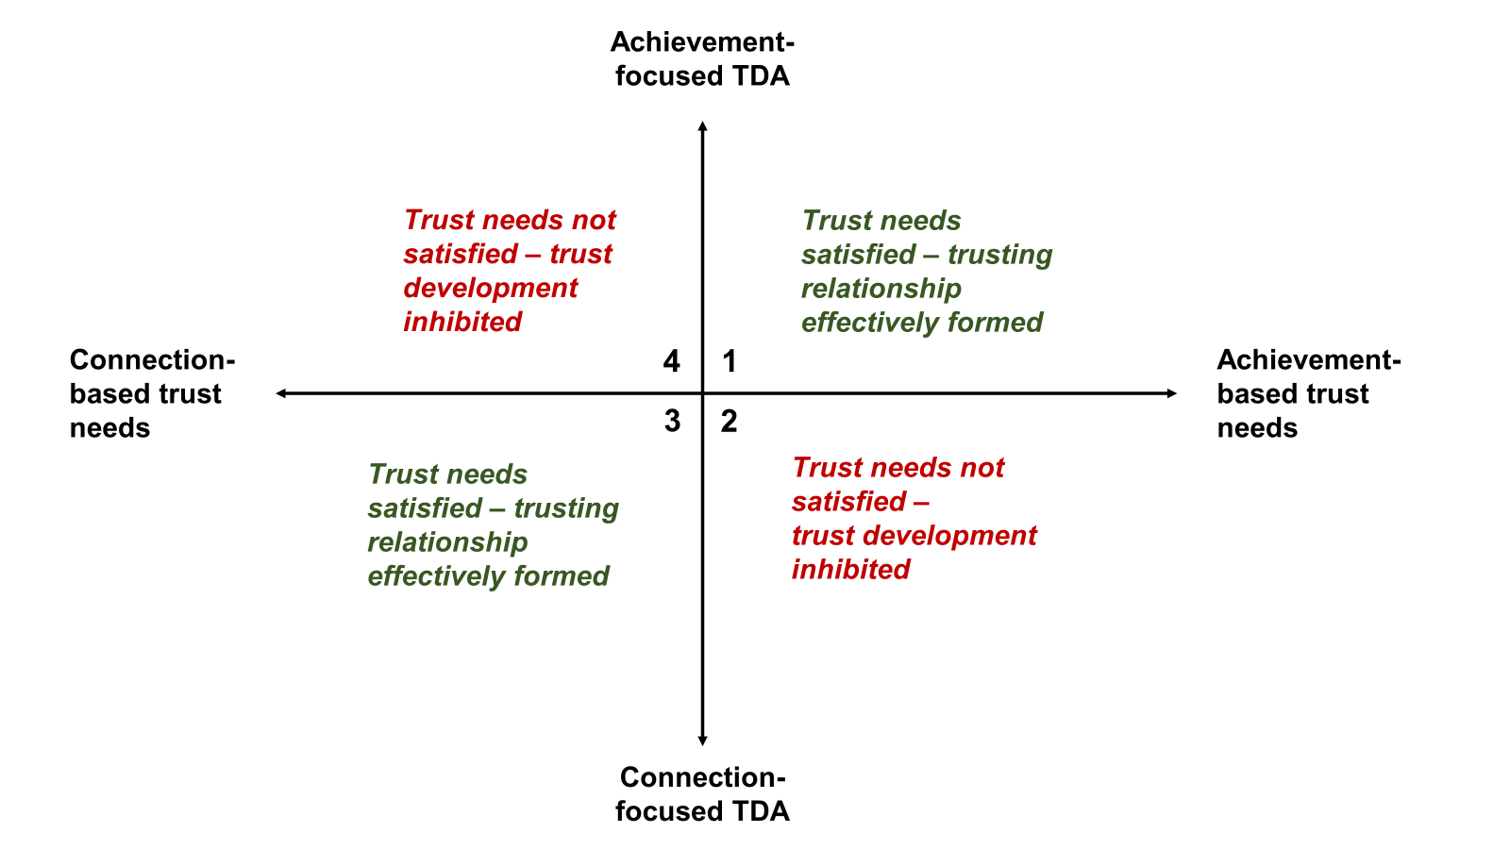
Figure 4.3 Matrix showing Alignment of Trust Needs and Trust Development Actions

Dyadic counterparts mostly satisfied one another's trust needs and as a result effectively formed trusting relationships (see Table 4.3). As noted, it was not essential for counterparts to have the same needs as one another to form trusting relationships once each party’s needs were met by their counterpart's trust development actions (i.e., Quadrants 1 & 3). Dyadic counterparts who did not satisfy one another’s needs were inhibited from forming trusting relationships (i.e., Quadrants 2 & 4). Examples of dyads that fit into each of these categories are described in detail below.

Table 4.3 Individuals and Dyads with Trust Needs Satisfied or Unsatisfied
Type of Trust Need | Trust Need Satisfied | Trust Need Unsatisfied
Connection-based  Trust needs | D1, D2, D4(e), D6(e), D7, D8(e), D9, D11(e), D12, D14, D15, D17, D21, D24, D25, D26(e) | D5(e), D18(e)
Achievement-based  Trust Needs | D3, D4(m), D6(m), D8(m), D10, D13,  D16, D19, D20,  D22, D23 D26(m) | D5(m), D18(m)
Trust Outcome | Dyads effectively developed trusting relationships | Dyad's development of trusting relationships inhibited
*Note D represents the dyad, (m) or (e) represents the manager or employee only

5.4.5 Categories of Dyads and Relates Trust Outcomes
Within the sample, I identified three groups of dyads: dyads with aligned needs that developed trusting relationships, dyads with misaligned needs that developed trusting relationships, and dyads with misaligned needs that did not develop trusting relationships. Through the analytic process, I discovered that trust need satisfaction, i.e., both parties having their trust needs satisfied by one another’s proactive efforts to build trust, was integral for dyads to develop trusting relationships effectively. Given those dyads with aligned and misaligned needs developed trusting relationships effectively, I interpreted that trust need satisfaction was the core mechanism that supported dyads to develop trusting relationships. That said, while alignment in counterparts’ needs was not necessary for dyads to develop trusting relationships, participants referenced that it helped them to do so. This is evidenced by Patrick, who reflected that he and his manager had “similar expectations on not necessarily what people do but how they do it and what's acceptable behavior and what's not. And I think that alignment between the two of us probably helped build a quicker rapport than maybe would have happened otherwise” (E22). This suggests that dyadic counterparts' alignment in what they need or expect from one another is a further mechanism that supports them to develop trusting relationships more readily.

In comparison, dyads with misaligned needs that developed trusting relationships achieved this via the core mechanism of trust need satisfaction only. I interpreted two main factors to influence their effectiveness in doing so. First, the relationship had longer to develop. Compared with dyads with aligned needs that reported developing a relationship quickly, some dyads with misaligned expectations reported this process took longer. Individuals attributed this to the time it took them to get to know their counterparts and identify what they liked. For example, Mary reflected on her relationship with her manager, Joe, that “at the start, it was quite tough just because I didn't know the job and I just didn't know him as a person”, but this got easier as she got to “know him…what he likes, what he doesn’t like” (E4). Despite this initial challenge, Mary did not stop effortfully trying to build trust and actively tried to identify and satisfy Joe’s needs. At times, these efforts were also reciprocated by Joe which, in turn, satisfied Mary’s connection-based needs. For example, Mary reflected: “because I opened up with a couple of things, I would say that makes him think that he can open up a bit more as well” (E4). At the same time, as they continued to work together, Joe was afforded more opportunities to satisfy Mary’s connection-based needs. For example, when Mary opened up to him about things that were going on in her life, Joe responded in a kind and empathic way: “I said to her look, I trust you to go and take leave and it's paid and it's unlimited, knowing that she would come back. I think the fact that we did that probably helped her trust in us” (M4).

Second, in some cases, the range of individuals' proactive efforts to build trust was broader, meaning that they were more likely to satisfy their counterpart's needs regardless of whether they identified what they were. This is evidenced in Al and Jane’s relationship, wherein Al engaged in proactive efforts to build trust that represented all three trust development strategies, including challenging Jane, asking for help, sharing personal information, seeking to know Jane, delivering on projects, and being responsive. Therefore, Al’s proactive efforts to build trust satisfied Jane’s competence-based needs and supported her to trust him - “I mean, he's a great worker, I have 100% trust in him” (M6), without being specifically targeted to do so. Overall, this suggests that misaligned trust needs do not inhibit dyads from developing trusting relationships, but such dyads can be required to invest more time and effort to build trust than those with aligned needs. Moreover, this reinforces the idea of alignment in dyadic counterparts' needs acting as another mechanism that supports the development of trusting relationships.

Finally, two dyads with misaligned needs did not develop trusting relationships effectively. In such cases, neither party’s trust needs were satisfied by their counterpart’s efforts to build trust, and the development of trust was inhibited. While their misaligned needs were likely a factor that added to their difficulties in developing trust, as evidenced by the previous group of dyads with misaligned needs who did develop trust, I interpreted that the absence of trust need satisfaction was the inhibiting factor. Compared with the dyads with misaligned trust needs that did develop trusting relationships, these dyads did not invest time and effort to identify and satisfy one another’s needs in the same way. For example, at the time of the interview, Laura acknowledged that despite struggling to develop a trusting relationship with her employee Dan for a year, she was not intentionally seeking to identify his needs: “I just didn't understand him at all, and I wasn't really trying was the point” (M5). Dan also felt let down by Laura who did not satisfy his needs, describing her as “the person that I suppose I looked for kind of guidance and support” (E5). However, despite both parties reporting finding it difficult to work together, neither party actively sought to identify the other party’s needs or adapted their trust-building efforts to satisfy the other's needs. Laura reported that once their initial efforts to build trust were not effective, working with Dan annoyed her, and she shifted her management style to deal with this: “then everything about him annoyed me. I was like he’s not listening to me; he is just doing his own thing the whole time…I had to check everything, and I don’t like micromanaging, that's not my style at all” (M5). This approach also annoyed Dan who felt that he “had actually been bombarded with a lot of you know, even stuff down to grammar and spelling” (E5), and further strained the relationship.

Similarly, Kay and Chloe did not satisfy one another’s needs and, therefore, the development of their trusting relationship was inhibited. At the time of their interviews, they had been working together for six months, however, based on how they were working together at that point, I interpreted that it was unlikely that either party would satisfy the other's trust needs without a very conscious, effortful approach to do so. In particular, Kay reflected that feeling let down by her manager encouraged her to shift her working style to be more transactional: “I would be like this is what I have done. This is why I did it the way I did it. This is what I need from you” (E18). However, she also acknowledged that this shift meant that she and Chloe had “fewer opportunities to either fix what might have been broken in terms of their trust or to create new opportunities to develop trust” (E18). Interestingly, Chloe followed up with me six months later to let me know that she had resigned from her job, predominantly because of the lack of trust in her relationship with Kay. Overall, through the analytic process, I uncovered trust need satisfaction to be the core mechanism that supports dyads to develop trusting relationships effectively. While aligned needs supported dyads to more readily do so, it was not a necessity and some dyads with misaligned needs developed trusting relationships effectively. In these cases, dyads invested more time and effort to do so compared with dyads with misaligned needs that did not develop trusting relationships.

Therefore, in relation to the second research question of how individual trust needs play a role in the development of trusting relationships, the findings illustrate that for dyads to develop trusting relationships effectively, both party’s trust needs must be satisfied by their counterpart's trust development actions, i.e., trust need satisfaction must occur. Moreover, having aligned trust needs supported dyads to identify and satisfy one another’s needs and, therefore, to develop trusting relationships more readily. In the absence of trust need satisfaction, the development of trusting relationships is inhibited.

Chapter Five
Trust Maintenance

This chapter is based on Kelly, S., van der Werff, L., & Freeney, Y. Plain sailing or choppy waters? Maintaining interpersonal trusting relationships in times of uncertainty, paper presented at the 12th Trust within and between organizations, FINT conference, 14-17th June 2023, LUT University, and University of Eastern Finland, Helsinki, Finland.
Paper was nominated in the category of Promising Early Career Research

This chapter is also in the first round of a revise and resubmit: Kelly, S., van der Werff, L., & Freeney, Y. Plain sailing or choppy waters? Maintaining interpersonal trusting relationships in times of uncertainty, Journal of Management

Plain sailing or choppy waters? Maintaining interpersonal trusting relationships in times of uncertainty

5.1 Introduction
Trust is essential in facilitating healthy work relationships, with its value evident across multiple referents (Fulmer & Gelfand, 2012). Although trust permeates all organizational relationships, the manager-employee relationship is positioned as a particularly critical intra-organizational trusting relationship (Ferris et al., 2009; Jawahar et al., 2019). This is warranted given a trusting manager-employee relationship affords increased performance, citizenship behaviors, and reduced counterproductive behavior (Colquitt et al., 2007; Dirks & Ferrin, 2002; Legood et al., 2021). Owing to the desirable outcomes associated with trusting manager-employee relationships, an abundance of research over the previous decades has sought to understand how trust develops at this conceptual level (Baer et al., 2021; Brower et al., 2009; Child & Möllering, 2003). Although some ongoing debate endures, trust scholars have largely reached a consensus that the aggregate workings of one's cognitive, affective and motivational systems support trust development (Mayer et al., 1995; McAllister, 1995; van der Werff et al., 2019; Williams, 2001).

Despite this valuable insight into how trusting is achieved, trust does not exist in a vacuum and established trusting relationships are vulnerable to the actions of internal parties and external uncertainty (Williams & Belkin, 2016). While we continue to make great strides in developing theory on trust repair (Bachmann et al., 2015; Sala & Pratt, 2022), theoretical advances in interpersonal trust have been hampered by the assumption that trust is maintained in the absence of violations (Williams & Belkin, 2016). In reality, trusting relationships frequently experience relational threats that require mutual effort from counterparts to maintain their trusting relationship (Gustafsson et al., 2021; Weibel et al., 2023). Indeed, in an era of health crises, technological disruption, economic downturn, and climate change, trusting relationships are operating in highly volatile and ambiguous environments (Budhwar et al., 2022; Vanneste & Gulati, 2022). Accommodating this uncertainty is likely to make existing relationships even more interdependent and reliant on trust (Luhmann, 1979). In turn, this heightened interdependence creates a more pressurized relationship, wherein managers and employees are more likely to clash with one another (Korsgaard et al., 2002). Taken together, the changing nature of work relationships, and the world they operate in, implies an inevitability of external and internal disturbances that threaten to destabilize existing trusting relationships. I define these disturbances as relational threats and argue that they are frequent occurrences that remain unexplored in the context of interpersonal trust.

While a relational threat is conceptualized as something that destabilizes but does not necessarily damage established relationships, a lack of theorizing about how to manage them leaves us ill-equipped to advise organizations and their employees about how to ensure they do not result in trust violation. This is a particular cause for concern as interpersonal trust repair is a multi-stage, time-consuming process (Kramer & Lewicki, 2010). Further, persistent relational conflict impacts a trustor’s ability to self-regulate, diminishing their resources and making the chance of repair less likely (van der Werff et al., 2019). Therefore, it is imperative to intervene before trusting relationships break down and face a long and complex road to recovery - one that in many cases does not lead to pre-violation levels of trust (Schilke et al., 2013). Recent scholarship has taught us that trust in organizations can be maintained in times of heightened uncertainty (Gustafsson et al., 2021; Weibel et al., 2023), but trust scholars caution about treating trust referents as interchangeable (Dietz & Gillespie, 2009; Fulmer & Gelfand, 2012). Coupled with that, this small body of research focuses specifically on threats to the trusting relationship attributed to external sources, however, in the context of the focal relationship, threats from an internal source are also highly plausible. This implies a lack of completeness for existing theory and our understanding of the nuances of trust maintenance. Practically speaking, this means managers and employees are not prepared to deal with the frequent relational threats their trusting relationships will likely experience. As a result, existing trusting relationships, that hold value at multiple levels across the organization, may unnecessarily break down.

The present research set out to address this incomplete theoretical and practical understanding of interpersonal trust maintenance. To achieve this, I first address how do manager-employee trusting relationships experience a relational threat? By adopting a broad focus on relational threats, I can identify patterns in how trust maintenance plays out across the sample, positioning us to generate new theory regarding the maintenance of interpersonal trusting relationships (Saunders et al., 2019; Van Maanen et al., 2007). Specifically, I theorize interpersonal trust maintenance can take a different form depending on subjective assessments of the threat experience. Building on this, I seek to uncover how trust is maintained during such experiences by addressing how do managers and employees support the maintenance of established trusting relationships when they experience a relational threat? Given the interdependence between managers and employees, they represent a fitting sample in which to explore trust maintenance in the context of relational threats. Further, the dyadic data moves us beyond a unidirectional view of trusting (Jones & Shah, 2016; Korsgaard et al., 2015) and allows us to tap into the experience and efforts of both parties, as well as their mutual agency, in the dynamic process of trust maintenance (Korsgaard et al., 2018; McEvily et al., 2017).
This paper makes several important contributions to theory and practice. Firstly, I contribute to trust theory by illustrating how relational threats can be harnessed to strengthen manager-employee trusting relationships. I contend that the new information that dyads access about one another and the shared vulnerability dyads experience when they face a relational threat strengthens their trusting relationship. Second, I add to the promising but nascent stream of research on trust maintenance (Gustafsson et al. 2021; Weibel et al., 2023; Williams & Belkin, 2016) by contributing the first empirically derived model of interpersonal trust maintenance. Within the model, I highlight trust maintenance strategies that can be adopted by both parties in manager-employee dyads. This addresses a criticism of the broader trust literature for treating trust as unidirectional (Korsgaard et al., 2015) and extends trust repair literature (and the nascent trust maintenance literature) that focuses on the (re)active strategies used by one party (for review see Sharma et al., 2023). Finally, I extend the work of Tomlinson and Mayer (2009) to understand the role of attribution and emotion in the maintenance of interpersonal trusting relationships in the absence of violation. All of this has important implications for practice, including improvements to leadership, teamwork, and conflict management programs, and will address recent calls for scholarly work on trust to provide “practical, actionable insights for managers and organizations” (Dirks & de Jong 2022, p. 23).

5.2 Theoretical Background

5.2.1 Interpersonal trusting relationships
Trust is defined as “a psychological state comprising the intention to accept vulnerability based upon positive expectations of the intentions or behavior of another” (Rousseau et al., 1998, p. 395). Trust exists at multiple conceptual levels (e.g., individual, dyadic, team, organizational), and can be directed towards different referents (e.g., employee, peer, leader, organization) (Fulmer & Gelfand, 2012). The focus of this research is on interpersonal trusting relationships between managers and employees, i.e., relational trust between two specified counterparts in a dyad (Zaheer et al., 1998). At this person-to-person level, trust offers the expectancy that individuals will not take advantage of one another’s vulnerabilities and encourages risk-taking behavior i.e., trusting action (Mayer et al., 1995). Given the intersubjective nature of trust, both parties in the dyad are simultaneously acting as the trustee, i.e., the individual being trusted, and the trustor, i.e., the individual making trust-related judgments (Jones & Shah, 2016). This relational ontology addresses a common pitfall of trust research that exclusively focuses on employees’ trust in their managers (for an exception see Brower et al., 2009) and allows the consideration of how the trusting relationship is jointly produced (McEvily et al., 2017; Möllering, 2013).

Although a growing body of literature recognizes trusting as an active process (Child & Möllering, 2003; Williams, 2007), traditional models have tended to suggest that trust is relatively passive (Lewicki & Bunker 1996; Mayer et al., 1995). That is, individuals do not intentionally interfere with the natural rhythms of trust processes (aside from being reactive when trust is violated). As put by Kramer and Lewicki, trustors are viewed as “vigilant social perceivers” who evaluate the presence or absence of cues about the “trust-warranting properties” (2010, p. 257). Meanwhile, trustees are modeled as passive actors who do not exert effort to build or maintain trust or try to influence the evaluation of their trustworthiness (William, 2007). An alternative argument is available via the concept of active trust, which views trust as an ongoing accomplishment that requires continuous work by actors, even once established (Möllering, 2006, 2013). My thinking aligns with this conceptualization of trusting as a co-created process; developed and sustained by the interplay of efforts from both the trustee and trustor (Giddens, 1994; McEvily et al., 2017). Hence, both parties in a trusting relationship are envisioned as dynamic agents, who act with motive and intentionality. Where this becomes particularly salient is when trusting relationships experience a relational threat that disturbs ongoing patterns of trusting.

5.2.2 Relational threats
I conceptualize a relational threat as any disturbance, from an internal or external source, that poses potential risk of destabilizing the trusting relationship. The experience of a relational threat disrupts familiar patterns of trusting and transforms the relationships context from being more predictable to one fraught with uncertainty, for example, a change in one party’s role or the acquisition of the trusting party’s organization. This shift in context creates the need for (re)action by those in the trusting relationship as individuals attempt to return the relationship to its familiar world (Luhmann, 2000, 2017). Therefore, building on previous theorizing (e.g., Gustafsson et al., 2021; van der Werff et al., 2019), I depict a relational threat to trigger more intentional efforts by individuals to maintain the existing trust in their relationship. This theorizing extends previous work in two important ways. Firstly, I move beyond threats that are attributed to an external source and take a broader view by including anything that threatens to destabilize an existing trusting relationship. Secondly, I am curious about the relational experience of the threat and how trusting relationships can be interpersonally maintained. To explore this notion of mutual agency in trust maintenance, I diverge from previous theorizing at this conceptual level that focuses on the active response of one party to a disruption (e.g., van der Werff et al., 2019; Williams & Belkin, 2016).

The experience of a relational threat differs from a trust violation where trust has been damaged or lost and the efforts are directed at restoring trust to a past state (Kramer & Lewicki, 2010). In contrast, a relational threat is any disruption that brings trust into question because of its potential to destabilize the relationship but does not necessarily lower trust. Indeed, by its very definition, a threat is something that has the potential to cause damage as opposed to something that has done so. This is reflected in Gustafsson and colleagues' distinction between trust repair and preservation and framing of preservation as something that attempts to “avoid a loss of trust” (2021, p. 1414). Further, a trust violation has a polarizing effect, such that interpersonal trust repair mostly involves one party (the violator) engaging in strategies in an attempt to restore trust to pre-violation levels (Kramer & Lewicki, 2010; Sharma et al., 2023). In contrast, a relational threat is anticipated to trigger mutual efforts by both parties to protect the trusting relationship. Therefore, on the basis of its conceptual differences from what constitutes a trust violation and the general lack of theorizing on relational threats (see Table 1), I see this as a novel concept that enables us to further understand interpersonal trust maintenance. Given that relational threats are likely frequent occurrences for interdependent manager-employee relationships, they provide a useful lens to examine active trust and the ongoing efforts by trusting individuals in this regard (Giddens, 1994; Möllering, 2006, 2013). That said, due to the novelty of the concept of relational threats, it is important to understand how such threats to trusting relationships are experienced. To achieve this, I will address the following research question: How do manager-employee trusting relationships experience a relational threat?

Table 5.1 Conceptual Differences Between Relational Threats and Trust Violations

Relational Threat Trust Violation

Impact on Existing trust brought into question Existing level of trust lowered
trust Potential/threat of trusting Trusting relationship
relationship being destabilized damaged

Level of Heightened uncertainty Certainty of problem and
(un)certainty Relational and contextual damage to trust
uncertainty

Active party Triggers both parties to Triggers transgressor to play
engage in trust more salient role in trust repair
maintenance efforts efforts

Temporal focus Present Past
Window of time to Immediate damage to trust
maintain trust

Research/theory Limited insight Stage based model
focus Repair mechanisms and tactics

5.2.3 Active trust maintenance
At an organizational level, recent maintenance theory agrees with the trust repair literature that when trusting relationships are destabilized, active investment is needed to protect and maintain trust (Gustafsson et al, 2021; Weibel et al., 2023). At the interpersonal level, trust maintenance efforts have been depicted as trustee attempts to shift attribution away from her/himself, via the use of meaning-making processes, when they behave in a way that could be perceived as harmful (Williams & Belkin; 2016). From the trustor perspective, engaging in self-regulation of trust cognitions, emotions or behavior can support trustors to overcome disruption and realign them to their trust goal, i.e., maintaining their trusting relationship (van der Werff et al., 2019). In the context of maintaining trust in the organization, researchers argue that if leaders (who act as representatives for the organization) utilize active maintenance strategies that prioritize and involve employees during times of disruption they will continue to trust the organization (Gustafsson et al., 2021; Weibel et al., 2023). Taken together, this growing body of literature lends valuable insight to what each party in a trusting relationship can do to maintain trust. I build on this and adopt a relational lens to expand theorizing on trust maintenance by exploring the mutual agency of dyadic counterparts.

Although some overlap can be observed in the maintenance efforts portrayed in existing literature, they also diverge in other ways. This provokes speculation regarding whether different strategies may be more or less fitting to support trust maintenance in different scenarios. Trust regulation theory tells us that a disruption to the trusting relationship can evoke a cognitive, affective or behavioral regulation strategy, depending on the nature of the event (van der Werff et al., 2019). In line with this theorizing, Weibel and colleagues (2023) depict different maintenance strategies to reduce the salience of different forms of employee vulnerability (discontinuity vulnerability or socio-emotional vulnerability, see Misztal, 2012), triggered by technological advancement in their organization. By tapping into specific mechanisms through which strategies support maintenance, authors start to delineate which strategies are effective for certain situations. This offers a meaningful extension to previous work which portrays the cumulative effect of overall strategies to maintain trust (Gustafsson et al., 2021; Williams & Belkin, 2016). That said, the harnessing of new technologies may be perceived as somewhat out of the organization's control (comparable to a financial crisis, see Gustafsson et al., 2021). Trust maintenance, amid such unavoidable disruptions, is anticipated to differ from what would maintain trust in the case of a relational threat, given their external and uncontrollable nature. At present, trust literature offers us no empirical insights into how trust can be maintained when the disruption is perceived as controllable - in addition to a lack of insight on uncontrollable threats in the case of interpersonal trust maintenance.

In summary, owing to varying foci in terms of trust referents and contexts, the literature does not offer a clear conceptualization of the trust maintenance process. Further, the most up-to-date research has focused on trust in the organization as opposed to interpersonal trusting (Gustafsson et al., 2021; Weibel et al., 2023). Considering previous warnings that assumptions regarding interpersonal trust are not always interchangeable with trust in an organization (Fulmer & Gelfand, 2012; Gillespie & Dietz, 2009), I believe the same assumptions should not be made in reverse. Therefore, despite the valuable insights gained from research to date, we do not have a clear understanding of how trust maintenance unfolds interpersonally. This is particularly salient in the context of relational threats, which are argued to be frequent occurrences in manager-employee working relationships. The present research aims to address this shortcoming by providing an empirically validated response to the following question: what strategies do managers and employees use to maintain their trusting relationship when they experience a relational threat?

5.3 Methodology

5.3.1 Design and data collection
I designed qualitative, exploratory research to align with the aim of generating theory about interpersonal trust maintenance (Edmondson & McManus, 2007; Strauss & Corbin, 1998; Van Maanen et al., 2007). Specifically, I analyzed the experience of a relational threat as a means to unpack trust maintenance in our sample. In line with the research aim, and trust scholars’ methodological recommendations (Hughes & Saunders, 2021; Korsgaard et al., 2015), I employed a dyadic approach, eliciting data from both parties in the trusting relationship. This allowed me to consider trusting as socially co-constructed (Luhman, 1979).

Data were collected via semi-structured, in-depth, conversational interviews with managers and employees (n=52). This approach was deemed the most appropriate as it allowed participants to reflect openly on their subjective lived experience of trusting (Lamont & Swidler, 2014), which could be extended or redirected in response to probes by the interviewer (Saunders et al., 2019). I sampled conveniently (Patton, 1990) from my professional network by asking individuals, who had a willing manager or employee counterpart, to volunteer to take part in the study. I also used a snowball sampling technique such that participants were asked to identify potential dyads who may be willing to take part in the study (Patton, 1990). The final sample consisted of 26 manager-employee dyads (see Table 3.1 for a breakdown of dyad demographics). This is in line with sample size recommendations for interview data (Saunders & Townsend, 2016) and avoids the likelihood of losing the thickness of the data by including too many cases (Miles & Huberman, 1994). In the later stages of interviewing, I stopped observing new theoretical insights and was therefore satisfied theoretical saturation had been reached (Eisenhardt, 1989).

Interviews were conducted on an individual basis and took place either in person or online via Zoom, depending on the participant’s preference and their geographical location. Interviews lasted approximately one hour; some were slightly shorter, lasting 40-45 minutes, and others up to 90 minutes. All interviews were recorded and transcribed. Data was anonymized and participants were assured of their confidentiality and anonymity of any quotes used. Dyads were labeled from 1-26, with all managers labeled as M, e.g., “M1”, and all employees labeled as E, e.g., “E1”. In line with best practice, throughout the interviewing period (September 2021 to August 2022) I took field notes to capture rich descriptions of interviewees and their context (Phillippi & Lauderdale, 2017), and the research team met regularly to discuss emerging theory (Corley & Gioia, 2011).

The interview protocol was designed to generate detailed accounts of the trust maintenance process within manager and employee dyads (unit of analysis). Participants were first asked a number of questions about the relationship more generally (e.g., can you please tell me about your working relationship with your manager/employee?), before honing in on trusting more specifically (e.g., how important is trust in this relationship?). These questions were deliberately broad to avoid leading participants and to allow empirical ‘puzzles’ to emerge (Grodal et al., 2021). Participants were then asked to think about a time when their relationship had experienced a particular challenge, but they had maintained their trusting relationship and were asked to reflect on how this was achieved. This critical incident method has been previously adopted to study trust (Breuer et al., 2020; Korsgaard et al., 2002), as it is useful to cue participants to a specific event when trying to elicit their specific actions or behaviors. This approach also helped to address the issue of recall bias as participants are more readily able to recall specific behavioral details when recalling a particularly meaningful time (Munscher & Kuhlmann, 2012). In line with methodological guidance, data analysis as early as possible (Saunders et al., 2019), which allowed me to ensure that the data being elicited from the participants was appropriate to answer the research questions.

5.3.2 Data analysis
In the analysis, I took an interpretive approach, scanning the data for underlying meanings, contradictions, puzzles, and potential different interpretations (Alvesson & Sköldberg, 2017). To guide me in achieving this, I used Braun and Clarke's (2006) thematic analysis. This approach was judged as a suitable choice as its six phases offer a systematic and rigorous approach to the analytical process, while at the same time allowing me to remain flexible and open-minded to different interpretations and discoveries within the data (Braun et al., 2022).

The purpose of the first phase of analysis, familiarization with the data (Braun & Clarke, 2006), was to immerse myself in the data to ensure in-depth familiarity. This involved transcription of recorded interviews, before moving on to reading each transcript several times to gain an intimate understanding of participants' lived experience. Following other scholars' recent approach to dyadic theory generation (Freeney et al., 2021; Panda et al., 2020), I initially focused the analysis at the individual level and then moved to the dyadic level. Once at the dyadic level, I engaged in within-case analysis which involved in-depth familiarization of the intricacies of each trusting dyad (case) and creating a comprehensive memo for each dyad (Eisenhardt, 1989). This step helped me to cope with the volume of data and to identify generalized patterns more readily across cases.

Once the familiarization phase - “the bedrock for the rest of the analysis” - was completed I then started to move through the next phases of thematic analysis, generating initial codes, searching for themes, reviewing themes, defining and naming themes (Braun & Clarke, 2006, p. 87). This involved moving from initial codes that stayed close to participants' own language, to identifying patterns and grouping these into second order codes and finally into themes (Saunders et al., 2009). As I progressed through the stages of coding, I purposefully narrowed to more theoretically relevant themes that helped to address the research questions (see Figure 5.1). Next, I used the themes to search for cross-case patterns across the sample (Eisenhardt, 1989). This was supported using tables which enabled me to condense rich data to display evidence in a way that helped reveal meaningful patterns and insights relevant to the research questions (Cloutier & Ravasi, 2021). For example, I noticed some divergence in strategies used across dyads which pushed me to interrogate the data further to understand why different approaches to trust maintenance were taken. All of this served as the building blocks for the model development.

Naturally, all of this was not a linear process and involved iterating between phases, as well as contemplating the findings in the context of existing trust research in line with an abductive approach (Saunders et al., 2019; Van Maanen et al., 2007). Throughout this analytical process, there was an ongoing discussion among the research team to refine the emerging theory (Corley & Gioia, 2011). Finally, once researchers were satisfied that the analysis process adhered to the standards of trustworthy research (Lincoln & Guba, 1985), I produced the final model of interpersonal trust maintenance, and a scholarly report of the analysis (Braun & Clarke, 2006).

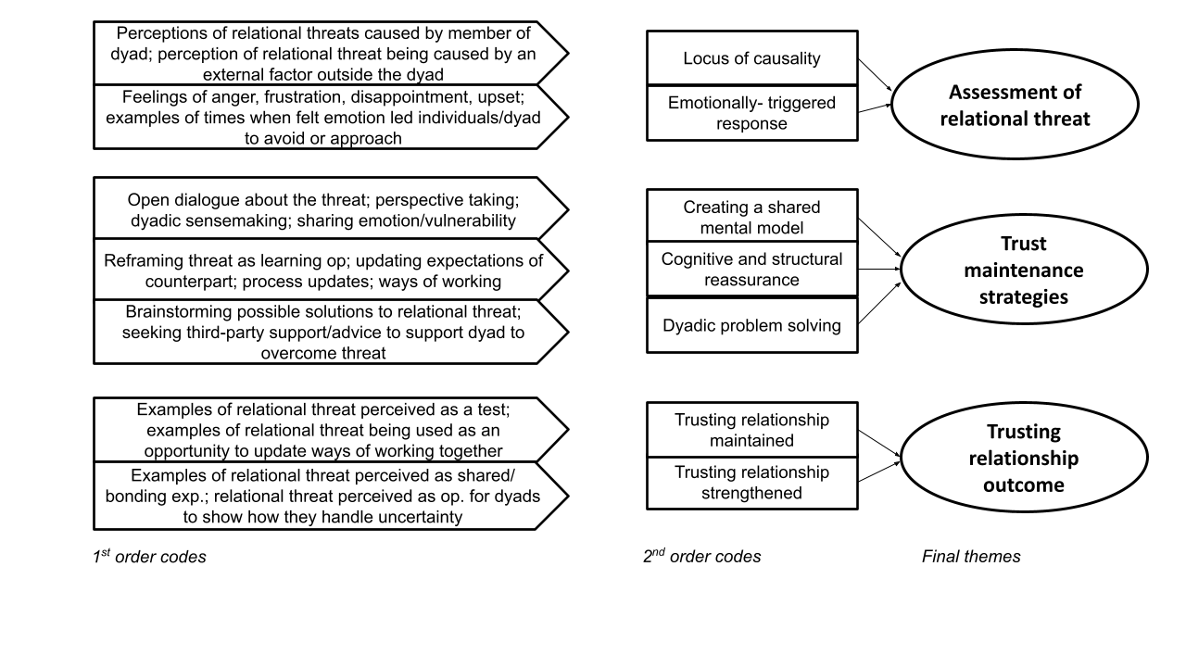
Figure 5.1 Data Structure

5.4 Findings
In this section, I outline the experience of a relational threat and interpersonal trust maintenance as uncovered in the sample of manager-employee dyads. The findings illustrate that dyadic counterparts typically made their own subjective assessment of the relational threat, while efforts to overcome the relational threat, via trust maintenance strategies, involved mutual agency. The findings also highlighted that the experience of a relational threat could result in different trust outcomes. Specifically, dyads either maintained their trusting relationships, or the experience of a relational threat was harnessed to strengthen their trusting relationship (see Figure 5.2).

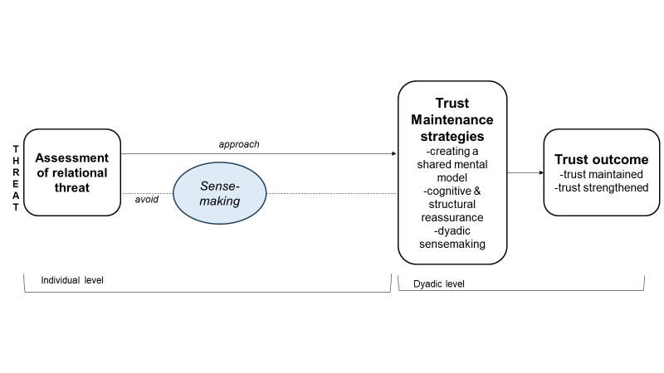
Figure 5.2 Model of Interpersonal Trust Maintenance

5.4.1 Assessment of relational threat
Participants discussed a broad range of relational threats ranging from disagreements with one another to adjusting to organizational changes. I broadly grouped these relational threats into change-related, performance-related, partnership-related, and disagreement- related (see Table 5.2), however, it is apparent from the data that the overall assessment of the threat, as opposed to its content, was more likely to influence dyads approach to deal with the threat.

Table 5.2 Examples of Relational Threats with Illustrative Quotes

Example of Relational Threat (RT) Illustrative Quotes

Change-related RT:
Change of role and perception that “So I went from that perfectly structured,
the manager did not allow her time to settle knowing exactly what was happening and
into new role (ILoc) totally in control of my brief and performing
really well in it, to suddenly standing over a
team that wasn’t really all working together
and then suddenly it was my fault” (E7)

Performance/Feedback related RT:
Complaint about their team (ELoc) “So, we actually had a really big conflict last
year. It was a girl who was on sick leave..we
basically got a threatening email saying the
way we responded has been not acceptable,
and that she went over our heads” (E11)

Partnership-related RT:
Working with a difficult senior leader “At one stage we were dealing with a
in the organizations (ELoc) very senior person who was a sheer micro-
manager slash panicker. Who was
constantly on our case about everything and
anything..” (M16)

Disagreement-related RT:
Different perspectives on a hiring “But anyway, we were at loggerheads decision (ILoc) really about hiring her. I didn’t want to hire
her.. We did hire her and then it actually
didn’t work out really” (E8)

The experience of a relational threat triggered a need for individuals to engage in cognitive and affective sensemaking, as evidenced by one employee recognizing that her manager's actions resulted in her being “confused as to how to feel about it, I didn't know where it was coming from, like if it was coming from a good place or not” (E21). Sensemaking aided individuals to gain a clearer understanding of the threat and how it made them feel, which shaped their assessment of the threat. Cognitively this involved an attribution process, wherein individuals determined who was to blame i.e. the locus of causality (LOC) of the threat (Weiner, 1985). Threats were either perceived as having an internal locus of causality (ILOC) or external locus of causality (ELOC). This meant individuals either perceived someone inside the dyad as being responsible for the threat (i.e., ILOC), or perceived the threat as being attributed to an external source outside the dyad (i.e., ELOC).

Individuals also made sense of and reflected on how the relational threats made them feel, which ranged from upset or worried, to being annoyed or frustrated. For example, one manager referenced a disagreement he had with his counterpart who had prioritized someone else's work ahead of his and caused him delay (ILOC), reflecting that “based on this as I didn't see the same courtesy being extended to me, and that was very frustrating, irritating, and it threatened to kind of derail the relationship” (M2). From an external perspective, one dyad described feeling like another team were “stepping on their toes” (ELOC) but were both able to recognize the “external source” (E19) of this threat. Here, and something I observed to be more common to ELOC relational threats, both parties expressed feeling “frustration” (M19, E19). For other dyads, their subjective experience of a relational threat triggered different emotions, for example within dyad B, their disagreement about the manager not feeling prioritized which led to him feeling “irritated” (M2), caused the employee to feel “upset” (E2).

5.4.2 Emotionally triggered responses
Participants described how their assessment of relational threats manifested in them being pulled towards or away from their dyadic counterparts. I broadly characterized these responses as approach or avoidance, according to Methot and colleagues’ (2017) distinction of approach-oriented versus avoidance-oriented emotions. For example, one employee referred to a time when she felt “upset” (approach emotion) as a consequence of receiving unsolicited feedback from her manager but approached her to share that she “really didn’t think it was fair” (E21). Meanwhile, another employee talked about a situation when he felt “frustrated” (E23) (avoidance emotion) with how his manager handled his bonus allocation and described how he distanced himself from his manager:
I was like I don't accept this as okay, I go look, you've caught me off guard completely, which is a bit much. I need to digest that, take that away and think about it myself. (E23)

Here, the contrast of emotionally triggered responses is evident with those who expressed an approach emotion (Dyad U), pulling towards their counterpart, versus those who expressed an avoidance emotion (Dyad W) pulling away and seeking some emotional and physical distance from their counterpart. Further, this demonstrates that an individual can either have an approach or avoid response to an ILOC threat depending on how the relational threat makes them feel. For dyads who experienced ELOC threats, they were more likely to have an approach response because the threat was attributed to an external source and therefore any negative emotion was not directed towards one another. This was evidenced by one dyad whose ongoing trusting relationship was disrupted by the potential sale of their organization and their uncertainty about their future job security. Despite being “frustrated”, they were able to acknowledge their “rubbish mood not with each other but just generally” and still described “dealing with it together” (M13). Therefore, the data made apparent that these different responses outlined by dyads were influenced by their cognitive and affective sensemaking of the threat, with neither alone being able to fully explain dyads responses.

For those dyads who had an initial avoidance response, the data points to two ways in which they then re-engaged with one another. First, responsible parties were able to acknowledge their role and approached their counterparts to work towards a resolution. For example, following a disagreement with her manager which she recognized to be her fault, one employee reported that she approached him to say, “I think we need to have a meeting, we need to kind of set out our stall, what you see me doing, what I see me doing and then decide” (E2). Second, despite feeling hurt by their counterparts’ actions, some individuals were able to recognize that they “had to get through it” and there was no room for “huffing or puffing, or you know, sulking or any of that kind of stuff” (E7). Despite this awareness, the employee in this dyad still acknowledged that she needed to further consider her best approach before she engaged with her counterpart to work toward a solution to the threat:
I just figured things out with her, you know, but I had thought carefully about how I put things on the table. Having figured out what was important to me, having figured out what my values were and who I was in this new role… I needed to discover them for myself and then I had to make sure that I signposted those for Aoife as well, in a non-confrontational way. (E7)

5.4.3 Trust Maintenance Strategies
The analysis highlighted that dyads acted with mutual agency to maintain their trusting relationship via the use of trust maintenance strategies. Specifically, I discovered three overarching strategies that dyads utilized: creating a shared mental model, cognitive and structural reassurance, and dyadic problem-solving (see Table 5.4). Depending on their assessment of the relational threat, dyads typically used a combination of these strategies. Following the experience of an ILOC threat, dyads were more likely to engage in creating a shared mental model and cognitive and structural reassurance, while dyads who experienced an ELOC relational threat were more likely to engage in creating a shared mental model and dyadic problem-solving.

Creating a shared mental model. Creating a shared mental model (Weick & Roberts 1993) represents dyads’ attempts of getting on the same page about the relational threat and to position themselves to move forward to overcome the threat. Some of the groundwork for this was done via sensemaking, meaning dyads had already started to interpret the threat individually and could use this as a springboard to create a shared mental model with their counterpart. This is in line with learning theory that positions interpreting blending quite naturally into integrating as individuals move away from feelings and hunches toward a collective mind (Crossan et al., 1999, Weick & Roberts 1993). The specific behaviors that supported dyads to create a shared mental model were open dialogue, perspective-taking, dyadic sensemaking and emotional expression.

Open dialogue was an essential strategy for dyads to create a shared mental model. Put simply, open dialogue provided dyads with an important opportunity to come together to “just talk to each other and tell each other where we're at” (E13). Dyads themselves recognized its vitality in the maintenance process, with one employee noting: “the biggest thing was just that we were able to communicate really clearly with one another'' (E25).

Perspective-taking allowed one to consider their counterpart's position - i.e., to “see where they are coming from” (M10) - and helped dyads to create a shared mental model of the relational threat. Vitally, this enabled individuals to challenge or shift their way of thinking about their counterpart or the threat. For example, in one dyad an employee noted that perspective-taking helped her “pull away from feeling sorry for herself” and start to work with her counterpart toward overcoming the relational threat:
You realize that you can't run, you can't walk through your life, only applying your own lens, you really do have to understand what's going on for other people (E7).

Dyadic sensemaking involves counterparts coming together to collectively interpret a relational threat. Compared to one party considering their counterpart’s perspective, this was a more collective effort by dyads to make sense of the threat. For example, one employee described how she and her manager came together to make sense of their organization’s acquisition and figure out what this meant for their roles and their future at the company:
I would have questioned my position in the company, for sure and I actually would have had that conversation with Shane, as Shane would have had that conversation with me, because I know he found it very difficult, he told me he found it very difficult. And I think we kind of both came to the same crossroads like you know where are we going from here sort of thing (E2).

Emotional expression represents dyadic counterparts’ deliberate expression of emotion to one another. Such expressions of emotion aided counterparts to empathize with how the threat had made their counterpart feel while also providing a platform to reciprocate (emotionally) - in some cases also creating a sense of shared vulnerability. For example, one manager expressed her annoyance about her counterpart's performance on a project and, in doing so, presented an opportunity for both parties to air their grievances with one another, create a shared understanding of how the threat had affected one another, and move forward towards a resolution:
We sent it to the client, and she then calls us up and she's like, basically do you understand why I'm annoyed here today? I'm like yes totally, I didn't do X Y Z, oh, and by the way, you're annoying because of this. Maybe not in those words, but the point is that with that level of transparency with her making the call it makes Monday morning really easy because you've blown off everything that happened on Sunday. (E3).

Cognitive and structural reassurance. Cognitive and structural reassurance involved making adjustments (cognitive or physical) to enable dyads to move past relational threats towards a resolution. This was achieved via one of two mechanisms; either by shifting one's thinking about the relational threat or making physical changes to how counterparts work together to ensure that the threat will not reemerge. Through the analysis, I uncovered a pattern such that dyads who experienced an ILOC were more likely to engage in cognitive and structural reassurance. For these dyads, the responsibility of causing the relational threat was attributed to a party within the dyad, meaning it was essential for dyads to adjust their way of thinking about the threat and/or put assurances in place to avoid future disturbance. Behavioral examples of how dyads achieved this include cognitive reframing, resetting expectations, and updating ways of working together.

Cognitive reframing of threats involved dyads shifting their way of thinking about a relational threat. Dyads themselves talked about this as “trying to see the positives” (N1) that could come from experiencing the threat as opposed to dwelling on the negative. Therefore, by engaging in cognitive reframing, individuals made a conscious decision to view a situation in a different light which enabled them to avoid further confrontation with their counterpart and move beyond the relational threat. For example, in one dyad, the employee reflected on a disagreement with her manager about a hiring decision and the choice she made to avoid blaming or provoking him and to learn from the situation:
It could be very easy for me to be like, “well, I told you so!” I told you not to hire them. But it was more that we can all learn from this…it was more that okay, that happened, but it’s good that it happened because we can learn from it (E8).

Resetting expectations helped dyads make the necessary cognitive adjustments to overcome a relational threat. Similar to cognitive reframing, this allowed individuals to shift their way of thinking about the perceived threat in order to overcome it. For example, following a disagreement with her employee about his performance review meeting, one manager reflected on her realization that her counterpart’s performance was never going to reach the level she had hoped for and her need to “re-measure” (M5) her unrealistic expectations. Resetting expectations also had a protective element such that the manager's adjustment enabled her to accept her counterpart’s performance and avoid this causing future issues:
I think my expectations were too high. I am a high achiever and I have pushed myself quite a lot and have very high standards for what to do. And I think I put that on him. And it wasn't fair because it wasn't his same standards (M5).

Updating ways of working involved dyads making changes to how they worked together or handled specific processes associated with the relational threat in a bid to avoid recurrence. Often dyads coupled this with cognitive adjustments meaning they reframed their thinking about the threat and put measures in place to ensure the threat would not reoccur. For example, after reframing their hiring decision disagreement as a “learning”, dyad H used this as an opportunity to “improve our process and what we’re looking for” (E8). Similarly, following their fallout over the review process and the manager resetting her expectations, dyad E adapted how they handled the organizational review process:
We started to do things for each other, like I would note down things, a compliment for her yearly review, and vice versa. So we turned it into a positive and not just for the sake of saying, this is what it is, we actually worked on and set out realistic objectives at the start of the year that I actually followed (E5).

Dyadic problem solving of relational threat. Dyadic problem-solving involved counterparts coming together to come up with a solution to the threat facing their trusting relationship. In line with the previously observed pattern, I became aware that dyads who experienced an ELOC were more likely to engage in dyadic problem-solving. The rationale being that the threat was attributed to a source external to their relationship and the perception of a shared threat brought dyads together to find a solution. Behavioral examples of this trust maintenance strategy include brainstorming solutions seeking third party support.

Brainstorming solutions involved dyads coming together to discuss potential ways of dealing with the relational threat and work towards a “resolution”. This was evident in dyad Q, when something went wrong on their project at the last minute. The manager refused to give up, striving for the dyad to “find the solution together to make it work, because all the other pieces were in place, and it was just one thing” (M17). Her counterpart explained how they achieved this via brainstorming solutions:
So I was like, “Well, I’d do this”, and I did sort of suggest maybe, I was like, “Oh, maybe we can meet them in the middle and do X, Y, Z”. And she was like, “No, I don't think we should do that, I think we should do X or Y, but not Z. (E17)

For some dyads, it wasn't within their scope to resolve a threat in its entirety, but members of the dyad could work together to minimize or partially resolve it. For example, one dyad talked about another team in the organization “stepping on their toes” (E19) and getting rewarded for doing some of the work they felt should sit with their team. Although they could not control the roles and responsibilities of another team within the organization, one member of the dyad talked about how they worked together to leverage the situation:
We just really discussed the ways of working with this team. And like we're not going to shut down their operation, but let's like, figure out how we can work with them…. just very much being clever about it and working together, brainstorming, impromptu meetings (E19).

Seeking third party support involved dyads looking to external sources to help them to deal with relational threats. The goal here was for dyads to seek the perspective of someone “outside looking in” (E2) that could help them understand things in “a different way” (M2). For example, one dyad talked about struggling to deal with a difficult client and sought advice from colleagues who they speculated may have dealt with a similar situation. In this case, the manager first sought advice from a colleague and then encouraged his employee to do the same:
He went away and then spoke with another partner in Org 23 to get their view. He told me, you know, maybe chat with someone on another team at your level to see what their view is.. and then I suppose, how we came about it, you know, putting out different scenarios and discussing the matters between ourselves. (E23)

Table 5.3 Supporting Evidence for Trust Maintenance Strategies
Active Trust  Strategy | Example  Behavior | Illustrative  Quote | Counterpart Illustrative  Quote
Creating a shared mental model | Open dialogue  Perspective taking  Dyadic sense-  making  Emotional expression | “So if there are challenges..I will not bypass him to deal with the issue. I will say my mind, I will recommend things in my small way that when the business do or organization do will help… So, as I said, I would not bypass him. I would suggest this to him..When we put this or that, or that or this in place, I think it will help.” (E10)  “So I know that was disappointing for him…it meant a project that was supposed to go live on Fourth of July is only going to go live next week. So big delay, legitimately big delay. I know he was really disappointed..” (M19)  “This (employee prioritizing a colleague’s work) didn’t go down well. My conversation (with E2) was around that and I said I just don’t understand if I’m being the person that’s being straight with you, you know, if you tell me that you’re too busy?…” (M2)  “I got upset, I felt obviously quite attacked. And also I just felt like it wasn't fair. I think it was at a point where Sarah wasn't feeling good in her role and I just thought it was a little bit icey and I did say to her like I feel like you're only saying this because you weren't confident in the meeting…we had a bit of a cry. I think she she felt really bad” (E21) | “He wants to share everything with me. He doesn't want to keep me in the dark. So that is what he does and I like about him. He always wants to share, give me first-hand information before I hear it from any other person.” (M10)  “I explained that it kind of put me in a negative situation and timelines that I was meant to be keeping to were just gonna have to be thrown out the window basically…and she was very understanding, said like “yeah, we'll push back, let's just try to get it as soon as possible”. (E19)  “So I knew it was important to him and my interpretation of that then when I thought about it was okay he’s setting out his stall here..So I was like well if you ask me to do something you don't put a timeline on it, and somebody else does put a timeline on something, naturally, in my world I'm gonna prioritize something that has a timeline on it..” (E2)  “So when I had a moment (of time) I was like I just want to say like I'm really sorry, that wasn't your fault. I shouldn't have acted like that. And I explained my point of view, but I also kind of had an opportunity to say a little bit about where the frustration was coming from in terms of like respecting my direction” (M21)
Cognitive and structural re-  assurance | Cognitive reframing  Resetting expectations  Updating ways of working | “So when England didn't work, he gave me the choice of like, pick a city anywhere in the UK and we'll just start again. And I was like, I feel like I failed. And he was like, did we fail or did we learn? That's very much his mentality” (E12)  “So I'd say, look, I expect you to show up to my management team. I don't expect you to read your mails when you're supposed to be concentrating and all of this. So we'd have had lots of conversations like that to say, you've got to come on a new journey now you're part of a different team” (M7)  “And the way we moved forward was to just set down some horizons. Many horizons, meet every two weeks, touch base with each other, talk about what's been happening for the last two weeks and note it down on a rolling basis, and that's what actually worked. so probably the biggest thing to come out of that was the one to ones, where we actually sat down and met” (E5) | And I'm sure there are times in here where it like what's going on?..but at the same time, once you know that someone's doing everything they can, you can't take it personally. They're going out there and working hard and doing everything they can do, sometimes things aren't gonna go right and that's fine…So I've got to recognise that I have to try to support her” (M12)  “And I could see very clearly what the expectations was..so crystal clear what the expectations were, there was no.. no kind of forgiveness. There wasn't going to be a period of time where it was okay, for the team to be making errors” (E7)  “So around February, I started with feedback sessions with him and we did them once every two weeks.…So we did this and we started setting goals around this, so what could he bring within the company that maybe that was slightly different, so we tapped into those things” (M5)
Problem solving | Brain-  storming solutions  Third-party support | “And so it was instead of playing it out in my own head internally, we will do a level and then we'll bring it to each other and go let's play devil's advocate, here's what I'm thinking, okay let's say it doesn't go out like what's the next alternative? How could it go? Trying to box off every eventuality..” (M2)  “I suppose myself and John had to come together and say, we need to support her on this and give her advice, but this is kind of outside of our decision here so we enlisted the HR business partner and asked her to give advice because really, you know, it's outside of our expertise” (E16) | “What happens if, what happens if, what do we do? We would be screwed if that happens, and like we kind of talk it through that way…” (M1)  “So that is difficult but in fairness he is handling it quite well…he talks to me about that and we agree, this is the approach and well we can be very supportive of a staff member but at the same time, there's procedures and protocols so we have to follow those” (M16)

5.4.4 Trust Outcomes
Dyads’ experience of, and response to, relational threats determined the outcome for their trusting relationship. Dyads either maintained their trusting relationship or strengthened their trusting relationship. Through the analysis process, I became aware of a pattern that dyads who experienced an ILOC relational threat were more likely to maintain their trusting relationship, while dyads who experienced an ELOC relational threat were more likely to strengthen their trusting relationship (see Figure 5.3.)

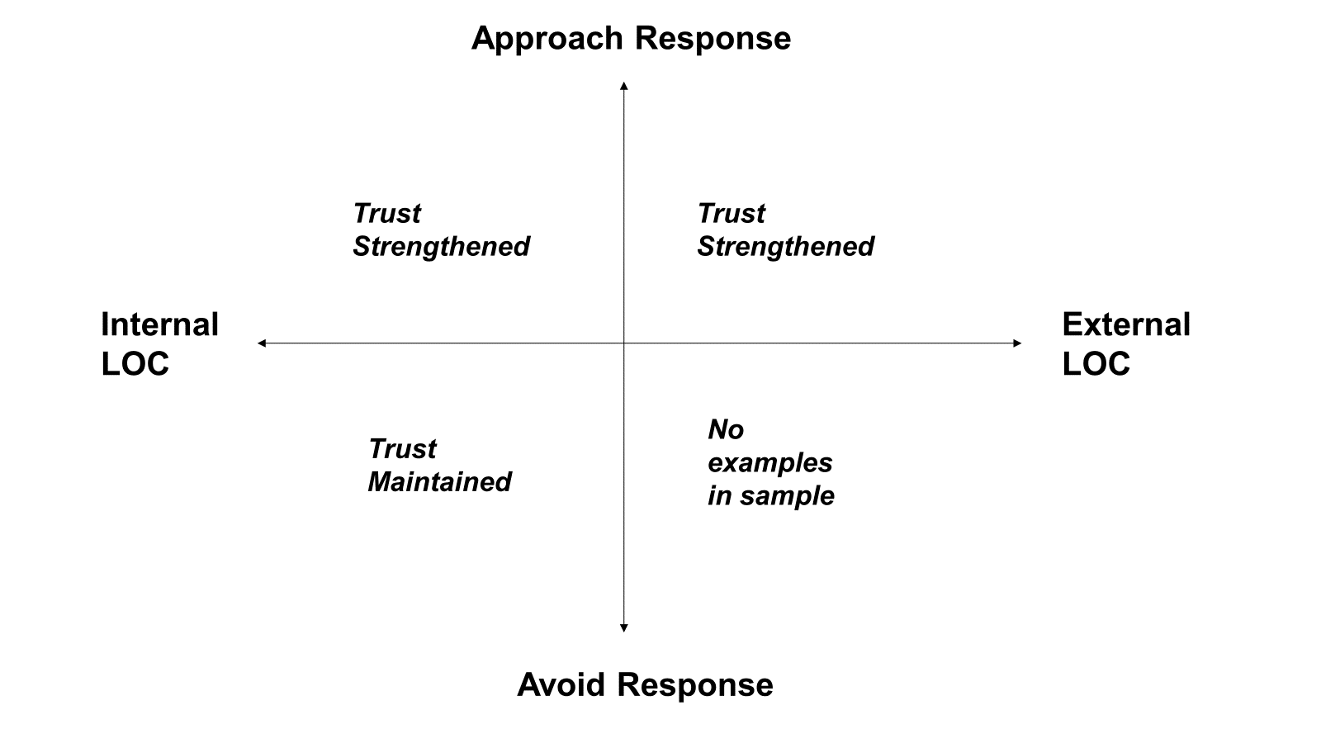
Figure 5.3 Mapping of Trust Outcome Patterns

Trusting relationship maintained. For ILOC relational threats, the blame for causing the threat was attributed to a party within the dyad. For responsible parties, their response afforded them an opportunity to avoid a loss of trust by engaging in the appropriate maintenance strategies. Responsible parties were readily willing to acknowledge the role they played in causing the threat and work with their counterpart to overcome the relational threat. For example, in Dyad 19, the manager reflected on her role in delaying her counterpart’s project by not doing the work he had assigned her when going on leave:
I suppose as soon as he was back from holidays it was like welcome back, none of that stuff is done…I know he was probably a bit pissed off because he will be the face of this project so I can totally understand that. (M19)

In this case, her counterpart acknowledged the value of her explaining the work he assigned to her had “turned into a bigger project than we thought it was so that's why it's not done”, noting he “would have been so much more angry about it but because she was reasonable about it like okay push that deadline, get it out as soon as you can” (E19). Hence, acceptance of blame, coupled with engagement in trust maintenance strategies, supported the dyads to work through and overcome the relational threat that threatened to destabilize their trusting relationships.

Trusting relationships strengthened. The data points to two explanations for the experience of a relational threat strengthening dyads trusting relationships. First, relational threats served as an opportunity to demonstrate to one another how they handle such disruptions and provided new information about “who people really are when their backs against the wall” (E17). For example, Dyad 11 talked about their experience of adapting to working together during the COVID-19 pandemic. From both perspectives, they felt this was handled well, with the manager referring to this as a “period of building the trust, because you need to set up some new process. And we're doing it together” (M11). This was reinforced by the employee reflecting that “the trust only has grown from it, because it was such a thing that …a very intense situation that we both came together and worked as a team” (E11). The new information made available via the experience of a relational threat also provided them with assurance about their trusting relationships’ resilience to future threats. As highlighted by the employee noting “if one of these situations were to come up again, I know we both have each other’s back, and we could do it again because that one was extremely stressful” (E11).

Second, dyads who strengthened their trusting relationships described a sense of shared emotion and vulnerability to a relational threat. For example, one dyad talked about experiencing “shared adversity” when their organization was being bought over and both parties were “frustrated by the same thing” (M13). Despite feeling that they were “both in the bunker” the dyad reported a shared sense of “camaraderie” (M13). Therefore, despite dyads being faced with relational threats that were often associated with avoidance emotions, dyads experienced these as a shared experience that served to strengthen their trust. Another dyad reflected how experiencing a challenging period of time within their team strengthened their trusting relationship. The manager rationalized that they have “gotten closer with all the things that have happened and like facing the challenge in the team has gelled us a lot more” (M21). Her counterpart speculated that their shared emotion and her vulnerability was the reason for their trusting relationship strengthening:
I think actually it built our trust more because I understood more where she was coming from and maybe she saw a or more vulnerable side to me…it's nice in a relationship when you have both see each other like feel upset or feel stressed out, you know those things like it does make you feel closer (E21).

Chapter Six
Discussion and Conclusions

Discussion and Conclusions

6.1 Chapter Outline
This chapter situates the research findings in the context of the extant literature. It begins by illustrating how the findings address the research questions set out in the introduction chapter. Following this, the overall research contributions are discussed. These include contributions to theory, as well as implications for practice. Next, the limitations of the research are outlined and an agenda for future research is set out. The chapter ends with a short conclusion to the overall research presented in this thesis.

6.2 Discussion of Research Questions
The objective of this research was to explore the active and relational nature of interpersonal trust in manager-employee dyads across trust development and trust maintenance processes. Building on this objective, the research set out to address one overarching research question - how do managers and employees, individually and relationally, support the development and maintenance of trusting relationships - and four sub-questions (see Figure 6.1). The key findings will be discussed in relation to each of these research sub-questions.

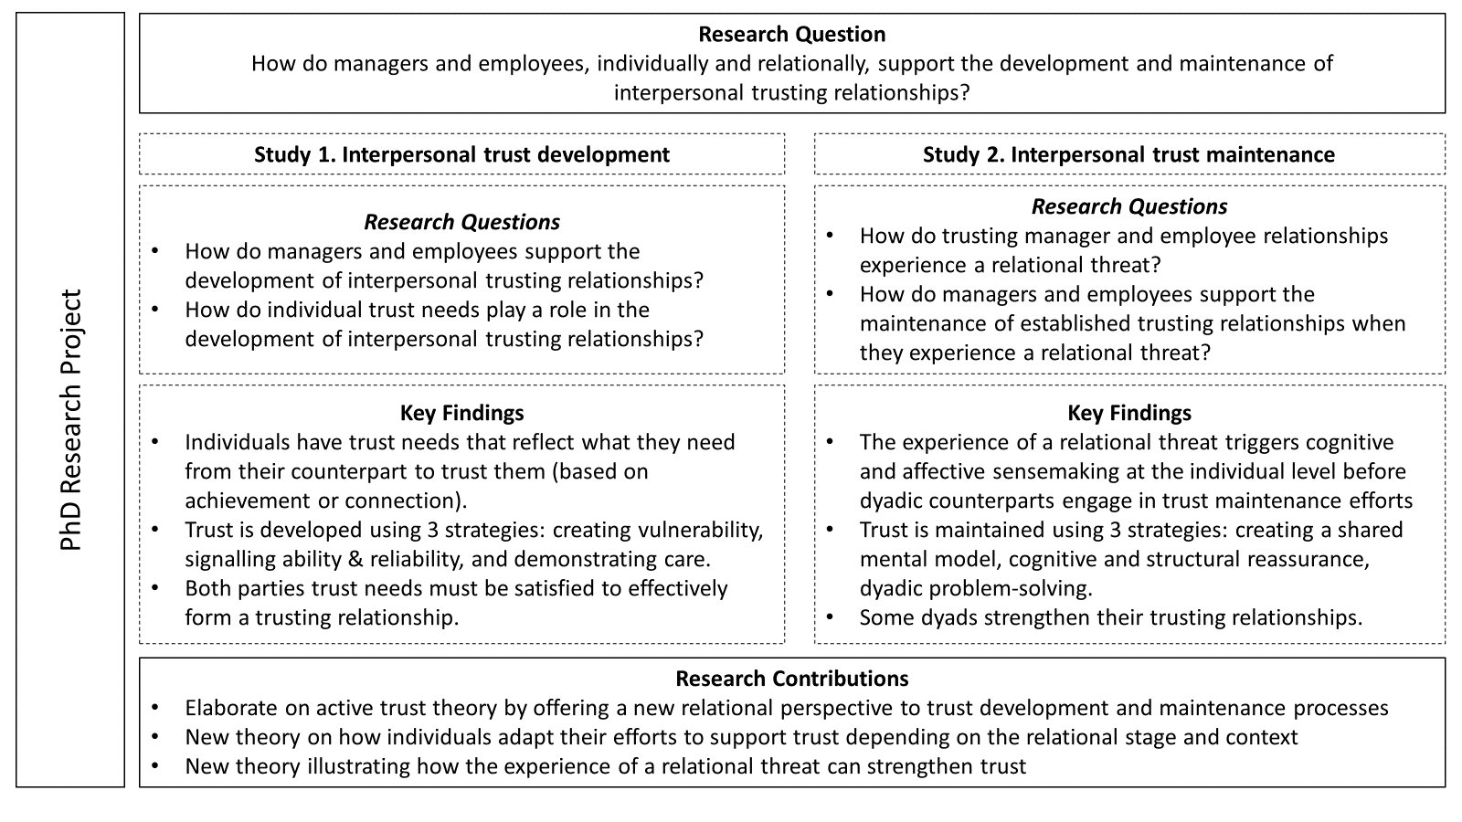
Figure 6.1 Mapping of Key Findings and Research Contributions to Research Questions

6.2.1 How do managers and employees support the development of interpersonal trusting relationships?

The findings demonstrate that both managers and employees relied on three overarching trust development strategies: creating vulnerability, signaling ability and reliability, and demonstrating care. Signaling ability and demonstrating care are somewhat unsurprising findings given the salience of ability, benevolence, and integrity to trustworthiness (Mayer et al., 1995). Further, existing research has demonstrated that individuals can proactively signal these trustworthiness cues to encourage others to trust them, as opposed to waiting for these to be passively observed (e.g., Hughes & Saunders, 2021; Long, 2018). Interestingly, the behavioral element of integrity – which centers on being reliable and following through on your word (see Tomlinson et al., 2014) – was evident in the findings but integrity - as described by Mayer and colleagues (1995) as value congruence – was rarely something that participants mentioned. A possible explanation for this is the time it takes to understand another’s values, meaning it is not something that individuals can necessarily gauge or act on in the early developmental stage of their relationship - as well as it being potentially challenging to signal value congruence. Regardless, this nuanced finding about integrity was surprising - particularly as research has shown integrity to be a strong predictor of trust in leaders (Colquitt et al., 2007; Moore et al., 2023).

That said, other empirical work has also demonstrated integrity to have unexpected patterns of influence on trust. For example, research on new relationships found integrity to be a less important cue for trust decisions than other personal trust cues, i.e., ability and benevolence (van der Werff & Buckley, 2017). Further, when separated from behavioral integrity, Tomlinson and colleagues (2020) found value congruence was not the most important trustworthiness factor for cultivating trust (Tomlinson et al., 2020). Instead, ability and behavioral integrity were the most important in the context of cognitive-based trust and benevolence was the most important for affective-based trust. This indicates that the results of the present research are consistent with scholarly work, such that strategies related to benevolence, ability, and behavioral integrity (captured in the present study as part of the signaling ability and reliability strategy) were found to be more salient than value-congruence when forming trusting relationships.

The findings also highlight the active creation of vulnerability as a strategy that dyads used to build trusting relationships. Specifically, trustees made themselves vulnerable by engaging in certain trust development actions, e.g., sharing personal information and acknowledging mistakes with their counterparts, as a means to support the development of trust. This sense of active vulnerability (see Nienaber et al., 2015) puts the trustee in a more vulnerable position because the trustor could use the information to exploit them (Jeong et al., 2020). However, participants shared that their counterpart’s openness and vulnerability helped them feel more connected to them and trust them - comparable to the pattern of iterative influence described in reciprocal trust (Korsgaard et al., 2015). Therefore, the findings suggest that vulnerability can be actively created by trustees as a means to build trusting relationships. This finding aligns with the portrayal of vulnerability in the field of sociology as a source of connection (Brown, 2015). That said, this finding was still unexpected as trust scholars have mostly theorized about vulnerability from the trustor perspective (e.g., Möllering, 2006; Nienaber et al., 2015; van der Werff et al., 2019). Moreover, vulnerability is often talked about with negative connotations, such that a trustor must demonstrate a willingness to be vulnerable (Mayer et al., 1995), accept vulnerability (Rousseau et al., 1998), or take a leap of faith (Giddens, 1991; Lewis & Weigert, 1985). Although there is also some risk attached to trustees' active creation of vulnerability to build trust, overall, this differs from a trustor’s subjective experience of vulnerability and represents a novel finding in terms of what we know about how managers and employees proactively form trusting relationships.

Another interesting finding about how managers and employees proactively form trusting relationships is that both groups rely on the same overarching strategies but enact these using different trust development actions. As previous work has focused explicitly on managers' active efforts to build trust without accounting for employee actions (e.g., Hughes & Saunders, 2021; Long, 2018; Six et al., 2010), this pattern of difference across the two groups has not been identified. For example, the findings indicate that both groups demonstrated they care about their counterparts as a way to build trust, but managers did so by providing emotional and/or development support, while employees offered their managers help with work tasks. Given the context of manager and employee relationships, these differences are potentially due to their different roles and the expectations attached to these. For example, managers' expectations of employees are mostly based on their work efforts, whereas managers are responsible for supporting employees more broadly (e.g., work assignments, pay, promotion) (Dirks, 2006). Relatedly, the sense of authority a manager has over an employee's career implies a power imbalance between the two groups (Brower et al., 2000) that likely makes some trust development actions less appropriate or likely for employees to enact e.g., developmental support or emotional support. It is important to note that there was also some crossover in how managers and employees enacted the strategies. For example, both groups showed an interest in their counterpart's life as a way of demonstrating they care (these similarities and differences are illustrated in more detail in Chapter 4).

Overall, these findings offer a detailed response to the question of how managers and employees support the development of trust. However, as is often the case when dealing with interpersonal phenomena there are nuances and individual differences at play that need to be accounted for. As detailed in Chapter 3, it became clear during the early stages of data analysis that the trust development actions did not work in a one-size-fits-all manner across all dyads, and this motivated the inclusion of another research question that aimed to unpack these differences.

6.2.2 How do individual trust needs play a role in the development of interpersonal trusting relationships?

The findings demonstrate that differences exist in what individuals need from their counterparts to trust them. Specifically, individuals’ trust needs were centered on either connection or achievement, meaning that their counterpart gained their trust by doing things that supported them to feel connected to them or that supported them to achieve work-related goals, e.g., performance or development. This explains why actions that supported trust to develop in some dyads did not have the same outcome for others and vice versa. While a logical finding, this was also surprising as existing literature mostly depicts proactive efforts to build trust to be effective for all members of a group, e.g., managers (Child & Möllering, 2003; Long, 2018; Six et al., 2010). Further, preferences in what individuals look for in a counterpart are often attributed to their role, e.g., a preference for high-integrity managers (Moore et al., 2023), as opposed to individual differences. The findings suggest that individuals’ trust needs were somewhat influenced by group-level factors such as their role, given that achievement-based needs were more common for managers and connection-based needs were more common for employees. However, differences also existed at the individual level as individuals from either group were found to have achievement-based or connection-based trust needs, regardless of their role.

This finding also taps into the idea that individuals are motivated to trust others because of the function(s) of the relationship, i.e., how the relationship satisfies their intrinsic or extrinsic needs (van der Werff et al., 2019). Specifically, an individual's trust needs can be viewed as drivers of trust such that people are motivated to trust others that satisfy their achievement-based or connection-based trust needs. These findings align with drivers of behavior put forward by the dominant motivation frameworks, e.g., relatedness, autonomy, and competence (Ryan & Deci, 2000); affiliation, power, and achievement (McClelland, 1971). In this sense, connection-based trust needs can be viewed as an intrinsic driver of trust, such that individuals are intrinsically motivated to develop a trusting relationship because they satisfy their desire to feel connected to their counterpart. On the other hand, achievement-based trust needs may be closer to an autonomous extrinsic motivation given that they reflect a more instrumental goal that is not just about the relationships (van der Werff et al., 2019)., e.g., an achievement-based goal that reflects individuals desire to develop. It is important to note that trust needs are anticipated to coexist alongside other motivational drivers relevant to managers and employees, such as their affective attachment (Williams, 2001) and dependence (Webber et al., 2004). In any case, the findings relating to trust needs empirically support the idea that individuals are motivated to trust because the relationship can satisfy functions that are important to them. This suggests that one of the ways that trust needs play a role in the development of trusting relationships is through motivational processes that drive individuals to trust.

At the relational level, the findings illustrate the importance of each party’s efforts to build trust by satisfying their counterpart’s trust needs, i.e., trust need satisfaction. In the absence of trust need satisfaction, the development of a trusting relationship is inhibited, whereas when both party’s trust needs are satisfied, they will effectively form a trusting relationship. The lack of dyadic research has meant that such relational factors have mostly been overlooked (Korsgaard et al., 2015), despite their ability to provide integral insights into interpersonal trust development. For example, without its dyadic lens, the present research would have uncovered the trust development strategies and actions used by each group and (wrongly) assumed that these would be effective for all managers and employees to build trusting relationships. Therefore, by addressing the second research question, the individual and relational factors that influence trust formation are considered and the research offers a more complete understanding of interpersonal trust development. Specifically, the findings show that each party in a manager-employee dyad has their own trust needs (that can be either aligned or misaligned) and both party’s trust needs must be satisfied to effectively form a trusting relationship.

6.2.3 How do trusting manager and employee relationships experience a relational threat?

The findings show that the experience of a relational threat triggered cognitive and affective sensemaking. This occurred at the individual level, where each party in the dyad made sense of who they thought was to blame for the threat, i.e., the locus of causality (LOC) (Weiner, 1985), and how the threat made them feel. This attribution process is somewhat comparable to a trustor determining the LOC of a trust-violating event (e.g., Kim et al., 2009; Tomlinson & Mayer, 2009). However, in the case of a violation, a trustor’s (specific) emotional reaction is determined by their cognitive evaluation of the negative outcome, i.e., anger in the case of a violation perceived to have been within the trustee’s control and fear in reaction to violating events that are likely to reoccur (Tomlinson & Mayer, 2009). In the context of trust maintenance, cognitive sensemaking did not determine how individuals felt in response to a relational threat, instead, these sensemaking processes (cognitive and affective) happened simultaneously and, together, had important implications for how dyads dealt with relational threats. Namely, if a threat was determined to have an internal LOC, i.e., attributed to a party within the dyad, counterparts were more likely to initially pull away from one another and engage in further sensemaking, compared to an external LOC, where counterparts came together and faced the threat relationally. However, this was not always the case, and some dyads who experienced relational threats attributed to an internal LOC came together to face the threat relationally, suggesting how the relational threats made individuals feel also influenced how they were experienced.

The findings indicate that a combination of individuals' assessment of the LOC and their emotional reaction to the threat can explain their emotionally triggered response, i.e., approach or avoidance. For example, recognizing the external LOC of a relational threat helped explain why some individuals had an approach response despite feeling frustrated. This sense of coming together to deal with a shared external threat aligns with existing research that shows that a common enemy or threat can have a unifying effect (Flade et al., 2019). Interestingly, the findings also show that some individuals who experienced an internal LOC threat and felt upset had an approach response. This was a surprising observation as the experience of a relational threat caused by a party within the dyad that induced a negative emotion would more logically lead to an avoidance response. In contrast, the findings suggest that, depending on their emotional reaction to the threat, individuals can either have avoidance or approach responses to threats attributed to an internal LOC. Building on previous work that considers the social function of emotions (e.g., Methot et al., 2017; van Kleef, 2009), the emotional responses were determined to be a reflection of whether the threat made individuals feel closer to their counterpart (leading to an approach response) or further from them (leading to an avoidance response). This explains why individuals had different emotionally triggered responses to feeling upset (approach-oriented emotion) versus feeling frustrated (avoidance-oriented emotion) when the threats experienced were both attributed to an internal LOC.

As noted, when individuals had an initial avoidance response, they engaged in further sensemaking before coming back together to work with their counterpart to overcome the threat, whereas those who approached fast-tracked to working together to overcome the threat relationally. The experience of a relational threat triggering sensemaking at the individual level was not surprising as this is a common response to a negative event or relational experience (Weick, 1995) and aligns with the attribution process triggered by a trust breach or violation (Kim et al., 2009; Tomlinson & Mayer, 2009). However, some individuals engaging in prolonged sensemaking (beyond determining who was to blame and how the threat made them feel) was a surprising finding. That said, the individuals in question had an avoidance response meaning they had experienced a threat attributed to a party within the dyad and felt an avoidance-oriented emotion (most commonly frustrated), hence needing to further reflect on and make sense of the threat is understandable. The findings suggest that individuals used this time to think about how they would move forward with their counterparts, implying that sensemaking was more about how the threat could be overcome compared with the earlier sensemaking that focused on who was to blame and how the threat made them feel.

6.2.4 How do managers and employees support the maintenance of established trusting relationships when they experience a relational threat?

The findings demonstrate that dyads used three active trust maintenance strategies: creating a shared mental model, cognitive and structural reassurance, and dyadic problem-solving. The first step for all dyads was to create a shared mental model. This was achieved by dyads engaging in open dialogue, perspective-taking, dyadic sensemaking, and emotional expression. Importantly, these represent the most common behaviors used across the sample to create a shared mental model, as opposed to all dyads engaging in all four behaviors. Creating a shared mental model represents quite a logical first step in overcoming any kind of disruption to a trusting relationship and is often an outcome associated with collective sensemaking (Weick & Roberts, 1993), hence was not an unexpected finding. Moreover, this aligns with existing theorizing about interpersonal trust maintenance that suggests that individuals use interpersonal sensemaking and perspective-taking as initial strategies to determine how they should approach trust maintenance (Williams & Belkin, 2016). Once dyads had created a shared mental model, depending on their experience of the relational threat, they either engaged in cognitive and structural reassurance or dyadic problem-solving. Overall, the strategies have emotional, cognitive, and behavioral elements comparable to the empirically derived strategies Gustafsson and colleagues (2021) found to maintain inter-organizational trust. However, the distinction between the follow-on strategies dyads used after creating a shared mental model was not anticipated, as existing research depicts the same set of strategies to support trust maintenance (e.g., Gustafsson et al., 2021).

The findings suggest that the difference in trust maintenance strategies used by dyads can be explained by the LOC of the threat. Specifically, if a dyad experiences an internal LOC threat, they are most likely to engage in cognitive and structural reassurance following the creation of a shared mental model. Whereas if a dyad experiences an external LOC threat, they are most likely to follow creating a shared mental model with dyadic problem-solving. This differentiation relates to the extent to which these strategies operate by creating protection against future threats (internal LOC) versus working together towards a resolution to the relational threat at hand (external LOC). Cognitive and structural reassurance involved cognitive reframing, resetting expectations, and updating ways of working. These behaviors allowed dyads to shift their thinking about the relational threat and make changes to how they work together, in relation to what caused the threat, to avoid the same thing causing a future threat to their trusting relationship. For example, if a dyad disagreed about how a certain work situation was handled, they could reframe their thinking to focus on what they learned from the experience and update their process to deal with similar situations in the future. This resolution is appropriate in the context of internal LOC threats because the threat is attributed to a party within the dyad. This implies that the party who is not responsible for causing the threat must shift their thinking or expectations so that they can move forward and feel confident that the relational threat will not reoccur.

For dyads who experience an external LOC threat i.e., attributed to someone or something outside the relationship, they focused on working together to overcome the disruption. Once dyads created a shared mental model of the threat, they engaged in dyadic problem-solving which involved brainstorming solutions and seeking third-party support. For the most part, dyadic counterparts were able to work together to come up with solutions to overcome the threat to their relationships but in some cases, they needed the support of others outside the relationships to do so, e.g., seeking advice from a colleague or intervention from the human resources department. Therefore, in response to the question of how managers and employees support the maintenance of trust when they experience a relational threat, they used the three aforementioned strategies - creating a shared mental model, cognitive and structural reassurance, and dyadic problem-solving - however, the type of threat experienced influenced what strategies were used.

6.3 Research Contributions
The present research aims to explain interpersonal phenomena by generating new theory and elaborating on existing theory. This reflects the ideas from two frameworks that outline how scholars can contribute theoretically. Specifically, Colquitt and Zapata-Phelan (2007) delineate between theory testing and theory building as types of contributions. Building on this, Fisher and Aguinis (2017) added theory elaboration as another way researchers can make a valuable theoretical contribution without necessarily generating new theory. In line with the qualitative nature of the present research, the theoretical contributions will be mapped to theory generation or theory elaboration (see Table 6.1).

Table 6.1 Overview of Theoretical Contributions
Overarching Research Contribution | Theory Elaboration | Theory Generation
Contributes to a growing body of literature that reframes trust as an active process | Elaborates on existing active trust theory by contributing a relational perspective to how trusting relationships can be proactively developed and maintained  Elaborates on existing active trust theory by demonstrating that managers and employees enact trust development strategies using different actions  Elaborates on existing trust maintenance theory by delineating the strategies that are more fitting to deal with different types of relational threats | Generates new theory on interpersonal trust maintenance, including the role of attribution & emotion
Contributes new theory outlining how dyads’ ongoing efforts should be adapted to align with the relationship stage and the relational context | Elaborates on existing theorizing that reflects the changing nature of trust by illustrating dyads' adaptive efforts across different stages of their relationship  Elaborates on existing theory that portrays contextual features to influence trust by highlighting the influence of the relational context | Generates new theory that illustrates individual’s trust-building efforts must satisfy their counterpart's trust needs to effectively develop trusting relationships
Contributes new theory that illustrates for some established trusting relationships, depending on the party's active response, the experience of a relational threat can strengthen trust | Elaborates on existing theory that depicts salient experiences and events that lend new information to positively impact relationships | Generates new theory that illustrates that experiencing a relational threat with a sense of shared vulnerability can strengthen trusting relationships

Beyond theory, outlining how research contributes to practice is also an important task for researchers. Yet, there is still a disconnect between theory and practice. In a recent review, Dello Russo and colleagues (2023) voice concerns about the actionability of practical implications included in research articles (if they are included at all). Specifically, the authors highlight that they lack the specificity that makes them genuinely useful and easy for practitioners to implement (Dello Russo et al., 2023). With this in mind, this research will aim to translate its findings into actionable, practical contributions. The contributions this research makes to theory and practice are set out in the following sections. First, the theoretical contributions of each study will be outlined, followed by the overall contributions of the thesis to theory and practice.

6.3.1 Study 1 Theoretical Contributions

The first empirical study set out in this thesis makes three key contributions to theory. First, I elaborate on existing theory by introducing trust needs as a new construct (Fisher & Anguis, 2017). I conceptualize these as individual-level differences that represent what each party needs from their counterpart to trust them - grouped as achievement-based and connection-based trust needs. This constitutes a shift in thinking from seminal research that portrays one party as trusting another based on a general perception of their trustworthiness (Mayer et al., 1995), to a more nuanced understanding of idiosyncrasies related to trust formation. In this regard, I extend work by Baer and colleagues (2021) who found individual differences in how much trust is wanted by exhibiting that qualitative differences in what individuals want from their counterparts also exist. Specifically, I theorize that individuals have trust needs that are based on their desire for achievement or connection and that these can be aligned or misaligned with their dyadic counterpart’s needs. This fits with the idea that counterparts can have asymmetrical levels of trust (Korsgaard et al., 2015) by showing that counterpart’s trust for one another can be based on different elements and still have functioning trusting relationships. That said, alignment in trust needs supported dyads to develop trusting relationships more readily, which supports early theorizing that individuals are more likely to trust those whom they perceive as similar to them (McAllister, 1995; Whitener et al. 1998; Williams, 2001).

The construct of trust needs builds on a stream of research that challenges the assumption that all parties uniformly attend to the same characteristics when forming trusting relationships. For example, existing research shows that individuals have a preference for integrity in counterparts when working in high-reliability task contexts (Colquitt et al., 2011), and for either benevolent or high-integrity counterparts depending on key relational features (i.e., group size, emotional closeness, and hierarchy) (Moore et al., 2023). While this research offers great advances to our understanding of differences in preferences for counterpart characteristics, as well as the features that influence them, the findings point to a more generalized consensus in preferences and overlook subtleties at the individual level. I capture these by showing that individuals, regardless of whether they are managers or employees, have expectations of their counterpart that are shaped by their achievement-based or connection-based trust needs. This builds on existing theorizing by illustrating that these needs are shaped by both individual differences (Baer et al., 2021) and external factors (Colquitt et al., 2011).

Second, beyond introducing the construct of trust needs, I contribute to the trust literature by illustrating the role trust need satisfaction plays in trust development. Specifically, I offer new theory that shows that for dyads to form trusting relationships effectively, each party’s trust needs must be satisfied by their dyadic counterpart’s trust development actions and the absence of trust need satisfaction inhibits the formation of trust. This builds on recent empirical evidence demonstrating the value of attending to an individual's preference for how much trust they receive (Baer et al., 2021) and their counterpart's characteristics (Moore et al., 2023) in forming effective working relationships. I extend this research by illustrating how trust need satisfaction supports the development of trusting relationships. I use a matrix to illustrate how specific trust development actions can satisfy counterparts’ achievement-based or connection-based trust needs in favor of trust formation, as well as to show how some individuals efforts to build trust can be misaligned with their counterpart’s trust needs and inhibit trust development. In this regard, I also contribute a more relational perspective to active trust development that considers each party’s trust needs and efforts to build trust, as well as how these interact at a dyadic level. This responds to calls from trust scholars to consider each party’s trust and how this comes together relationally when trying to access dyadic trust (Jones & Shah, 2016; Korsgaard et al., 2015). Therefore, the dyadic approach enables me to contribute a novel perspective to interpersonal trust development that simultaneously highlights the influence of each party’s idiosyncrasies, as well as their relational interdependencies, on trust formation.

Building on this, I also illustrate that alignment in dyadic counterparts' trust needs can support them in developing trusting relationships more readily. Counterparts with the same needs could recognize the same things were important to them, and, therefore, identify with one another's needs and develop identification-based trust (Lewicki & Bunker, 1996). In this sense, I offer empirical support for Lewicki and Bunker’s (1996) theorizing by showing that interpersonal trust can develop based on dyadic counterparts' knowledge of the other's behavior, i.e., that their trust development efforts can satisfy one another’s needs, and, in some cases, based on their counterpart’s ability to identify with one another’s needs. Based on this, I theorize that dyads with aligned trust needs can develop trusting relationships more readily because these two bases or mechanisms simultaneously support the development of trust. This also supports early theorizing that individuals are more willing to trust those they perceive as similar to them or those in their “in-group” (McAllister, 1995; Whitener et al. 1998; Williams, 2001). Overall, I contribute to trust theory by outlining that trust need satisfaction can support the development of interpersonal trusting relationships in dyads with either aligned or misaligned trust needs, however, alignment in needs acts as another mechanism that enables dyads to develop trust more readily.

Third, I contribute to a growing body of literature that reframes trusting as a more active process by providing empirical evidence of managers' and employees' intentional efforts to build trust. This extends existing research that offers insights into how managers actively support trust development (Child & Möllering, 2003; Hughes & Saunders, 2021; Long, 2018; Six et al., 2010) by also contributing trust development actions used by employees. Moreover, I demonstrate that managers and employees rely on the same overarching trust development strategies to gain their counterparts' trust but enact these using different trust development actions. This elaborates on active trust theory by highlighting variations in how different populations can proactively support trust development. By taking an exploratory approach to understanding parties' intentional efforts to build trusting relationships, I highlight the active creation of vulnerability as a novel way to proactively build trust. In comparison to vulnerability being conceptualized from the trustor perspective, e.g., via risk-taking behaviours or a leap of faith (e.g., Mayer et al., 1995; Möllering, 2001, 2006), this portrays trustees acting in a way that creates a sense of vulnerability as a means to support trust development. This adds to a small but growing stream of literature that depicts vulnerability to foster connection (e.g., Brown, 2015; Johansson & Wickström, 2023). At the same time, this extends theorizing by Nienaber and colleagues (2015) on active vulnerability by showing this can be conceptualized beyond disclosure and can be enacted via multiple trust development actions that vary across different groups.

6.3.2 Study 2 Theoretical Contributions

The second empirical study set out in this thesis makes four important contributions to theory. First, I contribute to trust theory by illustrating how relational threats can be harnessed to strengthen manager-employee trusting relationships. To date, the dominant focus has been on how negative relational experiences undermine trust and how this can be restored (for review see Sharma et al. 2023), or most recently on how trust can be preserved or maintained (Gustafsson et al., 2021; Weibel et al. 2023). My observations (unexpectedly) revealed navigating a relational threat served to strengthen many of the dyads’ trusting relationships. I suggest this strengthening occurs because new information becomes available to dyads when relational threats disrupt the rhythms of a trusting relationship (Korsgaard et al., 2018) and triggers dyads to look for new ways of trusting (Mollering, 2013). This shift in their usual way of doing things lends the opportunity for individuals to discern how their relational counterparts respond in such instances. Indeed, Ballinger and Rockmann (2010) suggest certain anchoring events can cause a durable positive or negative change in organizational relationships because they override an individual's heuristic about their counterpart. For example, trust violation events can override initial trustworthiness assessments with new perceptions, impacting future trusting behavior (Campagna et al., 2022). Hence, when trusting dyads successfully navigate a relational threat, they acquire new information about their counterpart and about the resilience of their trusting relationship that replaced their existing trust belief (heuristic) and strengthened their trusting relationship.

A further explanation is that dyads experience a relational threat as a shared experience, characterized by shared vulnerability. This was particularly salient for ELOC dyads as both individuals were in a position of (shared) vulnerability to an external threat. For such dyads, the counterpart’s volitional will to be vulnerable to one another remains (van der Werff et al., 2019), but vulnerability also becomes a contextual feature of the environment their relationship is operating in and something that is experienced together. In such cases, the independent roles of trustee and trustor appeared less relevant as both parties acted with mutual agency to overcome the threat. I extend Misztal (2012) and Weibel and colleagues’ (2023) theorizing on vulnerability by demonstrating dyads experienced vulnerability relationally and I argue it is this sense of shared vulnerability that serves to strengthen the bond. Importantly, despite an ILOC relational threat initially triggering a sense of heightened vulnerability for one party, those who opt to share their feelings are engaging in active vulnerability (Nienaber et al., 2015) and providing a platform for reciprocal vulnerability. This shifts the vulnerability from being more salient for one party to being shared and experienced relationally. Taken together, these insights represent a useful extension as, despite acknowledging vulnerability as a relational construct, scholarship has mostly conceptualized it as experienced by the trustor or trustee individually (Nienaber et al., 2015). Finally, the observations of both contextual vulnerability and active vulnerability also add value to the ongoing debate of whether vulnerability is an existential condition or a deliberate decision (Schafheitle et al., 2023).

The second contribution is an empirically derived model of interpersonal trust maintenance. This is the first of its kind and represents an important addition to the trust literature - particularly given the challenges in applying insights drawn from one conceptual level of trusting to another (Fulmer & Gelfand, 2012). I put forward a model that portrays interpersonal trust maintenance to occur at multiple conceptual levels (see Figure 5.2). Specifically, I illustrate that individual parties each make a subjective assessment of the relational threat, while working towards a solution via the use of trust maintenance strategies unfolds at the dyadic level. Such insight to the multi-faceted nature of trust maintenance extends previous research which has primarily focused on the strategies trustees can adopt to avoid a loss of their counterpart’s trust (Gustafsson et al., 2021, Weibel et al., 2023, Williams & Belkin, 2016).

In comparison to the strategies put forward in previous work, I see both similarities and differences to the trust maintenance strategies in my model (i.e., creating a shared mental model, cognitive and structural reassurance, and dyadic problem-solving). For example, dyads initially creating a shared mental model before using one or other follow-on strategy aligns with the idea that individuals use interpersonal sensemaking and perspective-taking to determine how they should approach trust maintenance (Williams & Belkin, 2016). The overall strategies also have an emotional, cognitive, and behavioral basis comparable to those in Gustafsson and colleagues (2021) trust preservation model. However, by way of difference, I delineate strategies that dyads were more likely to use depending on the type of relational threat they were facing. Based on these observations, I contend that cognitive strategies that shift dyads’ way of thinking about threats may be more fitting for ILOC threats, while behavioral solution-focused strategies may be more fitting for ELOC threats. This builds on recent theorizing by Weibel and colleagues (2023) that positions certain strategies best to deal with specific core trust issues and types of vulnerability (differentiating between symbolic and substantive strategies). Compared to maintaining trust in an organization, where such symbolic strategies that serve visionary purposes are fitting (e.g., Gustafsson et al., 2021, Weibel et al., 2023), interpersonal maintenance strictly involved the use of tangible strategies geared towards overcoming the relational threat (i.e., substantive strategies). This difference is likely attributable to the interpersonal lens, wherein interdependent managers and employees are dealing directly with one another to overcome a relational threat that is affecting both parties.

The third contribution is an empirical illustration of the role of attribution and emotions in interpersonal trust maintenance. While Weiner’s (1986) causality attribution theory has advanced our understanding of trust development and repair (e.g., Kim et al., 2009; Korsgaard et al., 2018; Tomlinson & Mayer, 2009), the present research represents its first application in the trust maintenance literature. In trust development and repair, the attribution process enables individuals to make sense of the factors that caused a specific outcome and shift attribution towards or away from their counterpart in favor of trust development or repair (Korsgaard et al. 2018; Tomlinson & Mayer, 2009). In the context of trust maintenance, individuals' assessment of the LOC formed part of the overall sensemaking process, triggered by the experience of a relational threat. This assessment is functional, such that it delineates the appropriate active trust maintenance strategies for dyads to overcome the relational threat - extending the relevance of the assessment beyond just assigning blame. Further, both parties in trusting relationships assessed the LOC, which deviates from previous trust scholars' portrayal of this as unidirectional (Tomlinson & Mayer, 2009).

This research also adds valuable insight into the role of emotion in the trust maintenance process. As noted, in the case of ILOC relational threats, individuals either had an approach or avoidance emotionally triggered response following their assessment of the threat. This meant the LOC assessment itself was not enough to explain these responses and it was important to also consider the role of emotions. Further, the patterns I found in the data were more nuanced than whether emotions were positive or negative (Lerner et al., 2015). For example, reports of different negative emotions, such as upset or anger, had different responses. By applying learnings from the social-functional theory of emotions (van Kleef, 2009), I interpreted that the function of the emotion individuals felt in reaction to the relational threat determined their emotionally triggered response, as opposed to it being positive or negative. Specifically, emotions serve an interpersonal function of either making one feel further from a counterpart (avoidance, e.g., angry) or closer to them (approach, e.g., upset) (Methot et al., 2017). This enabled me to make sense of the intricacies of emotional responses individuals reported and simultaneously address a call for research studying emotion and trust to look beyond general positive and negative affect (Lee et al., 2023).

Interestingly, findings that support dyads pulling away in response to avoidance emotions go against recent appraisal theories of emotion that indicate anger relates to approach motivational tendencies (for a review see Carver & Harmon-Jones, 2009). In this view, anger arises when movement toward a desired goal is blocked, and this motivates efforts to reopen the path to the desired goal (Frijda, 1986). While this was not the immediate response observed in dyads in the present research, it is important to note that the avoidance responses were temporary, such that counterparts initially pulled away before engaging in maintenance strategies to overcome the threat to their relationship. The comparative experience of dyadic counterparts who felt upset and approached one another without delay suggests that threats that evoke anger-based emotions take individuals longer to make sense of. Therefore, the findings provide important insight into when and why emotionally triggered responses to negative relational events may be more nuanced than current emotions theory depicts. Aside from participants emotionally triggered responses, emotional expression supported some dyads to create a shared mental model of the threat, while the experience of shared emotion partially explains some dyads strengthening their trusting relationships. Therefore, the role of emotion is thoroughly reflected throughout the trust maintenance process, addressing recent criticism of its absence in trust literature (Dirks & De Jong 2022).
Finally, insights on how negative relational experiences can be overcome also contribute to the conflict management and negotiation literature. For example, it adds to a stream of literature that challenges the long-held assumption that intra-group conflict occurs primarily at the team level (e.g., Humphrey et al., 2017; Shah et al., 2021). Further, by eliciting detailed accounts from dyadic counterparts about their experiences of relational conflict, the findings support recent theorizing that conflict has different origins and evolutionary trajectories (Shah et al., 2021). Specifically, participants in this research shared experiences of conflict that originated from internal and external sources and, depending on how individuals made sense of this and the strategies they enacted to overcome it, reported different outcomes for their relationship. In this regard, the strategies uncovered also offer empirical support for the effectiveness of conflict resolution strategies put forward in previous research, e.g., communication, perspective-taking, and problem-solving (Behfar et al., 2008; Olekalns & Caza, 2024), in resolving relational conflict in addition to task conflict. Moreover, the research builds on recent theorizing on post-threat relationship trajectories that emphasizes the value strategies such as open communication and cognitive reappraisal in returning relationships to a positive trajectory (Olekalns & Caza, 2024) and contribute new insights into the role shared vulnerability plays in determining the trajectory of relationships post-relational threat. The findings may be particularly valuable in the context of negotiation, wherein scholars recognize there is a small window of opportunity following a setback in the negotiation process to redirect the negotiation to a positive trajectory (Olekalns & Smith, 2021). Therefore, by delineating the specific strategies that are appropriate to overcome conflict originating from internal or external sources, the findings provide negotiators with a better chance to capitalize on their window of opportunity.

6.3.1 Contributions to Theory

As a whole, the research presented in this thesis offers three valuable contributions to theory. First, it contributes to a growing body of literature that reframes trust as an active process. Specifically, this research adds empirical insights to each party's efforts to support the development and maintenance of interpersonal trusting relationships. This adds to a promising stream of literature that challenges the notion of trust development (e.g., Child & Möllering, 2003; Hughes & Saunders, 2021; Six et al., 2010; Williams, 2007) or trust maintenance as passive processes (e.g., Gustafsson et al., 2021; Weibel et al., 2023; Williams & Belkin, 2016). Importantly, as insights were elicited from both parties in a trust dyad, each party could simultaneously be treated as a trustee and a trustor, meaning that the strategies put forward reflect what genuinely supported trusting relationships to be developed and maintained (as opposed to strategies elicited from a one-sided account and not verified by trusting counterparts). This builds on a recent approach adopted by trust scholars (e.g., Gustafsson et al., 2021; Hughes & Saunders, 2021) and offers an extension to this work by using insights elicited from both parties to verify their counterparts' efforts. Moreover, the present research extends the conversation from what one party can do to proactively build or maintain trust to how dyadic counterparts can relationally form and, thereafter, safeguard trusting relationships. By considering each party's efforts and how these come together relationally, these findings more accurately represent trust development and maintenance processes at the dyadic level (see Korsgaard et al., 2015). Therefore, the present research contributes a new relational perspective to the active trust literature.

Across both the trust development and trust maintenance processes, the strategies that are fitting to build or maintain trust are delineated. For example, strategies that are aligned to forming trust with certain counterparts (depending on their trust needs) and maintaining trust when dyads face different relational threats (internal versus external locus of causality) are outlined. This extends previous research which mostly depicts a set of strategies that can be used to actively support the development (e.g., Child & Möllering, 2003) or maintenance of trusting relationships (e.g., Gustafsson et al., 2021). One exception to this is recent theorizing by Weibel and colleagues (2023) that positions certain strategies as fitting to deal with specific core trust issues and types of vulnerability. However, the authors focus on how the trustee (employers) can select strategies that fit the core trust issue (as opposed to the relationship) to maintain employee trust in the organization. The present research extends this unidirectional perspective by illustrating how dyadic counterparts overcome relational threats with mutual agency to maintain (or in some cases strengthen) their established trusting relationships. Further, given its focus on interpersonal trust maintenance, this research also elaborates on existing theory by delineating strategies that are more or less fitting to maintain trust at a different conceptual level (Fisher & Aguinis, 2017).

Second, this research contributes new theory outlining how dyads’ ongoing efforts should be adapted to align with the relationship stage and the relational context. As noted, existing research has mostly focused on individuals' proactive efforts to build trusting relationships (Hughes & Saunders, 2021; Long, 2018; Six et al., 2010; Williams, 2007) or (less frequently) to maintain established trusting relationships (Weibel et al., 2023; Williams & Belkin, 2016). The present research offers a meaningful extension to this by tracking dyadic efforts across these core trust processes and evidencing how counterparts adapt their efforts to align with the stage of their relationship. This builds on early theorizing by Luhmann (1979) that stresses the importance of adapting efforts used in the developmental phase of a trusting relationship to reflect its later stage. Specifically, this research illustrates that individuals rely on trust development strategies that showcase their strengths and demonstrate that they care about their counterpart and their willingness to be vulnerable, while maintenance efforts (in the face of relational threats) involve dyadic counterparts coming together to understand and overcome the disruption to their trusting relationship.

In this sense, the efforts are adapted to achieve different trust goals (van der Werff et al., 2019). As dyads shift from one trust goal to another, their efforts also shift from individual efforts simultaneously working towards the same goal, i.e., forming a trusting relationship, to maintenance efforts enacted at the relational level. Previous theoretical discussions of trust recognize a shift in the nature of trust from knowledge-based to identification-based trust (e.g., Lewicki & Bunker, 1996). While they don’t unpack the proactive efforts that support relationships to evolve through these stages, they do portray a shift in thinking about trust from an individual (i.e., your knowledge) to a relational level (i.e., our identification), comparable to how efforts evolve across trust development and maintenance processes. Therefore, this research elaborates on previous theoretical discussions by lending novel empirical insights into dyads' adaptive efforts across different stages of their relationship.

Coupled with the relational stage, this research also illustrates that individual efforts should also be adapted to align with the relational context. Specifically, to develop a trusting relationship effectively, individuals' efforts should satisfy their relational counterpart's achievement-based or connection-based trust needs. Moreover, certain trust development actions that satisfy achievement-based and connection-based trust needs in favor of trust formation are set out. This builds on and extends existing theory that depicts how much trust received should be adapted to meet counterparts' needs (Baer et al., 2021) by also showing that efforts should be adapted to satisfy counterpart's trust needs. This furthers our understanding about how individuals can proactively support trust development by shifting our thinking away from generalized strategies that are suitable in all circumstances toward the idea that strategies should be adapted depending on the specific referent and relational context. By introducing the concept of trust needs, this research also supports a need-based perspective on positive work relationships set out in the relationships literature (e.g., Kahn, 2007; Ragins & Dutton, 2017). For example, existing research on mentoring, which can be an exemplar of a positive work relationship, recognizes that the success of the relationship depends on the capacity of mentors and protégés to meet one another's needs (Ragins & Verbos, 2017). By conceptualizing trust development to occur through the process of trust need satisfaction, the findings support recent theorizing by Ehrhardt and Ragins (2019) that integrates insights from the fit literature, e.g., complementary fit (Muchinsky & Monahan, 1987), to accounts for individual differences in what employees want and receive from their work relationships.

By contextualizing participants’ responses about how they maintain their trusting relationships in a period of uncertainty, theoretical insights are also gained regarding how individuals adapt their efforts to deal with a more uncertain relational context. This builds on existing research that shows uncertainty in the context of the task being completed to influence the salience of certain trustworthiness cues (Colquitt et al., 2011) by also showing that dyads adapt their efforts when operating in more uncertain relational contexts. Specifically, in the context of a relational threat, trusting relationships feel less stable and certain, and dyads work together to overcome the threat and return their relationship to a more stable and certain relational context. In contrast, Colquitt and colleagues (2011) consider that some trusting relationships inevitably have to work in uncertain task contexts, e.g., firefighters responding to fire calls, and demonstrate that integrity is the most important counterpart characteristic for individuals to trust counterparts when doing so. This distinction is important as it shows that uncertainty in the context of dyads' tasks and relational experiences that reduce certainty require dyads to adapt their efforts to build and maintain trust. The present research also extends current theory by considering how the source of the uncertainty, i.e., if it has an internal or external locus of causality (Weiner, 1985), should also be considered when adapting efforts to maintain trust. Taken together, these novel insights offer a more complete theoretical understanding of how individuals adapt their efforts to build and maintain trust to align with the relational stage and context.

Third, this research contributes new theory illustrating that for some established trusting relationships, depending on the party's active response, the experience of a relational threat can strengthen trust. The dominant focus in the existing trust literature has been on how negative relational experiences undermine trust and how this can be restored (for review see Sharma et al. 2023), or more recently on how trust can be maintained (Gustafsson et al., 2021; Weibel et al. 2023). The findings of the current research suggest that if dyadic counterparts actively and appropriately respond then a negative relational experience can have a strengthening effect on dyadic trust. The first explanation offered for this novel finding is that working together to overcome a relational threat that disrupted the ongoing rhythms of their trusting relationship (Korsgaard et al., 2018) supported dyadic counterparts to acquire new positive information about one another regarding how such experiences are handled. This builds on Ballinger and Rockmann's (2010) theorizing on anchoring events that suggest new insight can override individuals' existing trust belief and have a durable positive change on organizational relationships by demonstrating this can also occur in the context of less catastrophic events, such as relational threats.
The second explanation is that, for some dyads, the experience of a relational threat is characterized by shared vulnerability. As outlined in Chapter 5, in some cases, dyadic counterparts were both vulnerable to an external threat and this was experienced with a sense of shared vulnerability. However, for other dyads, their shared vulnerability was actively created (see Nienaber et al., 2015) by counterparts who opted to approach one another and disclosing how the experience of the relational threat made them feel (as opposed to other dyadic counterparts who had an avoidance response). The different sources of vulnerability fit with the previous theoretical discussion that individuals can feel vulnerable when exposed to external shocks (e.g., Briguglio et al., 2009) or can more voluntarily choose or embrace vulnerability (Kegan et al., 2014). In either case, whether created by shared exposure to external threats or actively created, dyads’ experience of shared vulnerability strengthened their established trusting relationship in the face of a negative relational experience. This finding challenges the notion that vulnerability constrains interpersonal trusting relationships by heightening cautious behaviors (Lapidot et al., 2007) or decreasing trust in unfamiliar contexts (Tsui-Auch & Möllering, 2010) and builds on a small but growing stream of literature that depicts vulnerability to foster connection (e.g., Brown, 2015; Johansson & Wickström, 2023).

Taken together, this implies that proactive responses to relational threats offer new positive insights into how such negative experiences are handled or create a sense of shared vulnerability between counterparts can strengthen trusting relationships. This represents an important theoretical contribution, alongside contributing new theory outlining how dyads’ ongoing efforts should be adapted to align with the relational stage and context and a new relational perspective to the active trust literature. The practical contribution of this research will be outlined in the next section.

6.3.2 Practical Contributions
The research presented in this thesis holds significant value for organizations and workers alike. Specifically, this research provides a detailed account of the strategies that managers and employees can use to develop and maintain trusting relationships, alongside behavioral-level examples of how these can be enacted. Vitally, the strategies that will be (in)effective in forming trusting relationships, depending on whether they satisfy their counterpart's need for connection or achievement, are delineated. As well as strategies that are more or less fitting depending on the type of relational threat trusting relationships experience. Such detailed insights address Dello Russo and colleagues' (2023) aforementioned call for academic work to provide “truly actionable recommendations they can implement” (p.1634). This is particularly relevant, as trust research has been criticized for not keeping pace in terms of offering practical guidance to organizations (Dirks & de Jong, 2022), and scholars have been called to action to provide “actionable insights for managers and organizations” (p. 269).

The insights gained from this research can be embedded into organizational learning and development programs and supported by learning and development professionals. Given the well-recognized association between organizational learning and employee attitudes and performance (for review see Ju et al., 2021) this would be a valuable endeavor for organizations. Specifically, guidance to build and maintain trusting relationships at work can support the design of effective socialization, team and manager development programs, and conflict management training. The socialization period represents a valuable opportunity for organizations to share insights with new joiners about how to effectively develop trusting relationships. Yet, socialization programs rely on tactics aimed at reducing newcomer uncertainty about their role and organizational norms, and social tactics incorporated tend to focus on facilitating role transition as opposed to relationship development (Kowtha, 2018). This feels like somewhat of a missed opportunity by organizations as supporting the early development of trust would unlock the array of desirable outcomes associated with interpersonal trust (Fulmer & Gelfand, 2012). Introducing individuals to the concept of trust needs and the idea that different strategies will be more or less fitting to build trust with others (depending on their trust needs) represents an important learning for those forming new relationships. Similarly, embedding the learnings associated with trust maintenance will add value to socialization programs. Specifically, highlighting the specific trust maintenance strategies that newcomers can enact if their established trusting relationships experience different types of relational threats will help prevent new relationships from breaking down. This is particularly important for newcomers as negative interactions in the early stage of a relationship can have a greater impact as they are not considered in the context of a history of interactions (Tomlinson & Mayer, 2009).

The findings are also highly relevant to team and manager development programs. Naturally, organizations could gain some of the same advantages from embedding the insights into team and manager development programs as socialization programs, however, development programs also offer some unique opportunities. For example, team development programs provide those working together in the organization an opportunity to engage in a shared learning process wherein team members come together to share insights about their trust needs in a safe space. Such teambuilding exercises are known to influence trust development in teams (Dirks, 1999). In particular, exercises centered on sharing such personal insights would support the development of trusting relationships based on mutual understanding between counterparts. This could also enable counterparts to identify with one another’s needs and/or values more readily and form a deeper type of trust (Lewicki & Bunker, 1996). At the same time, when sharing insights related to trust maintenance, learning and development professionals could use examples, and role plays of relational threats that are highly relevant to the type of work that team does. For example, a trainer working with a sales team might use an example of a manager offering an employee feedback about how to deal with a certain client despite not having all the relevant information to understand why the sale had not been a success. Making training content more applicable to the learner in this sense, coupled with the learning taking place at the team level can positively influence the success of training programs (Martin et al., 2014).

Similarly, for manager development programs, the examples and content could be adapted to the audience. Although the employees would not be directly involved in the program, working with practicing managers would allow them to relate the information to their employees and potential real-life challenges. For example, if a manager was struggling to develop trust with a particular employee, learning that the reason may be that their efforts to build trust are not aligned with the employee's needs represents a crucial learning that would support the manager to address this roadblock. While manager development programs often do incorporate elements focused on interpersonal skills (Day et al., 2014; Holt et al., 2018) specific guidance to develop or maintain trust does not tend to be included. These learnings are particularly important for those in management and leadership roles who are in a position to adapt learning-oriented behaviors. For example, they can influence others' learning directly via knowledge sharing or role modeling, and indirectly by freeing up resources for learning and encouraging a learning climate at the team or organizational level (Wallo et al., 2024).

Finally, the findings relating to trust maintenance can be used by organizations to design conflict management training. At present, this is not a widely implemented training, and organizations often rely on mediation or third-party intervention to deal with conflicts at work (León-Pérez, 2013). Given that, almost every participant had an example of a relational threat they had experienced, a more worthwhile and economical approach for organizations would be to design effective conflict management training that could be delivered at a wider organizational level or to specialized groups depending on the organization's needs. For example, as Human Resources (HR) professionals often facilitate interventions when relationships or teams are not working cohesively, training HR professionals to support the resolution of such conflicts would also be a highly worthwhile endeavor for organizations. Specifically, incorporating the tangible steps that individuals can use when they experience a threat to their trusting relationships would be an important learning outcome of this training. Embedding a mock relational threat into the training could be a worthwhile endeavor (Ballinger & Rockmann, 2011) as providing individuals opportunities to put their learnings into action via role-play has been found to influence the success of training (Martin et al., 2014). The training could include examples of different types of relational threats (internal and external LOC) to allow individuals to practice enacting the different strategies in the presence of a professional. Therefore, the training would equip organizational workers to deal with the inevitable relational threats they will experience at work, rather than organizations outsourcing the issue.

Beyond training, organizations could create more opportunities for individuals to talk about their working relationships. As the findings highlighted, individuals have different needs when it comes to trust, and it is necessary to move individuals away from thinking that one-size-fits-all in working relationships. One way to do this would be to incorporate a trust goal that individuals want to work towards with their relational counterparts alongside performance and development goals that are routinely set in working relationships (Brown et al., 2018). For example, individuals could identify a particular team member or stakeholder relationship where trust has not developed for whatever reason (this could be shared or kept confidential) and set a trust goal to make a more conscious effort to develop a trusting relationship. Including a goal focused on relationship-building would help move organizations away from the traditional approach to performance management, which has been subject to much criticism, towards a more holistic model of developmental performance management (Brown et al., 2018). At the same time, it would counterbalance the influence that organizational reward systems have on intergroup competition which can lead to people viewing others in terms of their group membership (Williams, 2001).

Progress towards trust goals could be discussed at managers and employees monthly one-to-one meetings and a final review could take place at the next bi-annual review. While this goal would not be linked to any formal performance rating or compensation, its inclusion would provide important opportunities for these conversations to happen and emphasize the value organizations place on professional and personal development more broadly. This is particularly important in manager-employee relationships where a sense of power imbalance may discourage employees from initiating such conversations (Brower et al., 2000). Incorporating relational trust goals and touchpoints to check on them into organizational processes removes this barrier and normalizes these important conversations.

Overall, the research presented in this thesis also has important implications for practice. Given that interpersonal trust facilitates effective work relationships (Fulmer & Gelfand, 2012) and is associated with desirable behavioral and performance outcomes (Legood et al., 2021), sharing empirically derived insights outlining how trusting relationships can be formed, and thereafter safeguarded, is of significant value to organizations and workers alike. By embedding these insights into learning and development programs (e.g., socialization, development, conflict management) and providing valuable opportunities for trust to be discussed, organizations can empower individuals to develop and nurture trusting relationships.

6.4 Limitations and Future Research
As with all scholarly work, the research presented in this thesis is not without limitations. As the main methodological limitations of the research have been discussed in Chapters 4 and 5, they will only be briefly mentioned and the focus in this chapter will be on how they limit theorizing based on the research findings. These limitations are outlined along with suggestions for how future researchers can overcome them. Avenues fruitful for further research that came to light through the completion of this overall thesis are also outlined.

As noted, the exclusive focus of this research on manager-employee dyads limits the ability to apply theorizing based on the findings to other conceptual levels and trust referents (Fulmer & Gelfand, 2012). For example, it cannot be assumed that individuals' trust needs center on connection and achievement across all organizational relationships, e.g., peer, leader, mentor, etc. Therefore, this limits theorizing on whether an individual’s trust needs differ across relationships. At the same time, theorizing about characteristics of the manager-employee relationship e.g., dependence and/or power imbalance, is also limited by not having another organizational relationship to draw comparisons. One way to overcome these theoretical limitations would be to shift the research focus from dyads to triads (see Dirks & de Jong, 2022), meaning that insights from participants would be elicited about two relationships as opposed to one. While this would potentially introduce other concerns (e.g., length of interviews), it would address the aforementioned theoretical limitations. Existing research on triads demonstrates trickle-down effects from one trusting relationship to another (De Cremer et al., 2018). Building on this idea, it would be interesting for future research to adopt a broader focus beyond one relationship to see if the satisfaction of trust needs in one relationship would have any impact on another. For example, if one’s connection-based trust needs were satisfied by their co-worker, would they feel less of a need to connect with their manager for example, or would their achievement-based needs become more salient in this relationship?

The cross-sectional nature of the research also presents theoretical limitations. First, theorizing cannot account for any changes in trust needs over time. It would be interesting to explore longitudinally if individuals' trust needs change over time given that seminal models depict the basis for trust to evolve (e.g. Lewicki & Bunker, 1996). Second, in the absence of follow-up data from the initial interviews, theorizing regarding the fate of dyads with unsatisfied needs is limited. Specifically, theory derived from the findings cannot account for whether dyadic counterparts who did not initially satisfy one another’s trust needs could address this over time and establish a trusting relationship, or if there is a certain window of time early in the relationship where trust need satisfaction must happen. While a longitudinal approach would be ideal to study this, if this is not a viable option researchers could purposefully sample (Patton, 1990) dyads that had a rocky start to their trusting relationship and try to understand if unsatisfied trust needs were a potential explanation for this, and if so, how this was addressed. Future researchers should also explore if there is a further explanatory variable that explains why some dyads with misaligned trust needs developed trust, while others did not. For example, some kind of bias or a specific relational feature that exacerbated misaligned trust needs for some dyads and inhibited the development of a trusting relationship.

Third, the opportunity to probe participants on related topics that were not directly linked to the research questions was limited. For example, a growing stream of research focuses on individuals’ perception of how others perceive them, i.e., meta-perceptions (e.g., Grutterink & Meister, 2019; Yuan et al., 2022). Given the focus on how individuals proactively support the development and maintenance of interpersonal relationships, it was crucial to elicit insights from participants about their efforts, and their perception of the counterpart's efforts, to build and maintain their trusting relationship. Naturally, some participants shared inferences on how their counterparts perceived them and their relationship, however, this was not something that participants were explicitly asked about. Further research should do so and build on existing theorizing on the associated outcomes of accuracy in meta-perceptions (e.g., Campagna et al., 2019; Yuan et al., 2022), to also consider how metaperceptions, and potential inaccuracies, influence proactive efforts to build or maintain trust. For example, if an individual inaccurately perceives that their counterpart trusts them and prematurely relaxes their efforts, would this have negative relational implications? Relatedly, individuals have meta-perceptions of generalized others, i.e., how the perceiver thinks others generally see them (Grutterink & Meister, 2019). It would be interesting to explore how this impacts individuals’ active efforts across trust processes, and whether those who infer that others generally perceive them as trustworthy exert less effort. It would also be interesting to examine how these fits with individuals propensity to trust, i.e., if individuals are cautious in terms of trusting others and perceiving that others seem them as trustworthy, or do people tend to interpret how others perceive them in a biased way, e.g., a self-protection bias (see Yuan et al., 2022).

Fourth, being limited to one interview meant that most participants only reflected on one relational threat their trusting relationship experienced, and this was often a recent threat that was fresh on their minds. This limited theorizing about the longer-term impact of this experience. While the research findings suggest that the experience of a relational threat supported some dyads to feel more resilient to future threats, a longitudinal approach is recommended to more fully explore how the trust maintenance process plays out over time (see Langley, 1999). Further, this theorizing was mostly based on the insights shared by dyads who experienced a threat with an external LOC as opposed to dyads who experienced a threat that one party was responsible for causing. It makes sense that dyads who overcame a threat attributed to an external source (and strengthened their trust in the process) would feel more resilient to future threats as such external LOC threats represent a unifying experience wherein dyadic counterparts came together in overcoming a common threat (Flade et al., 2019).

This prompts the question of whether dyads who experienced an internal LOC threat would also feel more resilient to future threats. Instead, their relationship might feel less stable and more open to change such that individuals might continue to trust the party responsible for causing the threat at the same level but may feel less certain of this judgment (Holtz, 2013; Holtz et al., 2020). In such cases, it seems highly probable that the experience of another relational threat caused by the same party would have detrimental consequences for the trusting relationship. Future research should unpack this by adopting a longitudinal approach and following up with dyads about additional relational threats or focusing explicitly on relational threats and eliciting information about multiple experiences of relational threats during a one-off interview. If the latter approach is adopted, shifting the focus to triads would offer insightful comparisons across different relationships (Dirks & de Jong, 2022). Indeed, the relational context is important to consider as individuals may be motivated to continue to trust a specific referent depending on certain characteristics of the relationship (van der Werff et al., 2019). For example, managers and employees who are highly interdependent might be more motivated to maintain their trusting relationships and may have a different threshold for threats with one another than others. This might result in individuals thinking about negative relational experiences with more cognitive flexibility (Williams et al., 2020) or evaluating their counterpart's trustworthiness more favorably towards a positive trust decision (Webber et al., 2004; Williams, 2001). Further, dependent individuals could adapt the content or hierarchy of their trust goal (i.e., to maintain their trusting relationship) to accept the relational threat more readily (van der Werff et al., 2019).

While the interdependence between managers and employees is a particularly salient relational characteristic, other factors might also influence the experience of a relational threat. Building on the idea of individuals or dyads potentially having different thresholds for relational threats, future research should explore what constitutes a relational threat that damages trust versus one that can be overcome and whether this varies depending on individual and relational differences. For example, recent research shows that women are more sensitive than men to benevolence when forming trust judgments (Qui et al., 2022), indicating that gender may influence tolerance levels to certain types of relational threats. Further, research indicates that the context of what has previously happened between dyadic counterparts influences how negative relational experiences are evaluated (Lewicki et al., 2006; Tomlinson & Mayer, 2009), suggesting that dyads of longer relational tenure may be more resilient to relational threats - provided their history of interactions has been mostly positive. This fits the idea that positive interpersonal affective bonds can support individuals to process trust-violating events more flexibly and respond more cooperatively (Williams et al., 2020). Future research should consider these individual and relational differences, e.g., gender, cognitive flexibility, relational tenure, and affective bond, in the context of trust maintenance and explore how they influence the experience of a relational threat. Further, if and how they influence the difference between a negative relational experience that damages trust versus one that does not. Again, a more explicit research focus on relational threats would enable future researchers to address these questions.

A final avenue for future research brought to light by this research is the role of emotion in trust maintenance. Considering the findings in line with learnings from the social-functional theory of emotions (van Kleef 2009), the function of the emotion individuals felt in reaction to the relational threat was found to determine their response (as opposed to it being positive or negative). Specifically, dyads’ emotionally triggered responses could be explained by Methot and colleagues' (2017) categorization of emotions as avoidance or approach-oriented emotions. While this theorizing takes a necessary step toward understanding how emotions influence trust judgments (Lee et al., 2023; Legood et al., 2022), the influence of emotion beyond the assessment of a relational threat was not unpacked. Future research should examine the overall emotional experience of a relational threat. For instance, it could explore how dyads feel when they overcome a threat to their trusting relationship and how this influences their subsequent judgment and decision-making.

Building on Legood and colleagues (2022), researchers could apply insights from Lerner and colleagues (2015) review on emotion and decision-making more broadly to trust and tease out how emotion influences individuals’ decision to trust following a relational threat. Recent trust scholarship uses the distinction of prospect emotions (Ortony et al., 1990) to illustrate that trusting is followed by a vulnerability phase that is characterized by different emotional reactions, i.e., hope or fear (Ballinger et al., 2024). This distinction is fitting to explore relational threats caused by a party within the dyad which may induce fear about the potential of future threats, versus relational threats attributed to an external source and overcome relationally which may induce hope. Therefore, this could help future researchers understand the longer-term impacts of relational threats on trusting relationships. This is just one example of many interesting avenues research could explore to examine the role of emotion in trust maintenance. Future research should explore this topic more broadly, as well as the previously highlighted areas that are ripe for research.

6.5 Conclusion

This research explores interpersonal trust between managers and employees across two core trust processes: trust development and maintenance. In particular, it challenges the typically passive portrayal of these core trust processes and considers how trusting relationships are formed and subsequently maintained via the active investment of effort from each party, as well as their mutual agency. The results of the research illustrate the active trust strategies that dyads use to support the development and maintenance of trusting relationships. They also highlight that efforts should be adapted to align with the relational stage and relational context. In doing so, this research clarifies our understanding of how manager-employee dyads effectively form trusting relationships and how they overcome relational threats with mutual agency to maintain, or in some cases strengthen, their trusting relationships. These findings make valuable contributions to active trust, trust development, and trust maintenance theory and highlight important areas that need future research to unpack the intricacies of interpersonal trusting relationships. In particular, the novel concept of trust needs and relational threats and how these vary across time points and relationships should be unpacked by future research. Finally, the research set out in this thesis offers practical guidance that organizations and workers can embrace to develop and maintain interpersonal trusting relationships.

References
Alexopoulos, A. N., & Buckley, F. (2013). What trust matters when: The temporal value of professional and personal trust for effective knowledge transfer. Group & Organization Management, 38(3), 361-391.

Alvesson, M., & Sköldberg, K. (2017). Reflexive methodology: New vistas for qualitative research. London: Sage.

Armstrong, R. W., & Yee, S. M. (2001). Do Chinese trust Chinese? A study of Chinese buyers and sellers in Malaysia. Journal of International Marketing, 9(3), 63-86.

Bachmann, R., Gillespie, N., & Priem, R. (2015). Repairing trust in organizations and institutions: Toward a conceptual framework. Organization Studies, 36(9), 1123-1142.

Baer, M. D., & Colquitt, J. A. (2018). Why do people trust?: Moving toward a more comprehensive consideration of the antecedents of trust. In Searle, R., Nienaber, A. & Sitkin, S. The Routledge companion to trust, (pp.163-182). London: Routledge.

Baer, M. D., Dhensa-Kahlon, R. K., Colquitt, J. A., Rodell, J. B., Outlaw, R., & Long, D. M. (2015). Uneasy lies the head that bears the trust: The effects of feeling trusted on emotional exhaustion. Academy of Management Journal, 58(6), 1637-1657.

Baer, M. D., Frank, E. L., Matta, F. K., Luciano, M. M., & Wellman, N. (2021). Undertrusted, overtrusted, or just right? The fairness of (in) congruence between trust wanted and trust received. Academy of Management Journal, 64(1), 180-206.

Baer, M. D., Matta, F. K., Kim, J. K., Welsh, D. T., & Garud, N. (2018). It's not you, it's them: Social influences on trust propensity and trust dynamics. Personnel Psychology, 71(3), 423-455.

Ballinger, G. A., & Rockmann, K. W. (2010). Chutes versus ladders: Anchoring events and a punctuated-equilibrium perspective on social exchange relationships. Academy of Management Review, 35(3), 373-391.

Ballinger, G. A., Schorrman, F. D., & Sharma, K. (in press). What do we do while waiting: The emotional experience of vulnerability in trusting relationships. Academy of Management Review.

Behfar, K. J., Peterson, R. S., Mannix, E. A., & Trochim, W. M. (2008). The critical role of conflict resolution in teams: A close look at the links between conflict type, conflict management strategies, and team outcomes. Journal of Applied Psychology, 93(1), 170.

Bird, C. M. (2005). How I stopped dreading and learned to love transcription. Qualitative inquiry, 11(2), 226-248.

Blau, P. M. (1964). Exchange and power in social life. NewYork: Wiley.

Braun, V., & Clarke, V. (2006). Using thematic analysis in psychology. Qualitative research in psychology, 3(2), 77-101.

Brattström, A., Faems, D., & Mähring, M. (2019). From trust convergence to trust divergence: Trust development in conflictual interorganizational relationships. Organization Studies, 40(11), 1685-1711.

Braun, V., Clarke, V., & Hayfield, N. (2022). ‘A starting point for your journey, not a map’: Nikki Hayfield in conversation with Virginia Braun and Victoria Clarke about thematic analysis. Qualitative Research in Psychology, 19(2), 424-445.

Breuer, C., Hüffmeier, J., Hibben, F., & Hertel, G. (2020). Trust in teams: A taxonomy of perceived trustworthiness factors and risk-taking behaviors in face-to-face and virtual teams. Human Relations, 73(1), 3-34.

Briguglio, L., Cordina, G., Farrugia, N., & Vella, S. (2009). Economic vulnerability and resilience: Concepts and measurements. Oxford Development Studies, 37(3), 229-247.

Brower, H. H., Lester, S. W., Korsgaard, M. A., & Dineen, B. R. (2009). A Closer Look at Trust Between Managers and Subordinates: Understanding the Effects of Both Trusting and Being Trusted on Subordinate Outcomes. Journal of Management, 35(2), 327–347.

Brower, H. H., Schoorman, F. D., & Tan, H. H. (2000). A model of relational leadership: The integration of trust and leader–member exchange. The Leadership Quarterly, 11(2), 227-250.

Brown, B. (2015). Daring greatly: How the courage to be vulnerable transforms the way we live, love, parent, and lead. Penguin.

Brown, T. C., O’Kane, P., Mazumdar, B., & McCracken, M. (2019). Performance management: A scoping review of the literature and an agenda for future research. Human Resource Development Review, 18(1), 47-82.

Budhwar, P., Malik, A., De Silva, M. T., & Thevisuthan, P. (2022). Artificial intelligence–challenges and opportunities for international HRM: a review and research agenda. The International Journal of Human Resource Management, 33(6), 1065-1097.

Campagna, R. L., Dirks, K. T., Knight, A. P., Crossley, C., & Robinson, S. L. (2020). On the relation between felt trust and actual trust: Examining pathways to and implications of leader trust meta-accuracy. Journal of Applied Psychology, 105(9), 994.

Campagna, R. L., Mislin, A. A., Dirks, K. T., & Elfenbein, H. A. (2022). The (mostly) robust influence of initial trustworthiness beliefs on subsequent behaviors and perceptions. Human Relations, 75(7), 1383-1411.

Carter, M. Z., & Mossholder, K. W. (2015). Are we on the same page? The performance effects of congruence between supervisor and group trust. Journal of Applied Psychology, 100(5), 1349.

Carver, C. S., & Harmon-Jones, E. (2009). Anger is an approach-related affect: evidence and implications. Psychological Bulletin, 135(2), 183.

Child, J., & Möllering, G. (2003). Contextual confidence and active trust development in the Chinese business environment. Organization Science, 14(1), 69-80

Cloutier, C., & Ravasi, D. (2021). Using tables to enhance trustworthiness in qualitative research. Strategic Organization, 19(1), 113-133.

Colquitt, J. A., LePine, J. A., Zapata, C. P., & Wild, R. E. (2011). Trust in typical and high-reliability contexts: Building and reacting to trust among firefighters. Academy of Management Journal, 54(5), 999-1015.

Colquitt, J. A., Scott, B. A., & LePine, J. A. (2007). Trust, trustworthiness, and trust propensity: A meta-analytic test of their unique relationships with risk taking and job performance. Journal of Applied Psychology, 92(4), 902-927.

Colquitt, J. A., & Zapata-Phelan, C. P. (2007). Trends in theory building and theory testing: A five-decade study of the Academy of Management Journal. Academy of management journal, 50(6), 1281-1303.

Corley, K. G., & Gioia, D. A. (2011). Building theory about theory building: what constitutes a theoretical contribution?. Academy of Management Review, 36(1), 12-32.

Coyne, I. T. (1997). Sampling in qualitative research. Purposeful and theoretical sampling; merging or clear boundaries?. Journal of Advanced Nursing, 26(3), 623-630.

Creswell, J. W., & Poth, C. N. (2016). Qualitative inquiry and research design: Choosing among five approaches. California: Sage.

Crossan, M. M., Lane, H. W., & White, R. E. (1999). An organizational learning framework: From intuition to institution. Academy of Management Review, 24(3), 522-537.

Crotty, M. J. (1998). The foundations of social research: Meaning and perspective in the research process. The foundations of social research, 1-256.

Day, D. V., Fleenor, J. W., Atwater, L. E., Sturm, R. E., & McKee, R. A. (2014). Advances in leader and leadership development: A review of 25 years of research and theory. The Leadership Quarterly, 25(1), 63-82.

De Cremer, D., & Tyler, T. R. (2007). The effects of trust in authority and procedural fairness on cooperation. Journal of Applied Psychology, 92(3), 639.

De Cremer, D., Van Dijke, M., Schminke, M., De Schutter, L., & Stouten, J. (2018). The trickle-down effects of perceived trustworthiness on subordinate performance. Journal of Applied Psychology, 103(12), 1335.

De Jong, B. A., & Dirks, K. T. (2012). Beyond shared perceptions of trust and monitoring in teams: Implications of asymmetry and dissensus. Journal of Applied Psychology, 97(2), 391.

Dello Russo, S., Mirfakhar, A. S., & Miraglia, M. (2023). What is the narrative for practice? A review of recommendations on feedback and a guide to writing impactful practical implications. Applied Psychology, 72(4), 1624-1652.

Deutsch, M. (1958). Trust and suspicion. Journal of conflict resolution, 2(4), 265-279.

Dietz, G., & Den Hartog, D. N. (2006). Measuring trust inside organizations. Personnel Review. 35(5), 557-588.

Dirks, K. T. (1999). The effects of interpersonal trust on work group performance. Journal of Applied Psychology, 84(3), 445-455.

Dirks, K. T. (2006). Three fundamental questions regarding trust in leaders. In Bachmann, R. & Zaheer, A. Handbook of trust research, 15-28.

Dirks, K. T., & de Jong, B. (2022). Trust within the workplace: A review of two waves of research and a glimpse of the third. Annual Review of Organizational Psychology and Organizational Behavior, 9, 247-276.

Dirks, K. T., & Ferrin, D. L. (2001). The role of trust in organizational settings. Organization Science, 12, 450-467.

Dirks, K. T., & Ferrin, D. L. (2002). Trust in leadership: Meta-analytic finding and implications for research and practice. Journal of Applied Psychology, 87: 611-628.

Dirks, K. T., Lewicki, R. J., & Zaheer, A. (2009). Repairing relationships within and between organizations: building a conceptual foundation. Academy of Management Review, 34(1), 68-84.

Eberly, M.B., Holley, E.C., Johnson, M.D. & Mitchell, T.R., 2017. It’s not me, it’s not you, it’s us! An empirical examination of relational attributions. Journal of Applied Psychology, 102: 711-731.

Edmondson, A. C., & McManus, S. E. (2007). Methodological fit in management field research. Academy of Management Review, 32(4), 1246-1264.

Ehrhardt, K., & Ragins, B. R. (2019). Relational attachment at work: A complementary fit perspective on the role of relationships in organizational life. Academy of Management Journal, 62(1), 248-282.

Eisenhardt, K. M. (1989). Building theories from case study research. Academy of Management Review, 14(4), 532-550.

Eisenhardt, K. M., & Graebner, M. E. (2007). Theory building from cases: Opportunities and challenges. Academy of management journal, 50(1), 25-32.

Ferrin, D. L., Dirks, K. T., & Shah, P. P. (2006). Direct and indirect effects of third-party relationships on interpersonal trust. Journal of Applied Psychology, 91(4), 870.

Ferris, G. R., Liden, R. C., Munyon, T. P., Summers, J. K., Basik, K. J., & Buckley, M. R. (2009). Relationships at work: Toward a multidimensional conceptualization of dyadic work relationships. Journal of Management, 35(6), 1379-1403.

Fisher, G., & Aguinis, H. (2017). Using theory elaboration to make theoretical advancements. Organizational Research Methods, 20(3), 438-464.

Flade, F., Klar, Y., & Imhoff, R. (2019). Unite against: A common threat invokes spontaneous decategorization between social categories. Journal of Experimental Social Psychology, 85, 103890.

Follmer, E. H., Talbot, D. L., Kristof-Brown, A. L., Astrove, S. L., & Billsberry, J. (2018). Resolution, relief, and resignation: A qualitative study of responses to misfit at work. Academy of Management Journal, 61(2), 440-465.

Frauenberger, C., Rauhala, M., & Fitzpatrick, G. (2017). In-action ethics. Interacting with computers, 29(2), 220-236.

Frazier, M. L., Johnson, P. D., & Fainshmidt, S. (2013). Development and validation of a propensity to trust scale. Journal of Trust Research, 3(2), 76-97.

Freeney, Y., van der Werff, L., & Collings, D. G. (2022). I left Venus and came back to Mars: Temporal focus congruence in dyadic relationships following maternity leave. Organization Science, 33(5), 1773-1793.

Frijda, N. H. (1986). The emotions. Cambridge, England/New York: Cambridge University Press.

Fulmer, C. A., & Gelfand, M. J. (2012). At what level (and in whom) we trust: Trust across multiple organizational levels. Journal of Management, 38(4), 1167-1230.

Gephart Jr, R. P. (2004). Qualitative research and the Academy of Management Journal. Academy of Management Journal, 47(4), 454-462.

Giddens, A. (1994). Risk, trust, reflexivity. In U. Beck, A. Giddens, & S. Lash, (Eds.), Reflexive Modernization. (pp. 184-197). Cambridge, U.K.: Polity Press.

Gillespie, N. (2003). Measuring trust in working relationships: The behavioral trust inventory. Paper presented at the annual meeting of the Academy of Management Conference, Seattle, WA.

Gillespie, N., & Dietz, G. (2009). Trust repair after an organization-level failure. Academy of Management Review, 34(1), 127-145.

Gilson, L. L., Maynard, M. T., Jones Young, N. C., Vartiainen, M., & Hakonen, M. (2015). Virtual teams research: 10 years, 10 themes, and 10 opportunities. Journal of Management, 41(5), 1313-1337.

Glaser, B., & Strauss, A. (2017). Discovery of grounded theory: Strategies for qualitative research. Routledge.

Gouldner, A. W. (1960). The norm of reciprocity: A preliminary statement. American Sociological Review, 161-178

Graebner, M. E., Lumineau, F., & Fudge Kamal, D. (2020). Unrequited: Asymmetry in interorganizational trust. Strategic Organization, 18(2), 362-374.

Grant, A. M., & Sumanth, J. J. (2009). Mission possible? The performance of prosocially motivated employees depends on manager trustworthiness. Journal of Applied Psychology, 94(4), 927.

Grodal, S., Anteby, M., & Holm, A. L. (2021). Achieving rigor in qualitative analysis: The role of active categorization in theory building. Academy of Management Review, 46(3), 591-612.

Grutterink, H., & Meister, A. (2022). Thinking of you thinking of me: An integrative review of meta‐perception in the workplace. Journal of Organizational Behaviour, 43(2),327-341.

Guba, E. G., & Lincoln, Y. S. (1994). Competing paradigms in qualitative research. Handbook of qualitative research, 105(2), 163-194.

Gustafsson, S., Gillespie, N., Searle, R., Hope Hailey, V. & Dietz, G., (2021). Preserving organizational trust during disruption. Organization Studies, 42:1409-1433.

Holt, S., Hall, A., & Gilley, A. (2018). Essential components of leadership development programs. Journal of Managerial Issues, 214-229.

Holtz, B. C. (2013). Trust primacy: A model of the reciprocal relations between trust and perceived justice. Journal of Management, 39(7), 1891-1923.

Holtz, B. C., De Cremer, D., Hu, B., Kim, J., & Giacalone, R. A. (2020). How certain can we really be that our boss is trustworthy, and does it matter? A metacognitive perspective on employee evaluations of supervisor trustworthiness. Journal of Organizational Behavior, 41, 587-605.

Hughes, C. & Saunders M.N.K. (2021) Building and maintaining trust in virtual teams. In D. Wheatley, I. Hardill and S. Buglass (eds) Handbook of Research on Remote Work and Well-Being in the Post-COVID-19 Era. Hershey, PA: IGI Global 264-285

Humphrey, S. E. F., Cushenbery, A., Hill, A. D. & Fairchild, J. (2017). Team conflict dynamics: Implications of a dyadic view of conflict for team performance. Organizational Behavior and Human Decision Processes, 142, 58–70.

Jawahar, I. M., Stone, T. H., & Kluemper, D. (2019). When and why leaders trust followers: LMX as a mediator and empowerment as a moderator of the trustworthiness-trust relationship. Career Development International. 24(7), 702-716.

Johansson, J., & Wickström, A. (2023). Constructing a ‘different’strength: A feminist exploration of vulnerability, ethical agency and care. Journal of Business Ethics, 184(2), 317-331.

Johnson, P., Buehring, A., Cassell, C., & Symon, G. (2006). Evaluating qualitative management research: Towards a contingent criteriology. International Journal of Management Reviews, 8(3), 131-156.

Jones, S. L., & Shah, P. P. (2016). Diagnosing the locus of trust: A temporal perspective for trustor, trustee, and dyadic influences on perceived trustworthiness. Journal of Applied Psychology, 101(3), 392.

Ju, B., Lee, Y., Park, S., & Yoon, S. W. (2021). A meta-analytic review of the relationship between learning organization and organizational performance and employee attitudes: Using the dimensions of learning organization questionnaire. Human Resource Development Review, 20(2), 207-251.

Kahn, W. (2007). Meaningful connections: Positive relationships and attachments at work. In J. E. Dutton & B. R. Ragins (Eds.), Exploring positive relationships at work: Building a theoretical and research foundation: 189–206. New York, NY: Routledge.

Kegan, R., Lahey, L., Fleming, A., & Miller, M. (2014). Making business personal. Harvard Business Review, 92(4), 44-52.

Kim, P. H., Dirks, K. T., & Cooper, C. D. (2009). The repair of trust: A dynamic bilateral perspective and multilevel conceptualization. Academy of management review, 34(3), 401-422.

Klein, K. J., & Kozlowski, S. W. (2000). A multilevel approach to theory and research in organizations: Contextual, temporal, and emergent processes. Multilevel theory, research, and methods in organizations: Foundations, extensions, and new directions, 3-90.

Knoll, D. L., & Gill, H. (2011). Antecedents of trust in supervisors, subordinates, and peers. Journal of Managerial Psychology, 26(4), 313-330.

Korsgaard, M. A., Brodt, S. E., & Whitener, E. M. (2002). Trust in the face of conflict: The role of managerial trustworthy behavior and organizational context. Journal of Applied Psychology, 87(2), 312.

Korsgaard, M. A., Brower, H. H., & Lester, S. W. (2015). It isn’t always mutual: A critical review of dyadic trust. Journal of Management, 41(1), 47-70.

Korsgaard, A., Kautz, J., Bliese, P., Samson, K., & Kostyszyn, P. (2018). Conceptualising time as a level of analysis: New directions in the analysis of trust dynamics. Journal of Trust Research, 8(2), 142-165.

Kowtha, N. R. (2018). Organizational socialization of newcomers: the role of professional socialization. International Journal of Training and Development, 22(2), 87-106.

Kramer, R. M. (1999). Trust and distrust in organizations: Emerging perspective, enduring questions. Annual Review of Psychology, 50, 569-598.

Kramer, R. M., & Lewicki, R. J. (2010). Repairing and enhancing trust: Approaches to reducing organizational trust deficits. The Academy of Management Annals, 4(1), 245-277.

Krasikova, D. V., & LeBreton, J. M. (2012). Just the two of us: misalignment of theory and methods in examining dyadic phenomena. Journal of Applied Psychology, 97(4), 739-757

Lamont, M., & Swidler, A. (2014). Methodological pluralism and the possibilities and limits of interviewing. Qualitative sociology, 37, 153-171.

Langley, A. (1999). Strategies for theorizing from process data. Academy of Management review, 24(4), 691-710.

Lapidot, Y., Kark, R., & Shamir, B. (2007). The impact of situational vulnerability on the development and erosion of followers' trust in their leader. The leadership quarterly, 18(1), 16-34.

Lee, T. W. (1999). Using Qualitative Methods in Organizational Research. Thousand Oaks, CA: Sage

Lee, J. I., Dirks, K. T., & Campagna, R. L. (2023). At the heart of trust: Understanding the integral relationship between emotion and trust. Group & Organization Management, 48(2), 546-580.

Lee, A., Willis, S., & Tian, A. W. (2018). Empowering leadership: A meta‐analytic examination of incremental contribution, mediation, and moderation. Journal of Organizational Behavior, 39(3), 306-325.

Legood, A., van der Werff, L., Lee, A., & Den Hartog, D. (2021). A meta-analysis of the role of trust in the leadership-performance relationship. European Journal of Work and Organizational Psychology, 30(1), 1-22.

León-Pérez, J. M., Arenas, A., & Griggs, T. B. (2013). Effectiveness of conflict management training to prevent workplace bullying. In Workplace bullying (pp. 230-243). Routledge.

Lerner, J. S., Li, Y., Valdesolo, P., & Kassam, K. S. (2015). Emotion and decision making. Annual Review of Psychology, 66, 799-823.

Lester, S. W., & Brower, H. H. (2003). In the eyes of the beholder: The relationship between subordinates' felt trustworthiness and their work attitudes and behaviors. Journal of Leadership & Organizational Studies, 10(2), 17-33.

Lewicki, R. J., & Brinsfield, C. (2012). Trust research: Measures of trusting beliefs and behaviors. In F. Lyon, G. Möllering, & M. Saunders (Eds.), Handbook of research methods on trust (pp.29-39). Cambridge University Press.

Lewicki, R. J., & Bunker, B. B. (1996). Developing and maintaining trust in work relationships. In R. M. Kramer & T. R. Tyler (Eds.), Trust in organizations: Frontiers of theory and research: (p.114-139). Thousand Oaks, CA: Sage.

Lewicki, R. J., Tomlinson, E. C., & Gillespie, N. (2006). Models of interpersonal trust development: Theoretical approaches, empirical evidence, and future directions. Journal of Management, 32(6), 991-1022.

Lewis, J. D., & Weigert, A. (1985). Trust as a social reality. Social forces, 63(4), 967-985.

Li, P. (2012). When trust matters the most: The imperatives for contextualising trust research. Journal of Trust Research, 2(2), 101-106.

Lincoln, Y. S., & Guba, E. G. (1985). Naturalistic inquiry. sage.

Lindskold, S. (1978). Trust development, the GRIT proposal, and the effects of conciliatory acts on conflict and cooperation. Psychological bulletin, 85(4), 772.

Locke, K. (2000). Grounded theory in management research. Grounded Theory in Management Research, 1-160.

Long, C. P. (2018). To control and build trust: How managers use organizational controls and trust-building activities to motivate subordinate cooperation. Accounting, Organizations and Society, 70, 69-91.

Luhmann, N. (1979). Trust and Power. Chichester: Wiley.

Luhmann, N. (1988). Familiarity, confidence, trust: Problems and alternatives. In D. G. Gambetta (Ed.), Trust (pp. 94–107). New York: Basil Blackwell.

Luhmann, N., 2017. Trust and power. Cambridge: Polity Press.

Martin, B. O., Kolomitro, K., & Lam, T. C. (2014). Training methods: A review and analysis. Human Resource Development Review, 13(1), 11-35.

Mayer, R. C., Davis, J. H., & Schoorman, F. D. (1995). An integrative model of organizational trust. Academy of Management Review, 20, 709–734.

Mayer, R. C., & Gavin, M. B. (2005). Trust in management and performance: Who minds the shop while the employees watch the boss? Academy of Management Journal, 48, 874-888.

McAllister, D.J. (1995). Affect-and cognition-based trust as foundations for interpersonal cooperation in organizations. Academy of Management Journal, 38, 24-59.

McClelland, D. C. (1971). Assessing human motivation. New York: General Learning Press.

McDonald, R. M., & Eisenhardt, K. M. (2020). Parallel play: Startups, nascent markets, and effective business-model design. Administrative Science Quarterly, 65(2), 483-523.

McEvily, B., Perrone, V., & Zaheer, A. (2003). Trust as an organizing principle. Organization Science, 14(1), 91-103.

McEvily, B., Zaheer, A. & Kamal, D.K.F., (2017). Mutual and exclusive: Dyadic sources of trust in interorganizational exchange. Organization Science, 28: 74-92.

Methot, J. R., & Cole, M. S. (2023). Unpacking the microdynamics of multiplex peer developmental relationships: A mutuality perspective. Journal of Management, 49(2), 606-639.

Methot, J. R., Melwani, S., & Rothman, N. B. (2017). The space between us: A social-functional emotions view of ambivalent and indifferent workplace relationships. Journal of Management, 43(6), 1789-1819.

Miles, M. B., & Huberman, A. M. (1994). Qualitative data analysis: An expanded sourcebook. Sage.

Mintzberg, H. (1989). Mintzberg on management: Inside our strange world of organizations. Simon and Schuster.

Mishra, A. K. (1996). Organizational responses to crisis. In Kramer, R. & Tyler, T. Trust in organizations: Frontiers of theory and research, 261, 1996.

Misztal, B.A., (2012). Trust: Acceptance of, precaution against and cause of vulnerability. In Masamichi Sasaki, M. & Marsh, R. Trust (pp. 209-236). Brill.

Möllering, G. (2001). The nature of trust: From Georg Simmel to a theory of expectation, interpretation and suspension. Sociology, 35(2), 403-420.

Möllering, G. (2006). Trust: Reason, routine, reflexivity. London: Emerald Group Publishing.

Möllering, G. (2013). Process views of trusting and crises. In R. Bachmann & A. Zaheer. Handbook of Advances in Trust Research. (Eds.), pp. 285-305. Cheltenham: Edward Elgar.

Möllering, G., Bachmann, R., & Hee Lee, S. (2004). Introduction: Understanding organizational trust–foundations, constellations, and issues of operationalisation. Journal of Managerial Psychology, 19(6), 556-570.

Möllering, G. (2020). Communicating (about) trust. Journal of Trust Research, 10(1), 1-3.

Moore, A. K., Lewis, J., Levine, E. E., & Schweitzer, M. E. (2023). Benevolent friends and high integrity leaders: How preferences for benevolence and integrity change across relationships. Organizational Behavior and Human Decision Processes, 177, 104252.

Munscher, R. & Kuhlmann, T.M. (2012) ‘Using critical incident technique in trust research’, in Lyon, F., Mollering, G. and Saunders, M.N.K. (eds.) Handbook of Research Methods on Trust. Cheltenham: Edward Elgar, pp.161-172.

Muchinsky, P., & Monahan, C. (1987). What is person-environment congruence? Supplementary versus complementary models of fit. Journal of Vocational Behavior, 31: 268–277.

Nienaber, A. M., Hofeditz, M., & Romeike, P. D. (2015). Vulnerability and trust in leader-follower relationships. Personnel Review, 44(4), 567-591.

Olekalns, M., & Caza, B. B. (2024). Resetting relationship trajectories: A reconceptualization of the relationship repair process. Journal of Organizational Behavior, 45(2), 313-332.

Olekalns, M., & Smith, P. L. (2021). Cognitive processing and affect predict negotiators’ post-adversity subjective and economic outcomes. International Journal of Conflict Management, 32(3), 469-492.

Ortony, A., Clore, G. L., & Collins, A. (1990). The cognitive structure of emotions. Cambridge: University Press.

Panda, S., Srivastava, S., & Pandey, S. C. (2020). Nature and evolution of trust in business-to-business settings: Insights from VC-entrepreneur relationships. Industrial Marketing Management, 91, 246-256.

Parker, S. K., Morgeson, F. P., & Johns, G. (2017). One hundred years of work design research: Looking back and looking forward. Journal of Applied Psychology, 102(3), 403.

Patton, M. Q. (1990). Qualitative evaluation and research methods. SAGE Publications, inc.

Phillippi, J., & Lauderdale, J. (2018). A guide to field notes for qualitative research: Context and conversation. Qualitative Health Research, 28(3), 381-388.

Pratt, M. G. (2009). From the editors: For the lack of a boilerplate: Tips on writing up (and reviewing) qualitative research. Academy of Management Journal, 52(5), 856-862.

Pratt, M. G., Kaplan, S., & Whittington, R. (2020). Editorial essay: The tumult over transparency: Decoupling transparency from replication in establishing trustworthy qualitative research. Administrative science quarterly, 65(1), 1-19.

Pugh, A. J. (2013). What good are interviews for thinking about culture? Demystifying interpretive analysis. American Journal of Cultural Sociology, 1, 42-68.

Qiu, J., Kesebir, S., Günaydin, G., Selçuk, E., & Wasti, S. A. (2022). Gender differences in interpersonal trust: Disclosure behavior, benevolence sensitivity and workplace implications. Organizational Behavior and Human Decision Processes, 169, 104119.

Ragins, B. R., & Dutton, J. E. (2017). Positive relationships at work: An introduction and
invitation. In Exploring positive relationships at work: Building a theoretical and research foundation (pp. 2-24). Psychology Press.
Ragins, B. R., & Verbos, A. K. (2017). Positive relationships in action: Relational mentoring and mentoring schemas in the workplace. In J. E. Dutton & B. R. Ragins (Eds.), Exploring positive relationships at work: Building a theoretical and research foundation (pp. 91-116). Psychology Press.

Riege, A. M. (2003). Validity and reliability tests in case study research: a literature review with “hands‐on” applications for each research phase. Qualitative market research: An international journal, 6(2), 75-86.

Rotter, J. B. (1967). A new scale for the measurement of interpersonal trust. Journal of Personality, 35, 651-665.

Rotter, J. B. (1971). Generalized expectancies for interpersonal trust. American Psychologist, 26, 443-452.

Rousseau, D.M., Sitkin, S. B., Burt, R. S., & Camerer, C. 1998. Not so different after all: A cross-discipline view of trust. Academy of Management Review, 23, 393–404.

Ryan, R. M., & Deci, E. L. (2000). Self-determination theory and the facilitation of intrinsic motivation, social development, and well-being. American Psychologist, 55(1), 68.

Sætre, A. S., & Van de Ven, A. (2021). Generating theory by abduction. Academy of Management Review, 46(4), 684-701.

Sala, G. R., & Pratt, M. G. (2023). How organizations influence interpersonal trust repair: The case of a French antiterrorist unit. Academy of Management Journal, 66(4), 1263-1293.

Saldaña, J. (2016). Goodall’s verbal exchange coding: An overview and example. Qualitative Inquiry, 22(1), 36-39.

Saunders, M., Lewis, P., & Thornhill, A. (2012). Research methods for business students (6th ed.). Harlow: Pearson.

Saunders, M. N. K., Lewis, P., & Thornhill, A. (2019). Research methods for business students (8th ed.). Harlow: Pearson.

Saunders, M.N.K., & Townsend, K. (2016). Reporting and justifying the number of interview participants in organization and workplace research. British Journal of Management, 27, 836-852

Schafheitle S, Weibel A, Mollering, G., (2023). Call for papers for Special Issue: Trust and Vulnerability. Journal of Trust Research. https://special_issues/trust-and-vulnerability

Schaubroeck, J. M., Peng, A. C., & Hannah, S. T. (2013). Developing trust with peers and leaders: Impacts on organizational identification and performance during entry. Academy of Management Journal, 56(4), 1148-1168.

Schilke, O., Reimann, M., & Cook, K. S. (2013). Effect of relationship experience on trust recovery following a breach. Proceedings of the National Academy of Sciences, 110(38), 15236-15241.

Schoorman, F. D., Mayer, R. C., & Davis, J. H. (2007). An integrative model of organizational trust: Past, present, and future. Academy of Management Review, 32(2), 344-354.

Serva, M. A., Fuller, M. A., & Mayer, R. C. (2005). The reciprocal nature of trust: A longitudinal study of interacting teams. Journal of Organizational Behavior: The International Journal of Industrial, Occupational and Organizational Psychology and Behavior, 26(6), 625-648.

Shah, P. P., Peterson, R. S., Jones, S. L., & Ferguson, A. J. (2021). Things are not
always what they seem: The origins and evolution of intragroup conflict. Administrative
Science Quarterly, 66(2), 426-474.

Shapiro, D. L., Sheppard, B. H., & Cheraskin, L. (1992). Business on a handshake. Negotiation Journal, 8(4), 365-377.

Sharma, K., Schoorman, F. D., & Ballinger, G. A. (2023). How can it be made right again? A review of trust repair research. Journal of Management, 49(1), 363-399.

Shaw, E. (1999). A guide to the qualitative research process: evidence from a small firm study. Qualitative Market Research: An International Journal, 2(2), 59-70.

Simmel, G. (1950). The Sociology of Georg Simmel. New York: Free Press

Singer, J. D., & Willett, J. B. (2003). Applied longitudinal data analysis: Modeling change and event occurrence. Oxford: University press.

Sitkin, S. B., & Roth, N. L. (1993). Explaining the limited effectiveness of legalistic “remedies” for trust/distrust. Organization Science, 4(3), 367-392.

Six, F., Nooteboom, B., & Hoogendoorn, A. (2010). Actions that build interpersonal trust: A relational signalling perspective. Review of Social Economy, 68(3), 285-315.

Skinner, D., Dietz, G., & Weibel, A. (2014). The dark side of trust: When trust becomes a ‘poisoned chalice’. Organization, 21(2), 206-224.

Small, M. L., & Cook, J. M. (2023). Using interviews to understand why: Challenges and strategies in the study of motivated action. Sociological Methods & Research, 52(4), 1591-1631.

Stoel, M. D., & Muhanna, W. A. (2012). The dimensions and directionality of trust and their roles in the development of shared business–IS understanding. Information & Management, 49(5), 248-256.

Strauss, A., & Corbin, J. (1998).Basics of Qualitative Research: Techniques and Procedures for Developing Grounded Theory. London: Sage

Suddaby, R. (2006). From the editors: What grounded theory is not. Academy of Management Journal, 49(4), 633-642.

Thunberg, S., & Arnell, L. (2022). Pioneering the use of technologies in qualitative research–A research review of the use of digital interviews. International journal of social research methodology, 25(6), 757-768.

Tomlinson, E. C., Dineen, B. R., & Lewicki, R. J. (2009). Trust congruence among integrative negotiators as a predictor of joint‐behavioral outcomes. International Journal of Conflict Management, 20(2), 173-187.

Tomlinson, E. C., Lewicki, R. J., & Ash, S. R. (2014). Disentangling the moral integrity construct: Values congruence as a moderator of the behavioral integrity–citizenship relationship. Group & Organization Management, 39(6), 720-743.

Tomlinson, E. C., & Mayer, R. C. (2009). The role of causal attribution dimensions in trust repair. Academy of Management Review, 34(1), 85-104.

Tomlinson, E. C., Schnackenberg, A. K., Dawley, D., & Ash, S. R. (2020). Revisiting the trustworthiness–trust relationship: Exploring the differential predictors of cognition‐and affect‐based trust. Journal of Organizational Behavior, 41(6), 535-550.

Tsui-Auch, L. S., & Möllering, G. (2010). Wary managers: Unfavorable environments, perceived vulnerability, and the development of trust in foreign enterprises in China. Journal of International Business Studies, 41, 1016-1035.

Vanneste, B. S., & Gulati, R. (2022). Generalized trust, external sourcing, and firm performance in economic downturns. Organization Science, 33(4), 1599-1619.

van der Werff, L., & Buckley, F. (2017). Getting to know you: A longitudinal examination of trust cues and trust development during socialization. Journal of Management, 43(3), 742-770.

van der Werff, L., Legood, A., Buckley, F., Weibel, A., & de Cremer, D. (2019). Trust motivation: The self-regulatory processes underlying trust decisions. Organizational Psychology Review, 9(2-3), 99-123.

Van Kleef, G. A. (2009). How emotions regulate social life: The emotions as social information (EASI) model. Current directions in psychological science, 18(3), 184-188.

Van Knippenberg, D. (2018). Reconsidering affect-based trust: A new research agenda. In The Routledge companion to trust (pp. 3-13). Routledge.

Van Maanen, J. (1998). Qualitative studies of organizations. London: Sage.

Van Maanen, J., Sørensen, J. B., & Mitchell, T. R. (2007). The interplay between theory and method. Academy of Management Review, 32(4), 1145-1154.

Wallo, A., Lundqvist, D., & Coetzer, A. (2024). Learning-Oriented Leadership in Organizations: An Integrative Review of Qualitative Studies. Human Resource Development Review. Advanced online publication.

Wang, M., Sheng, S., & Zhou, K. Z. (2022). Fairness asymmetry, changes in mutual trust, and supplier performance in buyer-supplier exchanges in China: A dyadic view. Industrial Marketing Management, 106, 14-30.

Weber, J. M., Malhotra, D., & Murnighan, J. K. (2004). Normal acts of irrational trust: Motivated attributions and the trust development process. Research in organizational behavior, 26, 75-101.

Weibel, A., Schafheitle, S. & Van der Werff, L., 2023. Smart Tech is all Around us–Bridging Employee Vulnerability with Organizational Active Trust‐Building. Journal of Management Studies. 1-30.

Weick, K. (1995). Sensemaking in Organizations. Thousand Oaks, CA: Sage.

Weick, K. E., & Roberts, K. H. (1993). Collective mind in organizations: Heedful interrelating on flight decks. Administrative Science Quarterly, 357-381.

Weiner, B. (1985). An attributional theory of achievement motivation and emotion. Psychological review, 92(4), 548.

Whitener, E. M., Brodt, S. E., Korsgaard, M. A., & Werner, J. M. (1998). Managers as initiators of trust: An exchange relationship framework for understanding managerial trustworthy behavior. Academy of Management Review, 23(3), 513-530.

Wicks, A. C., Berman, S. L., & Jones, T. M. (1999). The structure of optimal trust: Moral and strategic implications. Academy of Management Review, 24(1), 99-116.

Williams, M. (2001). In whom we trust: Group membership as an affective context for trust development. Academy of Management Review, 26(3), 377-396.

Williams, M. (2007). Building genuine trust through interpersonal emotion management: A threat regulation model of trust and collaboration across boundaries. Academy of Management Review, 32(2), 595-621.

Williams, M., & Belkin, L. Y. (2016). Maintaining trust through active meaning construction. In Academy of Management Proceedings (Vol. 2016, No. 1, p. 11944). Briarcliff Manor, NY 10510: Academy of Management.

Williams, M., Belkin, L. Y., & Chen, C. C. (2020). Cognitive flexibility matters: The role of multilevel positive affect and cognitive flexibility in shaping victims’ cooperative and uncooperative behavioral responses to trust violations. Group & Organization Management, 45(2), 181-218.

Wilson, J. A., & Cunliffe, A. L. (2022). The development and disruption of relationships between leaders and organizational members and the importance of trust. Leadership, 18(3), 359-382.

Yao, J., Brett, J. M., Zhang, Z. X., & Ramirez-Marin, J. (2021). Multi-issue offers strategy and joint gains in negotiations: How low-trust negotiators get things done. Organizational Behavior and Human Decision Processes, 162, 9-23.

Yuan, Z., Morgeson, F. P., & Wang, X. (2022). I know how I feel but do I know how you feel? Investigating metaperceptions to advance relationship-based leadership approaches. Journal of Applied Psychology, 107(9), 1498.

Zaheer, A., McEvily, B., & Perrone, V. (1998). Does trust matter? Exploring the effects of interorganizational and interpersonal trust on performance. Organization Science, 9(2), 141-159.

Zheng, X., Wang, W., & Pinto, J. (2023). When Does Competence Matter? Character as a Moderator in the Development of Trust. Personality and Social Psychology Bulletin. 1-17.

Appendix A - Recruitment Post
LinkedIn Posts 

“Hi Everyone,

I am currently recruiting participants to take part in my PhD research project and would be extremely grateful if you would be willing to take part.

The research focuses on working relationships between employees and managers, and will explore how individuals make an effort to build trusting relationships. Data will be collected from both parties in the working relationship, meaning I would also need your manager to be willing to take part in the study. Interviews will take place on a one-to-one basis and any information shared will remain confidential.

Please contact me at sian.kelly268@mail.dcu.ie for more information or to indicate interest in taking part.

If you know anyone else in your professional network that may be interested in taking part, please feel free to share this information with them.

Thank you so much,

Sian”

“Call for participants!!

I am recruiting participants to take part in my PhD research which focuses on working relationships between managers and employees. Data will be collected from both parties in the working relationship via individual interviews (lasting approx. one hour) so I would also need your counterpart (manager or employee) to also be willing to take part. I am specifically looking for participants that have been working together for less than one year.

Please contact me at sian.kelly268@mail.dcu.ie if you would like to hear more about the research or would like to volunteer to take part :)

Please also feel free to share my info with anyone in your network who you think may be interested!”

Appendix B - Ethical Approval

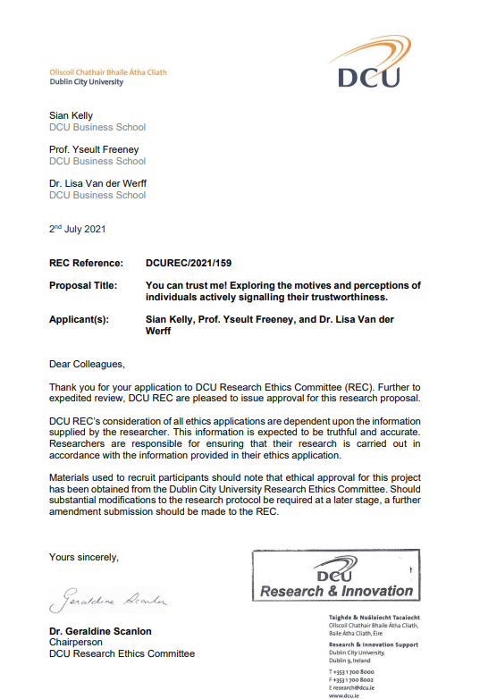

Appendix C - Participant Information Sheet

Dear Participant,

This study is being conducted by Sian Kelly, a PhD student, under the supervision of Prof. Yseult Freeney and Dr. Lisa van der Werff, academics from DCU Business School. The research is being conducted to explore manager and employee working relationships in organisations. The research is particularly interested in trust within these working relationships and how individuals make an effort to be trusted and build positive working relationships. Data will be collected from both parties in a working relationship, i.e.,, a manager and a member of their team. We are interested in understanding your experiences of trust and trustworthiness and how this impacts you and your working relationship. Participation in the research study will provide an opportunity to reflect on your working relationship with your manager or your team member.

Participation involves the completion of an interview which will last approximately one hour. Please note, during your interview, you can choose to stop the conversation at any time or choose not to answer any question put to you that you do not want to answer. The interview will address the following research questions:

What strategies do we use to help others trust us?
Why do we make an effort to ensure others trust us?
How does trust impact employee and manager working relationships?

I will arrange your interview to best suit your needs - I can travel to meet you, or I can interview you via zoom if that is more convenient for you, or alternatively you are welcome to come to DCU Business School to complete the interview on-site. The interview will be recorded for transcription purposes and transcribed by myself (Sian Kelly). A copy of the transcript will be shared with you should you wish to review it and any edits that you request will be made before the data analysis stage.

All data will be handled and stored in line with GDPR guidelines. Your identifying data (e.g., your name and contact details) will be held until the research project is completed and then destroyed, through the deletion of the electronic record stored. Your interview data will be pseudonymized so that the information you provide cannot be used to identify you or any individuals you mention. This data will be stored securely and will be accessible only to the research team and used only for research purposes. Information compiled from the interviews will only be reported in aggregate form, with any identifying information removed, and the information you provide will remain strictly confidential. As the data subject you have the right to access your own personal data, to do so please contact me at sian.kelly268mail.dcu.ie or alternatively by contacting the Data Protection Unit at DCU. In the case of this research DCU is the Data Controller and Mr. Martin Ward is DCU Data Protection Officer and can be contacted at data.protection@dcu.ie Ph.:7005118 / 7008257. If you have any concerns about the use of your data in this research, you have the right of the individual to lodge a complaint with the Irish Data Protection Commission. Please note confidentiality of information provided cannot always be guaranteed by researchers and can only be protected within the limitations of the law – i.e.,, it is possible for data to be subject to subpoena, freedom of information claim, or mandated reporting by some professions.

The findings of the study will be used in the production of a thesis that will be submitted by me, Sian Kelly, to the examinations board to fulfill the requirements of a doctoral degree of philosophy. The findings of the study will also be used for research purposes, for example, to create papers for publication in academic journals, to inform the scholarly community of the knowledge generated. You will also be sent details of the findings in the form of a report following the completion of the overall research project. Your participation in the study is voluntary and is greatly appreciated. It is possible to withdraw from the study during the two-month cooling-off period after your interview has been completed. Please contact me at sian.kelly268mail.dcu.ie during this time to withdraw from the study. After this point, once the qualitative data analysis has begun, participants' interview data will be combined and grouped to identify themes within the overall data from the entire sample. This process of analysis would make it impossible to detangle one participant’s data from another’s after the cooling-off period.

While it is not anticipated that participating in the research will cause any adverse effects, I would like to draw your attention to some resources that are available to you should you feel you need any support following the interview. The following service offers confidential, non-judgemental, emotional support and information to those contacting their helplines:

The Samaritans
www.samaritans.ie
Tel: 116 123
Text: 087 2609090
Email: jo@samaritans.ie

Thank you in advance for your time and effort in participating in my research. If you have any questions regarding the study or the progress of the project, please do not hesitate to contact me at sian.kelly268@mail.dcu.ie. Please note this research is made possible by funding by the DCU business school (2020-2021) and the Irish Research Council (2021-2024). If you have any concerns about the study and wish to contact an independent person, please contact; The Secretary, Dublin City University Research Ethics Committee, c/o Research, and Innovation Support, Dublin City University, Dublin 9. Tel 01-7008000. The supervisors of this study can also be contacted, using the details featured at the end of this document, should you have any questions or concerns for them.

Yours faithfully,

Sian Kelly.

Sian Kelly Prof. Yseult Freeney Dr. Lisa van der Werff
PhD student Study Supervisor Study Supervisor
DCU Business School DCU Business School DCU Business School
sian.kelly268@mail.dcu.ie yseult.freeney@dcu.ie lisa.vanderwerff@dcu.ie

Appendix D - Online Consent Form

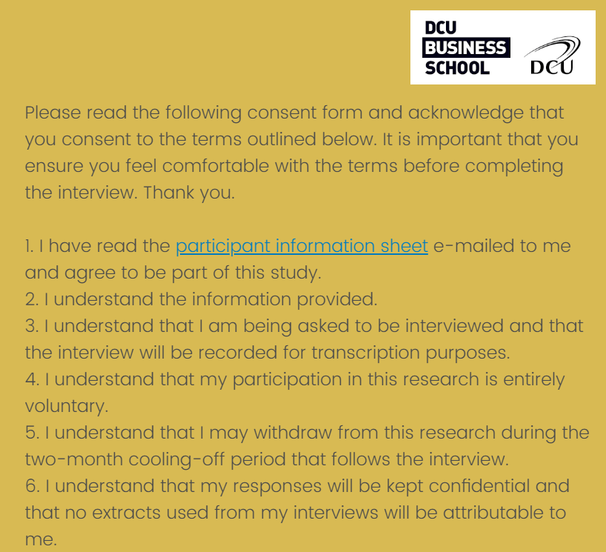
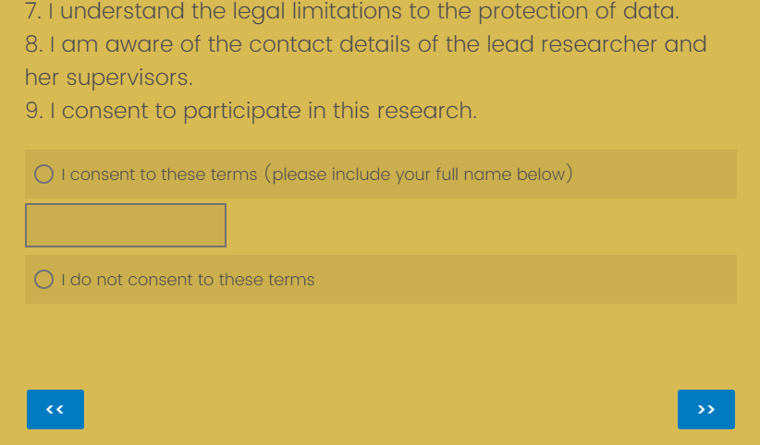

Appendix E - Online Survey (Demographics)

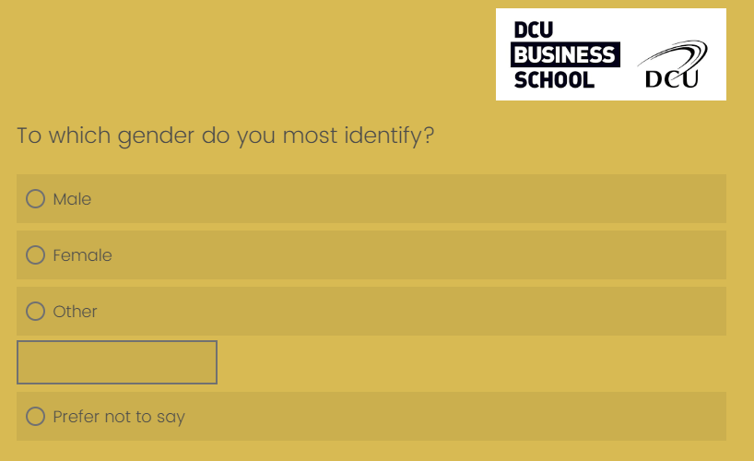
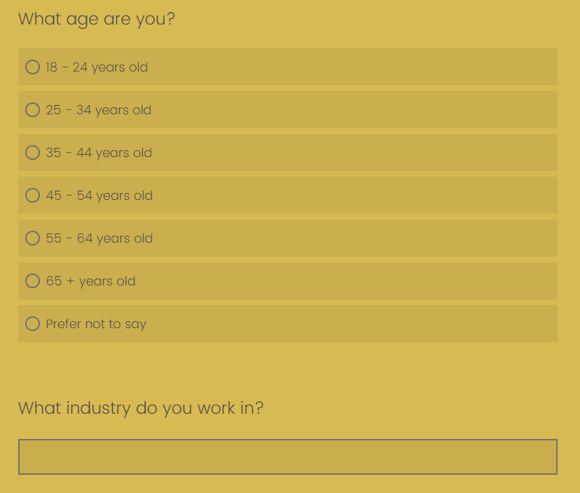
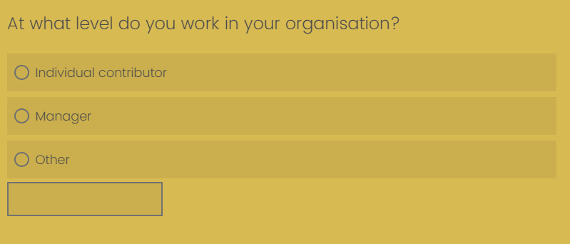

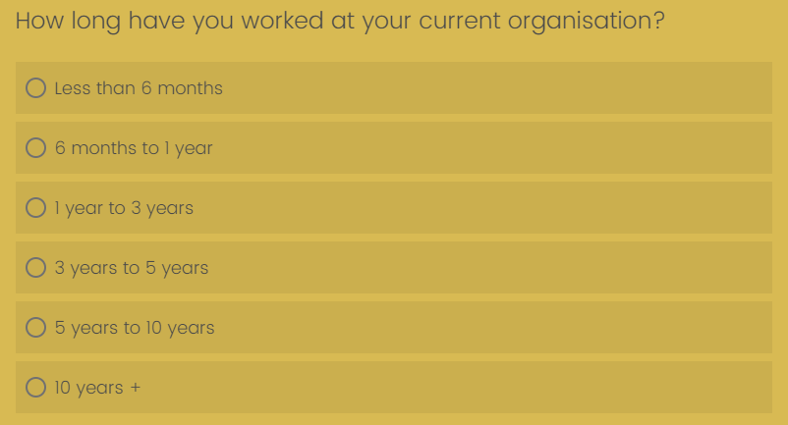
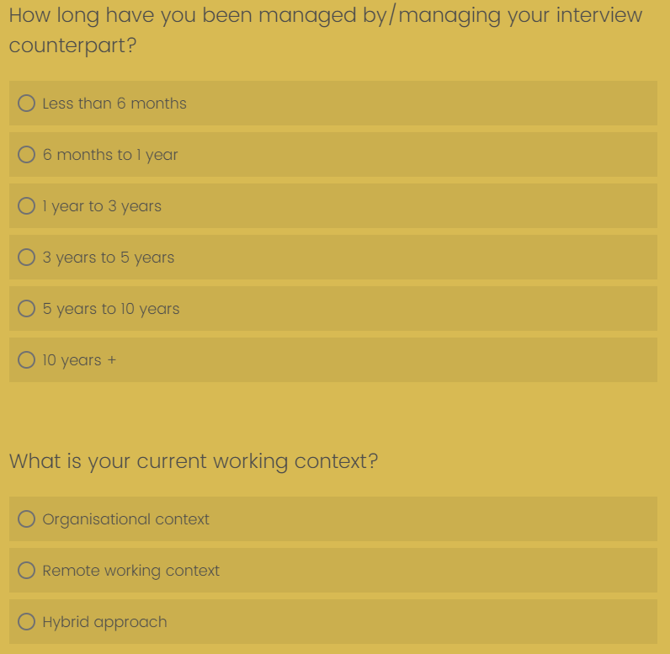
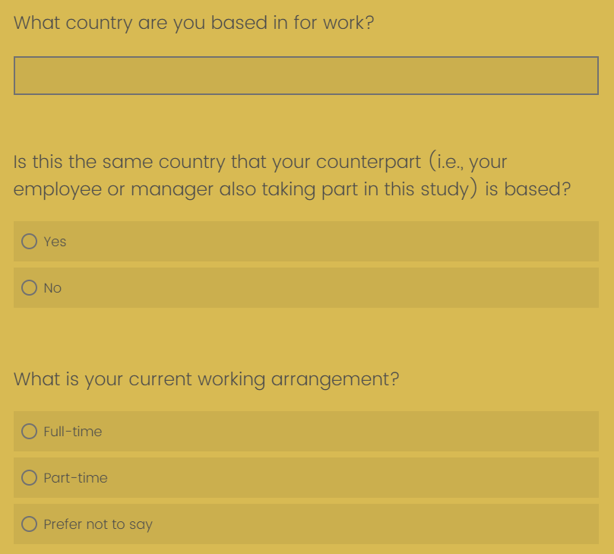
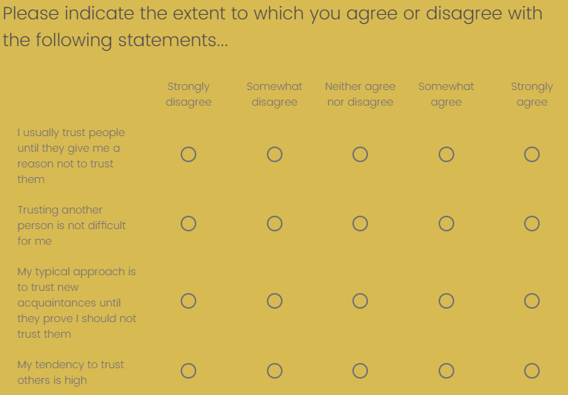

Appendix F - Interview Schedule

Welcome & thank you
Confirm consent form
Confidentiality

Opening Questions:

Can you please tell me about your working relationship with your manager?
-beginning
-dynamics now
-interactions
-roles

Active trust strategies

Is trust important in this relationship?

How trust developed? Now?
-(strategies; signalling; vulnerability)
-trusted
-trusting

Can you tell me about a time when something changed in work and how this affected your relationship?
-trusted
-trusting

Can you tell me about a time when your relationship experienced some kind of challenge and how you overcame this? (e.g., change in role, online working context etc.)
-trusted
-trusting

Felt Trust/Trust in counterpart

How do you think your manager rates you as an employee? (VICE VERSA)
-trust
-rely
-sharing information - personal/professional
-vulnerability

Do you think it is beneficial to you if you are trusted by your manager?
-motivation to be trusted
-Disadvantages

Closing Questions/Comments
Any other relevant info/questions?
Follow up? Review Transcription? Other participants?

