Supplementary Material (ESI)

Supplementary Information

Solvato-Morphologically Controlled, Reversible NIPAAM Hydrogel Photoactuators

Aishling Dunne¹, Colm Delaney¹, Larisa Florea^{*1}, Dermot Diamond¹
¹Insight: Centre for Data Analytics, National Centre for Sensor Research, Dublin City University, Dublin, Ireland

* To whom correspondence should be addressed. Tel.: + 353 1 700 6009 Fax: + 353 1 700 7995; E­mail: larisa.florea@dcu.ie

Single-Crystal X-ray Diffraction: The structure of SP-A was solved and refined using the Bruker SHELXTL Software Package, with a P21/c space group, for Z = 4. Representation of the Single-Crystal X-ray Diffraction structure of SP-A is shown in Figure S1. Full crystal data and structure refinement are presented in Table S1.
Figure S1. Representation of the Single-Crystal X-ray Diffraction structure of SP-A. (a) Single molecule structure with thermal ellipsoids at 50%; (b) shows the packing in the crystal lattice, offset along the a-axis. Hydrogen atoms are removed for clarity. Red: Oxygen; Blue: Nitrogen.

Table S1: Crystal data and structure refinement for SP-A
Empirical formula C₂₂H₂₁NO₃
CCDC 1475017
Formula weight 347.40
Temperature 297.78 K
Wavelength 0.71073 Å
Crystal system Monoclinic
Space group P2₁/c
Unit cell dimensions a = 11.520(3) Å α= 90°.
b = 21.866(6) Å β= 100.443(9)°.
c = 7.630(2) Å γ = 90°.
Volume 1890.1(9) Å3
Z 4
Density (calculated) 1.221 Mg/m3
Absorption coefficient 0.081 mm-1
F(000) 736
Crystal size 0.27 x 0.23 x 0.14 mm3
Theta range for data collection 2.589 to 28.394°.
Index ranges -15≤h≤15, -29≤k≤29, -9≤l≤10
Reflections collected 43348
Independent reflections 4690 [R(int) = 0.0520]
Completeness to theta = 25.242° 99.9 %
Absorption correction Semi-empirical from equivalents
Max. and min. transmission 0.7457 and 0.6810
Refinement method Full-matrix least-squares on F2
Data / restraints / parameters 4690 / 0 / 238
Goodness-of-fit on F2 1.029
Final R indices [I>2σ(I)] R1 = 0.0629, wR2 = 0.1492
R indices (all data) R1 = 0.1055, wR2 = 0.1736
Largest diff. peak and hole 0.293 and -0.223 e.Å-3

Hydrogel fabrication: Hydrogel discs were photo-polymerised using a photo-mask that had a 1mm diameter circle pattern. An “in-house cell” was fabricated to make the hydrogels discs, consisting of a bottom glass slide and a glass cover slide separated by a 250μm high spacer made out of Poly(methyl methacrylate)/pressure sensitive adhesive (PMMA/PSA) and the photo mask placed on top of the cover slide.
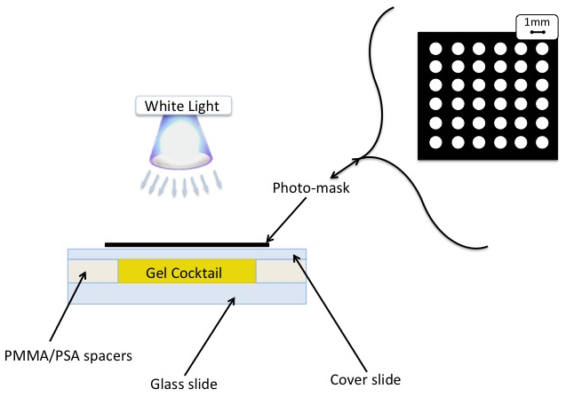
Figure S2. Schematic of “in-house” cell used for hydrogel fabrication.

The chosen monomeric cocktail was used to fill in the cell by capillary forces. Once the cell was filled with the specific cocktail, it was exposed to white light through the photo-mask for a predetermined time (20-30 seconds) depending on the polymerisation solvent used. Following polymerisation the hydrogel discs were washed gently with ethanol to remove any unpolymerised cocktail and finally washed with deionised water. The washed hydrogels were then placed in deionised water for 4-6 hours to ensure full hydration. All of the hydrogels in this study were fabricated in this fashion.

Rheology: The rheology curing study was carried out to investigate the effect different polymerization solvents have on the curing times and mechanical properties of the resulting hydrogels. Each sample cocktail was made up to 1 ml and this quantity was placed under the CP50-2 Anton Paar rheometer tool having an angle of 1.996°. Once the tool was lowered on to the cocktail sample the experiment was initiated, after 60s the white light was switched on and remained this way for a further 8 minutes.
Figure S3. Photo curing of hydrogels produced when the polymerisation solvent was THF: deionised water ((V:V) 4:1, 2:1 and 1:1). White light polymerisation was initiated after 60s.

Figure S4. Photo curing of hydrogels produced when the polymerisation solvent was Dioxane: deionised water ((V:V) 4:1, 2:1 and 1:1). White light polymerisation was initiated after 60s.
Figure S5. Photo curing of hydrogels produced when the polymerisation solvent was Acetone: deionised water ((V:V) 4:1, 2:1 and 1:1). White light polymerisation was initiated after 60s.

SEM study: The hydrogel samples were first swollen in DI water, and then frozen with liquid nitrogen and subsequently freeze-dried. The samples were kept overnight at 0.035 mBar pressure and temperature of -40 °C. Samples were attached onto silicon wafers and coated with 10 nm gold layer prior to imaging. The freeze-dried hydrogels were imaged using Scanning Electron Microscopy (SEM).
Figure S6. SEM image of hydrogel synthesised using 4:1 (v: v) ratio of Dioxane: DI water as the polymerisation solvent.
Figure S7. SEM image of hydrogel synthesised using 2:1 (V: V) ratio of Dioxane: DI water as the polymerisation solvent.
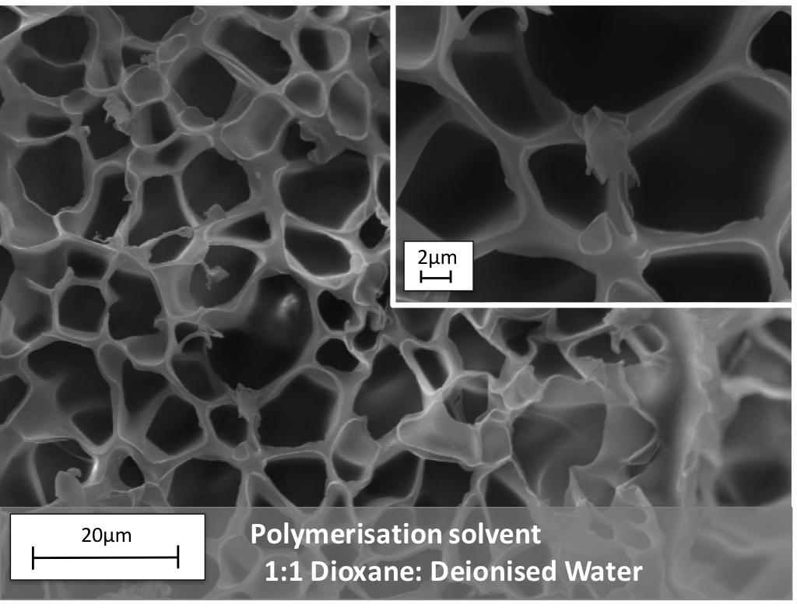Figure S8. SEM image of hydrogel synthesised using 1:1 (V: V) ratio of Dioxane: DI water as the polymerisation solvent.
Figure S9. SEM image of hydrogel synthesised using 4:1 (V: V) ratio of Acetone: DI water as the polymerisation solvent.
Figure S10. SEM image of hydrogel synthesised using 2:1 (V: V) ratio of Acetone: DI water as the polymerisation solvent.
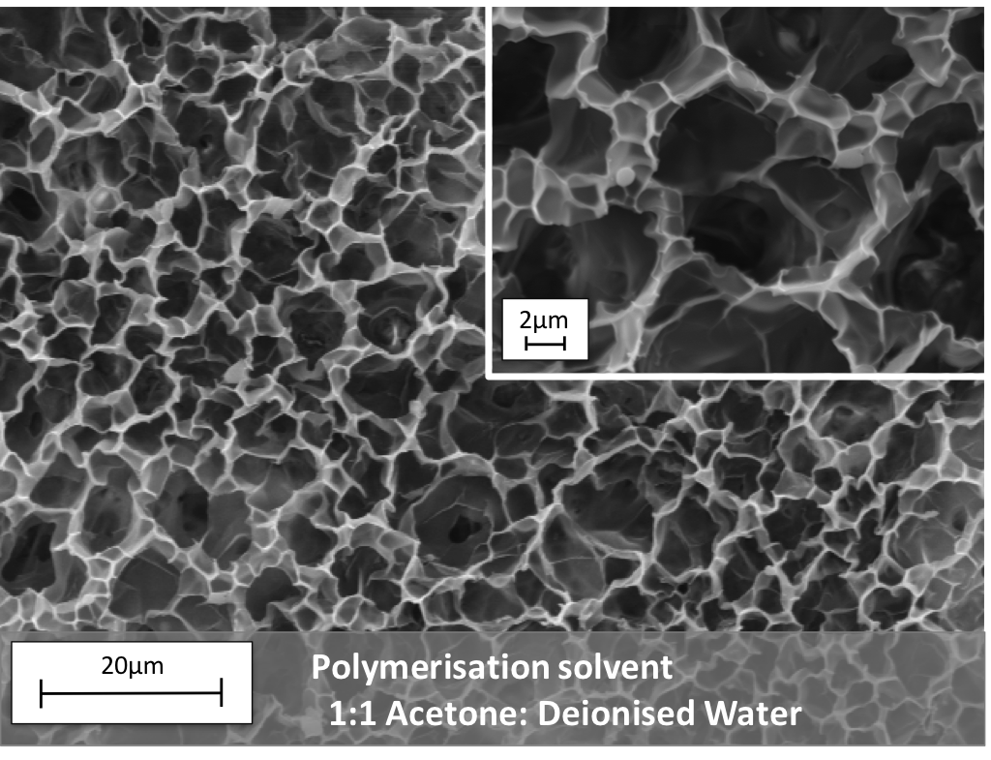Figure S11. SEM image of hydrogel synthesised using 1:1 (V: V) ratio of Acetone: DI water as the polymerisation solvent.
Oscillation study: The oscillation study was carried out on hydrated hydrogel samples. The results are presented as Storage modulus versus Shear Stress. During the experiment, the shear stress was increased from 0.01 to 100%, while the Angular Frequency was kept at 100 rad/s at a normal force of 1N.
Figure S12. Storage modulus versus Shear Stress of the hydrated hydrogels polymerised in the presence of Acetone: DI water mixtures during a strain amplitude sweep (Frequency was 1N).
Figure S13. Storage moduli Versus Shear Stress of the hydrated hydrogels polymerised in the presence of Dioxane: DI water mixtures during a strain amplitude sweep (Frequency was 1N)

Photo-actuation: For white light irradiation shrinking and reswelling measurements, the hydrogels were placed in a “in house” cell, comprised of 2 cover glass slides separated by 500 μm high spacers made out of PMMA/PSA arranged in a square fashion on the bottom glass slide. The hydrogel sample was placed in this “in house” cell and filled with deionised water. The cell was placed on a black background to aid the area measurements in the image J software. The hydrogel was measured under an Aigo digital-microscope –GE5 with a lens of X60 magnification during and after light actuation.

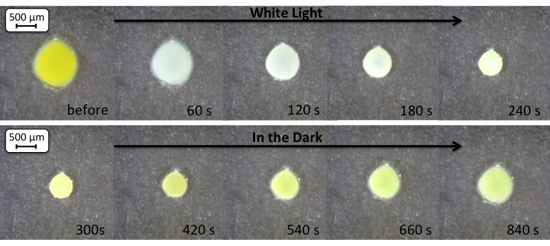Figure S14. Microscope images (magnification X60) of BI hydrogel during a shrinking and reswelling cycle.
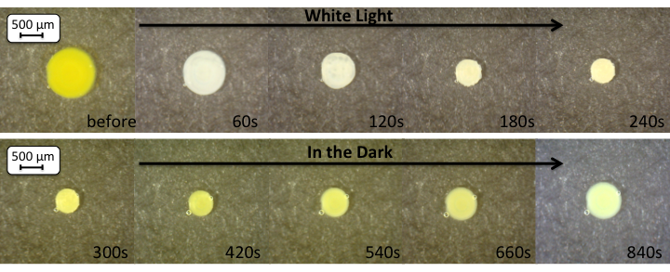Figure S15. Microscope images (magnification X60) of the BII hydrogel during a shrinking and reswelling cycle.
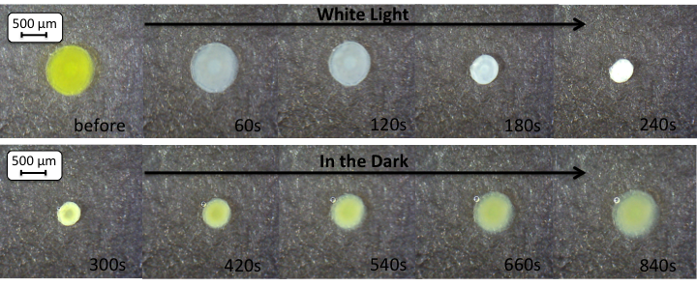Figure S16. Microscope images (magnification X60) of the BIII hydrogel during a shrinking and reswelling cycle.
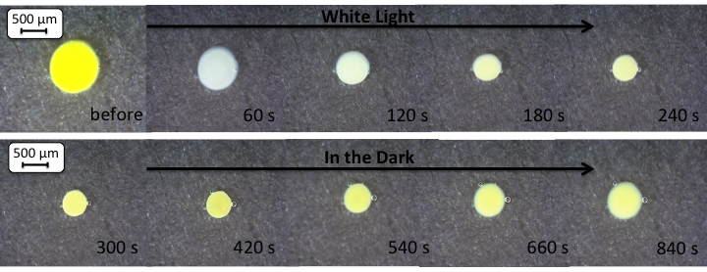Figure S17. Microscope images (magnification X60) of the CI hydrogel during a shrinking and reswelling cycle.
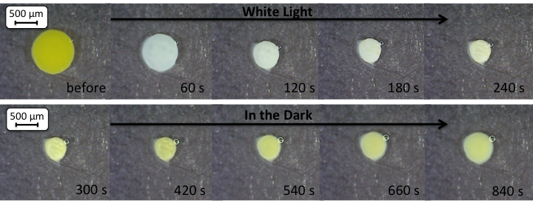
Figure S18. Microscope images (magnification X60) of the CII hydrogel during a shrinking and reswelling cycle.
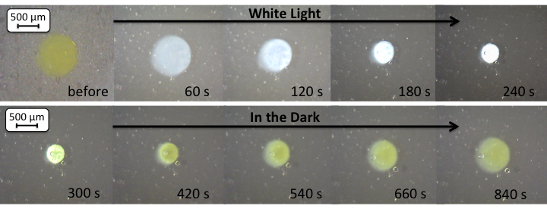Figure S19. Microscope images (magnification X60) of the CIII hydrogel during a shrinking and reswelling cycle.

Photo-actuation measurements: The area measurements of the freestanding hydrogel discs were done using Image J (1.47v) software. Three different hydrogels (n=3) were measured for each point and the relative area % was calculated as the ratio between the hydrogel area at specific times (A_{t}) and the area measurement of the hydrogel before actuation (A₀) as described in the following equation:
Relative area % = $\frac{A_{t}}{A_{o}} × 100$
A_{t} = measured area at time t
A_{o} = measured area of fully hydrated hydrogel.

Figure S20. Photo-actuation cycles of hydrogels produced when the polymerisation solvent was 4:1 (V:V) organic solvent (THF, dioxane and acetone, respectively) : deionised water, in real time.
Figure S21. Single photo-actuation cycle of three different hydrogels produced when the polymerisation solvent was THF: DI water, in real time.
Figure S22. Single photo-actuation cycle of three different hydrogels produced when the polymerisation solvent was Dioxane: DI water, in real time.
Figure S23. Single photo-actuation cycle of three different hydrogels produced when the polymerisation solvent was Acetone: DI water, in real time.

