Laser Surface Treatment of Materials with Presence of Carbides at the Surface

By

Abdul Aleem B. Jabbar

This thesis is submitted to Dublin City University as the fulfilment of the requirements for award of degree of

Doctor of Philosophy

Research Supervisors

Professor M.S.J. Hashmi (Ph.D., D.Sc., FIMechE., FIEI, MASME)
Professor B.S.Yilbas (Ph.D., D.Sc., D.Eng., MASME)

School of Mechanical & Manufacturing Engineering
Dublin City University

November 2011

Dedicated to
My beloved parents (late) and
My father in law (late)

DECLARATION

I hereby certify that this material, which I now submit for assessment on the program of study leading to the award of Doctor of Philosophy (Laser Surface Treatment of Materials with Presence of Carbides at the Surface) is entirely my own work, that I have exercised reasonable care to ensure that the work is original, and does not to the best of my knowledge breach any law of copyright, and has not been taken from the work of others save and to the extent that such work has been cited and acknowledged within the text of my work.

Signed: ____________ (Candidate) ID No.: 10113363 Date: _______

ACKNOWLEDGEMENTS

First and foremost, all praises and thanks to Almighty Allah for bestowing me with an opportunity to carry out this work.
I would like to express my sincere gratitude to my thesis supervisors, Professor M.S.J. Hashmi and Professor B.S. Yilbas for their remarkable help, valuable guidance and encouragement. They enlightened my path to pursue the Ph.D program. I am greatly indebted to them for giving special attention and support to my work and enlightening the achievement path.
I am deeply indebted to my family members, in particular my wife Humera, my daughter Habeeba, my sons Khalid and Usama and my mother in law Mrs. Nazneen Begum Waheed, for their moral support, constant prayers, encouragement and patience during the course of this work.
I wish to express my profound gratitude to Professor Zaki Ahmad, who was instrumental in all my publications related to corrosion. Working with him was an opportunity of great learning and experience.
Acknowledgements are due to King Fahd University of Petroleum and Minerals, Dhahran, Saudi Arabia for the support in carrying out this research.
Last but not the least my sincere gratefulness to my dearly loved parents (late) for their guidance. No personal development can ever take place without the proper guidance of parents. They are the basis why I have kept a smile on my face and strength in my soul.
Title of Thesis: LASER SURFACE TREATMENT OF MATERIALS WITH PRESENCE OF CARBIDES AT THE SURFACE
Name of Student: Abdul Aleem B. Jabbar Student Number: 10113363

ABSTRACT
Some of the studies associated with laser assisted processing including machining, surface treatment applications, and electrochemical response of the selective surfaces were carried out prior to the thesis work by the thesis author. In the light of the previous studies, additional study on laser controlled melting of surfaces is carried out for pre-prepared Haynes 188 and Inconel 718 alloys, and high speed steel workpieces. Metallurgical and morphological changes in the laser treated layer are examined using Scanning Electron Microscopy, Energy Dispersive Spectroscopy, and X-ray Diffraction. A carbon film of about 50 thickness and containing 5% TiC particles is formed at the workpiece surface prior to the laser treatment process. The carbon film formed at the surface enhances the absorption of laser irradiation and accommodates uniformly distributed TiC particles. The residual stress formed at the surface of the laser treated workpiece is obtained using X-ray Diffraction technique while indentation tests are carried out to measure microhardness and fracture toughness of the resulting surfaces. It is found that laser treated surfaces of Hayness 188 and Inconel 718 alloys, and high speed steel are free from microcracks and surface asperities. The formation of carbnotride and nitride phases at the surface vicinity of laser treated layer contribute to increased hardness and dense layer formation at the surface. The residual stress formed at the surface of Hayness 188 alloy is on the order of 590 ± 15 MPa, 460± 15 MPa for high speed steel, and 480±14 MPa for Inconel 718 alloy. For high speed steels, ε-Fe₃N, and ε-Fe₃ (N,C) compounds are formed at the laser treated surface which are attributed to the presence of carbon film and high pressure nitrogen assisting gas during the laser processing. The fracture toughness of laser treated surface reduces considerably because of increased hardness and dense layer formed at vicinity of laser treated surface. Partially dissolution of carbide particles takes place at the surface of the Inconel 718 alloy. The formation of fine grains, nitride compounds formed as well as dissolution of Laves phase at the surface region enhance hardness at the surfaces of laser treated Inconel 718 alloy workpiece.

Table of Contents

DECLARATION i
ACKNOWLEDGEMENTS ii
ABSTRACT iii
Table Of Contents iv
List of Tables vii
List of Figures ix
Chapter 1- Introduction 1
1.1Types of Lasers 1
1.2 Laser Heat Treatment 4
1.3 Laser Surface Melting 6
1.4 Laser Surface Alloying 7
1.5 Laser Cladding 8
1.6 Surface Texturing 10
1.7 Laser Welding 11
1.8 Laser Machining 11
1.9 Scope of Work 11
Chapter 2 - Literature Survey 13
2.1 Introduction 13
2.2 Brief Survey on Author’s Previous Work 13
2.3 Open Literature Review 16
2.4 Summary of Literature Review 36
Chapter 3 - Experimental Methods 38
3.1 Introduction 38
3.2 Equipment 38
3.2.1 Optical Microscope 38
3.2.2 Scanning Electron Microscope and Energy Dispersive Spectroscopy System 39
3.2.3 X-ray Diffraction Equipment (XRD) 40
3.2.4 Microhardness Tester 40
3.3 Laser surface treatment using CO₂ laser 42
3.4 Materials and Surface Preparation Prior to the Laser Surface Treatment 43
3.5 X-ray Diffraction Technique for Residual Stress Measurement 45
3.6 Fracture Toughness Measurements 46
3.7 Determination of Young’s modulus and Rate of Stress Release by Three-Point Bending Tests 48
Chapter 4: Results and Discussion 50
4.1 Introduction 50
4.2 Results and Discussions based on the Previous Research Work 50
4.2.1 Laser Treatment of Cemented Carbide Cutting Tool 50
4.2.2 Laser Gas Assisted Nitriding and Tin Coating of Ti-6Al-4V alloy: Experimental and Numerical investigation of Mechanical Properties. 57
4.2.3 Laser gas assisted nitriding of alumina surfaces 63
4.2.4 Laser Melting of Carbide Tool Surface: Model and Experimental Studies…….70
4.2.5 Laser Gas Assisted Nitriidng of Steel: Residual Stress Analysis : 74
4.2.6 Laser Nitriding of Tool Steel: Thermal Stress Analysis 80
4.3 Results and Discussions based on the Current Research Work 84
4.3.1 Haynes 188 alloy 85
4.3.2 High speed Steels 94
4.3.3 Inconel 718 alloy 103

Chapter 5 - Conclusion and Recommendations for Future Work 112
5.1 Conclusion based on the Previous Research Work 112
5.1.1 Laser treatment of cemented carbide cutting tool: 112
5.1.2 Laser gas assisted nitriding and tin coating of Ti-6Al-4V alloy: Experimental and numerical investigation of mechanical properties: 113
5.1.3 Laser gas assisted nitriding of alumina surfaces: 114
5.1.4 Laser melting of carbide tool surface: Model and experimental studies: 114
5.1.5 Laser gas assisted nitriidng of steel: Residual stress analysis: 115
5.1.6 Laser Nitriding of Tool Steel: Thermal Stress Analysis 115
5.2 Conclusion based on the Current Research Work 116
5.2.1 Haynes 188 alloy 116
5.2.2 High Speed Steels 117
5.2.3 Inconel 718 alloy 118
5.3 Recommendations for future work 119
References 121
List of Publications 137

List of Tables

Table 1.1 Typical Lasers and their emission wavelengths. 2
Table 1.2 Competing process for heat treatment 5
Table 1.3. Various competing laser melt melting processes . 6
Table 1.4. Competing surface alloying methods. 8
Table 1.5. Competing cladding techniques . 9
Table 3.1(a). Laser gas assisted nitriding conditions used for Hyness 188 alloy. 42
Table 3.1(b). Laser gas assisted nitriding conditions used for high speed steels. 42
Table 3.1(c). Laser gas assisted nitriding conditions used for Inconel 718 alloy. 43
Table 3.2. Chemical Composition of Experimental Alloys 44
Table 3.3. Data used in the calculations of Young’s modulus from three-point bending tests…….44
Table 4.1. Elemental composition of results after laser treatment (%wt.) of cemented carbide cutting tool. 52
Table 4.2. Microhardness measurement at the surface (cemented carbide cutting tool) prior and after the laser treatment 57
Table 4.3. Surface roughness values for the treated surfaces of T-6Al-4V alloy. 60
Table 4.4. EDS results of the laser nitrided layer of T-6Al-4V alloy. 61
Table 4.5. Data obtained after indentation tests of alumina surface. 70
Table 4.6. Elastic modulus of laser nitrided layer and fracture toughness of the as received and laser nitrided steel surfaces. 74
Table 4.7. Elastic modulus and fracture toughness obtained after indentation tests of tool steel surfaces. 84
Table 4.8. EDS spectrums (wt%) and their locations at the surface of Haynes 188 alloy..............92
Table 4.9. EDS spectrums (wt%) and their locations at the laser treated surface and at the as received surface of high speed steels. 100
Table 4.10. Fracture toughness of the surface and data used in the calculations for high speed steels. 102
Table 4.11. Microhardness of laser treated and as received surface of Inconel 718 alloy. 109
Table 4.12. EDS analysis at laser treated surface of Inconel 718 alloy. 110
List of Figures

Figure 1.1. Range of laser processes mapped against power density and interaction time . 3
Figure 1.2 Experimental arrangement for laser heat treatment process 4
Figure 3.1 Photograph of optical Microscopy . 38
Figure 3.2. Scanning Electron Microscope JEOL 6640 LV 39
Figure 3.3. Photograph of Bruker XRD equipment. 40
Figure 3.4. Photograph of Microhardness Tester 41
Figure 3.5. Geometric configuration of indention mark and crack length in relation to fracture toughness measurement. 46
Figure 3.6. A schematic view of three-point bending testing and relevant dimensions. 48
Figure 4.1. XRD results for the workpiece (cemented carbide cutting tool) prior and after laser treatment process. 51
Figure 4.2. SEM micrographs of laser treated workpiece (cemented carbide cutting tool) surface. 53
Figure 4.3. SEM micrograph of cemented carbide tool surface. 54
Figure 4.4. SEM micrograph of laser treated workpiece (cemented carbide cutting tool) cross-section. 54
Figure 4.5. Indention marks on the as received and laser treated surfaces (cemented carbide cutting tool) for the fracture toughness measurements 56
Figure 4.6. Cross-section of the laser nitrided specimen prior to TiN PVD coating of Ti-6Al-4V alloy. 58
Figure 4.7. Cross section of i) the laser nitrided and coated specimen of Ti-6Al-4V alloy. and ii) the heat treated and TiN coated specimen of Ti-6Al-4V alloy. 59
Figure 4.8. Surface roughness of the laser nitrided specimen of Ti-6Al-4V alloy. 60
Figure 4.9. Surface of the as received and coated specimen after three-point bending test of Ti-6Al-4V alloy. 62
Figure 4.10. Surface of the laser nitrided and coated specimen after three-point bending test of Ti-6Al-4V alloy. 63
Figure 4.11. Optical and SEM micrograph of laser treated and as received alumina surfaces. 65
Figure 4.12. SEM micrographs of cross-section of laser treated workpiece (alumina). 67
Figure 4.13. XRD difractogram for laser treated and as received workpieces (alumina). 68
Figure 4.14. Optical photograph and SEM micrograph of top view of the laser irradiated spot (alumina). 71
Figure 4.15. SEM micrograph of top view of the cemented carbide tool steel without laser irradiation. 72
Figure 4.16. Cross-sectional view of laser treated carbide tool for two β values. 73
Figure 4.17. XRD results for laser nitrided steel surface at different depths. 75
Figure 4.18. SEM micrographs of two surfaces: i) at the free surface (y = 0 m) and ii) at a depth 15 μm below the free surface of the nitrided layer (y = 15 μm). 76
Figure 4.19 SEM micrographs of the top surface of the laser nitrided workpiece 78
Figure 4.20: SEM micrographs for the cross-sectional view of the laser nitrided workpiece. 79
Figure 4.21. SEM micrographs for top view of laser treated surface (tool steel). 81
Figure 4.22. SEM micrographs of cross-section of laser nitrided workpiece (tool steel). 82
Figure 4.23. XRD diffractogram for laser nitrided workpiece (tool steel). 83
Figure 4.24 Optical photographs of laser treated surface and laser scanning tracks of Haynes 188 alloy. 86
Figure 4.25. SEM micrographs of laser treated surface, overlapping of laser spots, partially dissolved TiC particles at the surface, and small voids due to volume shrinkage in the dense layer at the surface vicinity of Haynes 188 alloy. 87
Figure 4.26. SEM micrographs at the cross-section of laser treated layer of Haynes 188 alloy: a) Cross section of treated layer b) Dense structure at the surface, TiC particles, small dendrites at the surface vicinity, feather like structure, and slightly longer dendrites below the surf ace vicinity, and c) large grains in the heat affected zone. 89
Figure 4.27. XRD diffractogram for the laser treated surface of Haynes 188 alloy. 91
Figure 4.28. Linear dependence of d(114) with sin² ψ of Haynes 188 alloy 93
Figure 4.29. Optical photograph of laser treated surface of high speed steel. 94
Figure 4.30. SEM micrographs of laser treated surface of high speed steel. 95
Figure 4.31. SEM micrographs of cross-section of laser treated layer of high speed steel: A) Cross-section, B) Dense layer at the surface vicinity and columnar structure, C) Feather like structure below surface vicinity, D) Large grains in the heat affec 97
Figure 4.32. XRD diffractogram for laser treated surface of high speed steel. 99
Figure 4.33. Linear dependence of d-spacing with sin²ψ of high speed steel. 102
Figure 4.34. SEM micrographs of top surface of laser treated work piece of Inconel 718 alloy: a) Laser scan tracks, b) Over lapping of laser spots, c) Partial dissolve TiC region at the surface, d) partially dissolve TiC particles e) close view of cracks 105
Figure 4.35. SEM micrographs of laser treated section of Inconel 718 alloy: a) Cross-section,b) Dense structure with fine grains at the surface, c) Columnar structure next to surface vicinity, d) Laves phase in the surface region, e) Grain boundary carbides f) Heat affected zone 107
Figure 4.36. XRD diffractogram of laser treated surface of Inconel 718 alloy. 109
Figure 4.37. d(220) spacing with sin²ψ for Inconel 718 alloy. 111

Chapter 1- Introduction

Currently, surface treatment is an important field of research with considerable interest due to its importance in improving its surface properties against harsh environments such as corrosion and wear. Laser has unique properties and one of the effective process in surface treatment of the metallic substrates. Electromagnetic radiation of a laser beam is absorbed within the surface layers of opaque materials. By using a laser beam the applied energy can be placed precisely on the surface enabling increasing substrate material temperature above the melting temperature.
The thesis author has carried out extensive research work on laser applications previously. The current research wok presented in the thesis is the extension of the previous studies, since laser surface treatment is one of the demanding technique for improvement of surface properties of engineering alloys, the work presented in the thesis focuses on laser treatment of alloy surfaces, such as Haynes 188 and Inconel 718 alloys, and High Speed Steels.
The advantages of laser surface process over the conventional treatment surface treatment processes are as follows:
- Chemical cleanliness
- Precise of operation
- Distortion is controlled by controlling thermal penetration
- Shape and location of heat affected zone is controlled by controlled thermal profile
- Non-mechanical contact with the workpiece surface
- Relatively easy to automate

Types of Lasers

There are many different types of lasers. The laser medium can be a solid, gas, liquid or semiconductor. Lasers are commonly designated by the type of lasing material employed. Table 1.1 [1] gives below typical lasers and their emission wavelengths.

Table 1.1: Typical Lasers and their emission wavelengths [1]
Laser Type | Wavelength (nm)
Argon fluoride (UV) | 193
Krypton fluoride (UV) | 248
Xenon chloride (UV) | 308
Nitrogen (UV) | 337
Argon (blue) | 488
Argon (green) | 514
Helium neon (green) | 543
Helium neon (red) | 633
Rhodamine 6G dye (tunable) | 570-650
Ruby (CrAlO₃) (red) | 694
Nd:Yag (NIR) | 1064
Carbon dioxide (FIR) | 10600

However, the most common lasers used in fabrication are the carbon dioxide (CO₂) laser, the Nd:YAG (neodymium-yttrium aluminum garnet) laser. The CO₂ laser uses a mixture of gasses including CO₂ as the active medium and produces a light with a 10.6 micron wavelength. The Nd:YAG laser uses a crystal as its active medium and produces light with 1.06- micron wavelength.
There are several other types of lasers, each has its advantages and limitations and are therefore used for different applications, in addition use of lasers in surface treatment include the following
- Surface heating for transformation hardening or annealing
- Scabbling, the removal of the surface of concrete or stone
- Surface melting for homogenization, microstructure refinement, generation of rapid solidification structure and surface sealing
- Surface alloying for improvement of corrosion, wear or cosmetic properties
- Surface cladding for improvement of corrosion, wear or cosmetic properties, in addition changing thermal properties such as melting point or thermal conductivity
- Surface texturing, surface roughening
- Sterolithography and other forms of layer manufacturing
- Enhanced plating by electrolysis using laser chemical vapour deposition (LCVD) or laser physical vapour deposition.
Range of laser processes mapped against power density and interaction time are shown in (Figure 1.1) [1]. The diagonal line in the diagram represents lines of constant temperature for the boiling and melting point of iron.

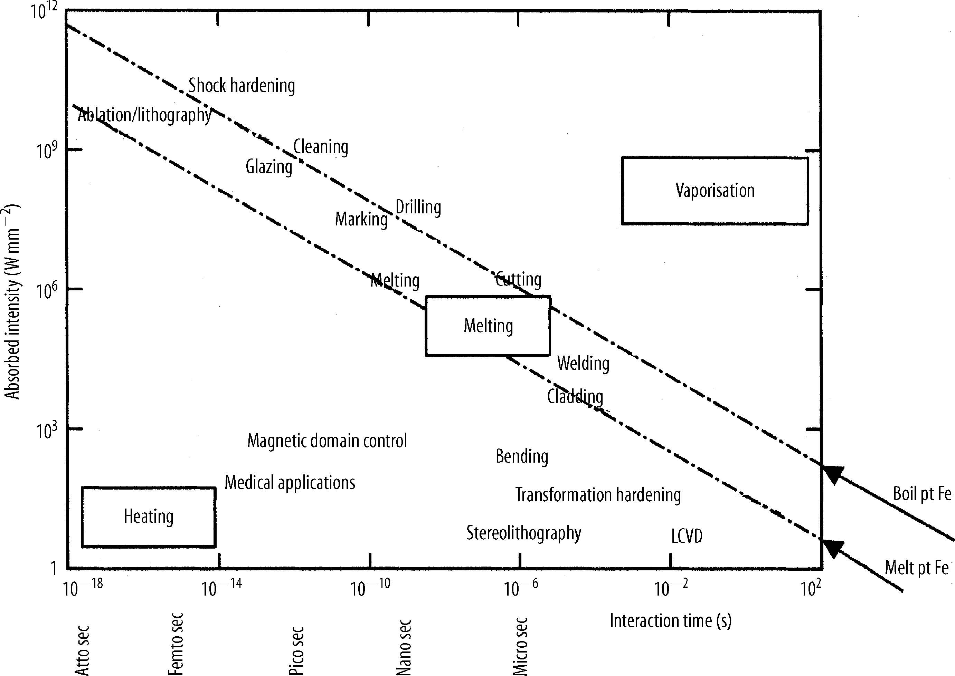

Figure 1.1. Range of laser processes mapped against power density and interaction time The diagonal line represent lines of constant temperature for the boiling and melting point of iron[1].

Laser Heat Treatment

Laser heat treatment is a selective surface hardening process for wear reduction; it is also used to change metallurgical and mechanical properties [2]. The laser heat treatment usually competes successfully with other processes owing to reduced distortion and high productivity. Practical uses of laser heat treatment provides increase in strength and hardness, reduced wear and friction [3], increase fatigue life, creation of surface carbide and unique geometrical wear pattern along with tempering
The process arrangement for laser heat treatment is illustrated in (Figure 1.2) and various heat treatment processes are given in Table 1.2 [1]. Laser heat treatment is used on titanium, aluminum alloys, steels with sufficient carbon content to allow hardening and cast irons with pearlitic structure.
Figure 1.2 Experimental arrangement for laser heat treatment process [1]
Table 1.2 Competing process for heat treatment[1]
- Heating Process
Advantages |  | Disadvantages
Laser | Minimum part distortion, selective hardening, no quenchant required , thin case depth controllable, eliminates post-processing and improves fatigue life | High equipment cost  Coverage area restricted  Absorbent coatings necessary  Multiple passes give local tempering
Induction | Fast process rates  Deep case obtainable  Lower capital cost than laser  Coverage area | Downtime for coil change  Quenchant required  Part distortion  Coil placement critical  Large thermal penetration  EM forces may spoil surface  Fabrication of complex coils for  specific processes
Flame | Cheap, flexible and mobile process | Poor reproducibility  Lacks rapid quench  Component distortion likely  Environmental problems
Arc (Tungsten Inert Gas) | Relatively cheap and flexible process | Section thickness limited, large thermal penetration  Stirring takes place  Poor control to avoid melting
Electro beam | Minimal distortion, selective hardening and no  quenchant required | High equipment cost  Requires vacuum  Low production rate  High processing costs
- Themochemical Diffusion Processes
Conventional <950º C
High temp. >950º C
Low pressure (“vacuum”)
N₂- Based carrier gas
Fluidized bed

Carburizing | Gas  Liquid  Pack  Conventional  Ion nitriding
Nitriding | Gas
Carbonitriding  (austentic) | Gas  Liquid

Laser Surface Melting

The experimental arrangement for laser surface melting is similar to (Figure 2), except that in this case a focused or near focused beam is used. The main characteristics of this process are
- Produces fine near homogeneous structure along with moderate to rapid solidification rates.
- Low distortion and possibility of operating thermally sensitive materials due to little thermal penetration
- Around 25µm surface finish is easily obtained
- Process flexibility, due to software control and possibilities in automation

Nonhomogeneous materials such as cast irons, tool steels and certain deep eutectics which form metallic glasses at high quench rates can be homogenized by laser surface treatment. The laser surface melting process is not widely used in industry due to the very high hardness achieved with cast iron and tool steel and may require some further surface finishing after treatment. Various surface melting processes are given in Table 1.3 [1].
Table 1.3. Various competing laser melt melting processes [1].
Process | Characteristics
Laser  Flame  Plasma  Tungsten Inert Gas  Induction | High capital cost, localized heating of sample, rapid solidification of melt zone to give fine recrystallized grain structure and good homogeneity. Controllable surface roughness. Powder density 10² – 10⁴ W cm ⁻²  Cheap capital cost, poor reproducibility, no fast quench available, environment problems and sample distortion. A flexible and mobile process  Medium capital cost, very low heat input to sample.  Limited section thickness, electromagnetic stirring, weld bead may be rough, large thermal penetration and medium heat input  Cheaper than laser, larger than thermal penetration, electromagnetic force may spoil surface, fast processing rate, deep case possible and fast area coverage

1.4 Laser Surface Alloying

Surface alloying with a laser is similar to laser melting except that another material is injected to the melt pool. The main characteristics of the process are as follows

- Alloyed region shows a fine microstructure with nearly homogeneous mixing throughout the melt region.
- Most materials can be alloyed into most substrates. The high quench rate ensures that segregation is minimum and alloys like Fe-Cr-C-Mn could only be prepared via a rapid surface quench [4].
- Very thin, very fast quenched alloy regions can be obtained using Nd:YAG lasers and the thickness of the treated zone could be 1-2000 µm.
- There is a possibility of loss of some volatile components [5].

Laser surface alloying is capable of producing a wide variety of surface compositions. At high solidification rates some metastable alloys can be formed on the surface. Various surface alloying methods are given in Table 1.4 [1]. Some alloys suffer from cracking and porosity, which may put restrictions on shrouding and preheat. The surface profiles obtained from laser surface alloying could be quite smooth. Surface alloying has several advantages and greater flexibility. Laser process offers the possibility of surface compositional changes with minimum distortion.

Table 1.4. Competing surface alloying methods [1].
Thermochemical Diffusion Treatments
Conventional <950º C
High Temp. >950º C
Low pressure (“vacuum”)
N₂- Based carrier gas
Fluidized bed

Gas
Liquid
Pack

Carburizing

Gas
Conventional

Ion nitriding
Nitriding
Liquid

Gas
Cabonitriding
Baronising

Pack
Pack
Chromising
Conventional
Aeration accelerated
Sulphite accelerated
Low toxicity processes

Nitro Carburizing

Liquid

Gas
Conventional

Low Temperature

Power density 10³ – 10⁶ W cm²
Flexibility and high power density allows, particular metallurgical properties to be obtained

Laser

1.5 Laser Cladding

Cladding operation is to overlay one metal with another to form a sound interfacial bond or weld without diluting the cladding metal with substrate material. Dilution is generally considered to be contamination of the cladding with which degrades its mechanical and corrosion resistance properties. Various cladding processes are given in Table 1.5 [1].

Table 1.5. Competing cladding techniques [1].
Low heat input, thin layers, low dilution and porosity, high hardness, small HAZ, high initial equipment investment and slow processing rates
Laser

Oxyacetylene- - liquid – solid bond, high heat input
TIG—reasonable bonding, medium heat input
Open arc – low heat input
Shielding metal arc
MIG – reasonable bonding, medium heat input
Submerged arc
Electroslag
Paste Fusion
Plasma arc
Chemical (electrolysis)

Welding

Powder

Wire

Fusion bond
No dilution

Flame
Electric arc metalizing

Spraying
Plasma – liquid – solid bond, low heat input, no dilution
Detonation (D-) gun – forge bond, very low heat input

Thick layers produced, high deposition rates, low equipment cost, covers large areas, high heat input and part distortion
Plasma arc

Chemical vapour deposition (CVD)
Vacuum coating (thermal evaporation)
Sputtering
Ion plating
Ion implantation

Physical vapour deposition (PVD)

Peening

Fillet Rolling

Mechanical plating

Aqueous

Fused salts

Electrochemical

Dilution is observed in most of the welding processes in which the melt pool is well stirred by electromagnetic and convective forces. Negligible dilution is achieved in other cladding processes which rely on either forge or diffusion bonding. Forge bonds are made through the impact of high speed particles with the substrate or clad layer and diffusion bonding occurs between a solid and a liquid phase. Fusion bond is usually the strongest and most resistant to thermal and mechanical shock, provided intermetallics are not formed. By using laser cladding process, a very thin layer, low dilution and porosity, high hardness, small heat affected zone could be obtained. The main applications of laser cladding are for corrosion resistance or wear resistance, recently the application include reverse machining, whereby the laser can put material on rather than having it removed. Therefore, a major application is in the repair business for refurbishment or salvaging high value components [6]. In one case, the laser is used to rebuild the splines on drive shafts [7] by completely removing the worn splines and rebuilding with alloy steel by laser cladding. The laser is used, since the heat input is low and there is little thermal distortion of the precision parts. Turbine blades could also be rebuilt at their tips or leading edges [8].

1.6 Surface Texturing

In this process, the rolls in the temper mills are textured to dull the surface of the sheet steels, which improves the grip in a press and the flow of paint on the final surface. Several techniques are available for doing this process [9, 10]. The conventional technique is to shot-blast the surface. However, this gives a random roughness which exhibits waviness in the finished paint surface. This problem could be resolved by providing a regular patterned roughness. This pattern can be achieved by electric discharge machining, electron beam or laser (either CO₂ or Nd:YAG) methods. Of these CO₂ laser technique comes out on top when comparison is made [10].

1.7 Laser Welding

Laser Beam Welding (LBW) is a modern welding process; used extensively to weld a wide range of materials. The laser beam is focused towards a seam or area which causes the material to change from solid to liquid and as the laser energy is removed, it will form solid. It is a high energy beam process that continues to expand into modern industries and new applications because of its many advantages such as deep weld penetration and minimizing heat inputs. There are many types of laser beam welding, but the most popular types in the industry are Nd:YAG, CO₂ lasers and the Diode laser.

1.8 Laser Machining

Laser machining refers to controlled removal of material by laser induced heating from the surface or bulk of the workpiece and includes laser assisted drilling, cutting, marking, scribing and several other forms of material removal or shaping processes [11,12, 13]. Laser cutting is the most common industrial application of laser in material machining. Metals, ceramics, polymers and composites may be laser cut or drilled irrespective of the hardness. Process can easily be automated for speed and accuracy giving clean edges with minimum heat affected zone. The advantages of laser cutting over other techniques are; flexibility, easy control of depth of cut, cleanliness, non-contact processing.

1.9 Scope of Work

Laser treatment of engineering alloys provides improved surface properties, since the process is fast and precise; laser surface treatment becomes favorable over the conventional technique. Moreover, tribological properties of the surface of Haynes 188, and Inconel 718 alloys, and high speed steels can be improved further through inserting titanium carbide (TiC) particles at the surface vicinity of the alloy during the laser treatment process. However, the presence of imbedded TiC particles at the surface influences the cooling rates at the surface vicinity and the difference in thermal expansion coefficients between TiC particles and the base material may cause crack network formation at the treated surface. In addition, during laser treatment of Inconel 718 alloy, niobium segregation, Laves phase, and microfissures could occur in the vicinity of the heat affected zone after the laser processing, which limits the practical applications of the laser processed surfaces.
As extension of the previous studies [14-69] laser treatment of pre-prepared selective alloy surfaces is carried out, in which case, the workpiece surfaces are pre-prepared prior to laser treatment process. In the surface pre-preparation cycle, carbon film containing 5% of TiC particles is formed using the water soluble phenolic resin. The carbon film provided improved absorption of the incident film and formation of carbonitride compounds at the surface vicinity during the laser treatment process. The microstructural and morphological changes in the laser treated region are examined using optical and scanning electron microscopy (SEM), energy dispersive spectroscopy (EDS), and X-ray diffraction analysis. The residual stress formed is measured after incorporating the XRD technique.
The thesis presented here has been divided into five chapters. Chapter 1 presents a general outline of the various laser treatment processes. Chapter 2 presents a summary of the present state of research in the field of laser treatment processes and chapter 3 describe the equipment used for experimental work, experimental procedure and the materials used. In chapter 4, the results of the experimental investigations conducted for Haynes 188 and Inconel 718 alloys and high speed steels are discussed, in addition few examples of the previous studies are included, which are associated with laser treatment of cemented carbide cutting tool, laser gas assisted nitriding and tin coating of Ti-6Al-4V alloy, laser gas assisted nitriding of alumina surfaces, laser melting of carbide tool surfaces, laser gas assisted nitriding of steel and laser nitriding of tool steel. Chapter 5 includes the conclusion drawn from the investigations and findings of selected previous studies as well as suggestions for future work have been listed.
Chapter 2 - Literature Survey

2.1 Introduction

The literature presented consists of two parts including: i) the previous studies reported by the thesis author and ii) reported by others in the open literature. Consequently, the studies reported in the literature related to the laser surface treatment of various materials have been presented in this chapter. Significant efforts have been made by several investigators in this important field of study. The effect on mechanical properties and subsequent changes in the morphology of the materials subjected to laser surface treatment has been reported by several investigators. An attempt has been made to present the published work of several investigators by using different techniques of laser surface treatment.

2.2 Brief Survey on Author’s Previous Work

The research works carried out previously by thesis author were published in journals as the scholarly outcome of the independent and collaborative research. The summary of the research record of thesis author is given as follows:
Attention in the Gulf region has shifted considerably from conventional to newly emerging engineering materials in recent years due to the harsh environment. Aluminum alloys such as Al 5052, Al 5954, Al 6061 and Al 6063, remained the focus of attention in the late 1970s and early 1980s for seawater application because of their good combination of mechanical strength, formability, corrosion resistance and cost advantage. One major reason that led to the intensified research activity was the unprecedented growth of desalination plants in Saudi Arabia, which has the highest population density of desalination plants in the world. In recent years, high performance polymers, advanced ceramics and metal matrix composite have been the focus of attention because of their unique mechanical and physical properties and promising application potential in petrochemical industries. Consequently my work was oriented towards the corrosion studies in aluminum alloys and metal matrix composites. In corrosion protection and flow induced corrosion, my studies are involved with the surface response of the engineering materials, such as aluminum alloys, metal matrix composites and alloys reinforced with hard particles, to the aqueous electrolytic solutions [14-16]. The electrochemical behavior of PVD coating applied to metallic surfaces, plasma nitrided alloys and High Velocity Oxy-Fuel (HVOF) coated components under electrostatic and electrodynamic testing were investigated in details [42, 47]. The surface characterization after the corrosion tests were carried out to identify and evaluate the pitting corrosion sites at the surface [19,31,36,39,40,51]. The corrosion rate of the composite surfaces under the salt bath in controlled environment was determined for the practical applications in industry. The erosion and corrosion behavior of the emerging engineering alloys particularly modified aluminum alloys, metal matrix composites, Al-Mg-Sc alloys was extensively investigated [23,24,43] and the large scale re-circulating test rig was built in the corrosion laboratory at KFUPM. The advancement in coating technology is adopted and electrochemical response of nano-structured plasma sprayed titanium oxide coatings was investigated [34, 53,59].
Advanced machining applications are a demanding and critical focus for research in the disciplines of material science and manufacturing. Lasers are considered to be the state-of-the-art processing tools for advanced manufacturing systems due to their precision, low cost, localized processing, and high speed of operation. With recent advancements in laser technology and computational power, laser machining applications have become almost an integral part of the aerospace, power generation, electronic, and sheet-metal forming industries. However, in laser machining operations, the physical processes are complicated in nature and this requires a deep understanding of these processes in order to ensure high end-product quality. Thesis author’s research activities include, but not limited to, the material processing in particular laser applications. Laser conduction and non-conduction limited heating cases were modeled for laser processing applications [32]. The thermal stresses developed in the solid substrate during laser heating process were modeled after incorporating the elasto-plastic analysis and simulated [61]. Phase changes during laser processing of metallic substrates were the focus for laser applications in surface treatment [30]. One of the challenging problems in laser heating of substrate is to model the phase change problems while incorporating the mushy zones at solid-liquid interface. This situation was tackled and the phase changes formulations were improved [50]. In industrial applications of lasers; laser drilling, cutting, surface treatment, were investigated experimentally as well as numerically. In machining applications, various engineering materials were drilled by a laser beam and parameters affecting the end product quality were studied [44, 55]. In laser cutting applications, experiments were conducted and the parameters affecting the laser cutting process were investigated [57,58]. The statistical method for assessment of the end product quality of cutting was accommodated [60]. The influence of the cutting parameters on the cut edge properties was examined numerically, the size of the kerf width was formulated using the scale law, and the cutting efficiency was introduced [48].
In surface engineering applications and material processing; the laser treatment of coating, the duplex treatment of the metallic surfaces, the plasma nitriding of titanium alloys, and the PVD TiN coating of the metallic surfaces for improved wear and corrosion resistance were studied [27,28,45,54]. The wear resistance of coated punch was investigated experimentally for industrial applications [38]. The metallurgical and corrosion properties of HVOF coating associated with the gas turbine industry were examined [42]. The mechanical and metallurgical properties of the friction welded metal bars and adhesive bonding were also studied [29,46].

2.3 Open Literature Review

Microstructural and mechanical properties of CO₂ laser welded Inconel 718 were examined by Hong et al. [70]. Three specimens were used, which were pre-heated at three different conditions, as received, 955ºC solution treated and 955ºC solution treated with aging. Optical microscopy and scanning electron microscopy (SEM) were used to analyze microstructures of heat affected and fusion zones. Tensile test was also performed to evaluate the mechanical properties of welded specimens at room temperature. CO₂ laser welding of Inconel alloy 718 resulted in changes of microstructure and mechanical properties in the weld section. The primary carbides were present adjacent to grain boundaries and δ-phases were also precipitated at grain boundaries. The amounts of δ-phases from cyclic heat treated specimen were smaller than that of 955ºC standard heat treated specimens. Ductility of welds was considerably lower than that corresponding to base material. This could be attributed to the formation of Laves phase on fusion zone and by the presence of δ-phases resulting from heat treatments.
Janaki et al. [71] investigated the microstructure and tensile properties of laser welded Inconel 718 alloy. The study was conducted on the laser welds subjected to three different post-weld treatments. They conducted microstructural analysis using SEM and Energy dispersive Spectroscopy (EDS). The study was extended to include microhardness measurement of the weld site. They reported that tensile properties in direct aged conditions were found to be inferior when compared to the tensile properties of base metal which was due to the presence of Laves phase in fusion zone. The observations revealed that the differences in weld metal and base metal hardness in various treatment conditions reelected the differences in the amount of γ” precipitations. However, the presence of Laves phase in the base material reduced Nb, which is significantly present in the base material and becomes the principal strengthening phase in the weld section.
Mechanical and microstrutural characteristics of Laser deposited Inconel 718 was investigated by Blackwell [72]. The study was conducted on several layers of laser deposited material subjected to several states of heat treatment processes. The tensile tests on the laser deposited specimens were carried out using a constant strain rate of 10⁻³ s⁻¹ at room temperature. The fractured faces after the tensile testing were examined using SEM, while the microstructure was examined by incorporating an electron backscatter pattern (EBSP) technique. It was observed that as-deposited material showed low proof strength and ultimate tensile strength with a high ductility. The aged samples showed a considerable increase in the proof strength and ultimate tensile strength with a lower ductility. In addition, they indicated that there could be two possible reasons for the lower ductility, one the substrate/ deposit bond was weak and the other the deposit was strongly anisotropic.
Zhao et. al [73] studied the effect of microstructure and mechanical properties of laser rapid forming Inconel 718. They focused on the experimental investigations on the microstructures and mechanical properties of as-deposited and heat treated specimens. SEM was used for microstructural studies and EDS was utilized to characterize the chemical composition of the fractured surface. It was reported that both the rupture life and ductility of laser rapid forming, gas atomized Incolel 718 alloy were significantly less than those of cast Inconel 718 alloy and it was also observed that the average microhardness for heat treated samples increased remarkably when compared with as-deposited samples. The investigations also revealed that a significant improvement in mechanical properties could be obtained through the suitable heat treatment process which caused the sufficient precipitation of γ” and γ’. They also reported that the existence of porosities in as-deposited samples, which was attributed to the inert gas entrapped in the hollow particles, which could not escape easily from the molten metal due to high cooling rates.
Yeni and Kocak [74] analyzed the fracture toughness of laser beam welded super alloys Inconel 718 and 625. 3.2 mm thickness flat plates were used for investigations. The samples used for determining the fracture toughness were in as-welded condition without any heat treatment. Microstructural characterization was carried out by using SEM. ASTM test method was adopted to carry out the tensile tests on flat specimens with a gauge length of 40 mm. In addition, microhardness measurements were carried out to establish the hardness variation across the weld. It was reported that the base metal hardness of Inconel 625 alloy showed slightly higher scatter than Inconel 718 alloy. It was also reported that the presence of Laves phase affected the weld metal hardness values and the increase in the hardness values could be attributed to the existence of Laves phase containing hard and brittle particles. The observations also revealed that both materials in all three notch locations, exhibited stable crack growth and there was a slight decrease in fracture toughness of the fusion and heat affected zone.
Li et. al. [75] conducted an experimental study to investigate the influence of different cold rolling processes on precipitates in Inconel 718 alloy. They conducted microstructural analysis using transmission electron microscopy (TEM), while X-ray diffraction was used to identify different phases. It was reported that cold rolling altered the morphology and nucleation sites of the δ-phase. In addition it promoted the precipitation of δ-phase and the γ” phase along with the γ” → δ transformation. It was also observed that double pass cold rolling increased the δ content compared with single pass cold rolling practice with a decrease in γ” content. This behavior was attributed to the enhancement effect of cold rolling on the precipitation of γ” and γ’ phases which increases dislocation density and the Nb segregation.
The precipitation and dissolution kinetics of δ-phase were examined by Azadian et al. [76]. They selected one spray formed and three wrought versions of Inconel 718 alloy samples covering a range of Nb contents. In the case of as received condition, all three wrought alloys attained a significant fraction of residual globular δ-phase, while the spray formed material was free of δ-phase. Metallographic investigations were conducted using TEM and SEM. EDS was used to measure the local variation in Nb content. It was reported that three wrought alloys exhibited a sharp increase in grain growth between 1040 and 1050ºC which was attributed to the dissolution of δ-phase. It was also reported that the δ-phase can contribute to the control of grain growth, but in its absence, other precipitate particles, such as carbides, could also contribute towards grain growth inhibition.
Xue et al. [77] studied the super plastic properties of Inconel 718 alloy by conducting a tensile test on a cylindrical specimen. Flow stress, strain rate and the value of strain rate sensitivity under different strain rates and different deformation temperature were examined. SEM was used to study the variation of microstructure and the dislocation structure in the deformation area was examined by TEM. The elongation decreased and flow stress increased as the strain rate increases. However, the increase in strain rate would lead to an increase in flow stress due to greater resistance of the dislocation movement. It was also reported that Inconel 718 alloy showed good super plasticity. An elongation of 467% and a stress of 41.3 MPa were obtained in a tensile test conducted at 1000ºC and a strain rate of 1.14 X 10⁻⁴ s⁻¹.
Leroy et al. [78] studied the effect of plasma assisted nitriding on Inconel 690 alloy. Inconel 690 alloy was subjected to a low temperature plasma assisted nitriding to improve the tribological properties without affecting the corrosion resistance of the alloy. In this study, the investigators have presented nitriding process of Inconel 690 alloy at low temperatures (T ≤ 400 ºC). Plasma assisted nitriding is one of the surface treatment method generally used to release the corrosion products on the material. Material characterizations of the nitrided substrates are performed by using optical microscopy, SEM and XRD. In addition, Sputtered Neutral Mass Spectroscopy was used to determine the composition of the nitride layers. According to investigators, the nitrided samples constituted two or three distinct layers depending on plasma reactivity. These layers were three different metastable FCC nitrogen solid solutions (γ_{N1,} γ_{N2} and γ_{N3}). It was reported that the growth of diffusion layer corresponding to γ_{N3} was controlled by volume diffusion of nitrogen atoms. However, dislocation and stacking fault generated in the nitrided layer were considered as major parameters in the nitriding mechanism of Inconel 690 alloy.
Gyu and Won [79] studied the influence of cutting parameters on surface characteristics of cut section of Inconel 718 alloy by using a laser. The parameters selected for the study were power of the laser, the cutting speed of the laser and the thickness of the workpiece. Several cutting experiments were performed using a laser cutting system to examine the influence of the cutting parameters on the surface roughness and morphology of the cut section. Optical microscopy, SEM and EDS were used to examine the effect of cutting parameters on the striation formation, microstructure and compositions of the oxides of the cut section. In addition, the surface roughness of the cut section was measured by a roughness tester. They observed large deviation from the mean and maximum roughness, this could be associated with the presence of more reactive gradients present in the Inconel 718 alloy and these reactive gradients produced deeper grooves with larger peaks and valleys in the cut section of the Inconel 718 alloy. In addition, they observed that microcracks were created in the valleys of the striations and the quality of laser cutting parts was highly dependent on the surface roughness of the cut section.
Influence of tungsten carbide particles on the wear resistance properties of Ni-WC composite coatings was examined by Wu et al. [80]. Nickel-based and tungsten carbide composite was prepared through using laser cladding under different laser beam powers. The morphology and distribution of WC particles were characterized by SEM. They have discussed the morphology, distribution of WC particles, interface between WC phase and matrix, and influence of WC on the wear resistance properties of the resulting coating. In addition, they prepared two kinds of gradient coatings to reduce the stress concentration and avoid the cracks for the experimental studies. They reported that they obtained a high quality coating without presence of porosity and cracks using the optimized WC particles composition and laser parameters under one step processing instead of a three step laser clad gradient coating.
Theriault et al. [81] studied the fatigue behavior of laser consolidated Inconel 625 alloy at room and elevated temperatures. They evaluated the fatigue behavior of laser consolidated Inconel 625 alloy at room temperature and 650ºC and compared with wrought and investment cast Inconel 625 alloy. Optical microscopy, SEM and EDS were used for material characterization. In addition, all the mechanical tests were performed on an Instron 8516 servo-hydraulic system. Both tensile and fatigue test were conducted according to ASTM standards. It was reported that laser consolidated Inconel 625 alloy had a fatigue resistance higher than the cast material, but lower than the wrought material. They also reported that the microstructure of laser consolidated Inconel 625 alloy was basically a cast microstructure. However, due to rapid solidification, the microstructure was much more refined and uniform compared to the investment cast material. In addition the laser consolidated material was free of cracks and porosity. They also reported that the elevated temperature environment caused a significant decrease in fatigue resistance for all the three forms of Inconel 625 alloy compared to room temperature tests.
Laser heat treatment of High Velocity Oxy Fuel (HVOF) sprayed WC-CrC-Ni coatings on Inconel 718 alloy was carried out by Shi-Hong Zhang [82]. They investigated the effects of laser scanning velocity on microstructure, microhardness and wear resistance of HVOF WC-CrC-Ni coatings. The phases and microstructures of the samples were examined by XRD technique, optical microscope and SEM. In addition, Vickers hardness tester was used to measure the microhardness of samples. A tribometer was also used to study the friction and wear behavior of coatings and a surface profilometer was used to measure the surface roughness. They reported that the microstructure, microhardness and wear performance of HVOF WC-CrC-Ni coatings were modified by laser heat treatment. It was also reported that with the laser heat treatment, a compact interface between the coating and the substrate was achieved. Friction and wear resistance of the coatings were improved significantly by laser heating process, and this could be attributed to the formation of the dense oxide tribofilm and the enhancement of cohesion strength of the coating by Cr₃C₂ and nickel matrix.
Laser beam weldability of Inconel 738 super alloy was analyzed by Egbewande et al. [83]. They studied the susceptibility of pre-weld heat treated laser beam welded Inconel 738 super alloy to heat affected zone cracking. SEM was used to study the microstructure and the microhardness studies were conducted by using Vickers hardness tester. They reported that solidification products such as carbides, which were rich in Ti, Ta and Nb could be formed in the interdendritic region and most of the inrerdendritic second phase particles believed to be MC carbides that form by a L → MC + γ type reaction during solidification of the alloy. Cracking was observed in both fusion and heat affected zone of the welded materials. The heat affected zone cracks were intergranular and some of them originated from the fusion zone and extended into the base alloy. They also reported the formation of microfissures due to the development of tensile stresses during weld cooling. It was also observed that increase in laser welding speed decreased the heat affected zone cracking in Inconel 738 super alloy which was in contradiction to what has been generally reported for most nickel-based super alloys. This behavior could be attributed to process instability-induced severe cracking that was prevalent at lower cutting speeds.
Liu et al. [84] conducted an experimental study to investigate the corrosion and wear behavior of three HVOF-sprayed Inconel 625 alloy and Inconel 625 bases WC composite coatings before and after the laser treatment process. Field Emission Gun- SEM was used to study microstructural morphology, EDS for chemical composition and XRD was used to identify phase formation. A potentiodynamic anodic polarization was used to assess the corrosion behavior. They reported that various HVOF-sprayed coatings presented non uniform microstructures with porosity, discrete splat structure and microcrevices between the WC and the metal matrix. They also reported that laser treatments improved the corrosion performance and wear resistance of the various HVOF sprayed coatings due to the removal of the discrete splat structures and microcrevices. In addition, they observed that the wear resistance of the coatings was increased by increase in the WC content.
Electrochemical response of laser surface melted Inconel 617 alloy was studied by Yilbas et al. [85]. The electrochemical experiments were performed using an EG&G PARC model 273 Potentiostat-Galvanostat. All the electrochemical tests were carried out in 0.1 N H₂SO₄ + 0.05 N NaCl aqueous electrolytic solution. Tafel and linear polarization test were conducted to determine the corrosion rates of the experimental alloy. SEM was used to study microstructural morphology and EDS for chemical composition. The findings revealed that laser surface treatment improved the corrosion resistance of the alloy and a long period of exposure resulted in partial degradation of the alloy elements at the surface.
Yilbas et al. [86] carried out the laser gas assisted re-melting of Inconnel 718 alloy and examined the metallurgical and morphological changes in the laser irradiated region by using optical microscope, SEM, and EDS. XRD was used to identify the nitrogen species formed in the irradiated region. In addition, the microhardness variation in the surface region was measured by using Vickers hardness method. It was reported that the surface was free from microcracks as well as cavities due to attainment of high stress levels and rapid evaporation of the surface. The depth of laser treated region was approximately 50 µm below the surface which was in good agreement with the predictions. The precipitation of primary carbides was also observed at grain boundaries, Laves phase was also observed in the region close to the surface. In addition, they reported that the formation of γN species and the grain refinement in the surface region due to high cooling rates, which would improve the microhardness at the surface.
The effect of heat treatment on the microstructure, microhardness and resistance to erosion properties of the laser surface clad Ni-based alloy was examined by Zhang et al. [87]. A martensitic steel specimen was used as a substrate and Ni alloy powder with the particle size of 10-30 µm was used as a coating material. A 2 KW continuous wave CO₂ laser beam was used for laser cladding. SEM, EDS, XRD, microhardness tester and erosion tester of the slurry type were used for investigations. The microhardness of the stainless steel increased from 230HV to 500-700 HV by applying a laser clad Ni base alloy, in addition heat treatment enabled the microhardness of the clad layer to increase further in the range of 850-1120 HV. It was also reported that the erosion rates of the surface alloy layer were significantly reduced, which could be attributed to the cladding layer being strengthened leading to the increase of coating hardness, formation of a more ductile structure and precipitation of M₂₃B₆ borides produced by heat treatment.
Zhang et. al [88] studied the microstructure and micrharness of HVOF-sprayed WC-CoCr coatings prior to and after laser heat treatment. Optical microscopy, SEM, EDS and XRD were used to investigate the microstructure and phase composition. In addition, the porosity of the coating was measured by combining Adobe Photoshop CS2 wit Image-Pro Plus 4.5 software and the depth profile of the microhardness was measured by Vickers hardness tester. They reported that the relative content of W₂C had not increased by laser treatment, however treatment has eliminated the porosity and obtained a more homogeneous and densified microstructure. The laser treatment had also affected the formation of a denser compact coating on the substrate and the thickness of the coating was reduced from 300 to 225 µm. It was also reported that there is a significant increase in the microharness of the laser treated surface.
Hidouci et al. [89] examined the micostructural and mechanical properties of laser coatings of Ni-, Co-base alloys and Ni+ WC composites produced on a steel substrate. Optical microscopy, SEM, XRD, quantitative analysis by X-ray spectroscopy and Vickers microhardness tester were used for investigations. Coatings were deposited by laser cladding on a medium carbon steel substrate using a 5.2 KW continuous wave CO₂ laser. Coatings were metallurgically bonded to the substrate. It was reported that, in the case of a Co- base alloy coating, a solidification planar front, cellular and dendritic structure were obtained, whereas a homogeneous structure was observed in the case of a Ni-base alloy coating with the presence of δ ferrite phase. However the Ni-WC composite coatings were dense, with good mechanical properties, but contained many cracks. Co-base alloys exhibited high values of microhardness which could be attributed to the presence of M₇C₃ type carbides (chromium rich carbides) dispersed in the γ-(Co) phase matrix. In contrast, the lower hardness of Ni-base alloy coatings was related to the presence of a γ-(Ni,Fe) solid solution and to low concentration of Cr and C.
A study was conducted by Shin et al. [90] to examine the microstructure and hardness of a hot work tool steel subjected to laser surface treatment. In the study, they investigated the influence of the process parameters, such as power of laser and defocused spot position on the characteristics of laser treatment surface. The specimen used in this study was H13, which was hot rolled mold tool steel. SEM and EDS analysis was carried out to examine the grains and components of hardened structure. Vickers hardness tester was used to measure the microhardness. The heat treatment optical system designed by the investigators showed more superior characteristics of heat treatment than the surface hardened by defocusing method. In addition, a homogeneous surface hardened zone and hardness distribution was obtained. The surface heat treatment method by optical system resulted in more superior hardness values, hardened width, and hardness distribution than defocusing method
Iordanova et al. [91] examined the changes occurred in microstructures and mechanical properties of a cold rolled carbon steel due to laser surface treatment. Changes of microstructure parameters were analyzed by XRD and optical microscopy. Vickers hardness tester was used for microhardness measurements. In the study, more focus was paid towards the anisotropy of the material before and after the laser treatment. They reported that surface melting of upto a thickness of 80 µm after laser treatment was achieved. This could be attributed to surface melting and resolidification. In addition, after solidification the treated surface had a completely different microstructure when compared with the initial deformed material. The study also revealed that the microhardness values for melted and resolidified regions were harder when compared with the region unaffected by the laser beam. The investigators also pointed out that the laser treatment did not affect the residual stress values in the rolling direction, but significantly increased in the transverse direction. This behavior could be associated with the anisotropy of the thermal conductivity in both rolling and transverse direction.
Comparison of the microstructure of the hot-work tool steels modified by laser surface treatment was examined by Dobrzanski et al. [92]. Tungsten carbide powder was used an alloying element and X40CrMoV5-1 conventionally heat treated steel was used as a substrate material. Optical microscopy, SEM, EDS were used for material characterization. In addition, the crystalline X-ray wave length dispersive spectroscopy (WDS) was also incorporated for quantitative analysis. Moreover, the roughness of the surface layer obtained after laser treatment increased as beam power increases. The investigations revealed small number of depression and surface irregularities resulting from its intensive heating during laser alloying of the surface layer. Using a high power diode laser source resulted in improving mechanical properties of the coated specimen as compared to the properties of the steel subjected to conventional heat treatment.
Nishio et al. [93] examined the surface modification of titanium using laser beam. A 15 KW laser power and argon was used as a shielding gas. Metallurgical examination of the laser melted zone was performed using an electron probe micro analyzer (EPMA), TEM and X-ray diffraction method. The investigators studied the effects of shielding gas flow rate, oxygen and nitrogen on the hardness of laser melted zone. As the shielding gas flow decreased the average microhardness increases and the oxygen and nitrogen concentrations of the laser melted zone also increased. A uniform dislocation structures in the laser melted zone was observed over a wide area where there was linear relationship between the hardness and the square root of the nitrogen equivalent. Lamellar structure, which alternated between two phases of αTi and TiN in the laser melted zone, was formed where the hardness was highe than those indicated by the linear relationship. It was observed that one phase of TiN contained a large quantity of nitrogen and the other phase of αTi contained little nitrogen.
The effect of nitriding process on the microstructure, adhesion, microhardness and residual stress of composite nitrided H13/TiN coatings were examined by Ma et al. [94]. The composite layer was developed by using plasma nitriding and plasma-enhanced chemical vapor deposition. TiN hard coatings were deposited on nitride and non nitride samples by pulsed DC plasma-enhanced chemical vapor deposition. The thickness of the coating was approximately 2~3 µm which was measured by SEM. Optical microscopy was used for the microstructure analysis. A Dmax-IIIA diffractometer was used for XRD analysis, and the residual stress in the nitriding diffusion structure was measured with the sin² Ψ method. Vickers microhardness was measured using a load of 0.5N. In addition, the adhesion of the TiN coating was characterized by an indentation adhesion test using a modified Rockwell hardness tester, on which the indentation force was applied with a continuous load. The adhesion of TiN coatings to substrate could be significantly enhanced by an optimized plasma nitriding process conducted at 25% flow ratio of N₂ / (H₂ + N₂) for1 hour. Increasing the flow ratio to 50% deteriorated the adhesion of TiN coatings due to premature brittle fracture between the coating and the substrate. This was attributed to the formation of a new compound layer during nitriding process. The surface hardness of nitride H13/TiN coatings and compressive residual stress in the diffusion interlayer increased with increasing pre-nitriding time; however, the adhesion of TiN coating decreased with pre-nitriding time, which could be due to an accumulation of compressive residual stresses in the diffusion interlayer, which probably caused premature fracture of the interlayer under indentation.
Fracture toughness of the heat affected zone on laser welded joint was studied by Costa et al. [95]. In the study, fracture toughness tests were performed in two hot working tool steels: AISI H13 and AISIP20. The specimens were prepared with U notches and filled with laser welded deposits. The Vickers hardness profiles for the welded joint and heat affected zone are obtained by using a microhardness tester. The hardness profiles were obtained at the middle cross-section of the specimens against distance to the surface in order to identify the microstructures present at the crack tip region. The fracture toughness obtained in each specimen was consistent with the corresponding microhardness: as microstructure hardness increased the fracture toughness decreased. In case of parts repaired by laser depositing welding resulted in a very narrow heat affected zone, the fracture toughness could present a greater variation due to the transient microstructures observed in the heat affected zone, therefore fracture assessment based on parent material was reported to be incorrect.
Pellizari et al. [96] studied the influence of gas and plasma nitriding on thermal fatigue resistance of 41CrAlMo7 alloy. SEM, microhardness tester and a thermal fatigue testing machine was used in the experimental study. The constituents of the compound layers were analyzed by XRD. Both gas nitriding and plasma nitriding were carried out in two steps. The thick and porous compound layer resulting from gas nitriding, was not very effective in preventing thermal crack nucleation and propagation up to the interface with the underlying diffusion layer. In contrast, the thin and compact compound layer obtained by plasma nitriding was able to prevent crack nucleation. It was also reported that excessive nitriding induced embrittlement. This had to be avoided in order to obtain high fatigue crack arrest toughness in the diffusion layer. The microstructure examination and X-ray diffraction analysis revealed the presence of a compound layer, this consisted of iron carbonitrides, γ’-Fe₄(N,C) and δ-Fe_{2,3}(N,C) whose relative percentage was connected with the nitriding parameters. It was pointed out by the investigators that the thickness of the compound layer increased as nitrogen potentials and nitridng times are increased.
Mihac and Nenadovic [97] studied the laser induced damage in thin Ti and TiN films deposited on dielectric surface. Morphological changes in the film surfaces as well as the shape and the size of the damaged area were investigated as a function of the applied power density of the laser beam and the film thickness. Morphological changes induced by laser radiation were observed by SEM and a profilometer was used to measure the film thickness. The applied laser power densities and film thicknesses were two very important parameters which strongly influenced the growth of the laser induced damage and its dimensions. This behavior was observed for all film thicknesses and for almost all power densities selected for study. For TiN films of approximate same thickness, craters were formed at high power densities, but molten metal was not concentrated at the periphery. It was reported that the width of the damaged zone increased with increase in power density and film thickness. A greater damage was observed for Ti films than TiN films.
Vedani et al. [98] examined the development of defects in laser repair-welding of a surface-treated tool steel. The investigations were carried out on 25 mm thick samples of a quenched and tempered type tool steel and the repair welding was performed by using a pulsed Nd-YAG laser beam. Optical microscopy and SEM were used to study the microstructure. EDS microprobe fitted to the SEM was used to identify chemical compositions across the surface treated samples and in the weld deposits. Microhardness profiles were measured with Vickers hardness tester. They reported that welding defects in the chrome plated samples were mainly due to chrome and oxygen overalloying of the weld metal, leading to extensive hot cracking. In the case of nitride samples, welding resulted in formation of gases due to nitrogen release during weld metal solidification. They also reported that a significant reduction of defects could be achieved in the nitride sample by using a combination of laser remelting and subsequent welding using a filler wire. A further improvement in deposit quality could be achieved by a proper control of technological parameters to produce an optimal volume and shape of the remelted region and by a more precise location of the weld deposit within this volume.
Young’s modulus and fracture toughness of HVOF sprayed bioceramic coatings were studied by Li et al. [99]. Indentation tests along with three and four point bend tests were utilized for the determination of Young’s modulus of HVOF sprayed hydroxyapaptite (HA) and HA/TiO₂ coatings. In addition, fracture toughness and strain energy release with reference to the coating/substrate interface were investigated by using the indentation technique and four point bend tests, respectively. Several types of HA and HA/TiO₂ coatings were prepared onTi-6Al-4V substrate. For the purpose of revealing the extensive influence of phase composition and post-spray heat treatment on Young’s modulus values, as sprayed, heat treated, and composite coatings were also investigated. Both the Young’s modulus and fracture toughness were substantially dependent on coating microstructure and phase composition. Addition of TiO₂ (10-20 Vol%) was found to effectively improve Young’s modulus and fracture toughness of HA coatings. Three and four point bend tests were found to be appropriate for determining the overall Young’s modulus of the coating, while the indentation test was shown to be strictly limited due to local phase dependent characteristics of the technique, also the Young’s modulus vaules obtained using the indentation tests were dependent on the surface roughness. In addition, coating structure had a significant influence on the values of Young’s modulus and fracture toughness.
Visuttipitukul et al. [100] studied the microstructure and hardness of nitride AISI H13 tool steel with different nitriding conditions. One set of sample was decarburized to decrease the carbon content, while the other set of sample had the usual carbon content of 0.4% for this grade of steel. Plasma nitriding was carried under N₂+ H₂ atmosphere with N:H ratio of 1:3 by pressure. Microstructure was obtained by optical microscopy and SEM. Hardness profiles of the nitride samples were analyzed by micro Vickers hardness tester. XRD was incorporated to analyze the presence of phases. The results revealed that plasma nitriding method increased the surface hardness of AISI H13 tool steel up to more than 100 HV. The surface hardness after plasma nitriding increases due to formation of precipitated nitrides. The set of samples without decarburizing had the microstructure of nitride layer without the distinction of white and diffusion layer.
Cavitation erosion behavior of laser gas nitride Ti and Ti6Al4V alloy was examined by Manetal. [101]. A continuous wave Nd:YAG laser was used to perform the laser gas nitriding process under a pure nitrogen environment on the substrate of a commercial pure titanium and Ti6Al4V alloy. The specimens were exposed to 3.5% NaCl aqueous solution to study cavitation erosion behavior of Ti and Ti6Al4V alloy before and after the laser gas nitriding process. An ultrasonic induced cavitation facility with a 550 W ultrasonic probe was used to conduct the cavitation erosion test in 3.5% NaCl solution at 23ºC. SEM was used to study the microstructure, while Vicker’s hardness tester was used to obtain the microhardness profile. The microstructure of the nitride layer was mainly composed of TiN dendrites. The cavitation erosion resistance of the nitride samples was significantly improved when compared with untreated samples. This behavior was attributed to mainly increase in surface hardness and the presence of a fine dendritic structure of TiN layer.
Ram et al. [102] studied the improvements in stress rupture properties of Inconel 718 alloy gas tungsten arc welds using current pulsing. Weld microstructures were characterized by optical microscopy and SEM. The study was extended to study Nb segregation, formation of Nb-rich, brittle intermetallic Laves phase during weld metal solidification by using electron probe microanalysis. Current pulsing technique was used to control Nb segregation and Laves phase formation in gas tungsten arc welds. The weld beads were produced using constant current and pulsed current in Inconel 718 alloy cold rolled sheets of 2 mm thickness. The use of current pulsing resulted in significant refinement of the fusion zone solidification structure with improvement in Laves morphology. A fine discrete particle in the Pulsed current weld was obtained in contrast constant current produced long chains of coarser interconnected particles. The current pulsing reduced the extent of Nb segregation during weld metal solidification. It was expected that the weld metal would be weaker when compared with base metal du eto improper precipitation of strengthening phases γ” (Ni₃Nb) and ’ (Ni₃(Al, Ti) as a result of severe Nb segregation. The presence of needle like δ-phase in excessive amount would be detrimental for stress rupture properties of Inconel 718 wrought alloy.
Effect of Co on microstructure and interfacial properties of Fe-based laser cladding was investigated by Li [103]. Three kinds of Fe-based powders with various Co contents (1%, 3% and 5%) were cladded onto the 42 mm diameter medium carbon steel substrate with argon gas shielding. The powders were mixed with ball grinder and heated upto 105ºC for 2 hours before laser cladding at a temperature of 25ºC. The laser clad layers were obtained by using a 3 KW continuous wave CO₂ laser. Electron Probe Micro Analyzer (EPMA) was used to analyze the microstructure and chemical composition of coatings. XRD was used to identify the phases formed in coatings. The microhardness was measured using Vickers microhardness tester. The study was extended by conducting shear test to obtain the bond strength. It was revealed from morphological study, the increase of carbon content in Fe-based alloy would not significantly change the solidification structure of coatings, which were composed of primary dendrites as matrix and interdendritic compounds as reinforcement. The coating containing 3% Co increase in the area fraction of the interdendritic region by about 5% when compared with coatings containing 1 and 5%. The bond strength depend on Co content, microstructure and microhardness. The interfacial bond strength of the coating containing 3% Co is about 30 MPa higher than that of the coatings containing 1 and 5% Co.
Newotnik et al. [104] identified and analyzed the presence of dynamically precipitated phases during hot working of Inconel 718 alloy. Compression test was conducted on precipitations hardenable steel based super alloy of Inconel 718 at a constant true strain of rates of 10⁻⁴ and 4 X 10⁻⁴ s⁻¹ at temperatures of 720 and 850ºC. Optical microscopy, SEM and TEM was used to observe the microstructural changes and EDS technique based on selected area diffraction pattern was used to identify the precipitated phases. Microstructural observations of solution treated Inconel 718 alloy deformed at high temperature revealed non uniform deformation effects. TEM observations of the samples deformed at 720 and 850ºC confirmed that localized deformation may promote intensive dynamic precipitation and coarsening of the particles within shear bands. Most of the carbides that precipitated within shear bands resulting from the deformation were Nb and Mo rich particles. These carbides are usually of irregular shape and were found within the shear bands.

Summary of Literature Review

Due to the recent developments and applications of materials in harsh environments, the laser treatment of engineering materials has drawn a great deal of attention to surface treatment process. Considerable research studies have been carried out and reported in the open literature including, the effects of laser surface treatment of various engineering materials. The literature review presented in this chapter focuses mainly on the effect of laser surface treatment on microstructure and mechanical properties of various materials in particular Inconel 718 alloy and high speed steels. It has been observed from the literature that most of the previous work on the laser treatment is focused mainly on the mechanical properties. The metallurgical changes after laser treatment process due to coating of carbon with the presence of TiC at the surface are not reported in details. Many articles point out that laser surface treatment improves mechanical properties and refines the microstructure. The open literature reviews show that there is a gap in the knowledge on the effect of carbon coating and presence of TiC on the workpiece surface prior to laser treatment process. Consequently, the objective of the research work under taken in this thesis is to investigate the effect of presence of TiC particles at the surface of Hyness 188 and Inconel 718 alloys, and high speed steel during the laser treatment process.

Chapter 3 - Experimental Methods

3.1 Introduction

The equipment used in this study and experimental details are given in this chapter. The equipment used includes Optical microscope, Scanning Electron Microscope (SEM), Energy Dispersive Spectroscopy (EDS), X-ray Diffraction, microhardnes tester and the CO₂ laser.

3.2 Equipment

3.2.1 Optical Microscope

The optical microscope, which is used in this study, is manufactured by Olympus (Figure 3.1) [105]. It has a Polaroid digital microscope camera, which is used to obtain an optical micrograph of the surface. The microscope has a resolving nosepiece with 5 objective lenses to achieve various magnifications. The magnifications levels are 50X, 100X, 200X, 500X and 1000X.
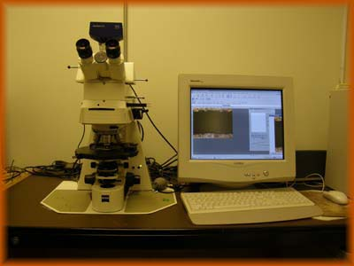
Figure 3.1 Photograph of optical Microscopy [105].

3.2.2 Scanning Electron Microscope and Energy Dispersive Spectroscopy System

Scanning Electron Microscope, Model 6640 LV manufactured by JEOL, Japan and integrated with Energy Dispersive Spectroscopy (EDS) system manufactured by Oxford instruments, UK (Figure 3.2) [106], was used to obtain photomicrographs of the surface and cross section. The high precision system incorporated in this SEM is effectively used with a large flexible chamber that can accommodate a specimen upto 200 mm diameter. It has a resolution of 3.0 nm with an accelerating voltage of 0.3 to 30 KV and a magnification range from 5X to 300,000 can be obtained. EDS system is analytical tool, which is used in the determination of elemental chemical composition and it is interfaced with SEM. The technique utilizes X-rays, which are emitted from the specimen during the bombardment by the electron beam. The EDS detector measures the number of emitted X-rays versus their energy levels. The energy of the X-ray is characteristic of the element from which the X-ray was emitted. It is important to note that EDS analysis of light elements such as oxygen is considered to be semi-quantitative, and the relative accuracy depends on the amount present in the sample. Errors in the analysis for concentrations below 5% can be as high as ± 50% [107].
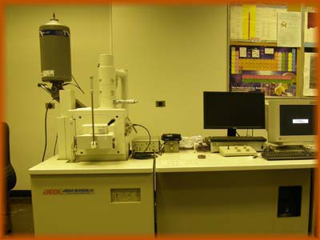
Figure 3.2. Scanning Electron Microscope JEOL 6640 LV [106]

3.2.3 X-ray Diffraction Equipment (XRD)

X-ray diffraction uses a non-destructive technique for analyzing of a wide range of materials. It is used for qualitative and quantitative phase analysis, crystallography, texture and residual stress investigations. XRD-D8 manufactured by Bruker of Germany [108] was used for phase analysis, which is shown in (Figure 3.3) and has a specifications of, 2-Theta (θ) angular range (degree) 110 to 168, with a peak count rate of 2 X 10⁶ and can hold a specimen upto 600 mm diameter. Cu-Kα radiation is used for XRD analysis with a computer based interface and display with an ability to process and analyze the diffraction data. A typical setting used was 40 Kv and 30 mA.
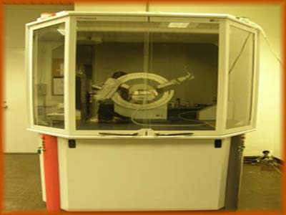
Figure 3.3. Photograph of Bruker XRD equipment[108].

3.2.4 Microhardness Tester

The indentation tests were performed by using an indentation hardness tester manufactured by Buehler, USA, (Figure 3.4) [109]. A wide range of loads 1, 5, 10, 50, 100, 300, 500 and 2000 g could be applied on the specimen by using the above hardness tester. Both thin and thick sections of the specimens could be examine. The fracture toughness of the surface was measured using the indenter test data. In this study, microhardness in HV and crack length generated du eto indentation at the surface was measured. In addition an optical microscope was used to visualize the cracks formed around indentation area. The indentation tests were performed at different locations of the laser treated surface to obtain the uniform distribution of data and to achieve the repeatabilty in results.
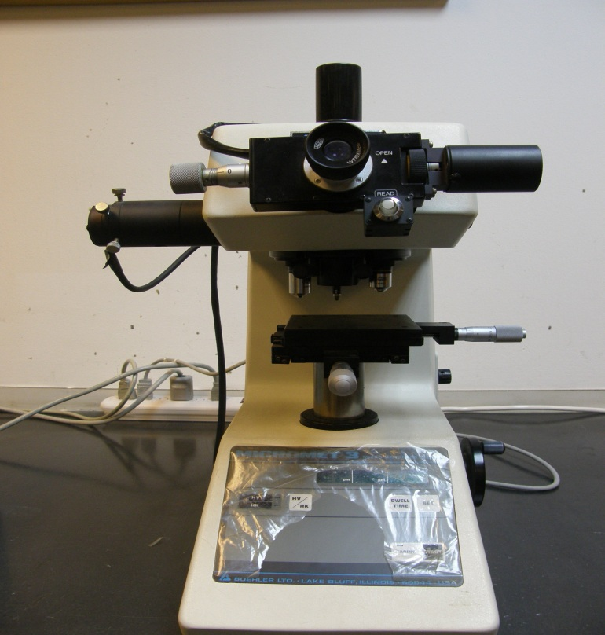
A Microphotonics digital microhardness tester (MP-100TC) was used to measure the microhardness at the surface of the nitride layer. The standard test method for Vickers indentation hardness of advanced ceramics (ASTM C1327-99) was adopted and a 300 gram load was used during the tests. The measurements were repeated three times at each location at the surface and the error estimated is on the order of 5%.

Figure 3.4. Photograph of Microhardness Tester [109]

3.3 Laser surface treatment using CO₂ laser

A carbon dioxide (CO₂) laser (LC-ALPHA III) delivering a nominal output power of 2 kW in pulse mode was used to irradiate the workpiece surface. The nominal focal length of the focusing lens was 127 mm. The laser beam diameter focused at the workpiece surface for Hyness 188 alloy and Inconel 718 alloy was 0.3 mm, and 0.25 mm for high speed steels. Nitrogen assisting gas was fed through a conical nozzle co-axial with the laser beam. The laser treatment parameters used for Hyness 188 alloy, high speed steels and Inconel alloy are given in Tables 3.1 (a-c).

Table 3.1(a). Laser gas assisted nitriding conditions used for Hyness 188 alloy.
Table 3.1(b). Laser gas assisted nitriding conditions used for high speed steels.

Table 3.1(c). Laser gas assisted nitriding conditions used for Inconel 718 alloy.
Feed Rate  (m/s) | Peak Power  (W) | Duty Cycle  (%) | Frequency  (Hz) | Nozzle Gap  (mm) | Nozzle Diameter  (mm)  (mm) | Focus Diameter  (mm) | N₂ Pressure  (kPa)
0.1 | 2000 | 15 | 500 | 1.5 | 1.5 | 127 | 600

3.4 Materials and Surface Preparation Prior to the Laser Surface Treatment

The material used in this investigation are Hyness 188, Inconel 718 alloys, and high speed steels. The chemical composition of these alloys are given in Table 3.2. Sample size was 15 mm × 13 mm × 3 mm. The water soluble phenolic resin was mixed with 5% (by volume) of TiC powders of about 400 nm particle size and homogeneous mixing was ensured prior to applying to the workpiece surface. A uniform phenolic resin film, containing 7% of TiC powder, thickness of about 40 micrometer was produced at the steel surface in a control chamber at 8 bar pressure and 175 ºC for two hours. The workpieces were then heated to 400 ºC in an argon environment for six hours to ensure the conversion of the phenolic resin into carbon. The carbon and TiC containing film provides improved absorption of the incident laser beam and holds TiC particles at the workpiece surface prior to laser treatment process. The carbon and TiC-containing film obtained on the specimen surface were scanned by a laser beam according to the parameters given in Table 3.1 (a-c).

Table 3.2 a,b & c Chemical Composition of Experimental Alloys

- Chemical Composition of Hayness 188
(b) Chemical Composition of HSS

C | Si | Mn | P | S | Cr | Mo | V | Fe
0.78-0.88 | 0.20-0.40 | 0.20-0.40 | 0.35 | 0.35 | 3.75-4.50 | 4.50-5.50 | 1.6-2.2 | Balance

(c) Chemical Composition of Inconel 718

Ni | Fe | Cr |  | Cu |  | Mo | Nb | C | Mn
50-55 | Balance | 17-21 | .3 max |  |  | 2.8-3.3 | 4.75 - 5.50 | 0.08 max | .35 max
P | S | Si |  |  | Ti | Al | Co | B
.015 max | .015 max | .35 max |  |  | .65-1.15 | .20-.80 | 1.00 max | 0.006 max

3.5 X-ray Diffraction Technique for Residual Stress Measurement

The position of the diffraction peak exhibits a shift as the specimen is rotated by an angle ψ. The magnitude of the shift is related to the magnitude of the residual stress. The relationship between the peak shift and the residual stress (σ) is given by [110]:

(1)
where E is Young’s modulus, ν is Poisson’s ratio, ψ is the tilt angle, and d_{n} are the d_{o} spacing’s measured at each tilt angle. If there are no shear strains present in the specimen, the d spacing changes linearly with sin²ψ. XRD measurements were repeated three times and the error related to the measurements is on the order of 3%. In addition, the coefficient of determination corresponding to the linear fit is R² = 0.98.

3.6 Fracture Toughness Measurements

The fracture toughness of the surface is measured using the indenter test data from microhardness (Vickers’s) and crack initiation (Figure 3.5).
Figure 3.5. Geometric configuration of indention mark and crack length in relation to fracture toughness measurement.

In this case, microhardness in HV and the crack length generated due to indentation at the surface are measured. The length of the cracks, which are generated due to indentation at the surface are measured. The length (l) measured corresponded to the distance from the crack tip to the intend. The crack lengths were individually summed to obtain ∑l as described in the previous study [111]. The crack length (c) from the center of the indent is the sum of individual crack lengths (∑l) and half the indent diagonal length (2a). Therefore, c = a + ∑l [112]. However, depending upon the ratio of , various equations were developed to estimate the fracture toughness (K). However, the equation proposed by Anstis et al. [113] and Evans [114] has limitations due to nonlinearity of the coefficients for values of , which is not the case for the alumina (≈ 0.8 - 1.5). Therefore, the equation proposed by Evans and Wilshaw [115] is used to determine the fracture toughness (K), which is applicable for ( [111]), i.e.:

(2)

where P is the applied load on indenter, c is the crack length, and a is the half indent diagonal length. Moreover, in order to visualize the cracks formed around the indention mark, top surface of coating is grinded slightly.

3.7 Determination of Young’s modulus and Rate of Stress Release by Three-Point Bending Tests

The Formulation of Young’s modulus is given in the previous study [116] therefore, only the governing equations will be presented. After assuming the symmetry during the bending test in relation to Figure 3.6, the Young’s modulus can be written as [117]
Figure 3.6. A schematic view of three-point bending testing and relevant dimensions.

(3)
where I_{s} and I_{c} are the moment of inertia of the substrate material and the coating, P is the applied load, l is the distance between the supports, and d is the displacement of the substrate material and coating during the bending tests. The moments of inertia are:
where b is the width of the substrate material and the coating.
The rate of strain energy release (G_{ss}) due to crack formation can be determined from the strain energy per unit cross [118-119]. It should be noted that the coating thickness (h_{c}) must be less than thickness of the substrate material (h_{s}):
(4)
Where M and λ are:
The load-displacement data in the plastic region is used to compute the stress relaxation rate. Table 3.3 gives the geometric data used in the simulations.
Table 3.3 Data used in the calculations of Young’s modulus from three-point bending tests.
 | As Received | Heat  Treated | TiN Coating | Laser-Nitrided Section | Laser-Nitrided and Coated Section
hs (m) | 0.003 | 0.003 | 0.003 | 0.003 | 0.003
P (N) | 6100 | 6100 | 7210 | 8140 | 8100
hc (m) |  | - | 0.000002 | 0.00008 | 0.000074
l (m) | 0.0265 | 0.0265 | 0.0265 | 0.0265 | 0.0265
d (m) | 0.00056 | 0.00057 | 0.0006 | 0.00065 | 0.00064
b (m) | 0.01875 | 0.01875 | 0.01875 | 0.01875 | 0.01875
Is (m⁴) | 4.21875E-11 | 4.21875E-11 | 4.21875E-11 | 4.21875E-11 | 4.21875E-11
Ic (m⁴) | 0 | 0 | 1.05609E-14 | 4.44775E-13 | 4.56492E-13

Chapter 4: Results and Discussion

4.1 Introduction

This chapter is divided into two sub-sections. The results and discussions based on the previous work is briefly introduced in the first sub-section and later the findings of the current research work are presented under the appropriate sub-headings.

4.2 Results and Discussions based on the Previous Research Work

4.2.1 Laser Treatment of Cemented Carbide Cutting Tool [50]:

Laser gas assisted processing of cemented tungsten carbide tool surface is carried out. Figure 4.1 shows XRD results obtained prior and after the laser heating process. Tungsten carbide peaks are present in the XRD spectrum and the peaks are dominant particularly prior to laser processing. Moreover, tungsten nitride (WN) peaks are evident after the laser treatment of the surface. In this case, the formation of tungsten nitride is due to volatile carbonic gasses leaving the modified tungsten compounds during laser processing. Due to the larger atomic sizes of tungsten as compared to nitrogen, tungsten possibly accommodates nitrogen with small distortion in the lattice (a = 2.91 A⁰ before the laser treatment and a = 2.893 A⁰ after the laser treatment). However, once the accumulation of nitrogen increases, lattice distortion results in amorphous compound in the surface region. However, WN peaks are weaker in XRD spectrum suggesting that the nitrogen rich region is considerably shallow, probably limited to the vicinity of the irradiated surface. In the case of EDS results, which are shown in Table 4.1, tungsten weight percentage reduces in the surface region after the laser treatment. However, enrichment of tantalum and cobalt at the irradiated surface is attributed to the melting and flow of tantalum from vicinity to the surface. Consequently, cobalt and tantalum partially fills the area evacuated by the early evaporation of these compounds from the surface as similar to the previous observations.
Figure 4.1. XRD results for the workpiece (cemented carbide cutting tool) prior and after laser treatment process.

Table 4.1 – Elemental composition of results after laser treatment (%wt.) of cemented carbide cutting tool.
 | W | Ta | Co | Ti
Laser Treated | Balance | 2.15 | 2.03 | 17.69
As received | Balance | 2.7 | 2.03 | 18

Figure 4.2 shows SEM micrographs of tool surface prior and after laser treatment process. Tool substrate composes of very fine (∼ 2µm size, figure (4.3)) tungsten carbide particles (71%, wt.) and the structure is free from voids and irregularities such as microcracks. Moreover, it is evident that multi-directional cracks are formed at the surface of the laser treated workpiece and the size of the cracks is notably large ( ∼ 500 µm). Cracks are formed because of the rapid heating and high cooling rates during the solidification of carbide compounds. Since cobalt and tantalum have relatively lower melting temperature than tungsten carbide, they melt and partially evaporate from the surface. Early evaporation and melting of binding agents cools the workpiece surface. This delays the melting of the tungsten carbide particles in the irradiated region. However, the cooling process is rapid, which in turn, results in crack formation in the region affected by the laser irradiation. Moreover, the depth of cracks extends deep into the substrate material. This can be observed from figure 4.4, in which cross sectional view of laser heated region is shown. The depth of affected region is extended to 60 - 80m below the surface. In this case, once the cracks are formed in the surface region due to high thermal stresses, they extend into the substrate material where the stress level is relatively lower than the surface region. In addition, some small cavities in the form of blow holes are observed at the surface, particularly along the crack sites.
Figure 4.2. SEM micrographs of laser treated workpiece (cemented carbide cutting tool) surface.
Figure 4.3. SEM micrograph of cemented carbide tool surface.
Figure 4.4. SEM micrograph of laser treated workpiece (cemented carbide cutting tool) cross-section.
The formation of small cavities can be attributed to carbon elements, which escape during the surface ablation. Although nitrogen at high pressure is used as an assisting gas during laser treatment of the surface, existing of small oxygen content in the melting ambient results in exothermic reaction with carbon atoms forming the volatile carbonic gasses such as CO and/or CO₂ in this region. This in turn, modifies the stoichiometric carbide phases in the surface region. The hilly appearance of the surface after laser processing is attributed to the different melting and evaporation temperatures of carbide compounds in the tool material; in which case, cobalt and tantalum melts earlier. The space occupied by cobalt and tantalum carbides appears as valley while tungsten carbide appears as small hill at the irradiated surface.
Figure 4.5 shows fractured surface after the indentation tests, which was conducted for the fracture toughness measurements. Multiple crack formation around the indent is evident indicating the hard and brittle structure in the surface region. The facture toughness was determined from equation 2 using the measurement data is 0.39 - 0.43 GPa while the fracture toughness of tungsten carbide is 0.3838-0.5793 GPa. Consequently, calculated values of fracture toughness using the present measurement agrees well with the values given in the open literature. Hardness of the surface prior and after the laser treatment varies slightly (Table 4.2). In this case, surface hardness after laser treatment improves, which may be due to the rapid solidification and nitrogen compounds formed at the surface.

Indention mark on the laser treated workpiece surface.
Figure 4.5. Indention marks on the as received and laser treated surfaces (cemented carbide cutting tool) for the fracture toughness measurements
.

Table 4.2 – Microhardness measurement at the surface (cemented carbide cutting tool) prior and after the laser treatment

As received Surface  (HV) | Laser Treated Surface  (HV)
1630 | 1500 - 1800

4.2.2 Laser Gas Assisted Nitriding and Tin Coating of Ti-6Al-4V alloy: Experimental and Numerical investigation of Mechanical Properties [54].

In this study, three-point bending tests of laser gas assiting nitrided, laser gas assisting nitrided and coated, heat treated and coated specimens are carried out. The Young’s moduli of the treated alloy surfaces are obtained through the three point bending tests. Material characterization of the laser nitrided surfaces is carried out using SEM and EDS. Jeol 6460 electron microscopy is used for SEM and EDS examinations.
Figure 4.6.a shows cross-section of laser nitrided surface prior to TiN PVD coating while figure 4.7 shows cross-section of i) laser nitrided and TiN coated surface and ii) heat treated and TiN coated surface. The laser nitride laser is uniform and free from cracks. The heat treatment conditions are given in [54]. The feathery like structure is the indication of the nitrogen rich components, which are located in the surface region. Moreover, cavity formation and voids are not observed in the surface region. However, some depth below the surface (∼ 80 μm), needle like structure is observed. This shows the termination of nitriding zone. Figure 4.8 shows surface roughness of laser nitrided surfaces while Table 4.3 gives the surface roughness (Ra) values of the surfaces after the treatments.
Figure 4.6. Cross-section of the laser nitrided specimen prior to TiN PVD coating of Ti-6Al-4V alloy.
Figure 4.7. Cross section of i) the laser nitrided and coated specimen of Ti-6Al-4V alloy. and ii) the heat treated and TiN coated specimen of Ti-6Al-4V alloy.
Figure 4.8. Surface roughness of the laser nitrided specimen of Ti-6Al-4V alloy.

Table 4.3. Surface roughness values for the treated surfaces of T-6Al-4V alloy.
 | Ra (μm)
Laser Nitrided Surface | 10
Laser Nitrided & TiN coated Surface | 2
Heat treated & TiN coated Surface | 0.8

It should be noted that the laser treated surfaces are polished briskly to obtain the surface roughness in the order of (1.5 μm) before TiN coating. This is because of the high surface roughness of the laser nitrided layer, which made it difficult for the uniform TiN coating. It is evident that surface roughness is significantly less in the case of duplex treated workpiece. The surface roughness of the specimen attains as high as 10 µm, which is due to the evaporation at the surface during the laser gas assisted nitriding process. EDS analysis in the surface region of the specimen reveals that aluminum depletion occurs in this region (Table 4.4). This is because of partial evaporation of the aluminum from the surface during the laser irradiation pulse. This surface roughness due to evaporation is also seen from figure (4.7), in which nitride layer cross section is shown.
Table 4.4. EDS results of the laser nitrided layer of T-6Al-4V alloy.
 | Ti | Al | V
At Nitrided Surface | Balance | 4.6 | 4.1
In Nitrided Layer | Balance | 6.1 | 4.1

Figure 4.9 shows surface of the coated specimen after-three-point bending tests. In the region close to the indent, where maximum deflection of the workpiece occurs, multiple cracks in coatings and delamination of fractured surface are observed, particularly for the as received and coated specimen. This situation is associated with the shear deformation taking place at coating base material interface. In this case, TiN coating with high stiffness is brittle and shear stress developed at coating-base interface initiates crack formation and deformation of coating during the bending tests. Moreover, initial crack formation in coating results in stress relaxation at coating-base material interface. However, as bending progresses, rate of shear strain enhances, which in turn accelerates crack formation in the coating. In this case, initially crack sites does not extend due to shear relaxation, but new cracks are formed in the coating. This situation results in multiple cracking of the coating as observed from the SEM micrograph. Cracks formed in coating do not propagate into the substrate material during the bending.
Figure 4.9. Surface of the as received and coated specimen after three-point bending test of Ti-6Al-4V alloy.
However, once the substrate material cracks during the bending, coating confines with material crack. This indicates that coating adherence to substrate surface is considerably sound so that substrate material deformation extends into coating without coating spalling and peeling off. In the case of laser nitrided and coated specimen, (figure 4.10) cracks are scattered in the coating and the density of the crack site is less than that of as received and coated specimen. This is because of the stiffness of the coating, which is almost similar to the nitride layer. This prevents excessive shear deformation at the coating and nitride layer interface. Moreover, some cracks extend into the nitride layer, particularly in the region of the indenting due to the high bending load.

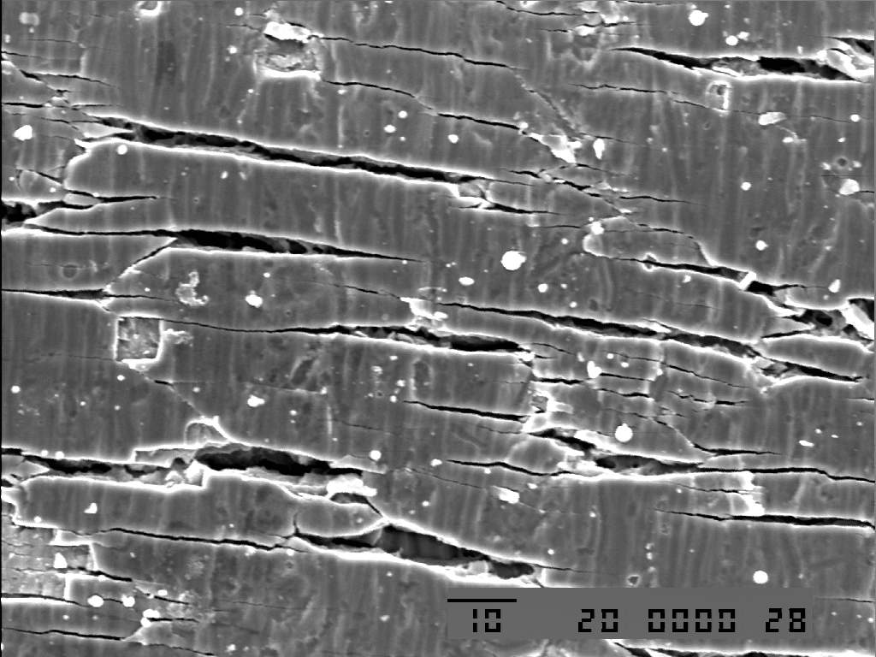

Figure 4.10. Surface of the laser nitrided and coated specimen after three-point bending test of Ti-6Al-4V alloy.

4.2.3 Laser Gas Assisted Nitriding of Alumina Surfaces [56]:

Laser gas assisted surface treatment of alumina is carried out and morphological as well as metallurgical changes in the laser irradiated zone are examined. The elastic modulus and fracture toughness of the resulting laser treated layer are measured using the indentation tests.
Figure 4.11 shows optical micrographs of laser irradiated surface and the SEM micrographs of the top surface of the laser treated and untreated workpieces. It is evident from SEM micrographs that the untreated alumina surface has some small scattered porosity. This is related to the manufacturing of the alumina tiles, in which the alumina powders are used. However, laser re-melting provided smooth surfaces without defects. However, in the case of high duty cycles of laser output, in which case the laser power intensity is high, scattered fine surface cracks are developed. Some of these cracks join to form larger and deep cracks while modifying the surface texture. The formation of cracks is associated with the high temperature gradient in the surface vicinity of the workpiece. This, in turn, results in excessive thermally induced residual stresses in this region. Moreover, scattered and arbitrarily distributed cracks indicate that the cooling rate is non-uniform across the surface and resulting in non-uniform distribution of the temperature gradient in this region. It should be noted that due to the presence of pores in the surface region, thermal conductivity reduces and temperature gradient increases significantly. SEM micrograph shows that surface is completely melted and pore holes are not visible at the surface. However, the short of crack formation at low laser power intensity is because of the low temperature gradient resulting in low thermal stress levels. In addition, some sub-micron size pores and heterogeneity in the laser treated zone limits the propagation of the micro-fracture. In this case, variation in thermal expansion coefficients for different species, in the irradiated zone, results in branching of micro-fractures at grain boundaries of different species.

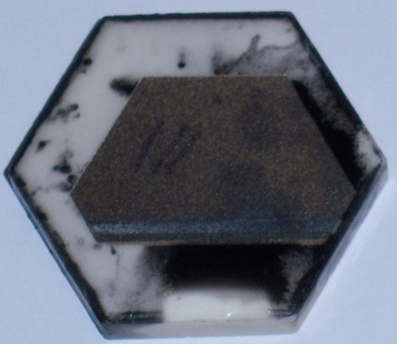
Untreated Surface
Laser Treated Surface
Carbon Residue

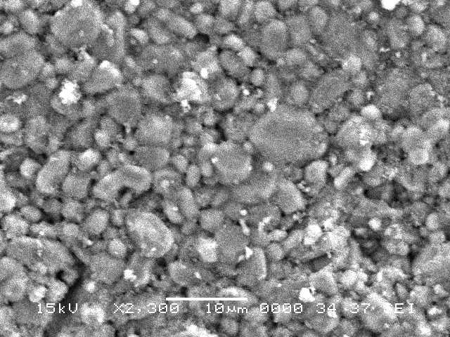
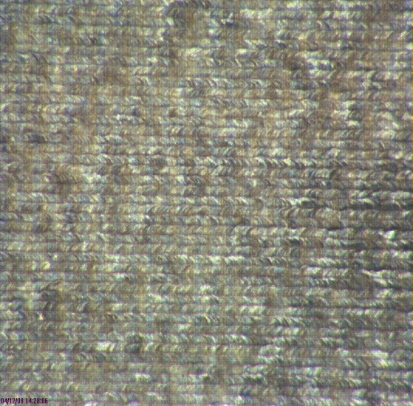
Top view of alumina tile
Laser Tracks

Voids

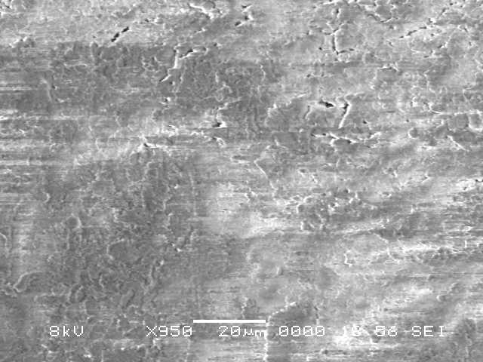
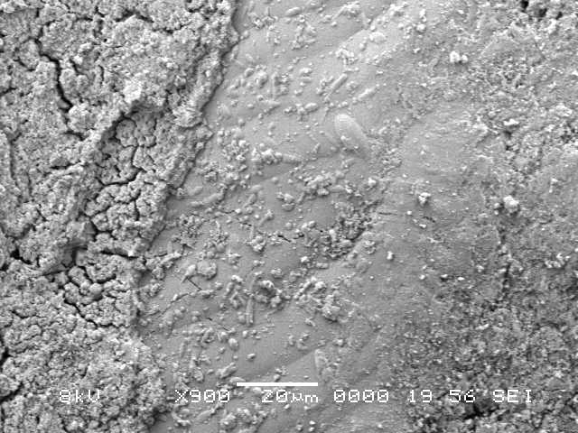
Optical micrograph of laser treated surface Micrograph of as received surface
Cracks
Laser Power = 120 W Laser Power = 180 W
Figure 4.11. Optical and SEM micrograph of laser treated and as received alumina surfaces.
Figure 4.12 shows SEM micrographs of laser treated alumina cross section. It can be observed that laser treated section extends about 40m below the surface. The close view of the laser treated region reveals that two regions can be distinguishable. The first region is close to the surfaces while the second region lies below the first region. The first region is dense and free from pores and cracks, which is true for the treatment at low laser power intensity while micro-cracks are observed for the condition of high laser power intensity setting. This is because of the development of the high temperature gradient and resulting high thermal stress levels. The dense layer is AlN and -Al₂O₃ and the second layer is -Al₂O₃. It should be noted that transformation of -Al₂O₃ to -Al₂O₃ occurs at around 1100⁰ C, which is lower than the melting temperature of alumina (~2050⁰ C). Moreover, the grains in the region close to the surface are considerably smaller than the alumina grains in the treated region. This is because of the one or all of the following reasons: i) Formation of AlN in this region, and ii) high cooling rate, due to heat convection at the surface, results in smaller grains in the surface region. Moreover, the transformation of Al₂O₃ in to AlN generates slight volume shrinkage, since the density of AlN is lower than Al₂O₃. The volume shrinkage results in excessive compactness in the coatings and randomly distributed sub-micro-pores in the surface region, provided that only few pores are observed in this region. However, in the second layer, randomly stacked lamellae structure is observed. In addition, heat affected zone is not observed clearly between the second region and the alumina base. This is attributed to the heat release during the solidification, which transfers heat to the solid phase at melt-solid interface. This, in turn, results in a solid phase transformation in the region next to the melt-solid interface. Since the thermal diffusivity of alumina is low, the depth of the heat affected zone becomes considerably shallow.
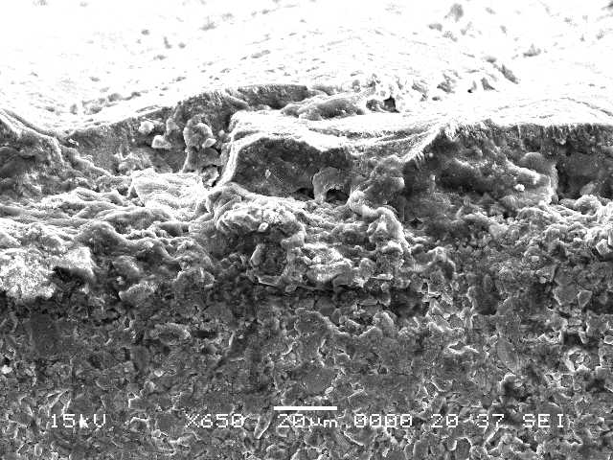
Free surface

First Region

Second Region
Base Material

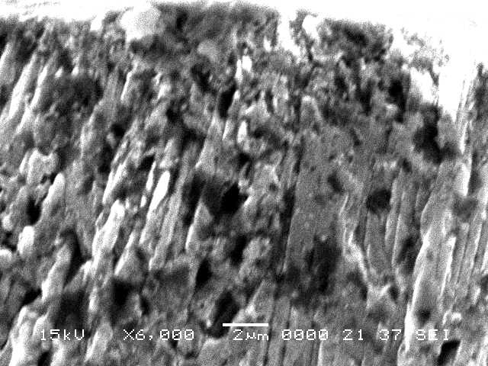
Cross-section of laser treated alumina
Pores

Cross-sectional close view of first region (Compact structure)
Figure 4.12. SEM micrographs of cross-section of laser treated workpiece (alumina).
Figure 4.13 shows XRD difractogram for the laser treated and untreated workpieces. The diffractogram for untreated workpiece shows that -Al₂O₃ phase is present predominantly with existing of -Al₂O₃ phase. It should be noted that during the preparation of alumina tiles from the powders, rapid cooling rates causes formation of metastable -Al₂O₃.

Figure 4.13. XRD difractogram for laser treated and as received workpieces (alumina).
However, laser treatment causes transformation of -Al₂O₃ in to a stable -Al₂O_{3.} The formation of thermodynamically stable -Al₂O₃ phase can be attributed to thermally relaxation of non-equilibrium -Al₂O₃ phase which has a defect spiral structure. Moreover, formation of AlN is evident with the lattice parameter nm and nm. The nitriding reactions cause AlN to grow gradually in the irradiated zone. Consequently, the depth of nitrided zone becomes shallow, which is limited with the first region in the nitrided surface. The diffractogram peak for AlON species is also observed. This can be related to lone oxygen released from the alumina during the laser treatment process. In this case, when temperature reaches above the melting temperature, AlO is formed through the reaction:
Al₂O₃ 2AlO + 1/2 O₂
The lone oxygen atom remains in the alumina structure. However, under the nitrogen ambient, the following reaction takes place:
2AlO + N₂ 2AlON
The formation of AlON species increases the hardness and ductility of the surface.
Table 4.5 shows fracture toughness measurement results. The fracture toughness of laser nitrided surfaces is less than that corresponding to as received surface. The percentage difference in the fracture toughness between the laser treated and as received surfaces is about 22%. Moreover, the microhardness for the laser nitrided surfaces attains slightly higher value than that of as received surface. This is associated with the AlN compounds formed in the surface region during the laser treatment process; in which case, compact structure is formed in this region. Since the stress value is negative, the compressive stress field is generated in the first region where AlN compound is formed. It should be noted that the fracture failure takes place at the surface in tension, but can also occur due to surface compressive stresses. Consequently, the failure under compression occurs, when the crack tip exceeds the sum of theoretical strength and compressive stress, in line with the early findings.
Table 4.5. Data obtained after indentation tests of alumina surface. The error estimated based on the repeats of the indentation test is 7%.
 | Fracture Toughness  (MPa•m^{1/2} ) | E  (GPa) | H  (HV) (GPa) |  | P  (N) | l×10⁻⁶ (m)
As received workpiece | 3.5 | 280 | 1100 | 10.8 | 20 | 320
Laser treated workpiece | 2.7 | 310 | 1150 | 11.3 | 20 | 380

4.2.4 Laser Melting of Carbide Tool Surface: Model and Experimental Studies [62]:

Laser heating of cemented carbide tool is carried out. The microstructural changes in the laser irradiated region are examined using Scanning Electron Microscopy. Figure 4.14 shows optical photograph and SEM micrograph of the laser irradiated spot while figure 4.15 shows SEM micrograph of untreated tool surface. Microvoids around the carbide particles for the as received carbide tool surface are visible (figure (4.15)), which in turn resulted structural inhomogenity. It is evident that no surface cracks or voids are visible after the laser treatment process (figure (4.14)). This can also be seen from the cross-sectional view of the laser treated carbide tools (Figure(4.16)). The melt depth layer extends almost 50 μm below the surface for β = 0 while it is about 20 μm for β =1 heating conditions. Moreover, the fine microstructures are developed in the surface region of the laser irradiated zone. This reveals that the high cooling rates during the solidification are responsible for the refinement of the grains. Consequently, convective cooling and heat diffusion into the solid substrate result in high cooling rates; which are sufficient to modify the grain structure in the irradiated region, i.e. homogeneous structure can be generated.
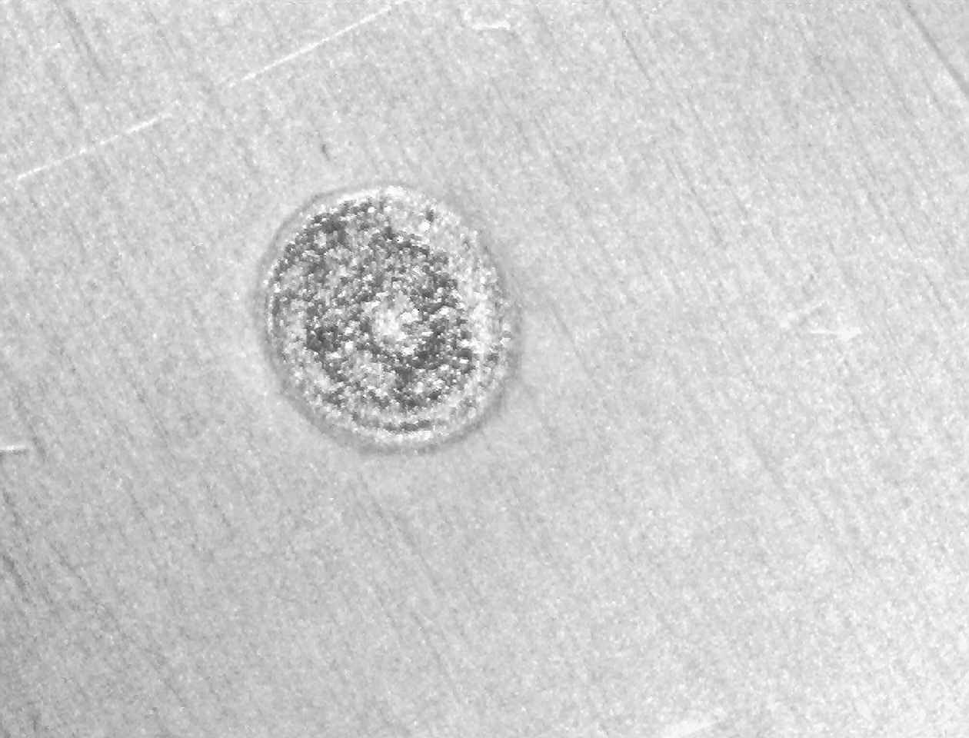

Top view of laser irradiated spot
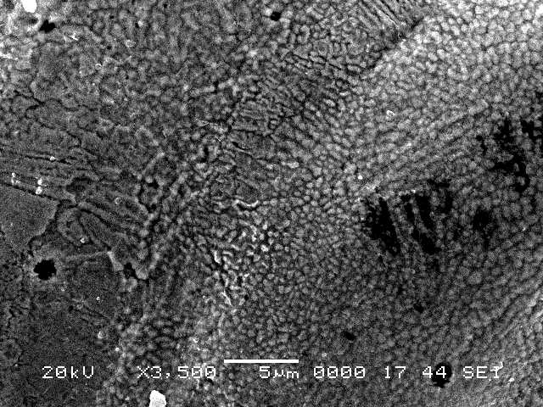

Top view of edge of the laser irradiated spot
Figure 4.14. Optical photograph and SEM micrograph of top view of the laser irradiated spot (alumina).
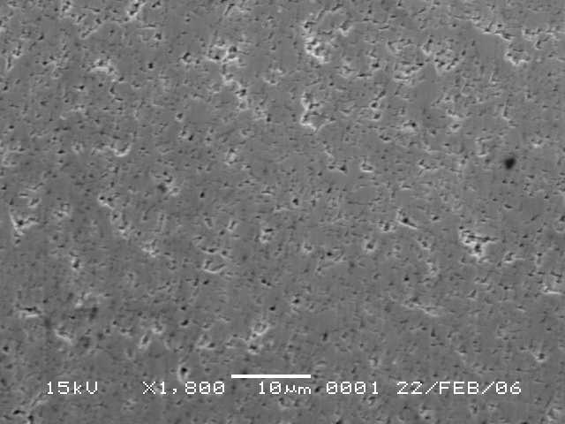

Voids

Figure 4.15. SEM micrograph of top view of the cemented carbide tool steel without laser irradiation.

Figure 4.16. Cross-sectional view of laser treated carbide tool for two β values.

4.2.5 Laser Gas Assisted Nitriidng of Steel: Residual Stress Analysis [65]:

Laser gas-assisted nitriding of steel surface is carried out. The metallurgical changes and residual stress formed in the laser irradiated region are examined using SEM, EDS, XRD, XPS and indentation tests. The elastic modulus of the laser nitrided region and the fracture toughness measured for the laser nitrided surface are given in Table 4.6. The data for the as received workpieces are also given for comparison. Elastic modulus of the nitrided region is similar to that presented in the literature. The fracture toughness of the surface reduces considerably after the laser treatment process due to the surface brittleness resulted from the nitriding process.
Table 4.6. Elastic modulus of laser nitrided layer and fracture toughness of the as received and laser nitrided steel surfaces.

Elastic Modulus  Laser Nitrided Surface  (GPa) | Fracture Toughness Laser Nitrided Surface  (MPa/m^{1/2}) | Fracture Toughness  Un treated Surface  (MPa/m^{1/2})
140 | 6.44× 10⁶ | 9.36× 10⁷

Figure 4.17 shows XRD results obtained at different depths of the nitrided layer. The different depths are obtained through a grinding of the workpiece surface at 15 μm and 60 μm depths below the surface. It should be noted that the depth of grinded surface was measured through electron microscopy. It is observed that in the surface region combination of ε−Fe₂N and ε−Fe₃N occurs. The high nitrogen content in the surface vicinity is because of the nitrogen
Figure 4.17. XRD results for laser nitrided steel surface at different depths.

diffusion which is governed by the concentration flux, i.e., high concentration flux is responsible for high nitrogen content at the surface. However, when examining the next layer (15 μm below the surface), ε−Fe₂₋₃N replaces with mixtures of ε−Fe₂₋₃N and γ′-Fe₄N precipitates. It should be noted that the rate of nitrogen diffusion is expected to be high at the grain boundaries. As the laser gas-assisted nitriding progresses, the nitrogen diffusion takes place from the grain boundaries to the grains. High nitrogen concentration results in very fine structure, which can be observed from SEM micrograph (Figure (4.18)). However, as the nitride species coarsens, the elongated and large structures are observed (Figure (4.18)). As the depth removed below the surface increases towards the solid bulk (depth of about 60 μm) ε−Fe₂₋₃N phases ceases and the intensity of γ′-Fe₄N reduces, i.e., it is only γ′-Fe₄N phase becomes notable in the XRD graph. In addition, the large structures with some small nitride compounds are dominant at this depth.
Figure 4.18. SEM micrographs of two surfaces: i) at the free surface (y = 0 m) and ii) at a depth 15 μm below the free surface of the nitrided layer (y = 15 μm).

Figure 4.19 shows SEM micrographs of the top surface of the laser nitrided workpiece. It is evident from both micrographs that nitrided surface is free from local cavitations and the cracks. However, the overlaying pattern of the laser melted zone is evident. The regular appearance of the melt pattern is associated with the laser scanning speed, provided that at higher laser scanning speed the regular pattern width reduces slightly because of the localized melt at the surface and minimized thermal agitation at high scanning speeds. Moreover, in all scanning speeds, the variation in the surface roughness is minimal. It is evident from the SEM micrograph (figure (4.20)) that the fine feathery-like fine structures are the representative of the nitride-rich compounds Fe₂₋₃N at the surface. However, the depth of nitride-rich zone is significantly shallow as observed from the cross-sectional views. This region is brittle in structure and associated with the white zone. The depth of nitride layer extends slightly more than 60 μm below the surface. It should be noted that increasing nitride depth below 60 μm from the surface was possible through increasing the laser output power. However, the high power laser irradiation initiated the evaporation at the surface while forming the cavity and increasing the surface roughness significantly. Consequently, the laser power was set to avoid the excessive surface evaporation during the nitriding experiments. This can be seen from figure (4.20), in which the SEM micrograph for the cross-sectional view of the workpiece is shown. The regular pattern appearing in the nitrided zone follows the base melt tracks. Moreover, almost uniform with constant depth of nitride layer formation is evident from the figure 4.20.
.
Figure 4.19: SEM micrographs of the top surface of the laser nitrided workpiece.

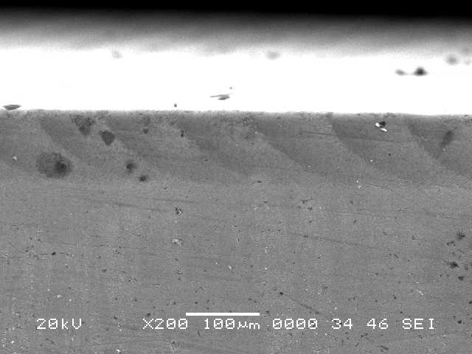
Nitride layer
Cross sectional view of the laser nitrided layer
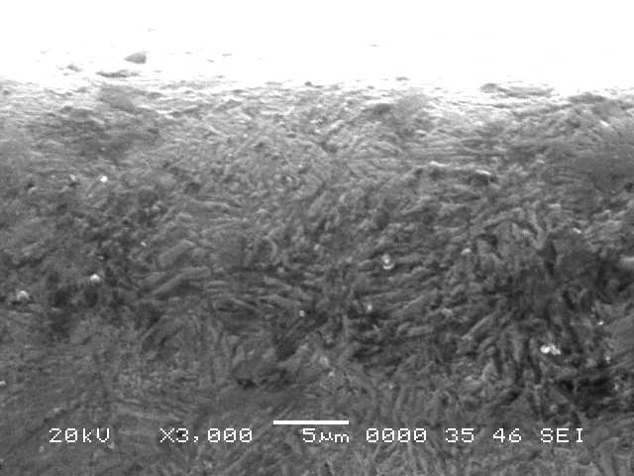

Cross sectional view of the surface region of the laser nitrided layer

Figure 4.20: SEM micrographs for the cross-sectional view of the laser nitrided workpiece.

4.2.6 Laser Nitriding of Tool Steel: Thermal Stress Analysis [66]:

Laser gas assisted nitriding of H13 tool steel is considered. Experiments are carried out to examine the microstuctural changes in the laser irradiated region and fracture toughness of the treated surface. Figure 4.21 shows SEM micrographs of laser nitrided surfaces. It is evident that nitrided surfaces are smooth and free from cracks and irregularities such as voids and cavities. It should be noted that the laser output power, feed rate, and duty cycle are selected such that evaporation at the surface was avoided during the nitriding process. Since the high frequency mode of laser is used during the nitriding experiment, the melting pattern shows continuous heating. In this case, the regular pattern of overlaps of laser spot is evident, which increases the surface roughness slightly (Ra = 0.7 m). Moreover, molten flow towards intersections of regular pattern is also evident, which appears as resolidified material at the surface of the workpiece in this region. The rapid solidification of the molten material does not result in crack formation at the surface. The dark golden color appearance of the surface reveals that the nitride species are formed in the surface region. Figure 4.22 shows SEM micrographs of the cross sectional view of the nitrided regions. Almost a uniform nitride layer is formed in the surface region and the depth of nitride layer extends about 50m (z = -0.05 mm) below the surface. Fine feathery like structures are formed in the surface region of the nitrided layer. The fine structures compose of nitride rich regions which are the representative of the white layer. As the depth below the surface increases beyond the white layer, grain size remains small. This is associated with: i) nitrogen diffusion, which replaces Fe₂₋₃N with '-Fe₄N, and ii) the cooling rate, which attains high values, since it is close to the surface vicinity. Consequently, feathery like structures replaces with fine elongated grains in the region next to the surface vicinity.
Figure 4.21. SEM micrographs for top view of laser treated surface (tool steel).
Figure 4.22. SEM micrographs of cross-section of laser nitrided workpiece (tool steel).
Figure 4.23 shows XRD diffractographs. The presence of -Fe₂N and -Fe₃N peaks reveals that nitride rich species are formed in the surface region of the workpiece (white layer). Moreover '-Fe₄N peaks indicate the presence of nitride precipitates below the white layer. It should be noted that nitrogen diffusion takes place from grain boundaries to grains; consequently nitride rich grains appear to be feathery like, which can be also observed from figure (4.22). It is also observed from the diffractogram peaks that CrN is formed in the surface region.
Figure 4.23. XRD diffractogram for laser nitrided workpiece (tool steel).

Table 4.7 gives the elastic modulus and fracture toughness of the surface region measured by the indentation tests. It can be observed that fracture toughness of the surface reduces after the laser nitriding process. This is because of : i) nitride species formation in the surface region resulting is fine and brittle structures, and ii) high cooling rates during the laser nitriding process contributes to the formation of the fine structures while increasing the surface hardness. Elastic modulus also changes after the laser treatment process; in which case, elastic modulus increases after the laser nitridng process.
Table 4.7. Elastic modulus and fracture toughness obtained after indentation tests of tool steel surfaces. The error estimated based on the repeats of the indentation test is 7%.

 | Fracture Toughness  (MPa•m^{1/2} ) | E  (GPa)
As Received Surface | 32 | 190
Laser Treated Surface | 17 | 230

4.3 Results and Discussions based on the Current Research Work

The current research studies include microsstructural, microhardness, morphological and residual stress analysis of Haynes 188 and Inconel 718 alloys, and high speed steels which are described under the appropriate sub-headings.

4.3.1 Haynes 188 alloy

Figure 4.24 shows optical photographs while (Figure 4.25) shows SEM micrographs of laser treated surface. The repetitive pulses at the surface form overlapping ratio of the irradiated spots on the order of 60%. This appears as a regular laser scan tracks at the treated surface. The laser scanning tracks are almost uniformly distributed and no excessive melt flow over the tracks is observed. In addition, no cavities or surface asperities take place after the laser treatment process. This indicates the control melting at the surface and suppression of the surface evaporation during the laser treatment process. The laser treated surface is free from major cracks. Moreover, it is evident from SEM micrograph that randomly distributed TiC particles are visible in between the tracks. This may be associated with relatively low laser intensity heating takes place in this region. It should be noted that the laser intensity distribution at the surface is Gaussian and high beam intensity occurs in the region at the center of the laser scanning tracks. However, the laser beam intensity is sufficiently high enough to melt the surface in the region between the tracks. This results in some partially dissolved TiC particles in this region. Since, the thermal expansion coefficients of TiC particles and the base material are different; the micro level stresses developed around the TiC particles during the re-solidification process. Therefore, TiC particles act as stress intensity centers at the surface region.

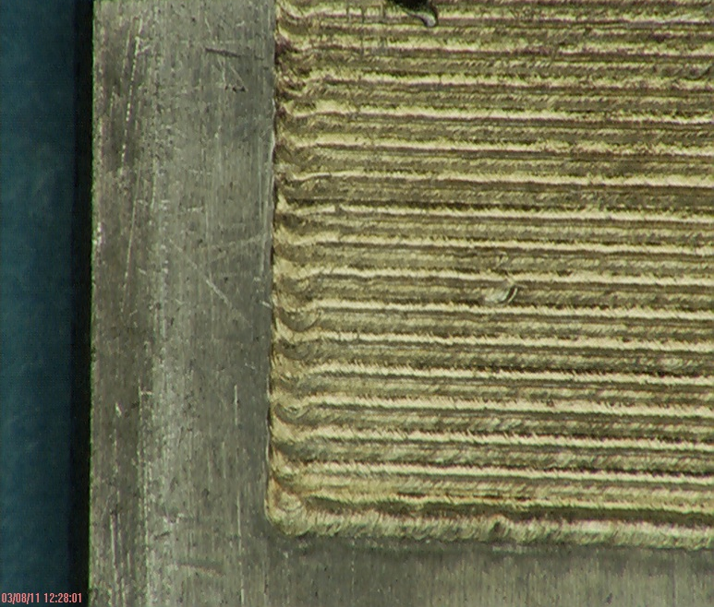
Laser Treated surface
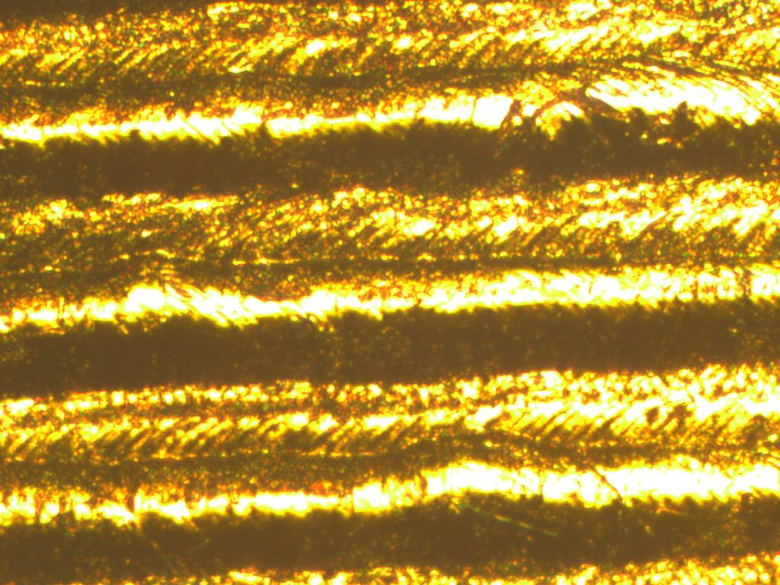
300 µm
Laser Scanning Tracks
Figure 4.24 Optical photographs of laser treated surface and laser scanning tracks of Haynes 188 alloy.
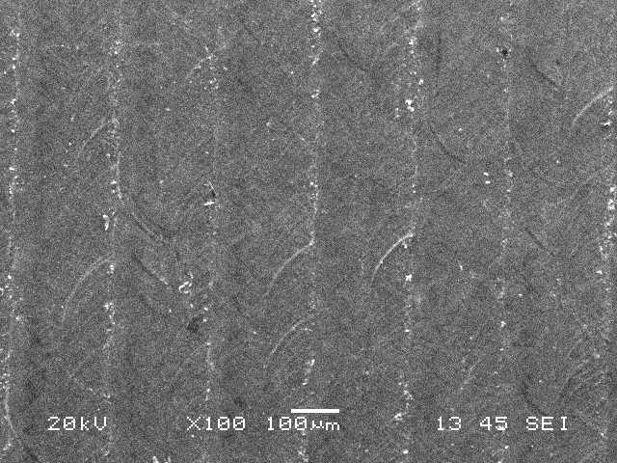
Laser Scan Tracks
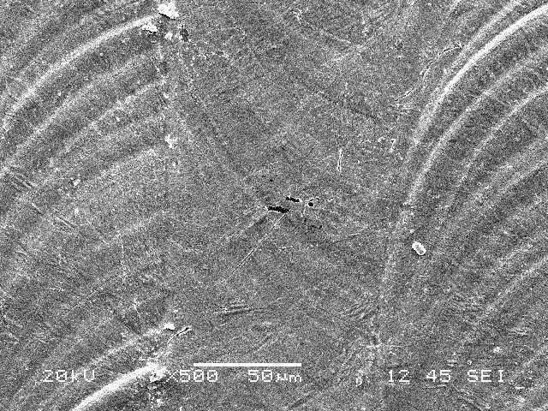
Overlapping of Laser Spots
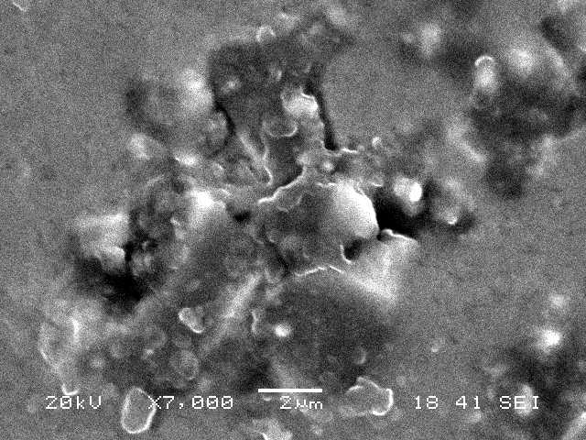
Partially Dissolved TiC particles
Microvoid
Figure 4.25. SEM micrographs of laser treated surface, overlapping of laser spots, partially dissolved TiC particles at the surface, and small voids due to volume shrinkage in the dense layer at the surface vicinity of Haynes 188 alloy.
The close examination of SEM micrographs reveals that no microcracks occur around TiC particles at the surface. This indicates that: (i) thermal stress formed around the TiC particles is not considerably high causing the crack formation in the neighborhood of TiC particles at the surface, (ii) Free expansion and contraction at the surface reduces the stress levels at the surface vicinity, hence, crack development at the surface is avoided, and (iii) the previously formed laser scanning tracks suppresses the heat conduction from the newly formed laser scanning tracks; consequently, this provides self annealing effect on the laser scanning tracks lowering the cooling rates and stress levels at the surface. The density variation due to the nitride species formation at the surface and the overlapping of the laser spots at the surface increases the roughness of the laser treated surface. In this case, the surface roughness increases almost 20% as compared to the as received workpiece surface and the average roughness (Ra) is on the order of 3.5 µm. The formation of fine grains at the surface is visible from the SEM micrographs, which is attributed to high cooling rates at the surface due to convective cooling effect of the assisting gas. It should be noted that nitrogen at high pressure is used as an assisting gas during the laser treatment process. Figure 4.26 shows micrographs of cross-section of the laser treated workpiece. It can be observed that the laser treated layer has a uniform thickness and the depth of the melt thickness extends almost 50µm below the surface. In addition, no large cracks and large size voids are notable across the cross-section of the laser treated layer. Moreover, the cross-section of the treated laser can be distinguished into three regions. In the first region, fine grains with the presence of TiC particles form a dense layer at the surface vicinity. In addition, formation of nitride species contributes to the dense structure in this region. This is because of the low density of the nitride compounds at the surface region, which results in volume shrinkage in this region.
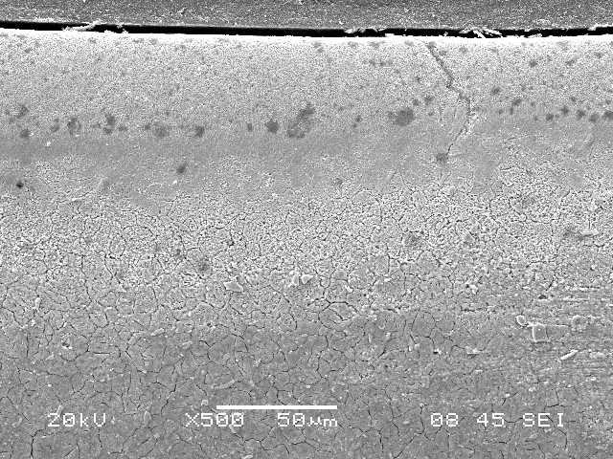
A
(a)
A
B
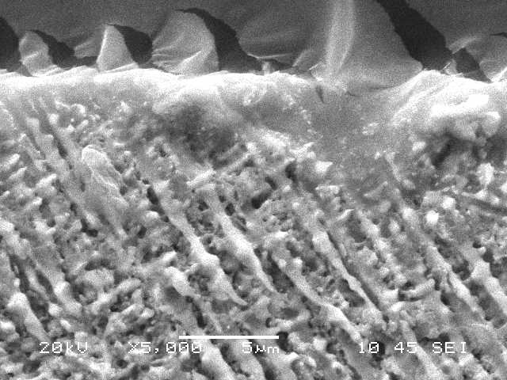
(b)
Microvoidss
A
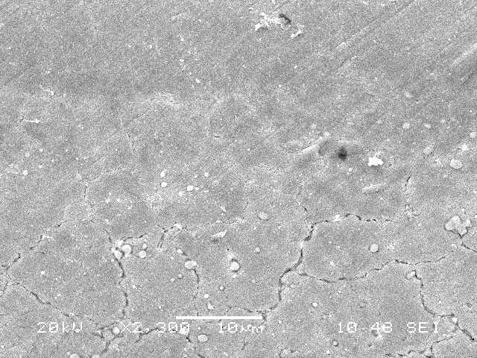
B
(c)
Large Grains
B
Figure 4.26. SEM micrographs at the cross-section of laser treated layer of Haynes 188 alloy: a) Cross section of treated layer, b) Dense structure at the surface, TiC particles, small dendrites at the surface vicinity, feather like structure, and slightly longer dendrites below the surf ace vicinity, and c) large grains in the heat affected zone.

The partial dissolution of TiC particles at the surface region reveals the melting temperature in this region well exceeds the melting temperature of Haynes 188 alloy. The micro size voids are observed from SEM micrograph at surface (Figure (4.26b)) and in the surface vicinity (Figure (4.26b)) because of the volume shrinkage. Although the thermal expansion coefficient of TiC and Haynes 188 are different, no excessive micro-stresses are formed around the TiC particles resulting the microcracks in this region. This is attributed to the self annealing effect of the previously formed laser tracks despite the high cooling rates at the surface. The dendrites are formed in the region next to the surface vicinity. In addition, feather like structures are observed in this region. The formation of dendrites in multi-direction indicates the non-uniform cooling in this region; in which case, cooling rates in all directions along the surface vicinity are not the same. This may occur because of the transient nature of the heating and cooling during the laser scanning process. Nevertheless, no microcrack is observed in this region. As the depth below the surface increases, the size of the dendrites becomes larger and the dendritic spacing becomes slightly larger, (Figure (4.26a)) as compared to that close to the surface. This indicates the slow cooling rates, which take place at some depth below the surface. However, in the region close to the base metal (Figure (4.26b)), the presence of heat affected zone is evident, in which case, large grains are observed.
Figure 4.27 shows X-ray diffractrograms corresponding to the surface of the laser treated layer. TiC peak is present in the diffractrogram due to partially resolved or solid phase TiC particles at the vicinity of the laser treated surface. The formation of ε-Fe₃ (N, C) at the surface is evident from the diffractogram. This indicates that the carbon film and high pressure nitrogen gas are responsible for the formation of carbonitride compound at the surface. In addition, formation of ε-Fe₂N is also evident at the surface region. The presence of the nitride phases results in micro- stresses developed at the surface vicinity because of the density change in this region [115].
Figure 4.27. XRD diffractogram for the laser treated surface of Haynes 188 alloy.

Consequently, this contributes to the stress levels and formation of dense layer formation at the surface vicinity. The nitrogen diffusion in to the region next to the surface vicinity causes nitride (γ'-Fe₄N) in this region, which is also seen from the X-ray diffractogram. Table 4.8 gives the EDS data at the laser treated surface. Since nitrogen is a light element and it is difficult to quantify with accuracy, the presence of nitrogen at the treated surface is evident from the EDS data. In addition, 5% of titanium indicates the presence of titanium carbides at the surface region of the laser treated layer.
Table 4.8. EDS spectrums (wt%) and their locations at the surface of Haynes 188 alloy. The error related to elemental analysis is in the order of 0.5%.

Spectrum | Ti | Cr | Mn | Fe | Ni | W | Co
Spectrum 1 | 5.02 | 27.03 | 1.04 | 3.90 | 21.23 | 13.30 | Balance
Spectrum 2 | 4.87 | 21.71 | 1.14 | 3.65 | 23.56 | 13.59 | Balance
Spectrum 3 | 4.96 | 20.89 | 1.31 | 3.70 | 23.28 | 13.40 | Balance
Spectrum 4 | 0.0 | 21.49 | 1.07 | 3.40 | 22.45 | 14.60 | Balance
Spectrum 5 | 0.0 | 21.42 | 1.11 | 3.64 | 23.60 | 13.15 | Balance

Figure 4.28 shows linear dependence of d (114) with sin² Ψ at the laser treated surface. The negative slope of the linear variation indicates the compressive residual stress at the surface. Since the intercept of the linear variation is 0.8571 Ǻ and the slope is 2.97×10⁻⁴ nm, the residual stress determined is 520±15 MPa. The data used for the stress calculation in equation 1 are E = 210 GPa and ν = 0.3. It should be noted that ε-Fe₃N (114) peak corresponds to 128.45º and interplanar spacing of 0.857Ǻ. Moreover, the measurements are repeated three times and the error related to the measurement is estimated as 0.03. The microhardness of laser treated surface increases to 560 HV which is almost 1.75 times of the base material hardness. The formation of dense layer, nitride phases, and TiC particles contribute to the microhardness increase at the surface.
Figure 4.28. Linear dependence of d(114) with sin² ψ of Haynes 188 alloy

4.3.2 High Speed Steels

Laser nitrogen gas assisted treatment of steel surface is carried out. A carbon film containing 5% TiC particles is formed at the workpiece surface prior to laser treatment process. Microstructural and morphological changes in the laser treated region are examined using optical and scanning electron microscopes, energy dispersive spectroscopy, and X-Ray diffraction.
Figure 4.29 shows optical photographs while (Figure 4.30) shows SEM micrographs of the laser treated surface. The remaining of the carbon film at the surface after the laser treatment process is evident from the optical photograph. The regular laser scanning tracks are evident from SEM micrograph at the surface and the scan width is about 200 µm wide. The overlapping ratio of the laser spots is 70%, which provides the continuous laser melting at the surface.
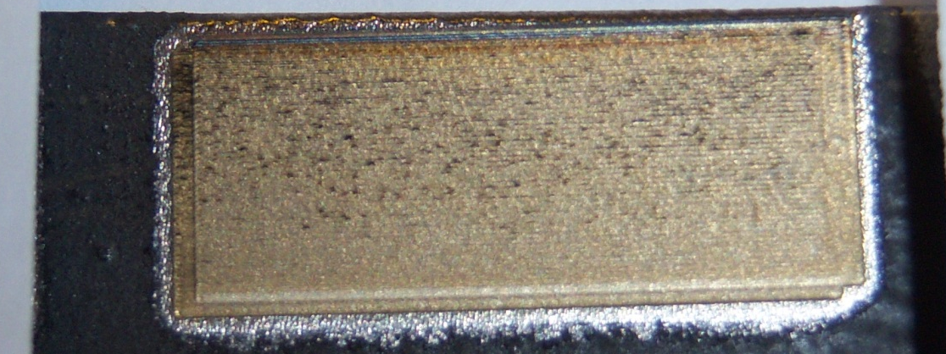
Carbon Film
Laser Treated Surface
Figure 4.29. Optical photograph of laser treated surface of high speed steel.

The close view of the surface reveals that there is no major large cracks and cavities formed. This is attributed to low laser power intensity, which suppresses the evaporation at the surface during the treatment process. However, few scattered micro-cracks are observed at the surface.

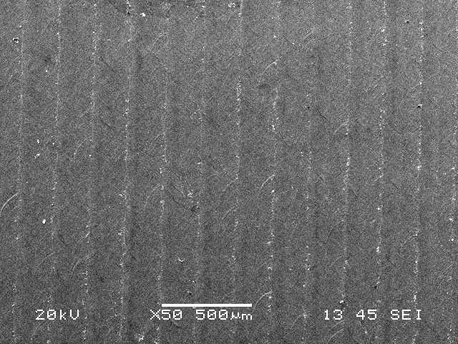
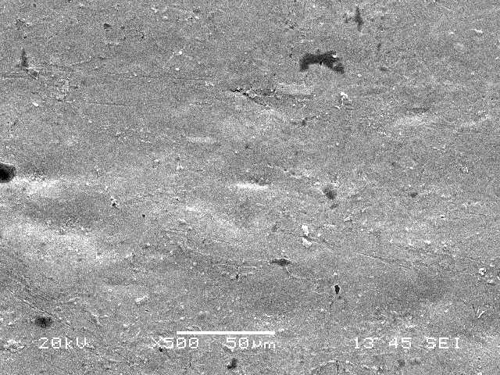
Laser Scan Tracks
As Received Surface
Laser Scan Tracks

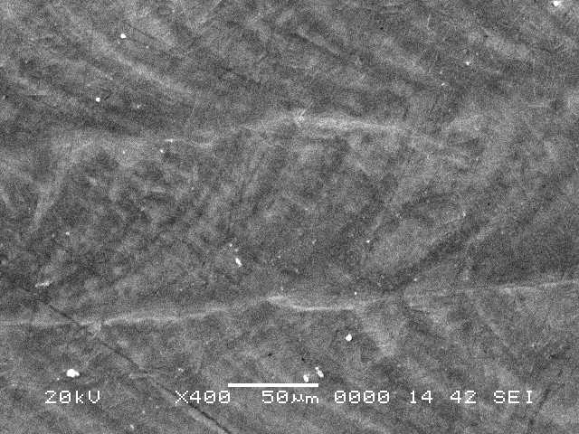
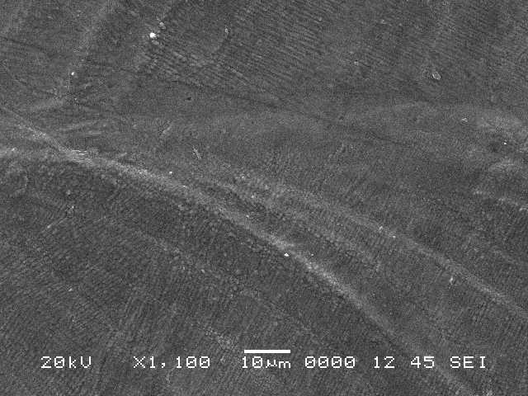
Laser Scan Tracks
Overlapping of Laser Spots
Laser Scan Tracks

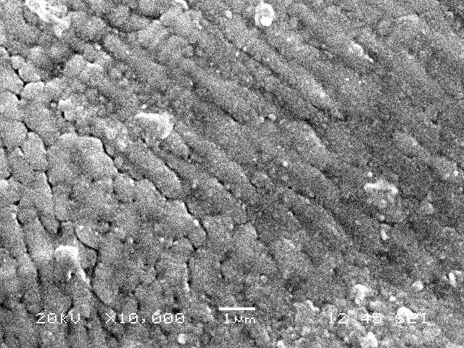
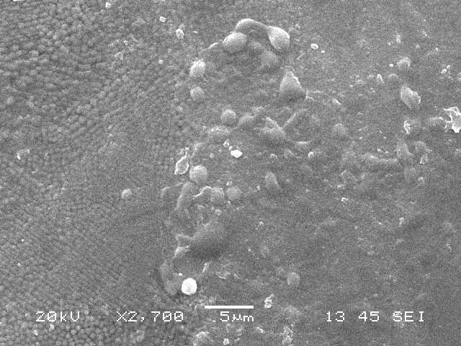
Micro-cracks
TiC Particles
Micro-cracks
Figure 4.30. SEM micrographs of laser treated surface of high speed steel.

This is attributed to the differences in thermal expansion coefficient of TiC and its surrounding steel, and high temperature gradient in the surface vicinity due to high cooling rates at the surface. It should be noted that thermal expansion and contraction of steel and TiC particles results in stress formation around TiC particles. Consequently, TiC particles acts as stress centers at the vicinity of the laser treated surface. The partially dissolved TiC particles are also observed at the surface, which is more pronounced in the between two laser scanning tracks. This is because of the relatively lower temperatures in this region as compared to that corresponding to the center of the laser scanning tracks. It should be noted that the laser intensity distribution is Gaussian, which results in high temperature at the center of the laser tracks. Moreover, the presence of few micro-cracks at the surface causes stress relaxation in this region. Therefore, the crack propagation at the surface forming the crack network is not observed. The overlapping of the laser spots results in slow cooling rates along the scanning tracks. In addition, previously formed scanning tracks cool at lower rates than those newly formed tracks. Consequently, slow cooling rates due to overlapping of laser spots and previously formed scanning tracks cause the annealing effect on the treated surface. This, in turn, suppresses the formation of major cracks and crack network at the treated surface. Moreover, the melt flow between the tracks due to excessive heating at the surface is not observed. This lowers the roughness of the laser treated surface.

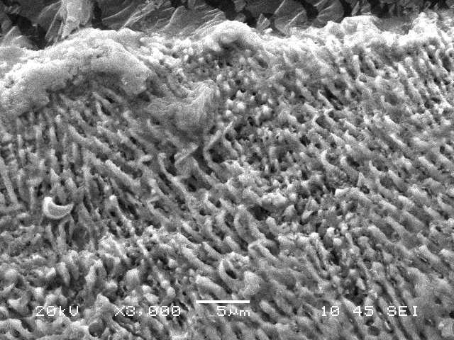
Figure 4.31 shows the SEM micrographs of the cross-section of the laser treated region. It can be observed that the depth of the laser treated region extends almost 50 µm below the surface with a uniform thickness. The demarcation line between the laser treated region and the base material is clearly seen. The microstructural changes in the treated region take place due to the phase change, high treating cooling rates, and compounds formed at the surface region.
B
A
B
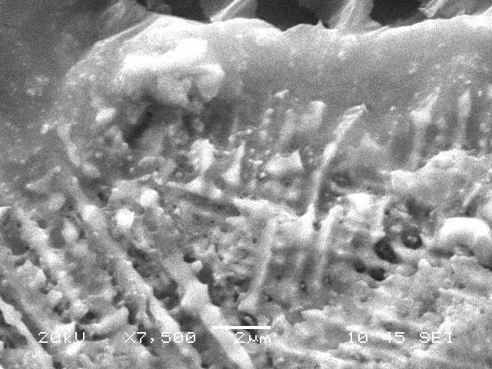
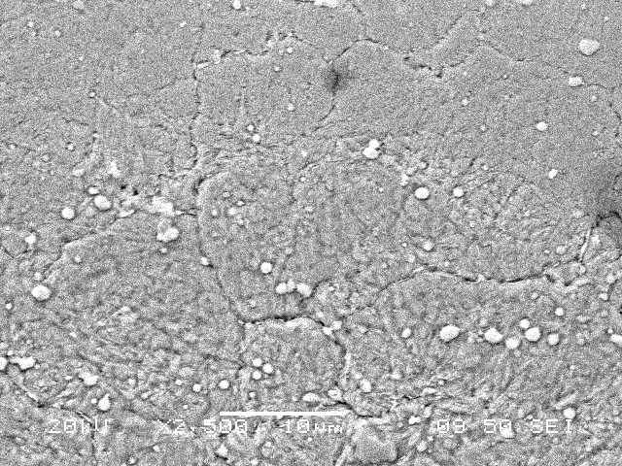
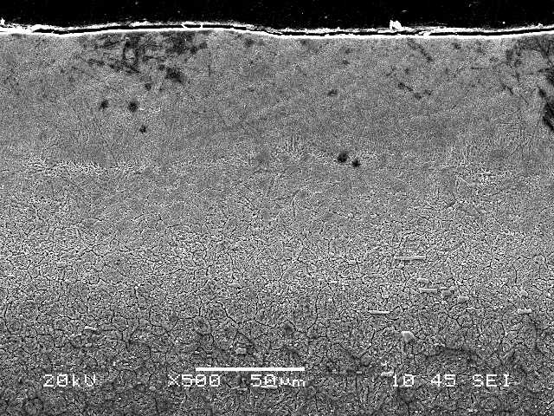
Feather like structure
Large Grains
C
Micro-void
Dense Layer
C
A
TiC Particles
Figure 4.31. SEM micrographs of cross-section of laser treated layer of high speed steel: A) Cross-section, B) Dense layer at the surface vicinity and columnar structure, C) Feather like structure below surface vicinity, D) Large grains in the heat affec
Moreover, due to high cooling rates during laser processing, high thermally stresses are generated, provided that there is no major crack being observed across the cross-section of the treated region. Three different regions can be monitored in the laser treated layer. The first layer consists of fine grains forming a dense layer at the surface vicinity. The formation of the dense layer is associated with the high cooling rates at the surface; in which case, convection and radiation heat transfer from the workpiece surface is significantly influence the grain size formation in this region. In addition, formation of nitride species at the surface vicinity results in volume shrinkage in this region contributing to the formation of the dense layer. The presence of partially dissolved TiC particles is evident at the surface vicinity. Moreover, few microcracks are observed around the TiC particles, since thermal expansion coefficients of TiC particles and its neighborhood are different. In addition, few microvoids are observed which is attributed to the volume shrinkage in this region. TiC particles are not densely populated at the treated surface vicinity due to low volume fraction of TiC, which is 5%. The second layer starts from next to the surface vicinity and extends some depth below the surface. In this layer, the microstructure is different from that at the surface vicinity. In this case, feather like structures are developed indicating the nitride compounds formation in this region. This is because of the nitrogen diffusion during the laser treatment process. The dendrites formed in this region are small, which is associated with the cooling rates. In this case, relatively slow cooling rates as compared to surface are responsible for the formation of the small dendrites in this region. No micro-crack is observed in this region, which is attributed to relatively slow cooling rates as compared to the surface. In the third region, the grain coarsening is evident due to the slow cooling rates. It should be noted that conduction heat transfer from this region towards the solid bulk governs the amount of cooling rates. The presence of heat affected zone next to this region is also evident where larger grains are observed. The demarcation line between the treated layer and the unaffected zone is clearly notable from the SEM micrograph. Figure 4.32 shows X-ray diffractogram for laser treated and workpiece surfaces.

Columnar structure
Figure 4.32. XRD diffractogram for laser treated surface of high speed steel.

The presence of TiC peaks in the diffractogram for laser treated and as received surfaces is because of the presence of TiC particles in the carbon coating. In addition, TiC peaks reveal that some of TiC particles remain in the solid phase at the laser treated surface. The use of high pressure nitrogen gas facilitates to form ε-Fe₃(N,C) and ε-Fe₃N, compounds at the surface vicinity, in which case the carbon film formed at the workpiece surface prior to laser nitriding contributes to formation of carbonitride compounds at the surface. It should be noted that formation of nitride phases involve with high micro-stresses due to the density change [110]. This contributes to the formation of dense layer at the surface vicinity. The nitride precipitates γ’–Fe₄N peak is also observed from the diffractogram. This reveals that nitrogen diffusion in the surface region is responsible for the precipitates. It should be noted that the nitrogen diffusion at grain boundaries is high. CrN peak shows the formation of chromium nitride phase at the surface. Table 4.9 gives the EDS data for as received and laser treated surfaces. It can be observed that the main constituting elements are remains almost the same for as received and laser treated surfaces. However, the presence of almost 5% titanium for laser treated surface is due to the TiC particles added in the carbon coating. Although, the quantification of the light elements like nitrogen involves with errors in the EDS data, the presence of nitrogen at the surface is evident.
Table 4.9. EDS spectrums (wt%) and their locations at the laser treated surface and at the as received surface of high speed steels. The error related to elemental analysis is in the order of 0.5%
Spectrum | Ti | Mo | V | Cr | W | Fe
Spectrum 1 | 5.1 | 4.9 | 1.42 | 4.61 | 5.74 | Balance
Spectrum 2 | 0.1 | 4.61 | 1.44 | 4.36 | 3.70 | Balance
Spectrum 3 | 4.7 | 4.97 | 1.51 | 4.25 | 3.50 | Balance
Spectrum 4 | 5.2 | 4.95 | 1.94 | 3.31 | 4.6 | Balance
Spectrum 5 | 4.8 | 4.95 | 1.80 | 2.69 | 2.94 | Balance
As Received | 0.0 | 4.92 | 1.63 | 4.21 | 3.75 | Balance
Figure 4.33 shows the linear dependence of d(114) with sin²ψ at the laser treated surface. It should be noted that ε-Fe₃N (114) peak corresponds to 128.45º and interplanar spacing of 0.857Ǻ. The slope of the linear dependence of d(114) is 2.44×10⁻³ Ǻ and the intercept of 0.857Ǻ. Since the elastic modulus is 210 GPa and Poisson's ratio is 0.3; after using equation 1, the residual stresses can be determined at the surface of the laser treated layer, which is 460 ±15 MPa. Moreover, Table 4.10 gives the fracture toughness of the laser treated surface and the data used in the calculation. The fracture toughness of the laser treated surface is on the order of 83 , which is lower than the fracture toughness of the bulk material, which is on the order of 100 . The reduction in the fracture toughness of the laser treated surface is attributed to increased surface microhardness and the dense layer formed at the surface vicinity.

Figure 4.33. Linear dependence of d-spacing with sin²ψ of high speed steel.

Table 4.10. Fracture toughness of the surface and data used in the calculations for high speed steels.

4.3.3 Inconel 718 alloy

Laser controlled melting of Inconel 718 alloy surface is carried out. A carbon film of about 40 µm thickness and containing 7% TiC particles is formed at the workpiece surface prior to laser treatment process. The microstructure and morphological changes in the laser treated region is examined.
Figure 4.34 shows SEM micrograph of the top view of the laser treated workpiece surface. It can be observed that laser treated surface consists of closely spaced regular laser tracks. The width of each track is on the order of 200 µm. The laser tracks are formed by the high frequency laser repetitive pulses during scanning at constant speed. The overlapping ratio of two consecutive pulses is about 70%, which results in continuous melting tracks without leaving un-melted region at the surface. In addition, no excess flow of the molten material in between the tracks is observed. The cavity formation due to surface evaporation is also not observed at the laser treated surface. It should be noted that increasing laser intensity and reducing the laser scanning speed results in excessive heating at the surface and cavity formation due to surface evaporation becomes unavoidable. Consequently, laser parameters selected provide controlled melting at the surface. On the other hand increasing the duty cycle from 0.15 to 0.25 (Table 3.1 a) and lowering the laser scanning speed from 0.1 m/s to 0.05 m/s (Table 3.1 b), microcracks are observed at the surface, (Figure 4.34). Therefore, low duty cycle and laser scanning speed are avoided in the experiments. The presence of partially embedded TiC particles is visible, particularly in between the tracks at the surface. This is attributed to slightly low laser intensity between the tracks; in which case, the Gaussian distribution of the laser intensity at the surface results in high intensity at the irradiated spot center and relatively low laser intensity at some distance away from the center. Moreover, due to the high cooling rates the surface, locally scattered few micro cracks are observed, provided that no crack network occurs at the surface. This prevails that the grain refinement due to high cooling rates do not yield considerably high stress levels at the vicinity of the laser treated surface. As a consequence, the crack network is avoided at the surface vicinity. Moreover, overlapping of the laser irradiated spots along the laser tracks during scanning results in self annealing of the previously irradiated spots while suppressing the formation of the crack network at the surface vicinity. The presence of partially imbedded TiC particles contribute to stress levels at the surface vicinity. This is because of the differences in thermal expansion coefficients between TiC particles and the base material. Consequently, TiC particles act as stress concentrators at the surface vicinity. It should be noted that the concentration of partially imbedded TiC particles is small at the surface vicinity; therefore, they are incapable to initiate crack network at the treated surface.

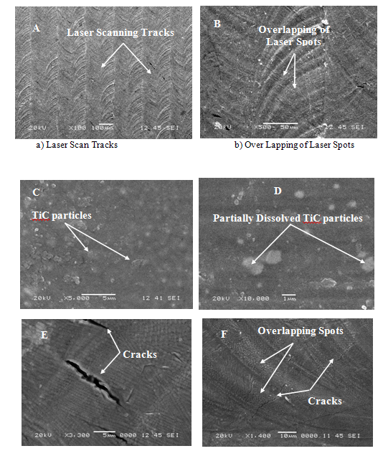
Figure 4.34. SEM micrographs of top surface of laser treated work piece of Inconel 718 alloy: a) Laser scan tracks, b) Over lapping of laser spots, c) Partial dissolve TiC region at the surface, d) partially dissolve TiC particles e) close view of cracks
Figure 4.35 shows SEM micrographs of the cross-section of the laser treated surface. It can be observed that the depth of the laser treated layer has a uniform thickness and extends almost 50µm below the surface. The fine grains forming a dense layer at the surface vicinity is evident. This is attributed to the high cooling rates at the surface due to the convection heat transfer of the assisting gas and conduction heat transfer from the surface vicinity towards the solid bulk. Although the surface is free to expand and contract during heating and cooling periods, the high temperature gradient developed at the surface vicinity results in formation of high thermal stress levels in this region. This, in turn, gives rise to microcrack formation in this region. However, no laterally extended cracks are observed. This may be attributed to the stress relaxation through micro-cracking. In addition, due to the presence of semi dissolved TiC particles at the surface vicinity, some small cracks are initiated in the neighborhood of TiC particles. This is associated with the difference in coefficient of thermal expansion due to TiC particle and its neighborhood. The dense layer formed at the surface vicinity extends at some depth below the surface. However, some locally scattered microcracks occur in the region next to the surface vicinity. This is attributed to the density variation in this region. In this case, high rate of solidification results in compressive stresses formed in the region next to surface vicinity and the carbonic gas formation increases the volume while reducing the density in this region. The formation of nitride species γ’’N and γ’N at the surface vicinity also modifies the density in this region. The diffusion of nitrogen in the region next to the surface vicinity results in formation of feather like structures in this region. The columnar dendrites are also seen at some depth below the surface vicinity. The precipitation of the particles at the grain boundary occurs, which is associated with the (NbC) carbides. This is due to that primary carbides (NbC) and γ phase precipitates are expected to occur at the grain boundaries [120].
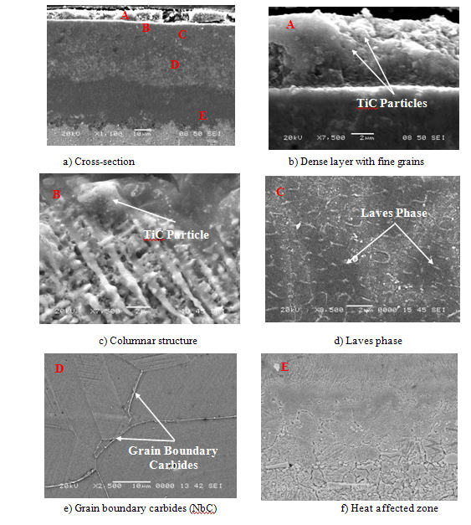
Figure 4.35. SEM micrographs of laser treated section of Inconel 718 alloy: a) Cross-section,b) Dense structure with fine grains at the surface, c) Columnar structure next to surface vicinity, d) Laves phase in the surface region, e) Grain boundary carbides f) Heat affected zone
The grain boundary cracking is not observed in this region despite the fact that the precipitation of niobium rich phase (δ - phase (Ni₃Nb)) at the grain boundaries, in general, causes the grain boundary cracking [102]. It is also possible that the amount of δ- phase precipitation at grain boundaries is small; therefore, crack initiation does not take place in this region. Moreover, in the surface region, the fine discrete particles presenting the Laves phase is observed. In this case, the precipitation strengthening phases γ’’⁽Ni₃Nb) and γ’(Ni₃(Al₃Ti)) are present. The highly interconnected Laves phase is expected to trigger the early initiation of cracks, which in turn, leads low energy fracture path [71].
Figure 4.36 shows X-ray diffractogram of laser treated surface γ’’N and γ’N nitride species are formed at the surface and the presence of TiC peak indicates the presence of solid phase TiC particles at the surface vicinity. Table 4.11 gives the microhardness results prior and after the laser treatment process. It is evident that microhardness increases at the surface, which can be attributed to the dense layer formed, nitride species formation, and dissolution of Laves phase in the region close to the surface; in this case, the amount of Nb for γ’’ precipitation increases while contributing the micro hardness at the surface. However, microhardness reduces at a depth 20 µm below the surface. Table 4.12 gives EDS data for laser treated surface. The presence of about 5% of TiC is, mainly, because of the TiC particles at the surface vicinity. Although light elements, like nitrogen is not accurately quantified from the energy dispersive spectrum, its presence at the surface is evident, which can be associated with the formation of the nitride species at the surface vicinity.
Figure 4.36. XRD diffractogram of laser treated surface of Inconel 718 alloy.

Table 4.11. Microhardness of laser treated and as received surface of Inconel 718 alloy.
 | Hardness (HV)
As Received Surface | 260±20
Laser Treated Surface | 460±20
Laser Treated Layer 20 µm below Surface | 390±20

Table 4.12. EDS analysis at laser treated surface of Inconel 718 alloy.
Spectrum | Al | Ti | Cr | Fe | Nb | Ni
Spectrum 1 | 2.27 | 4.04 | 18.06 | 18.72 | 6.18 | Balance
Spectrum 2 | 2.97 | 3.83 | 9.25 | 59.01 | 2.80 | Balance
Spectrum 3 | 0.83 | 22.25 | 14.49 | 14.86 | 5.07 | Balance
Spectrum 4 | 0.94 | 37.57 | 11.97 | 12.36 | 4.13 | Balance

Figure 4.37 shows the linear dependence of d(220), in Å on sin²ψ in the region of laser treated surface. The γ (220) peak corresponds to the inter-planer spacing of 1.272 Å. The linear dependence of d(220) results in the slope of -3.834×10⁻¹³ m and the intercept of 1.279×10⁻¹⁰ m in figure (4.14). The residual stress determined from the XRD technique at the surface vicinity is on the order of - 480±14 MPa. XRD measurements were repeated three times and the error related to the measurements is on the order of 3%. In addition, the coefficient of determination corresponding to the linear fit is R² = 0.98. In order measure the residual stress below the laser treated surface, the treated layer is grinded down 20 µm below the surface. The surface grinding results in partial stress relaxation in the treated layer; however, it is essential due to the shallow penetration depth of the X-ray source. The residual stress measured after grinding the surface is in the order of - 370±14 MPa. The attainment of the low residual stress at 20 µm below the surface is associated with the less nitrogen concentration and relatively less dense structure in this region as compared that of at the surface.

Figure 4.37. d(220) spacing with sin²ψ for Inconel 718 alloy.
Chapter 5 - Conclusion and Recommendations for Future Work

This chapter is divided into three sub-sections. The conclusion based on the previous research work is briefly introduced in the first sub-section and later the conclusion of the current research work is presented under the appropriate sub-headings. Recommendations for future work are presented in the last section.

5.1 Conclusion based on the Previous Research Work

5.1.1 Laser treatment of cemented carbide cutting tool:

Laser gas assisted processing of cemented tungsten carbide tool is investigated. Metallurgical changes in the region of irradiated surface are examined and the fracture toughness of the laser treated surface is measured. It is found that laser surface treatment of cemented cutting tool improves the surface hardness. Multi directional cracks are observed due to rapid heating and high cooling rates of the surface. Early melting and evaporation of cobalt results in delayed melting of tungsten carbide in the surface region. Consequently, depth of treated zone extends further in to the substrate material via conduction. Due to the attainment of high temperature gradient, excessive thermal strain is developed in the surface region. In this case, thermal stress developed in the laser irradiated region is responsible for surface cracking. The depth of cracks extends below the surface resulting in partial fracturing of the surface. This appears as partial delamination of the laser treated layer from the base material. Existing of voids like blow holes at the laser treated surface suggests that carbon content of carbide reduces and volatile carbonic gasses are formed in this region. Tungsten nitride formation is observed from XRD results. However, depth of nitride layer is expected to be shallow due to amorphous structure. The fracture toughness of the laser treated surface is within the range of fracture toughness of tungsten carbide.

5.1.2 Laser gas assisted nitriding and tin coating of Ti-6Al-4V alloy:

Three point bending tests of the as received and TiN coated, heat treated and coated, laser nitrided, and laser nitrided and coated Ti-6Al-4V alloy is carried out. The Young's modulus of coating, laser nitrided zone, and heat treated specimen are determined from the experimental data. Gas assisted nitriding was carried out using a CO₂ laser facility while TiN coating was realized using the PVD coating unit. It is found that uniform layer of laser nitrided zone of about 80μm thickness is achieved. The nitrided zone was free from cracks and other irregularities such as porosity and voids. A uniform layer of 2 μm TiN coating is realized on the specimen surface. The close examination of SEM micrographs of the surfaces after the bending test reveals that closely spaced multi cracks are formed for the as received and coated as well as heat treated and coated specimens. However, cracks are developed within the region of the surface and crack propagation into base material through the coating interface is not observed, expect in the region of base material failure. This is because of the fact that deformation of the coating relieves the stress levels at the interface and this has a positive effect on the stress relaxation in this region. Moreover, shear failure in the surface region of the coated section can be associated with the large differences between the elastic modulus of coating and the base material. The Young's modulus for the laser nitrided region is similar to that of the TiN coating. However, heat treatment modifies the Young's modulus slightly.

5.1.3 Laser gas assisted nitriding of alumina surfaces:

Laser gas assisted nitriding of alumina tiles is considered. Morphological and metallurgical changes in the laser irradiated region are examined. The fracture toughness of the resulting surface is measured using the indentation tests. It is found that laser treatment results in smooth surface, provided that locally scattered surface cracks are observed at high laser power intensity. The depth of laser treated zone extends about 40m below the surface while forming two distinct regions. The first region is free from cracks and some sub-micro-cracks are observed due to volume shrinkage during AlN formation. Moreover, the first layer is dense and contains -Al₂O₃ and AlN. In the vicinity of the surface, the grain size becomes small due to high AlN concentration in this region. In the second layer, randomly scattered and partially stacked lamellae structure is observed. Due to the low thermal diffusivity of alumina, the size of the heat affected zone is considerably small between the second region and the base material. The presence of lone oxygen in alumina at the irradiated surface results in the formation of AlON in the surface region, which is observed from the XRD diffractogram. The fracture toughness reduces for the laser nitrided surface as compared to alumina surface.

5.1.4: Laser melting of carbide tool surface: Model and experimental studies:

Laser heating of cemented carbide tool is carried out and microstructures developed in the surface region of the irradiated spot are examined using Scanning Electron Microscope The formation of the fine structures in the surface region of the irradiated surface is due to the high cooling rates in this region. Moreover, it is possible to extend the melt layer with along the radial direction through modifying the laser power intensity distribution across the irradiated spot.

5.1.5: Laser gas assisted nitriidng of steel: Residual stress analysis:

Laser gas-assisted nitiriding of steel is considered and the residual stress developed after the nitriding process was examined experimentally. In the experimental study, the XRD technique and indentation tests are carried out. It is found that the nitride compounds formed within the surface region of the substrate material is ε−Fe₂₋₃N, while as the depth below the surface increases domination of Fe₄N compound is observed. This is because of the nitrogen diffusion rate during the laser processing; in which case, nitrogen-rich compound are formed in the surface region. SEM micrograph reveals that nitrided region extended almost more than 60 μm below the surface and the nitrided layer is free from the microcracks and the voids. When comparing the residual stress obtained from the XRD technique and the indentation tests, both results are in reasonably good agreement.
5.1.6: Laser nitriding of Tool steel: Thermal stress analysis:
Laser heating of tool steel (H13) under nitrogen gas ambient is carried out. Metallurgical changes and nitride formation in the laser irradiated region are examined using SEM and XRD. The fracture toughness of resulting surface is determined using the indentation tests. The conclusion obtained from the experimental data prevails that no crack is observed from the SEM micrographs of the workpieces. The presence of feathery like and compact structures in the surface region of the laser treated workpiece reveal the formation of nitride species in this region. This is also observed from the XRD diffractograms. The main nitride compounds are -Fe₂N and -Fe₃N with the presence of '-Fe₄N. The fracture toughness of the laser nitrided surface reduces due to the brittle structure formed in the surface region.

5.2 Conclusion based on the Current Research Work

The conclusions derived from the current research work are listed in line with the alloys used in the experiments, which are given in the appropriate sub-headings

5.2.1 Haynes 188 alloy

It is observed that uniformly distributed laser scanning tracks are formed at the surface with the overlapping ratio of 0.5 of the laser spots. The laser treated surface is free from cracks and other surface asperities such as voids and cavities. The cross sectional examination of the laser treated surface reveals that dense layer comprising of fine grains and TiC particles is formed at the surface vicinity. No microcracks are observed in the neighborhood of TiC particles despite the fact that thermal expansion coefficients of TiC particles are different than that of Haynes 188 alloy. The presence of TiC particles and volume shrinkage due to nitride phases contribute to microstress levels at the surface vicinity of the laser treated layer. The dendrites are formed in the region next to the surface vicinity and some randomly distributed microvoids occur around the dendritic structures, which is associated with the volume shrinkage due to density variation. The dendritic spacing increases as the depth below the surface increases indicating the slower cooling rates in this region as compared to that of at the surface. The presence of carbon film and high pressure nitrogen gas results in the formation of carbonitride and nitride phases at the surface during the laser scanning process. The nitride phases contribute to the formation of dense layer at the surface and enhance the microhardness at the surface. The micohardness of the laser treated layer surface increases by 1.75 times of the as received workpiece surface. The residual stress obtained from the XRD technique is on the order of 590 MPa and the error estimated in the measurements is on the order of 3%.

5.2.2 High Speed Steels

The laser treated surface is free from cracks and other surface asperities such as voids and cavities. The overlapping ratio of the laser spots at the surface is on the order of 70%, which results in continuous melting of the surface along the scanning tracks. The dense layer with fine grains and partially dissolved TiC particles are observed at the laser treated surface. The dense layer is free from major cracks despite the presence of partially dissolved TiC particles which acts as a stress concentration centers due to difference in thermal expansion coefficients between TiC particles and their neighborhood. The feather like structure is formed below the surface vicinity indicating the nitride compounds and precipitation in this region. The clear demarcation line separates the laser treated region and the base material. The grain size increases notably across the demarcation line. The X-ray diffraction peaks reveal that ε-Fe₃N, ε-Fe₃(N,C) and CrN compounds are formed at the laser treated surface. The formation of nitride compounds is attributed to high pressure nitrogen assisting gas and carbon film formed at the workpiece surface prior to laser treatment process. The micro hardness of the laser treated surface increases almost twice the surface hardness of the as received workpiece. The formation of dense layer and nitride compounds at the surface are responsible for the surface hardness increase. The fracture toughness of the treated surface reduces as compared to the base material toughness, which is attributed to the high hardness and dense layer formed at the surface. The residual stress determined from the XRD data is on the order of 460 ±15 Mpa.

5.2.3 Inconel 718 alloy

The laser scanning results in regular melt tracks with overlapping ratio of about 70%. The treated surface is free from defects such as cavities and cracks. The cross-sectional examination of the laser treated surface reveals that fine grains presenting dense layer is formed at the surface and partially dissolved TiC particles are observed in the surface vicinity. Some locally scattered microcracks occurs in this region due to high cooling rates at the surface and differences in thermal expansion coefficients between TiC particle and its neighborhood. The stress relaxation through microcracking suppresses the crack formation in the surface vicinity. Feather like structures are formed at the surface vicinity indicating the nitride diffusion in this region and the precipitation of particles occurs at the grain boundaries which is associated with the (NbC) carbides. The grain boundary cracking is not observed despite the fact that niobium reach phase (δ - phase (Ni₃Nb)) at the grain boundaries takes place. This is because of small amount of δ - phase precipitate at the grain boundaries. Laves phase is observed at the surface region, which contributes to local microcracking. γ’N nitrides are formed at the surface and the occurrence of TiC peak in X-ray diffractogram reveals the presence of partially dissolved TiC particles at the surface vicinity. Microhardness of the laser treated surface improves due to: fine grains, γ’’ precipitations, formation of nitride compounds, and dissolution of Laves phase at the surface vicinity.

5.3 Recommendations for future work

The results presented in the present study are significant, however there is a great potential for further examination of the materials Haynes 188, and Inconel 718 alloys and high speed steels. The study could be extended to conduct the following studies:
- Haynes 188 and Inconel 718 alloys, and high speed steels laser treated surfaces could be exposed to the harsh environments, both at room and high temperatures to evaluate the corrosion resistance. The study could also be extended to evaluate the erosion-corrosion characteristics by using impingement tests.
- Analysis of fracture toughness of Haynes 188 and Inconel 718 alloys, and high speed steels laser treated surfaces and establish the hardness variation of the laser treated surface.
- Transmission electron microscopy studies could be conducted to identify the precipitation and dissolution kinetics of various phases formed after the laser surface treatment.
- The mechanical properties of Haynes 188 and Inconel 718 alloys, and high speed steels laser treated could be evaluated through 3 point bend test.
- Study of wear resistance of the laser treated surface is also an important field of study, by using a tribometer this study could also be conducted.
- Replacing TiC particles with boron carbide (B₄C) on the laser treated surface and compare the findings with the results obtained from the present study, where the effect of TiC has been reported.

References

- W.M. Steen, J. Majumdar, Laser Material Processing, Springer 2010, pp. 295-347.

- V.G. Gregson, Laser heat treatment, In: Bass M (ed) Laser materials processing, Noth-Holland, Amsterdam, Chapter 4, 1984.

- T. Bell, Surface heat treatment of steel to combat wear, Metallurgia, Vol. 49, No.3, 1982, pp. 103-111.

- E. Eiholzer, C. Cusano, J. Mazumdar, Wear properties of laser alloyed Fe-Cr-Mn-C alloys, In: ICALEO ’85 Proceedings, LIA, Orlando, 1985, pp. 8.

- A. Blake, J. Mazumdar, Control of composition during laser welding of Al-Mg alloy using plasma suppression technique, , In: ICALEO ’82 Proceedings, LIA, Orlando, 1982, pp. 33-50.

- M.A. Azer, Laser powder welding: key to component production, refurbishment and salvage, Photonics Spectra, 1995, pp. 122-127

- T. Anderson, Practical aspects of laser cladding with high power lasers, In: ICALEO, Proceedings, LIA, Orlando, 2002, paper 1505.

- Y.P. Katuria, Some aspects of laser surface cladding in the turbine industry, Surface Coating Technology, Vol. 132, 2000, pp. 262-269.

- K. Shibata, Recent trends in laser material processing in the Japanese automotive industry. In: Proceedings of the European conference on laser applications technology ECLAT, Gottingen, Germany, 1992, pp. 1-10.

- L.G. Hector, S. Sheu, Focused energy beam work roll surface texturing science and technology, Journal Materials Process Manufacturing Science, Vol.2, 1993, pp. 63-117.

- W.M. Steen, Laser material processing, Springer Verlog: New York, 1991

- W.W. Duley, Laser surface treatment of metals, NATO-ASI Series (E) No.: 115 (eds) Draper C.W, P. Mazzoldi, Boston: Martinus Nijhoff, 1986, p.3

- N.N. Rykalin, A. Uglov, A. Kokora, Laser machining and welding, Moscow:Mir, 1978

- Z.Ahmad and Abdul Aleem, The prediction of corrosion behavior of aluminum alloys by open circuit potential measurements, Int. Journal of Light Metal Age, Dec. 1990

- Z.Ahmad and Abdul Aleem, Effect of suspended solids on flow induced corrosion of a modified Al-Mg alloy, Journal of materials and Engineering and performance, 1(1), Feb. 1992, p. 61.

- Z.Ahmad and Abdul Aleem, Effect of heat treatment on the corrosion resistance of a modified Al-Mg alloy in seawater, Journal of materials and Engineering and Performance, 2(5), Oct. 1993.

- Z.Ahmad and Abdul Aleem, The corrosion performance of 90-10 Cupronickel in Arabian Gulf water containing Ammonia, International Journal of Desalination, 95, 1994, p. 307.
- Z.Ahmad and Abdul Aleem, Review and Application of closed loop system in flow induced corrosion, Journal of Materials Engineering and performance, 3(3), June 1994.

- Z Ahmad and Abdul Aleem, Evaluation of pitting potential of Aluminum alloys, Japan Journal of Corrosion Engineering, 44(9), 1995, p.407

- B.S.Yilbas, A.Z.Sahin, Z.Ahmad and Abdul Aleem Study on corrosion properties of TiN coated and nitrated Ti-6 Al-4 V material, Corrosion Science,37(10), 1995, p.1627

- Z.Ahmad and Abdul Aleem, Mechanical properties and corrosion resistance of aluminum alloys 6090 SiC(P)-T4 in Arabian Gulf water, Advanced Composite Letters, 4(3),1995,p.91

- Z.Khan, Z.Ahmad and Abdul Aleem, Corrosion and corrosion fatigue resistance of Al-Mg alloys, Arabian Journal for Science and Engineering, Theme issue,20(20, 1995,p.369

- Z.Ahmad and Abdul Aleem, Effect of temper on the corrosion of Al-SiC composite alloy, Corrosion, 52(11), 1996.

- Z. Ahmad and Abdul Aleem, Evaluation of corrosion behavior of Al-Mg-Li alloys in Arabian Gulf water, Journal of Materials Engineering and Performance, 1997.

- Z.Ahmad and Abdul Aleem Effect of velocity and elevated temperature on the pitting of Al-SiC Composites, British Corrosion Journal, 33(3), 1998, p. 230

- Z.Ahmad, Abdul Aleem, D.Mcnamara, T.Langen and S.Al-Abbas The corrosion behavior of new titanium based metal ceramic composite in corrosive internal combustion engine fluids, Journal of Plastic and Reinforced Composites, 18(9), 1999, p. 844

- B.S.Yilbas, A.Z.Sahin, Z.Al-Garni, Z.Ahmad and Abdul Aleem, Plasma nitriding of Ti-6Al-4 V alloy to improve mechanical properties, Surface Coating and Technology, 80, 1996, p.287

- B.S.Yilbas, A.Coban, M.Sunar and Abdul Aleem, Investigations in to nitrided spur gear, Journal of Materials Engineering and Performance, 5(6),1996, p.728

- B.S.Yilbas, A.Z.Sahin and Abdul Aleem, Investigations in to the properties of friction welding of aluminum bars, Journal of Materials Processing and Technology, 54 (1-4), 1995, p. 76.

- B.S.Yilbas, Nickle, Coban, Shuja and Abdul Aleem, Laser melting of plasma nitrided Ti-6 Al-4 V alloy,” Wear,212,1, 1997, p. 215

- B.S.Yilbas, M.M.Khalid, Kahraman, Abdul Aleem and A.Qutub, The corrosion behavior of TiN coated and uncoated Incoly 800 alloy, Journal of Materials Engineering and Performance, 7(6), 1998

- B.S.Yilbas and Abdul Aleem, Theoretical and Experimental investigations in to laser surface melting of 321 austenitic steels, Lasers in Engineering, 9, 1999, p.115-125

- Z.Ahmad, P.Paulette and Abdul Aleem, Mechanism of localized corrosion of aluminum silicon carbide composites in a chloride environment, Journal of Materials Science and Engineering, Vol. 35, 2000. Pp. 2573-2579

- Z.Ahmad and Abdul Aleem, Corrosion resistance of Al 6013-20SiC(P) in salt spray chamber, Journal of Materials Engineering and Performance, Volume 9 (3), June 2000, pp. 338-343.

- Z.Ahmad, Anwarul-Hamid and Abdul Aleem, The corrosion behavior of scandium alloy Al 5052 in neutral sodium chloride solution, Corrosion Science, Vol. 43, 2001 pp. 1227-1243.

- Z.Ahmad, I.Allam and Abdul Aleem, Effect of environmental factors on the atmospheric corrosion of mild steel in aggressive sea coastal environment, Anti-Corrosion, Vol. 47, No. 4, 2000.

- Z. Ahmad and Abdul Aleem, Degradation of aluminum metal matrix composites in salt water and its control, Materials and Design, Vol. 23, 2002, pp. 173-180

- B.S.Yilbas, A. Aleem and Zainul-Abdeen, Wear properties of punch with sheared edge, Industrial Lubrication and Tribology , Vol. 55, No. 3, 2003, pp 116-120

- Z. Ahmad and Abdul Aleem, The mechanical properties and localized corrosion of Al 6092 composites in Arabian Sea water, Journal of Materials and Manufacturing Processes , Vol. 18, No. 4, 2003, pp 643-651

- Z. Ahmad, Faleh Al-Sulaiman and Abdul Aleem, Corrosion behavior of carbon reinforced plain-weave laminates, Journal of reinforced plastics and composites Vol. 23, No. 10, 2004. pp 1041-1049

- Z. Ahmad, Abdul Aleem and Anwarul-Hameed, Effect of secondary phases on the localized corrosion behavior of hypoeutectic Al-Si-Mg composites in neutral sodium chloride solutions, Corrosion, Vol. 60, No. 10, October 2004, p 954

- B.S. Yilbas, M. Khaled and Abdul Aleem, Corrosion behavior of high velocity oxygen fuel (HVOF) coated sheet, Journal of thermal spray technology, Vol. 12(4), December 2003
.
- Z. Ahmad, A Abdul Aleem and Anwarul Hamid, Effect of scandium addition on the mechanical and corrosion behavior of Al-Mg alloys, Book chapter in Trends in Electrochemistry and corrosion at the beginning of the 21st century, Book edited by Prof. Enric Brillas and Prof. Dr. Pere – Lluis Cabot, University of Barcelona, ISBN, 84-475-2639-9, P. 1069, 2004

- B.S. Yilbas and Abdul Aleem, Laser hole drilling quality and efficiency assessment, Journal of Engineering Manufacture, Vol. 218, part B. 2004, pp. 225

- B.S.Yilbas, Sunar, Zuhair Gassem, Abdul Aleem and Zain, Study in to mechanical properties of TiN coating on Ti-6Al-4V alloy through 3 point bending test, Journal of Industrial Tribology, Vol. 58, No. 2, 2006, p. 118.

- M.Al-Harthi, R. Kaharaman, B. Yilbas, M. Sunar and Abdul Aleem, Influence of water immersion on the single-lap shear strength of aluminum joints bonded with aluminum-powder-filled epoxy adhesives, Journal of Adhesion science technology., Vol. 18, No. 15-16, 2004, pp 1699-1710.

- S.U. Rahman, M.S.Abu-Al-Hamayel and Abdul Aleem, Electrochemically Synthesized Polypyrole Films as Primer for Protective Coatings on Carbon Steel” Journal of Surface and Coating Technology, Vol. 200, 2006, p. 2948

- B.S.Yilbas and Abdul Aleem, Dross formation during laser cutting process, Journal of Applied Physics, Vol. 39, no 7, Apr 7, 2006, pp. 1451-1461

- Z.Ahmad and Abdul Aleem, Corrosion behavior of a Discontinuously Reinforced Composites in Salt Water Environment, Journal of Reinforced Plastics and Composites, Volume 25, Number 14, 2006, p. 1507

- Z C. Karatas, B.S. Yilbas, Abdul Aleem and M. Ahsan, Laser treatment of cemented carbide cutting tool, J. Material Processing Technology, Vol. 183(2-3), pp. 234-240, 2007.

- Z. Ahmad and Abdul Aleem, The effect of Inhibitors on the Susceptibility of Al6013/SiC Interface to Localized Corrosion, Journal of Materials Engineering and Performance, Vol. 18 (2) March 2009, p. 129

- Abdul Aleem and Z.Ahmad, Corrosion behavior of Al6013-20SiC (P) at controlled velocities and elevated temperatures, Journal of Corrosion Engineering, Science and Technology, Vol. 44, Number 4, 2009, p. 312-320

- Z.Ahmad and Abdul Aleem, The Erosion- corrosion behavior of Plasma sprayed Nanostructured Titanium Dioxide Coating in Sodium Chloride – Polystyrene Slurry , Corrosion - NACE ,Vol. 65, Number 9, 2009, pp. 611-623

- B.S. Yilbas, M. Sunar, Z. Qasem, and Abdul Aleem., Laser gas assisted nitriding and TiN coating of Ti-6Al-4V alloy experimental and numerical investigation of mechanical properties, Journal of Materials Processing Technology, Vol. 209, Issue 3, February 2009, pp. 1199-1208

- B.S. Yilbas., A.F.M. Arif, and Abdul Aleem., Laser cutting of holes in thick sheet metals: Development of Stress Field, Optics and Lasers in Engineering, Vol. 47, No.9, 2009, pp. 909-916

- B.S. Yilbas., A.F.M Arif, C. Karatas and Abdul Aleem., Laser gas assisted nitriding of alumina surface, Surface Engineering, Vol. 25, No.3, 2009, p. 235

- B.S. Yilbas, A.F.M Arif , and Abdul Aleem., Laser cutting of large-aspect- ratio rectangular blanks in thick sheet metal: thermal stress analysis, Journal of Engineering Manufacture, Vol. 223, Part B. October 2008, pp. 63-71

- A.F.M.Arif, B.S.Yilbas and Abdul Aleem., Laser Cutting of Thick Sheet Metals: Residual analysis, Optics and Laser Technology, vol. 41, 2009, pp. 224-232

- Z.Ahmad and Abdul Aleem, Resistance of nanostructured titanium dioxide coatings to erosion corrosion, Tribology , Vol 3, No 1, pp. 41-48

- B.S.Yilbas, A.F.M Arif and Abdul Aleem., Laser cutting of rectangular blanks in thick sheet steel: Effect of cutting speed on thermal stresses, Journal of Materials Engineering and Performance, Vol. 19, No.2, 201, pp. 177-184

- B.S. Yilbas, A.F.M Arif., and Abdul Aleem., Laser cutting of sharp edge: Thermal stress analysis, Optics and lasers in Engineering, Vol. 48, No. 1, 2010, pp. 10-19

- B.S.Yilbas, S.Z. Shuja, S.M.A. Khan, Abdul Aleem, Laser melting of carbide tool surface: Model and experimental studies, Applied Surface Science, volume 255, No. 23, 2009, pp. 9396-9403

- Z.Ahmad and Abdul Aleem, Effect of Nano Al (Sc_{x-1} Zr_{x}) Precipitates on the Mechanical and Corrosion Behavior of Al 2.5 Mg Alloys, Materials and Corrosion, Vol. 62, No.4, 2011, pp. 335-345

- B.S.Yilbas, A.F.M Arif and Abdul Aleem., Laser welding of low carbon steel and thermal stress analysis, Optics and Laser Technology, Vol. 42, No.5, 2010, pp. 760-768

- B.S. Yilbas., A.F.M Arif, C. Karatas and Abdul Aleem., Laser gas assisted nitriding of steel: residual stress, Industrial Lubrication and Technology, Vol. 62, No.4, 2010, pp. 214-223

- B.S. Yilbas., A.F.M Arif, C. Karatas., S. Akhtar and Abdul Aleem., Laser nitriding of tool steel: thermal stress analysis, International Journal of Advanced manufacturing Technology, Vol. 49, 2010, pp. 1009-1018

- B.S. Yilbas, A.Z. Sahin, T. Ayar and Abdul Aleem, Laser nitriding of Steel surface: Efficiency Analysis, International Journal of Surface Science and Engineering, Vol.4, No.4-5, 2010, pp. 492-504

- Z. Ahmad, Abdul Aleem, Kachalla Abdullahi and M. Abbas, Effect of Scandium Doping on the Corrosion Resistance and Mechanical Behavior of Al-3Mg Alloy in Neutral Chloride Solutions – Material Science and Applications, Vol. 2, 2011, pp. 244-250

- B.S. Yilbas., A.F.M Arif, C. Karatas., and Abdul Aleem., Laser control melting of alumina surfaces and stress analysis, Optics and Laser Technology, Vol. 43, No.4, pp. 2011, pp. 858-865

- J.K. Hong, J.H. Park, N.K. Park, I.S.Eom, M.B.Kim and C.Y. Yang, Microstructural and mechanical properties of Inconel 718 welds by CO₂ laser welding, Journal of Materials Processing Technology, Vol. 201, 2008, pp. 515-520.

- G.D. Janaki Ram, A. Venugopal Reddy, K. Prasad Rao, G.M.Reddy and J.K.S. Sundar, Microstructure and tensile properties of Inconel 718 pulsed Nd-YAG laser welds, Journal of Materials Processing Technology, Vol. 167, 2005, pp. 515-520.

- P.L. Blackwell, The mechanical and microstructural characteristics of laser- deposited IN718, Journal of Materials Processing Technology, Vol. 170, 2005, pp. 240-246.

- X. Zhao, J. Chen, X. Lin and W. Huang, Study on microstructure and mechanical properties of laser rapid forming Inconel 718, Materials Science and Engineering A, Vol. 478, 2008, pp. 119-124.

- C. Yeni and M. Kocak, Fracture toughness analysis of laser beam welded superalloys Inconel 718 and 625, Fatigue Fracture Engineering Material Structures, Vol. 29, 2006, pp. 546-557.

- Li Rongbin, Yao Mei Liu Wenchang, and He Xianchang, Effect of cold rolling on precipitates in Inconel 718 alloy, Journal of Materials Engineering and Performance, Volume 11 (5), 2002, pp. 504-508.

- Saied Azadian, Liu-Ying Wei and Richard Warren, Delta phase precipitation in Inconel 718, Materials Characterization, Vol. 53, 2004, pp. 7-16.

- Han Xue, Wu Lijun, Xia Hui, Liu Runguang, Wang Shaogng and Chen Zhonglin, Superplastic properties of Inconel 718, , Journal of Materials Processing Technology, Vol. 137, 2003, pp. 17-20.

- C. Leroy, T. Czerwiec, C. Gabet, T.Belmonte and H. Michel, Plasma assisted nitriding of Inconel 690, Surface and Coating Technology, Vol. 142-144, 2001, pp. 241-247.

- A.H.N. Dong-Gyu and Kyung-Wong Byun, Influence of cutting parameters on surface characteristics of cut section of Inconel 718 alloy sheet using CW Nd:YAG laser, Transactions Nonferrous Met.Soc, Vol. 19, 2009, pp. 32-39.

- P. Wu, H.M. Du, X.L. Chen, Z.Q.Li, H.L. Bai and E.Y. Jiang, Influence of WC particle behavior on the wear resistance of Ni-WC composite coatings, Wear, Vol. 257, 2004, pp. 142-147.

- A. Theriault, L. Xue and J.R. Dryden, Fatigue behavior of laser consolidated IN-625 at room and elevated temperatures, Materials Science and Engineering A, Vol. 516, 2009, pp. 217-225.

- Shi-Hong Zhang, Tong-Yul Cho, Jae-Hong Yoon, Ming-Xi Li, P.W.Shum and Sik-Chol Kwon, Investigation on microstructure, surface properties and anti-wear performance of HVOF sprayed WC-CrC-Ni coatings modified by laser heat treatment, Materials Science and Engineering B, Vol. 162, 2009, pp. 127-134.

- A.T .Egbewande, R.A. Buckson and O.A. Ojo, Analysis of laser beam weldability of Inconel 738 superalloy, Vol. 61, 2010, pp. 569-574.

- Z. Liu, J. Carbrero, S. Niang, Z.Y. Al-Taha, Improving corrosion and wear performance of HVOF-sprayed Inconel 625 and WC-Inconel 625 coatings by high power diode laser treatments, Surface and Coating Technology, Vol. 201, 2007, pp. 7149-7158.

- B.S. Yilbas, M. Khalid, and M.A. Gondal, Electrochemical response laser surface melted Inconel 617 of alloy, Optics and Lasers in Engineering, Vol. 36, 2001, pp. 269-276.

- B.S.Yilbas, S.S. Akhtar and C. Karatas, Laser surface treatment of Inconel 718 alloy: Thermal stress analysis, Optics and Lasers in Engineering, Vol. 48, 2010, pp. 740-749
- Da-wei Zhang, T.C. Lei, Ji-ge Zhang, and Jia-hu Ouyang, The effect of heat treatment on microstructure and erosion properties of laser surface-clad Ni-base alloy, Surface and Coating Technology, Vol. 115, 1999, pp. 176-183.

- Shi-Hong Zhang, Tong-Yul cho, Jae-Hong Yoon, Wei Fang, Ki-o Song, Ming-Xi Li, Yun-Kon Joo, Chan Gyu Lee, Characterization of microstructure and surface properties of hybrid coatings of WC-CoCr prepared by laser heat treatment and high velocity oxygen fuel, Material Characterization, Vol. 59, 2008, pp. 1412-1418.

- A. Hidouci, J.M. Pelletier, F. Ducoin, D. Dezert, R. El Guerjouma, Microstructural and mechanical characteristics of laser coatings, Surface and Coating Technology, Vol. 123, 2000, pp. 17-23.

- Ho Jun Shin and Young Tae Yoo, Microstructural and hardness investigations of hot-work tool steel by laser surface treatment, Journal of Materials Processing Technology, Vol. 201, 2008, pp. 342-347.

- I. Iordanova, V. Antonov and S. Gurkovsky, Changes of microstructure and mechanical properties of cold-rolled low carbon steel due to its surface treatment by Nd:YAG pulsed laser, Surface and Coating Technology, Vol. 153, 2002, pp. 267-275.

- L. A. Dobrzanski, M. Bonek, E. hajduczek, A. Klimpel and A. Lisiiecki, Comparison of the structures of the hot-work tool steels laser modified surface layers, Journal of Materials Processing Technology, Vol. 164-165, 2005, pp. 1014-1024.

- K. Nishio, T. Yamaguchi, H. Era, M. Katoh, Surface modification of titanium using laser beam, Materials Transactions, Vol. 45, 2004, pp. 1613-1619.

- Shengli Ma, Yanhuai Li, kewei Xu, The composite of nitride steel of H13 and TiN coatings by plasma duplex treatment and the effect of pre-nitriding, Surface and Coating Technology, Vol. 137, 2001, pp. 116-121.

- J.M. Costa, J.M. Refferira and C. Capela, fracture toughness of the heat affected zone on Nd-YAG laser welded joints , Engineering Failure Analysis, Vol. 16, 2009, pp. 1245-1251.

- M. Pellizzari, A. Molinari and G. Straffelini, Thermal fatigue resistance of gas and plasma nitride 41CrAlMO7 steel, Materials Science and Engineering A, Vol. 352, 2003, pp. 186-194.

- T. Minac and T. Nenadovic, Laser induced damage in thin Ti and TiN films, Vacuum, Vol. 40, no.1-2, 1990, pp. 139-141.

- M. Vedani, B. Previtali, G.M. Vimercati, A. Sanvito and G. Somaschini, Problems in laser repair-welding a surface-treated tool, Surface and Coating Technology, Vol. 201, 2007, pp. 4518-4525.

- H.Li, K.A.Khor and P. Cheang, Youngs modulus and fracture toughness determination of high velocity oxy-fuel sprayed bioceramic coatings, Surface and Coating Technology, Vol. 155, 2002, pp. 21-32.

- P. Visuttipitukul, C. Paa-rai and H. Kuwahara, Characterization of plasma nitriding AISI H13 tool steel, Acta Metallurgica Slovaca, Vol. 12, No. 3, 2006, pp. 264-274.

- H.C. Man, Z.D. Cui, T.M.Yue, and F.T. Cheng, Cavitation erosion behavior of laser gas nitride Ti and Ti6Al4V alloy, Materials Science and Engineering A, Vol. 355, 2003, pp. 167-173

- G.D. Janaki Ram and A. Venugopal Reddy, Improvements in stress rupture properties of Inconel 718 gas tungsten arc welds using current pulsing, Journal of Materials Science, Vol. 40, 2005, pp. 1497-1500.

- G.G.Li, B.X. Fang, T.Y. Sheng, F.U.C. Xia, Effect of Co on Microstructure and Interfacial Properties of Fe-based Laser Cladding, Journal of Iron and Steel Research, vol. 16, No.4, 2009, pp. 84-88.

- A. Newotnik, J. Sieniawski, G. M. Nowotnik, Identification of dynamically precipitated phases in hot-working Inconel 718 alloy, Journal of Achievements in Materials and Manufacturing Engineering, Vol. 31, No.2, 2008, pp. 275-279.

- Optical Microscope Axioplan 2 Imaging, Carl Zeiss, Konigsallee, 9-21, 37081 Gottingen, Germany.

- SEM- JEOL (U.K) LIMITED, 35 Vine Street, London, EC3N 2 PX.

- W.J Boettinger, M.D. Vaudin, M.E. Williams, L.A. Bedersky, W.R. Wagner, Electron backscattered diffraction and energy dispersive X-ray spectroscopy study of the phase NiSn₄, Journal of Electronic Materials, Vol. 32, No.6, pp. 511-515.

- X-ray Diffraction-D8 advance equipment, Bruker, AXS GnbH, Oestliche Rheinbrueckenstr, 49-D-76187, Karlsruhe, Germany.

- Micro-hardness Tester, Buehler Ltd, Worldwide Headquarters, 41 Waukegan Road, P.O. Box 1, Lake Bluff, Illinois, USA.

- Z. A. Khana, M. Hadfield, S. Tobe, Y. Wang, Ceramic rolling elements with ring crack defects - a residual stress approach, Materials Science and Engineering A, Vol. 404 p. 221–226, 2005.

- E. Lopez Cantera and B.G. Mellor, Fracture toughness and crack morphologies in eroded WC-Co-Cr thermally sprayed coatings, Materials Letters, Vol. 37, pp. 201-210, 1998.

- C.J. Copola, I. Avram, M.C. Rerzzoli, S. Duhalde, C. Morales, R. Perez, F, Audevert, Ph. Delaporte, M. Sentis, Influence of laser parameters on the nitriding of low carbon steel, Applied Surface Science. Vol. 197-198, pp. 896-903, 2002.

- G. R. Anstis, P. Chantikul, B. R. Lawin, D. B. Marshall. A Critical Evaluation of Indentation Techniques for Measuring Fracture Toughness: I, Direct crack measurements. Journal of the American Ceramic Society, Vol. 64, pp. 533-53, 1981.

- A. G. Evans, T. R. Wilshaw. Quasi-static, solid particle damage in brittle solids-I. Observations, analysis and implications, Acta Metallurgica, Vol. 24(10), pp. 939-956, 1976.

- W. Jiang, P. Molian, Nanocrystalline TiC powder alloying and glazing of H13 steel using a CO₂ laser for improved life of die-casting dies, Surface and Coating Technology, Vol. 135, pp. 139-148, 2001.

- N. Fawcett, Novel method for the measurement of Young's modulus for thick-film resistor material by flexural testing of coated beams. Measurement Science and Technology. Vol. 9, pp. 2023-2026, 1998.

- P.G. Charalambides, J. Lund, A.G. Evans, R.M. McMeeking, Test specimen for determining the fracture resistance of bimaterial interfaces. J. Applied Mechanics. Vol. 56, pp. 77-82, 1989.

- Y. Murakami, C. Sakae, Analysis of stress intensity factors for a three dimensional bent surface crack. Journal of the Society of Materials Science, Japan. Vol. 41(467), 1214-1220, 1992.

- I.P. Semenova, L.R. Saitova, G.I. Raab, Y.T. Zhu, T.C.Lowe, R.Z. Valiev, Superplastic behaviour of ultrafine-grained Ti-6Al-4V ELI processed by severe plastic deformation. TMS Annual Meeting, Ultrafine Grained Materials IV, pp. 433-438. 2006.

- C. Dayong, L. Wenchang, L. Rongbin, Z. Weihong, Y. Mei, On the accuracy of the X-ray diffraction quantitative phases analysis method in Inconel 718, J. of Materials Science, Vol. 39, 2004. pp. 719– 721

List of Publications arising from Thesis Work (Current Research Work)

- B.J Abdul Aleem, M.S.J Hashmi and B.S. Yilbas, Laser surface treatment of high speed steels: Presence of TiC particles at the surface, Surface Interface Analysis, Published online in Wiley Online Library, 2011
- B.J Abdul Aleem, M.S.J Hashmi and B.S. Yilbas, Laser controlled melting of Haynes 188 alloy: Presence of TiC particles at the surface, International Journal of Surface Science and Engineering, Accepted for Publication2011
- B.J Abdul Aleem, M.S.J Hashmi and B.S. Yilbas, Laser controlled melting of Pre-prepared Inconel 718 alloy surface , Optics and Lasers in Engineering, Vol. 49, pp. 1314-1319, 2011

List of Publications arising from Previous Research Work
- Z C. Karatas, B.S. Yilbas, Abdul Aleem and M. Ahsan, Laser treatment of cemented carbide cutting tool, J. Material Processing Technology, Vol. 183(2-3), pp. 234-240, 2007.

- B.S. Yilbas, M. Sunar, Z. Qasem, and Abdul Aleem., Laser gas assisted nitriding and TiN coating of Ti-6Al-4V alloy experimental and numerical investigation of mechanical properties, Journal of Materials Processing Technology, Vol. 209, Issue 3, February 2009, pp 1199-1208.

- B.S. Yilbas., A.F.M Arif, C. Karatas and Abdul Aleem., Laser gas assisted nitriding of alumina surface, Surface Engineering, Vol. 25, No.3, 2009, p. 235.

- B.S.Yilbas, S.Z. Shuja, S.M.A. Khan, Abdul Aleem, Laser melting of carbide tool surface: Model and experimental studies, Applied Surface Science, volume 255, No. 23, 2009, pp. 9396-9403.

- B.S. Yilbas., A.F.M Arif, C. Karatas and Abdul Aleem., Laser gas assisted nitriding of steel: residual stress, Industrial Lubrication and Technology, Vol. 62, No.4, 2010, pp. 214-223.

- B.S. Yilbas., A.F.M Arif, C. Karatas., S. Akhtar and Abdul Aleem., Laser nitriding of tool steel: thermal stress analysis, International Journal of Advanced manufacturing Technology, Vol. 49, 2010, pp. 1009-1018

